-By Aditya Mishra (19BCE1528)

**Instructions to be followed to execute the given files:**

1. Open “main.go”, “login.gtpl”, “post.gtpl” file in Visual Studio Code and just run “main.go” file.
2. Meanwhile just enter “localhost:9090/users” in the search bar of your browser to enter the details of the user.
3. Similarly, “localhost:9090/users/”, “localhost:9090/posts”, “localhost:9090/posts/” and “localhost:9090/posts/users/” to view the functioning of Users, New posts, Post By ID and All Post By Users respectively.
4. All the data that is entered in the forms will be stored in the Database present in the MongoDB Cloud as shown below.

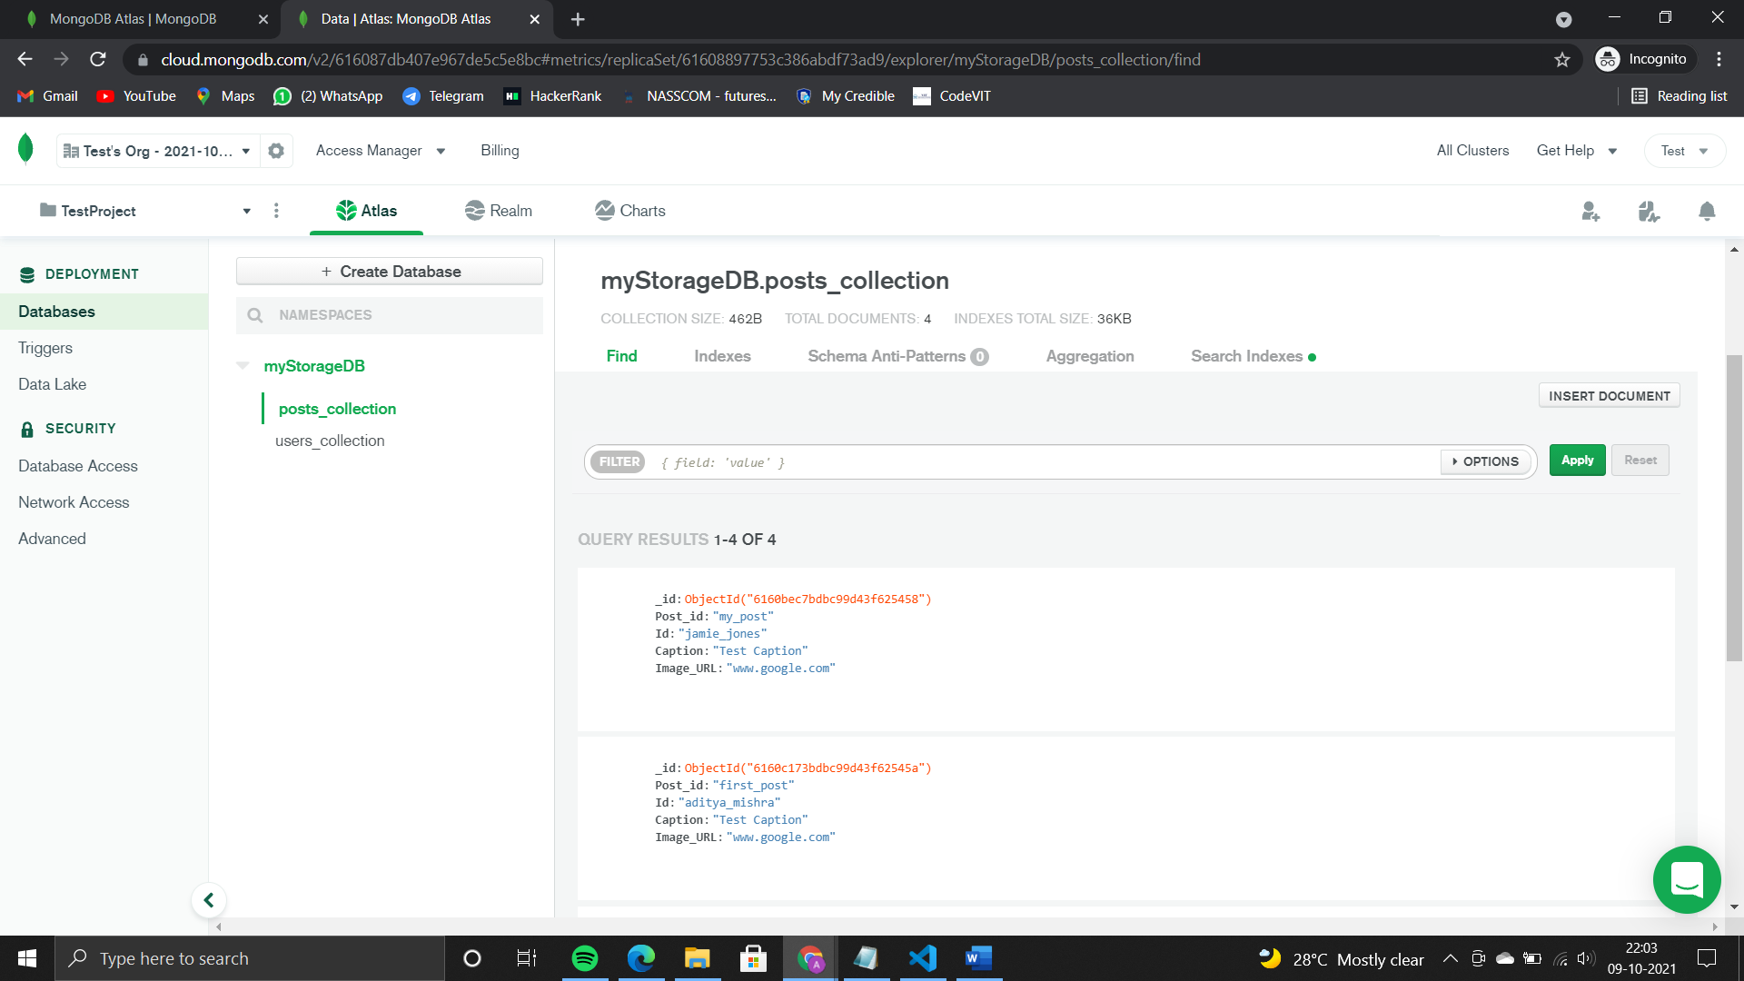

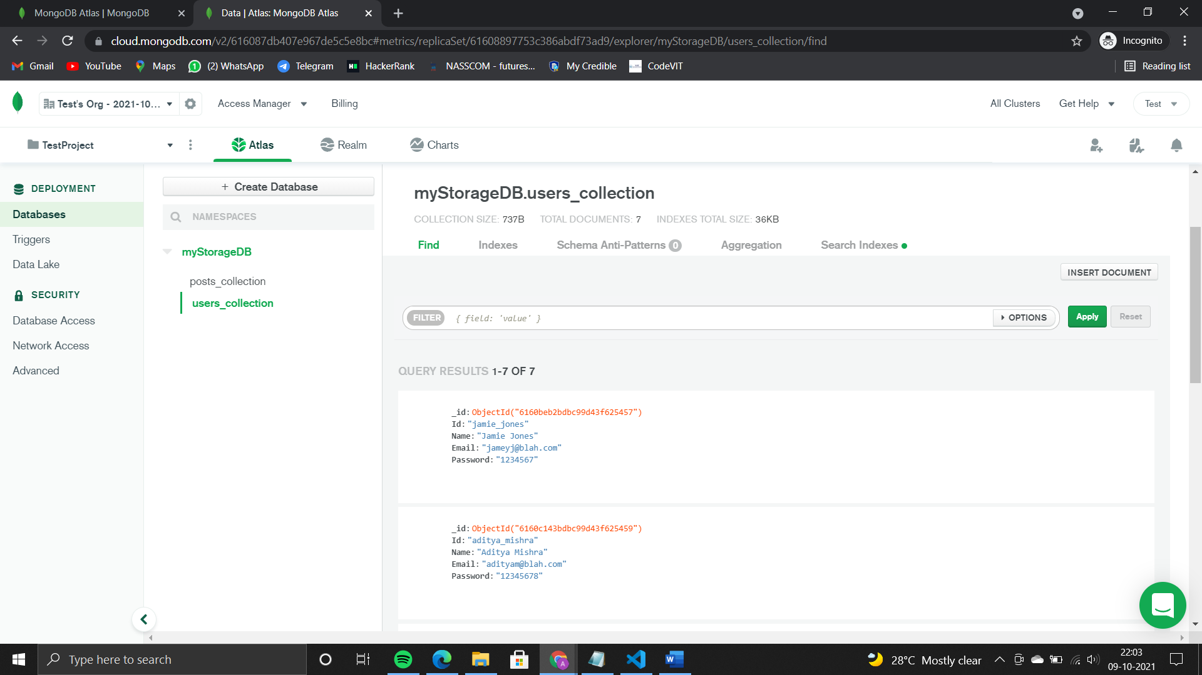

1. The output will also be shown in the Terminal section of VSCode.