Beta-beta density for KL_weighted approach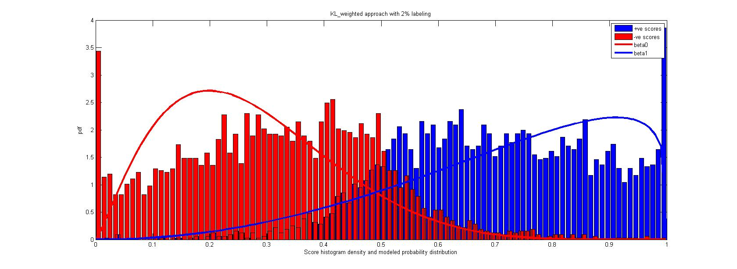

Beta beta density for marginalized density approach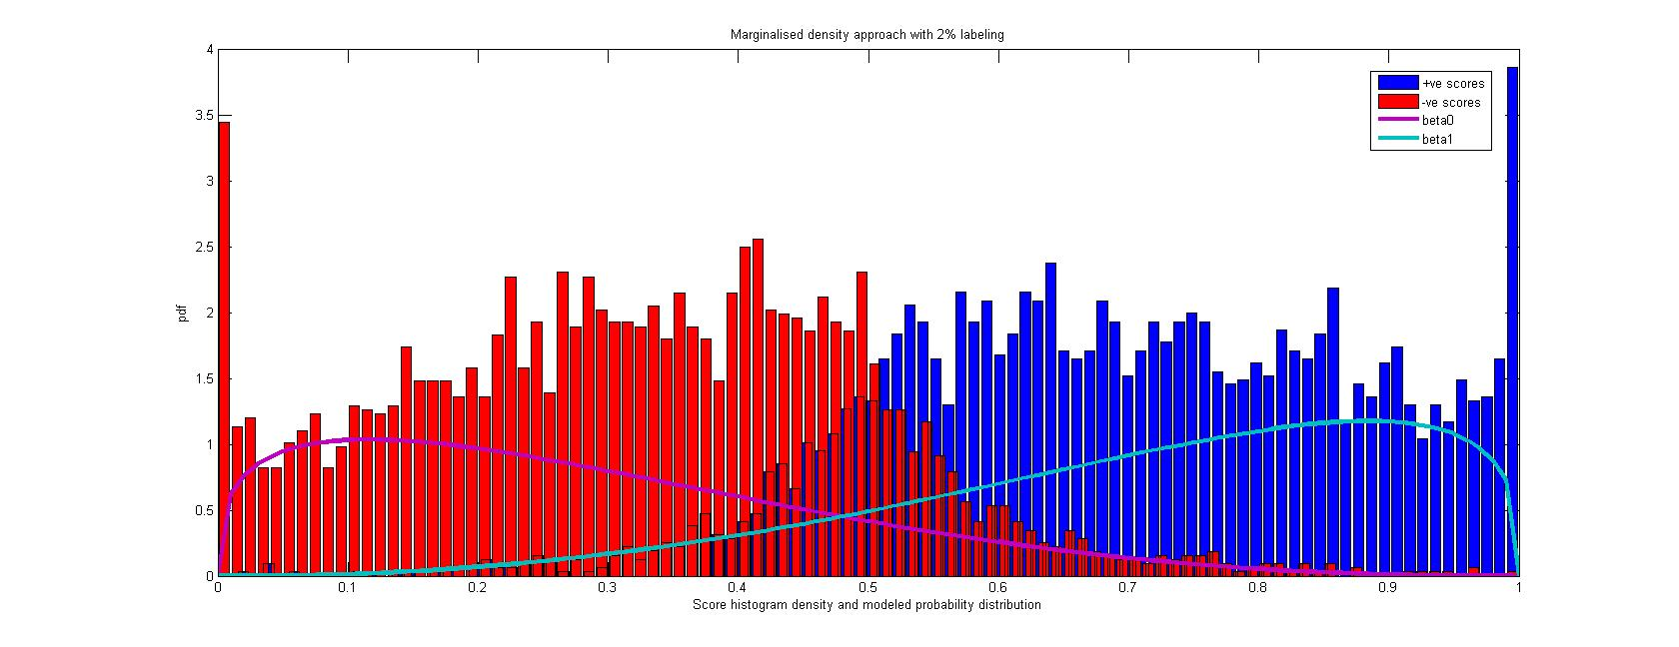Beta-Gaussian density for KL_weighted approach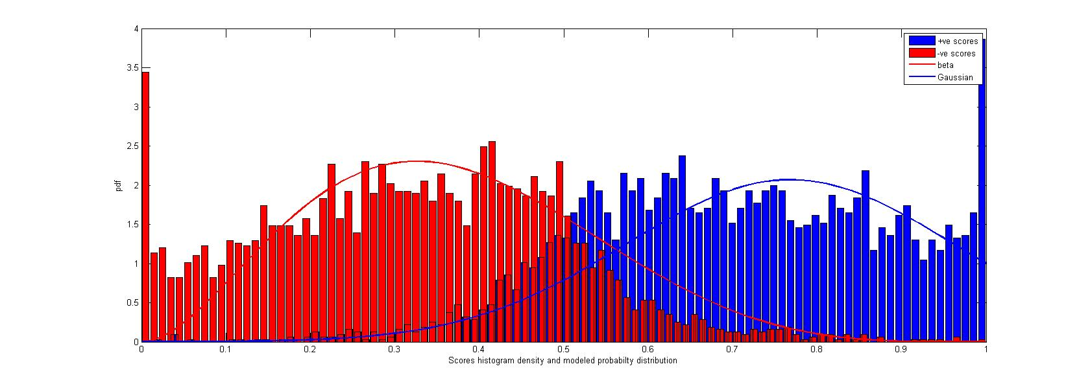

Beta-Gaussian density for marginalized density approach 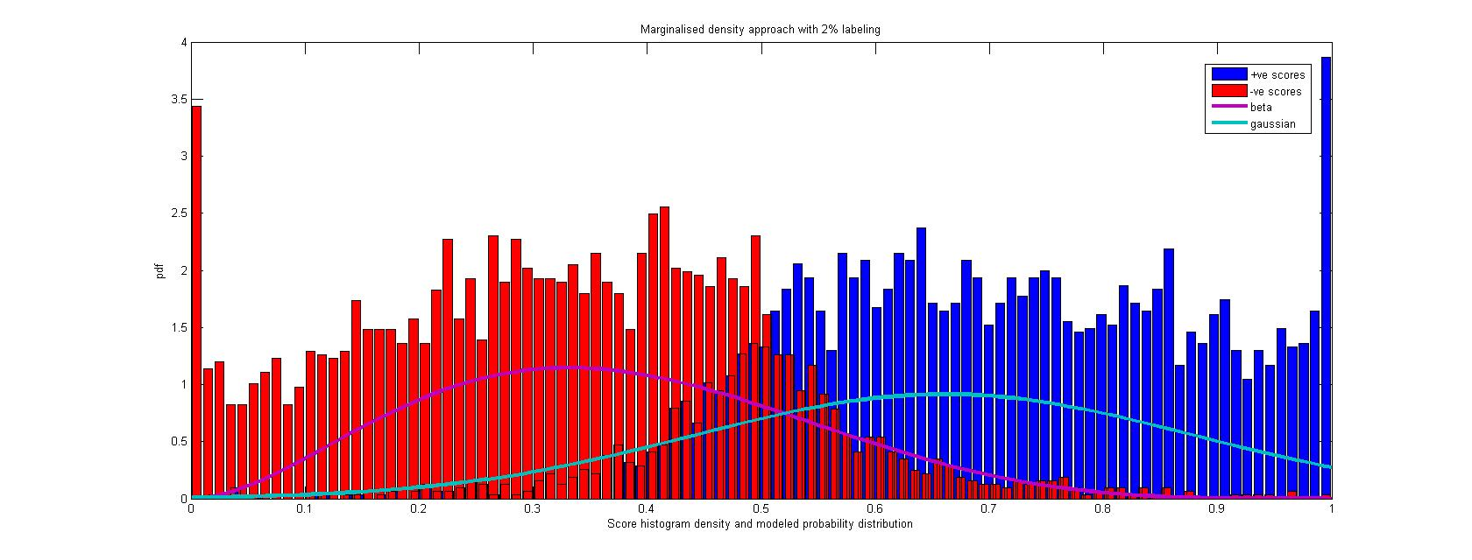 Beta-trunc-Gaussian density for KL_weighted approach 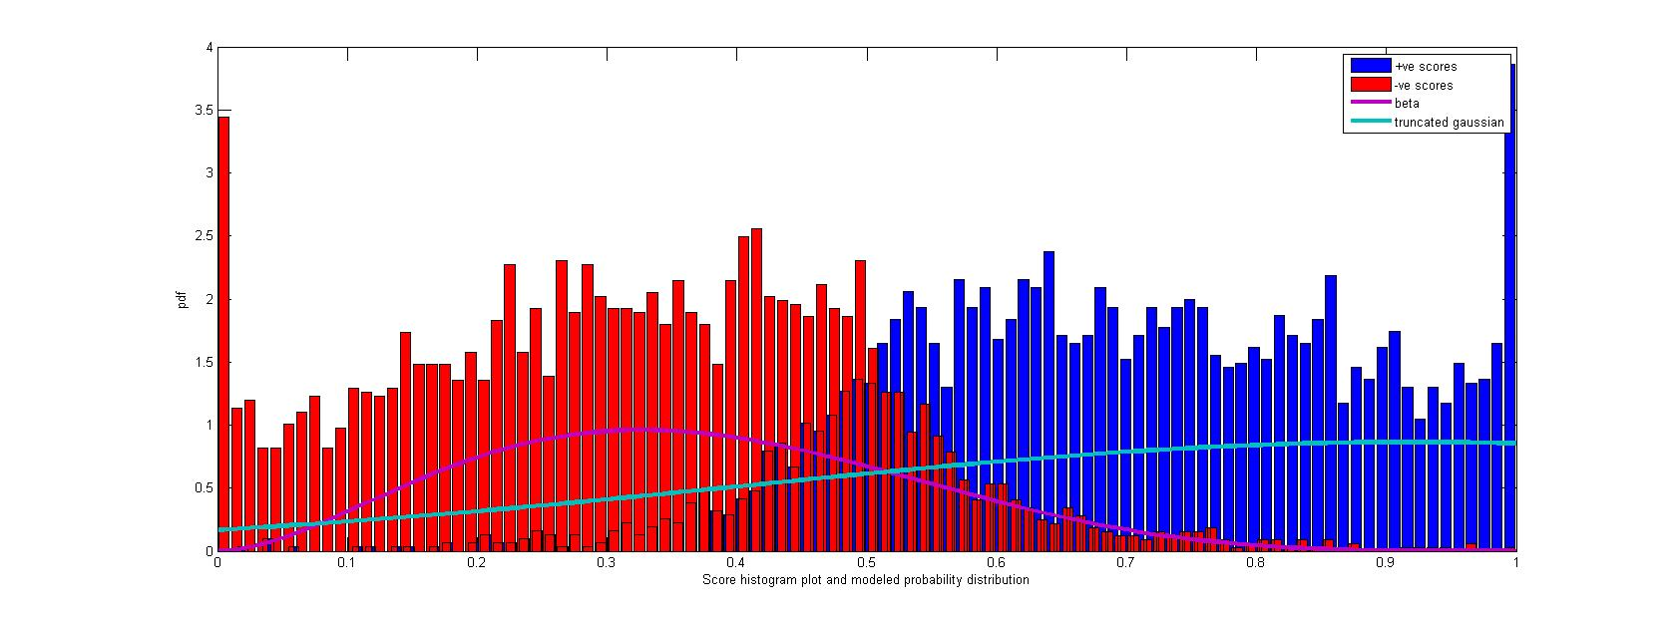 Beta-Trunc_Gaussian density for marginalized density approach 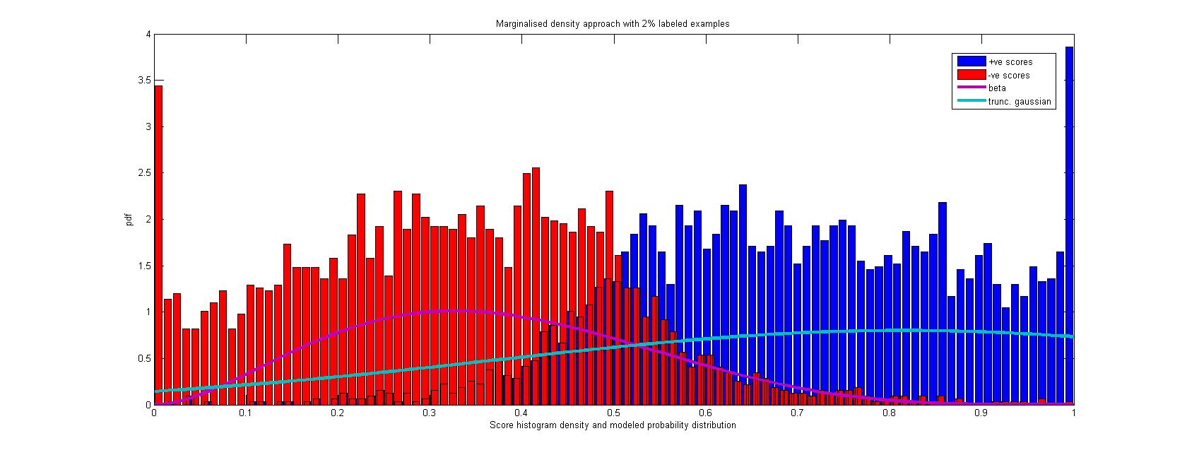

Gaussian-beta density for KL_weighted approach 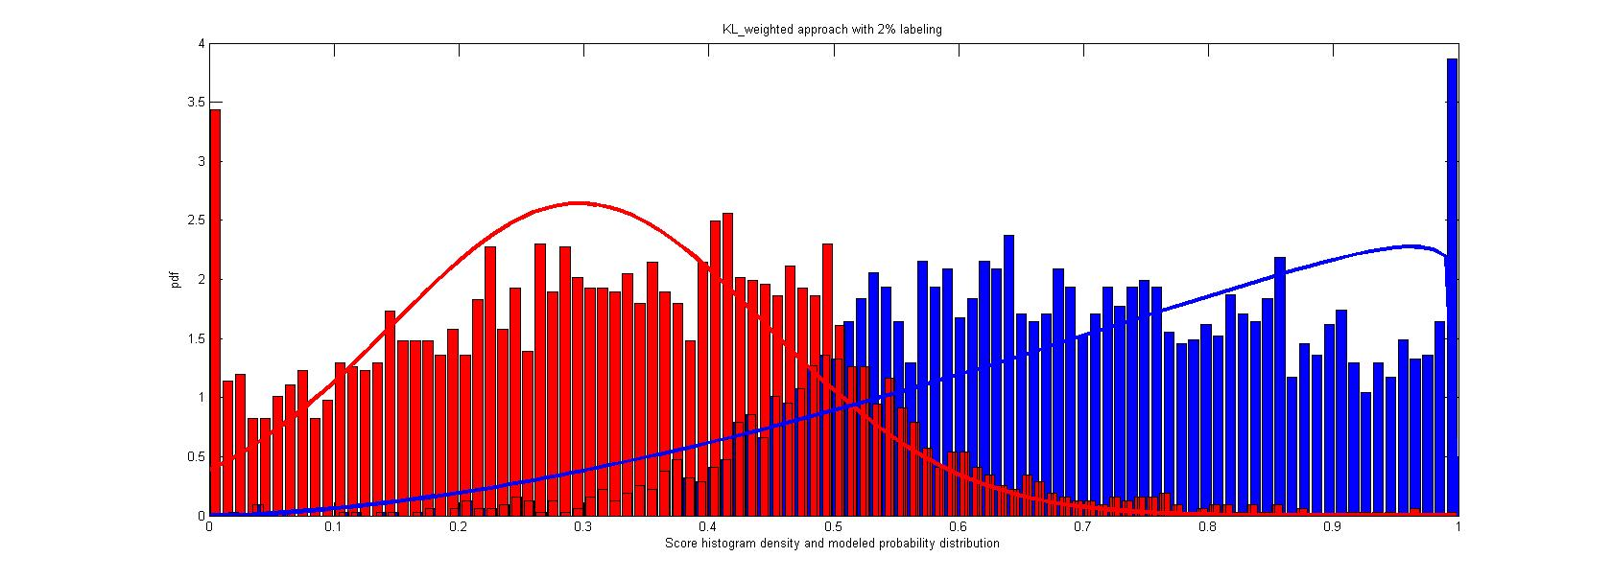 Gaussian-Beta density for marginalized density approach 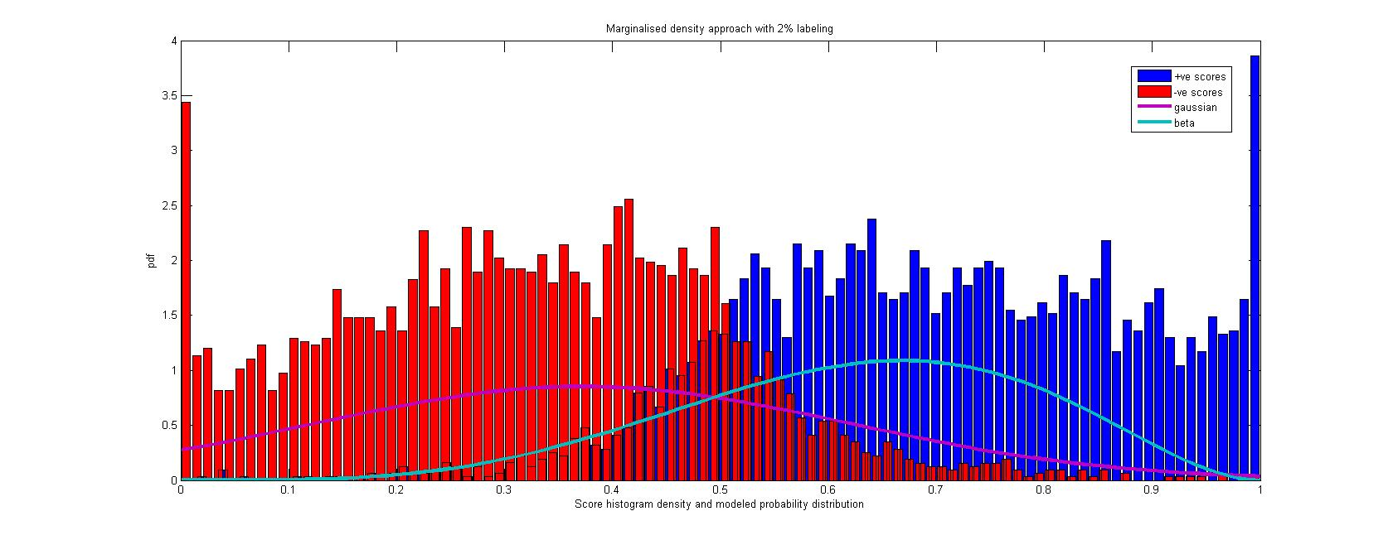 Gaussian-Gaussian density for KL approach 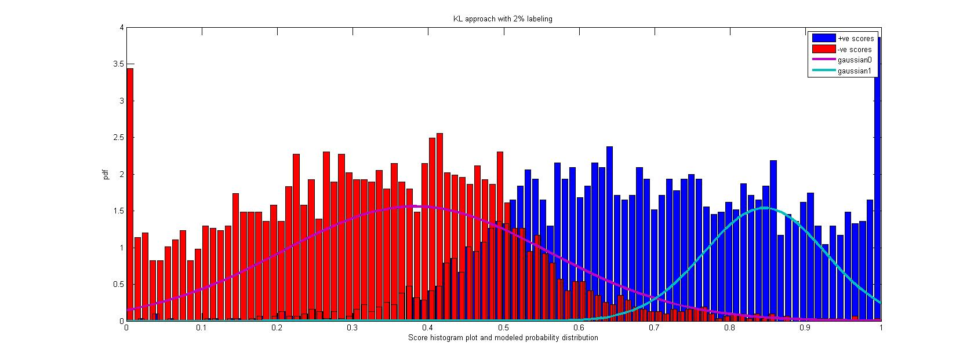

Gaussian-Gaussian density for KL_weighted approach 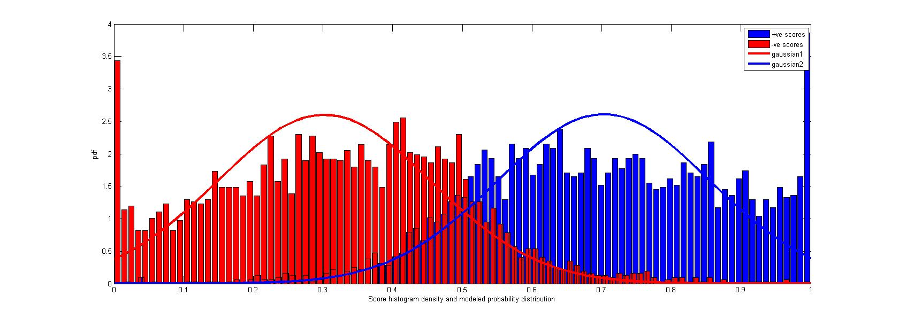 Gaussian-Gaussian density for marginalized density approach 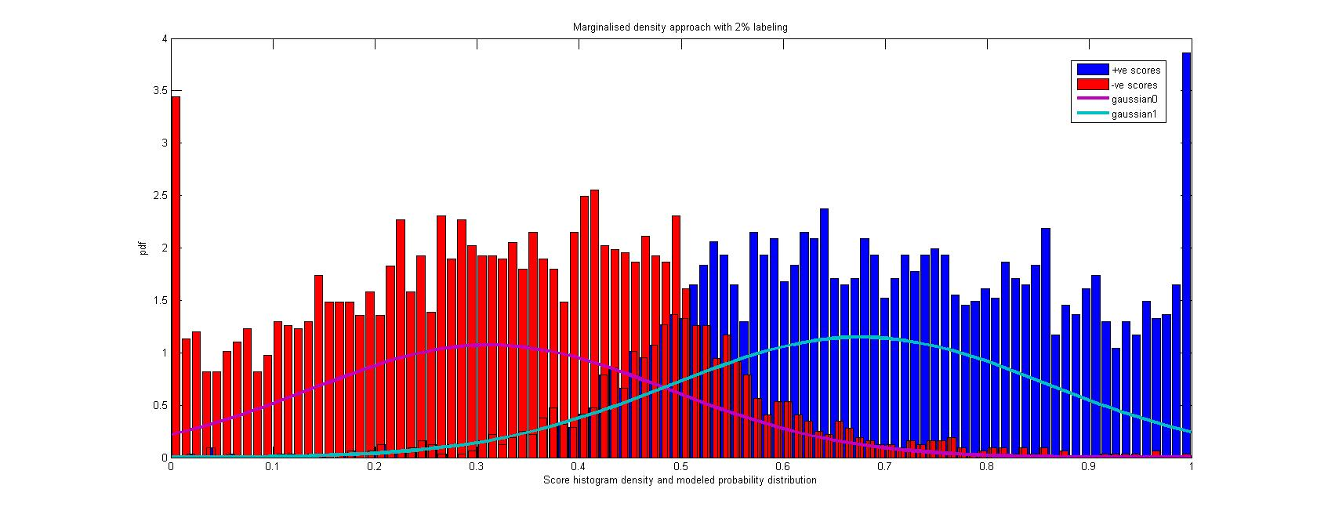 Gaussian-trunc_Gaussian density for KL approach 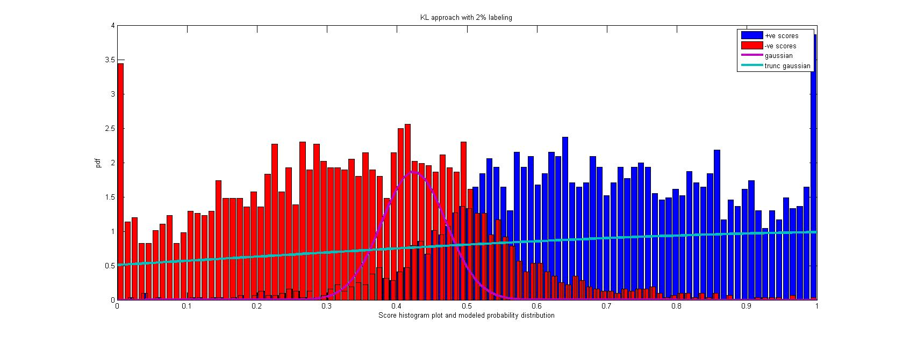

Gaussian-trunc_Gaussian density for KL_weighted approach 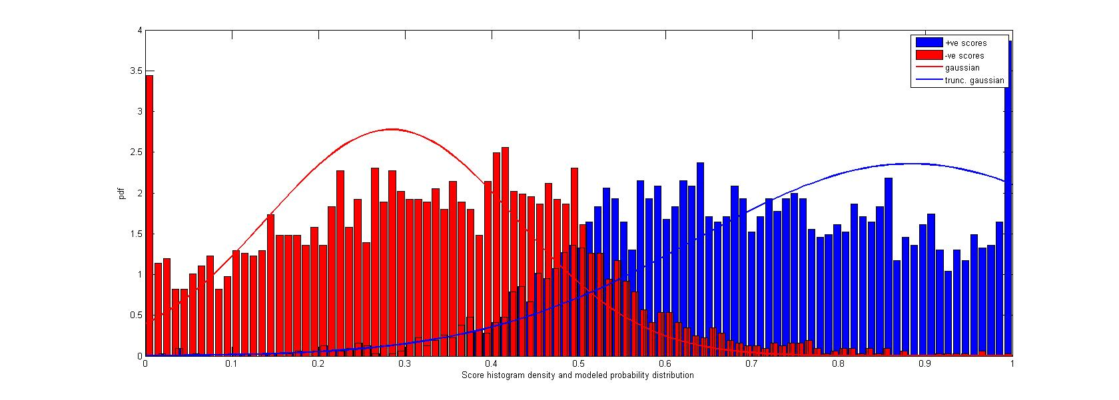 Gaussian-trunc_Gaussian density for marginalized density approach 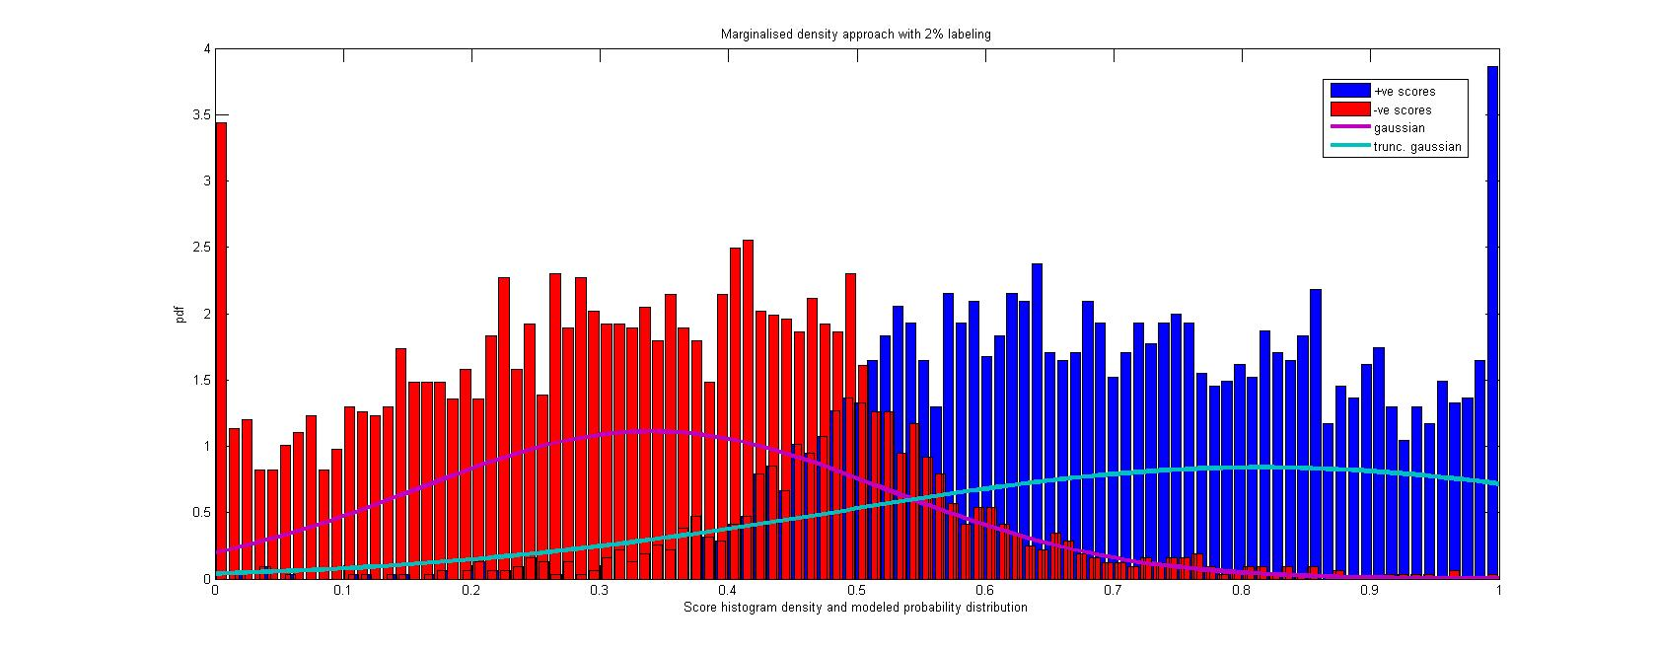 Beta-trunc_Gaussian density for KL approach 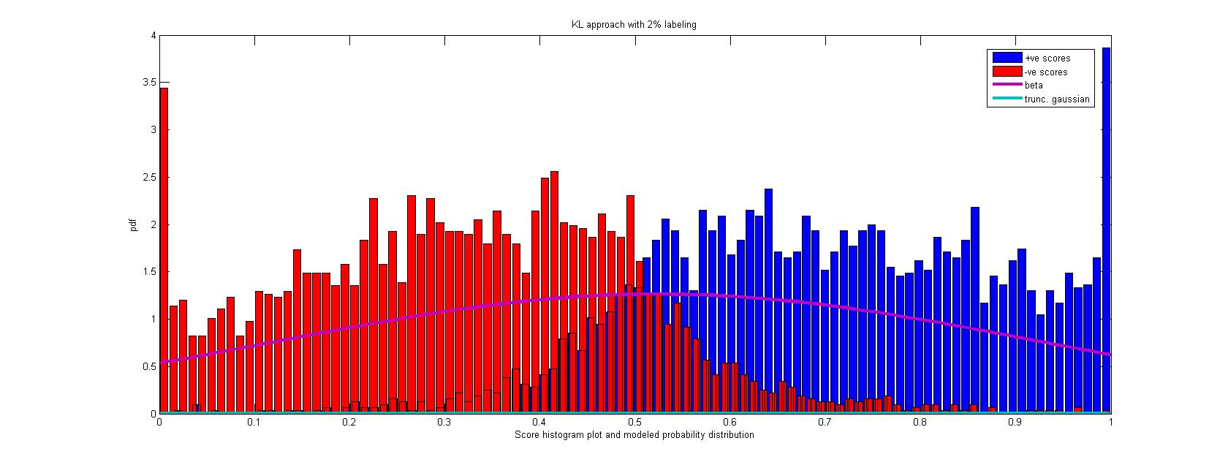

Trunc_Gaussian-Beta density for KL_weighted approach 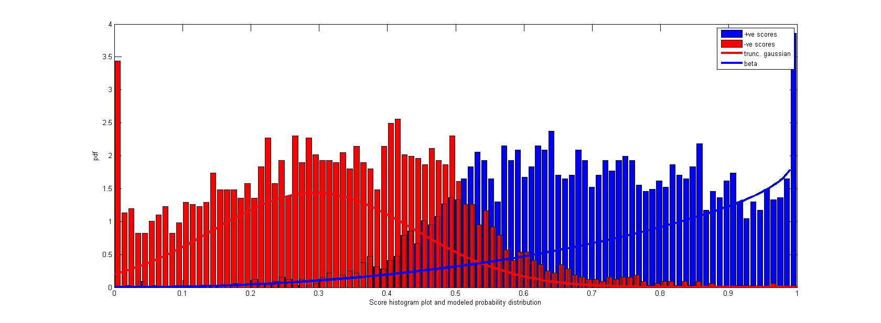 Trunc_Gaussian-Beta density for marginalized density approach 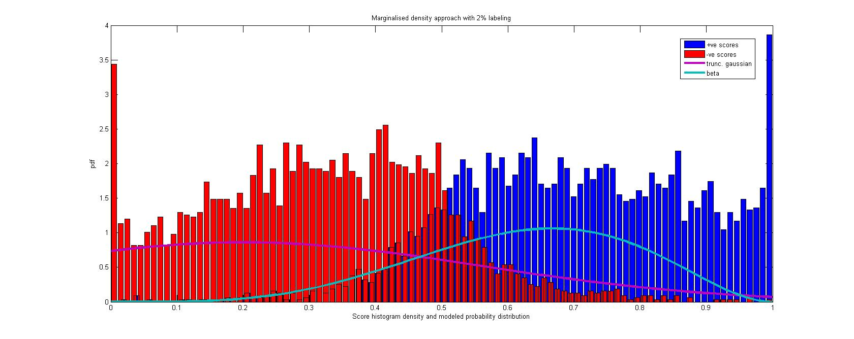 Trunc_Gaussian-Gaussian density for KL approach 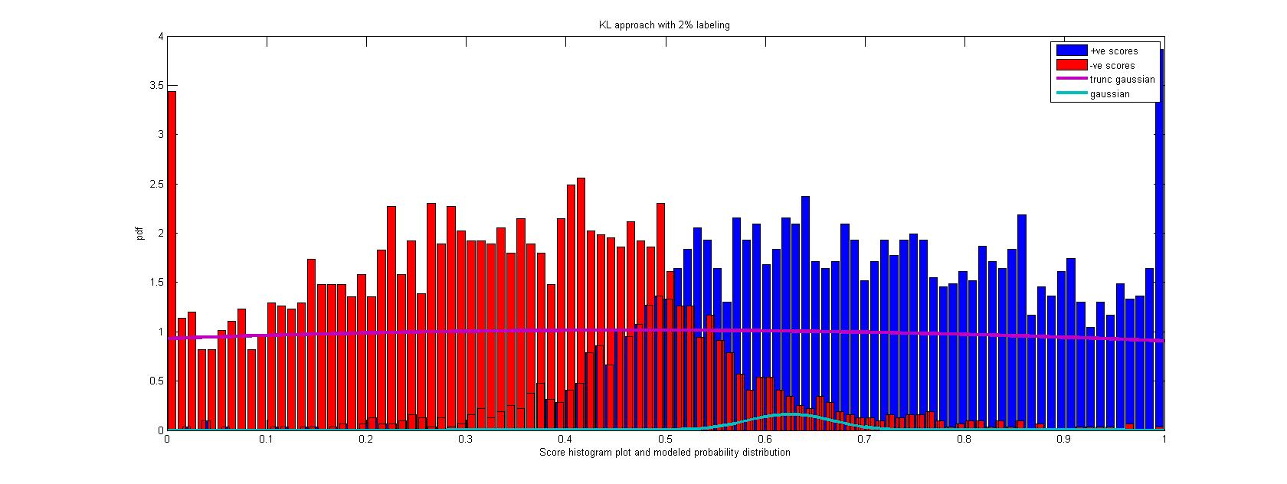

Trunc_gaussian-Gaussian density for marginalized density approach 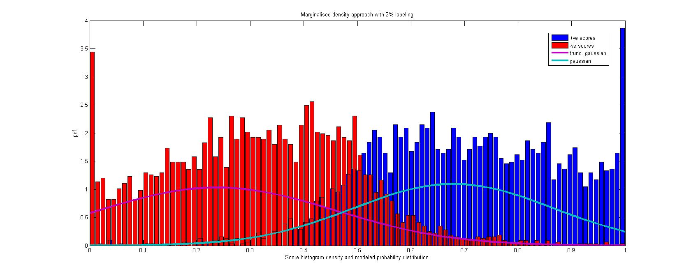 Trunc_gaussian-Trunc_gaussian density for marginalized density approach 