1. Table should not be expanded when page loads **Done**
2. Submit button to be disabled and grayed out and it should not be clickable **Done**
3. Add New Student Button should add new student with dummy values and dummy values should be dynamically added e.g for row 4 the values will be Student 4, Teacher 4 etc. and for row 5 the values will be Student 5, Teacher 5 etc. **Done**
4. For newly added rows make sure existing CSS are applied too. **Done**
5. After successful add of the record display the pop-up message as Record added successfully (any user-friendly message is also fine) and display error message in case add of record addition failed. **Done**

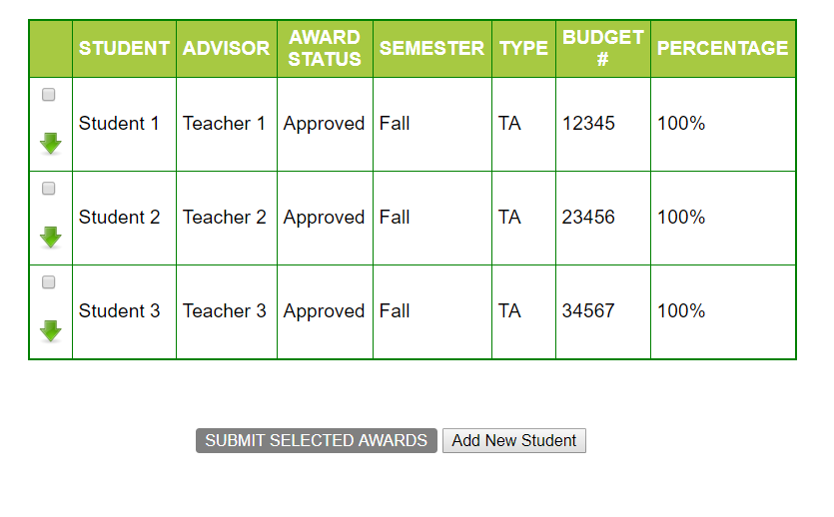

1. On selecting any of the check-boxes,  
   i] Background color to be changed for the particular row to “Yellow” and **Done**  
   ii] Submit button to turn orange. **Done**  
   iii]A delete button should get added dynamically in DELETE column and should delete the entire row when clicked. Also, pop-up message should be displayed by saying that Record deleted successfully. **Done**

iv) An Edit button should get added dynamically in EDIT COLUMN and should only display pop up box with message “Edit the details”. No need to display the field names **Done**

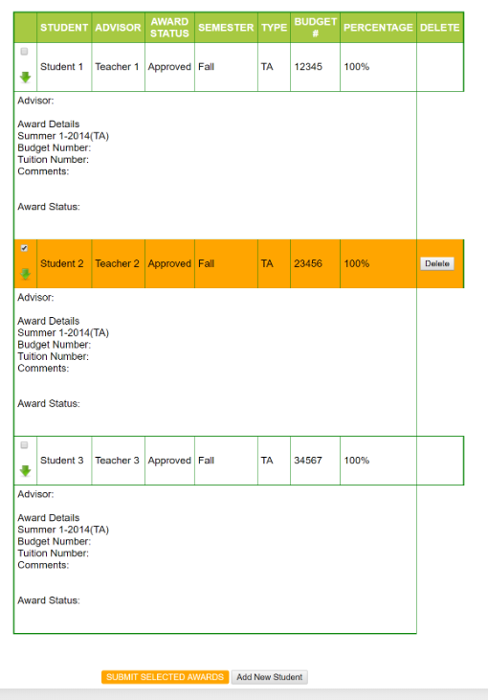

1. Deselecting the check box will
2. make the row background color white again. **Done**
3. Also, if none of the rows are selected, the Submit button should be Grayed out again(disabled). (i.e., if 1 or more of the check-boxes are selected, the Submit button will be enabled and background color will be yellow. If none are selected, it will be disabled and background set to Gray) **Done**
4. DELETE button in those de-selected rows will be hidden **Done**
5. EDIT button in those de-selected rows will be hidden **Done**

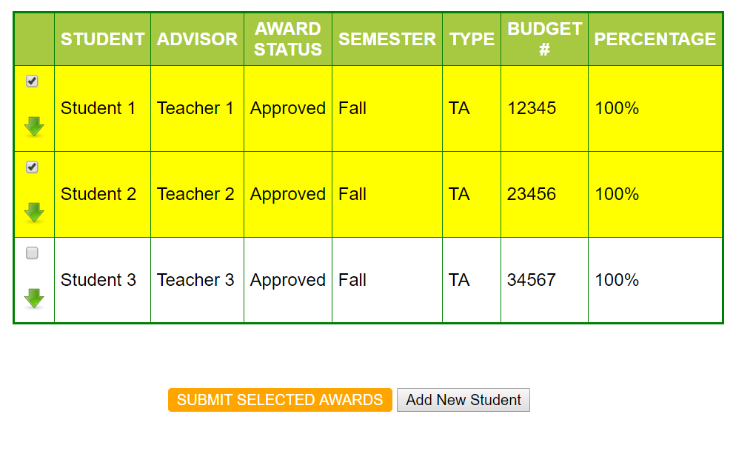

1. Clicking on any of the green arrows will expand the particular row. Clicking it again will collapse it (i.e., toggle view on click) DONE

