Apple Website analysis:

Screenshot of Original Website:

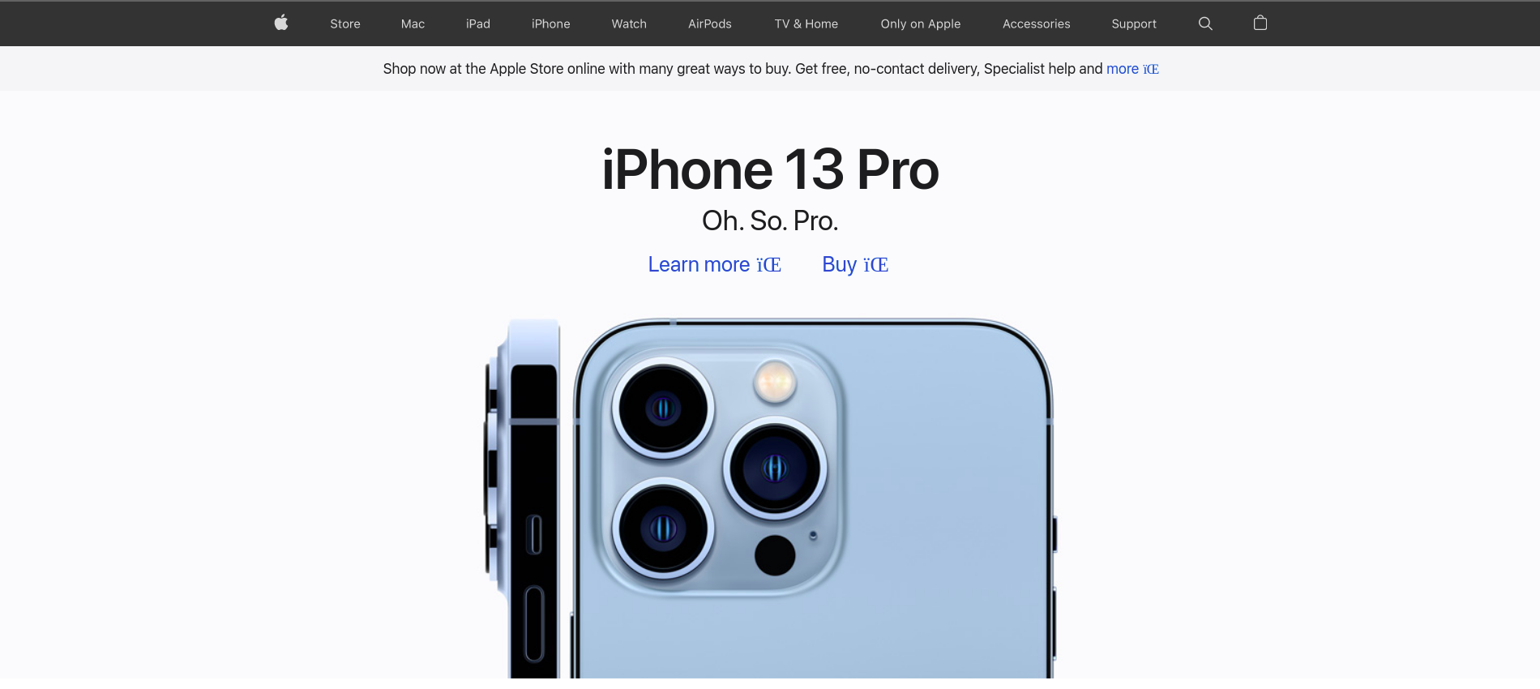

Screenshot of Recreated Website:

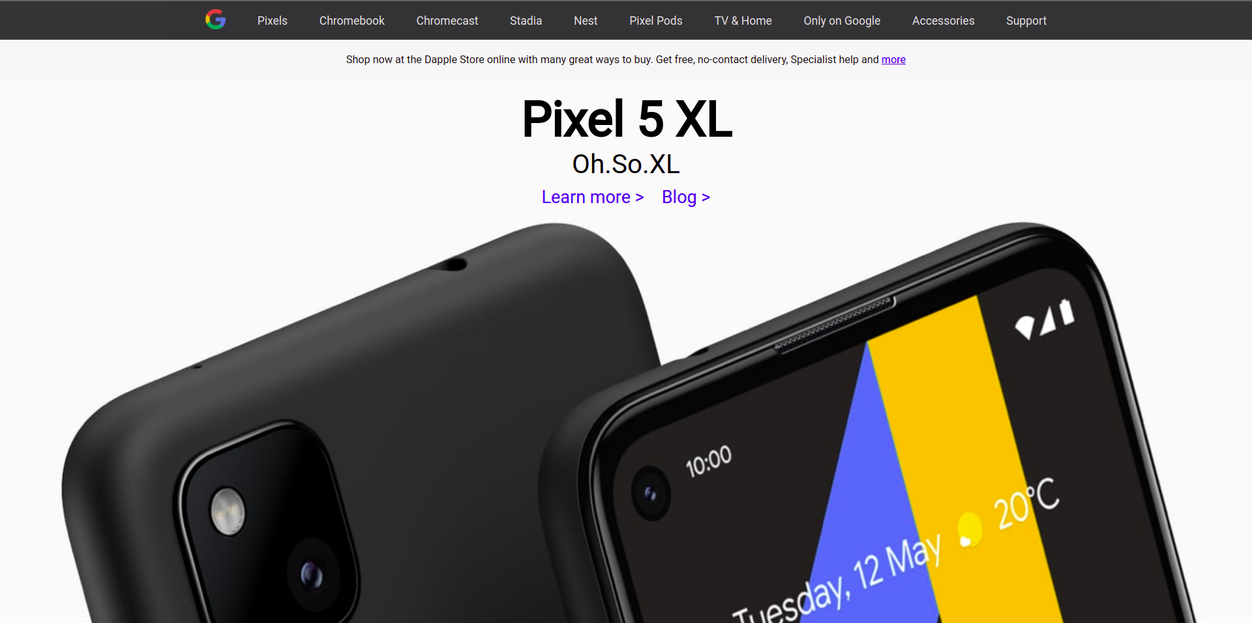

Meta:

*<meta*

*name="Description"*

*content="Discover the innovative world of Apple and shop everything iPhone, iPad, Apple Watch, Mac, and Apple TV, plus explore accessories, entertainment, and expert device support."*

*/>*

*<meta property="og:title" content="Apple (India)" />*

Meta tags like description are used by search engines in order to search for websites which match the user’s search keyword. Meta tags exist only in head tags.

Viewport And Encoding:

*<meta charset="UTF-8">*

*<meta name="viewport" content="width=device-width, initial-scale=1.0">*

Charset and viewport are used to specify the encoding of the html file and the viewport of the website.

SVG:

*<svg class="icon">*

*<use xmlns:xlink="http://www.w3.org/1999/xlink" xlink:href="/resources/prod/v1.5.16/i/svg-output/icons.svg#icn-share"></use>*

*</svg>*

SVGs are used to add vector graphics to websites. The use tags can be used to link svg from the internet.

Fieldsets:

*<fieldset>*

*<div class="form-group">*

*<label class="form-group__label" for="given_name">First name *</label>*

*<input class="form-group__element" type="text" required name="given_name" id="given_name" pattern="^[A-Za-z-\s]+$" maxlength="50"/>*

*</div>*

*<div class="form-group">*

*<label for="given_name">First name *</label>*

*<input class="form-group__element" type="text" required name="given_name" id="given_name" pattern="^[A-Za-z-\s]+$" maxlength="50"/>*

*</div>*

*</fieldset>*

Fieldsets are used to group together input fields that are of same group. Eg: first name,last name

Nav:

*<nav class="mobile-sub-menu js-global-navigation-quicklinks" data-widget="scroll-boundary" data-active-class="is-fixed"></nav>*

Nav tags are semantic tags which give specific meaning to a group of links and are used by accessibility features such as screen reading

Picture:

*<picture class="js-lazy-picture lazy-load content hero-hub__item-picture">*

*<source srcset="" data-image-src=”https://resources.pulse.icc-cricket.com/photo-resources/2021/10/24/0caa3eca-5daa-4af0-a646”>*

*</picture>*

Picture tags are used to render different images for different screen sizes. Multiple source tags are used inside picture tags each source tag is for each screen size.

Time:

*<time class="match-list-carousel__match—time">*

*18:00*

*<span class="timezone">(LOCAL)</span>*

*</time>*

Used to render a machine readable time. i.e the time can be distinguished by web crawlers and search engines.

Figure:

*<figure class="thumbnail__container">*

*<picture class="js-lazy-picture lazy-load thumbnail__picture">*

*<source srcset="" data-image-src="https://resources.pulse.icc-cricket.com/photo- ae38--">*

*<source srcset="" data-image-src="https://resources.pulse.icc-cricket.com/photo- " >*

*</picture>*

*<figcaption class="thumbnail__caption">*

*<h5 class="thumbnail__title">What makes new ball weapon Shaheen Afridi so valuable...</h5>*

*</figcaption>*

*</figure>*

Figure tags are used to render images which are self-contained and doesn’t relate to other images. Figcaptions are used to provide caption to these images. Images can be rendered using image or picture tags.

Section:

*<section*

*class="homepage-section collection-module"*

*data-module-template="ribbon"*

*data-analytics-region="ribbon"*

*>*

Section is another semantic element which is used to distinguish a seperate section of a document.