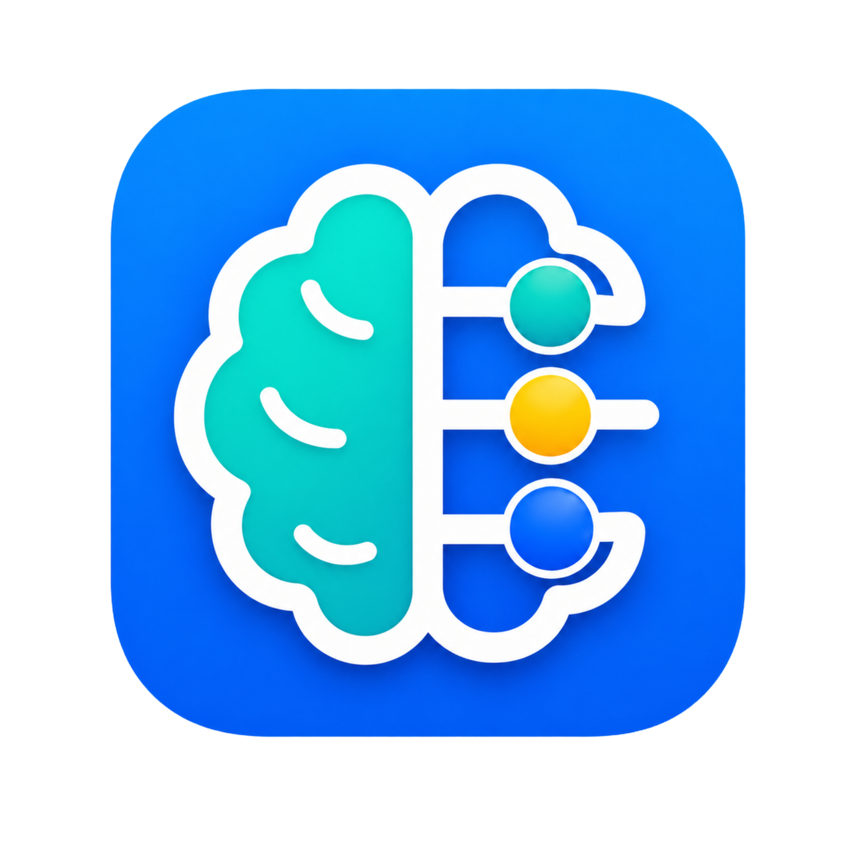
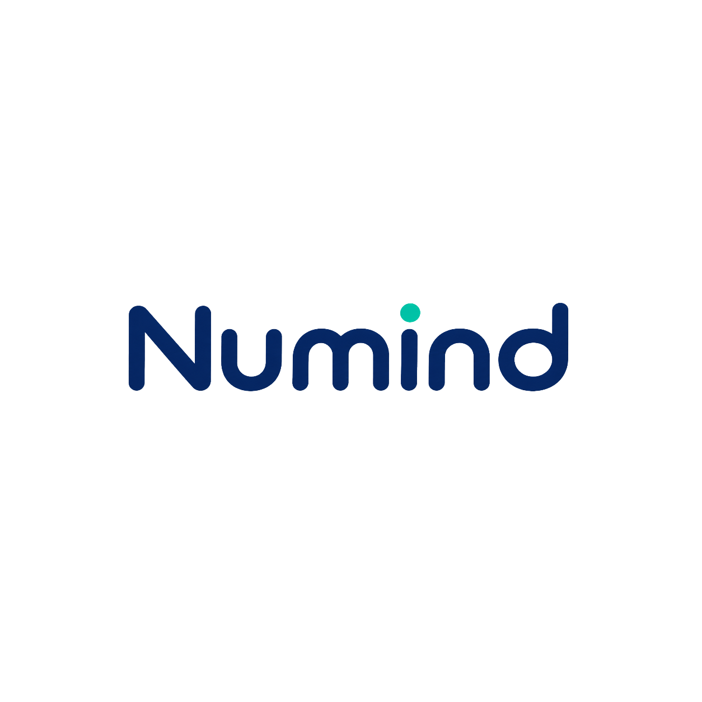
Brand Guidelines v1
Design language for an App Store-first mental math and number-sense product

Brand foundation
Numind helps people build fast, practical number sense through short daily practice. The brand should feel useful, friendly, and confidence-building rather than academic, childish, or overly gamified.
Brand should feel like | Brand should avoid
• Clean and modern  • Friendly but not childish  • Quick, practical, and real-world  • Confidence-building  • A little playful, never gimmicky | • School worksheet energy  • Generic brain-training cliches  • Finance or trading visual language  • Calculator-only utility positioning  • Overly cute mascot dependency

Brand pillars
Cognitive  Brain / thinking / mental sharpness | Numerical  Abacus / counting / structure | Friendly  Rounded shapes / soft color / approachable UI | Progressive  Practice / clarity / confidence

Logo system
The locked direction is a brain-abacus badge: the left half represents mental training, while the right half uses abacus rails and beads to represent number sense and structured practice.
Primary app badge | Standalone wordmark

Logo usage rules
Primary badge: Use the full blue rounded-square badge for the App Store, splash screen, home screen icon, and social avatar.
Wordmark: Use the standalone Numind wordmark for headers, website navigation, email, screenshot captions, and brand documents.
Lockup: Use badge + wordmark horizontally for landing pages, press kits, pitch materials, and App Store screenshot headers.
Clear space: Keep at least 3-4 times the teal i-dot height around all sides of the logo.
Consistency: Do not change bead order, rail spacing, brain silhouette, icon shape, or wordmark proportions.

Color system
The color system is intentionally small. Blue anchors the brand, teal communicates learning and cognition, yellow is reserved for insight and reward, and navy gives the product maturity.
Color | Hex | Usage | Swatch
Numind Blue | #006BFF | Primary CTAs, active navigation, progress moments
Deep Navy | #071E55 | Wordmark, body text, dark mode surfaces
Mind Teal | #06C7B7 | Learning cues, selected states, positive feedback
Insight Yellow | #FFC400 | Correct answers, rewards, aha moments, streaks
Soft Surface | #F6FAFF | Light mode backgrounds and subtle panels
Slate Gray | #536075 | Secondary text, helper labels, disabled states

Color behavior
Blue: Use for primary buttons, active navigation, onboarding gradients, progress confirmations.
Teal: Use for selected states, positive learning cues, progress beads, and correct answer framing.
Yellow: Use sparingly as the aha moment: correct answer, streak, milestone, reward, or key insight.
Navy: Use for wordmark, body copy, dark surfaces, and serious contrast.
Neutrals: Use off-white, pale blue-gray, and slate gray for calm reading surfaces.

Typography
The wordmark is rounded, friendly, and modern. Product typography should match that personality while keeping numerals highly legible.
Recommended characteristics | Avoid
• Rounded modern sans-serif  • Clear numerals for math problems  • High readability at small sizes  • Bold but not cartoonish  • Works well in both iOS and web UI | • Sharp corporate fonts  • Overly playful kid-app fonts  • Condensed fonts for questions  • Decorative numerals  • Too many typefaces

Type hierarchy
Hero / onboarding: Large, bold, concise. Example: “Build number sense in minutes.”
Lesson title: Medium-bold and instructional. Example: “How to calculate a tip.”
Quiz question: Large and highly readable. Example: “What’s 18% of $42?”
Answer options: Big tap targets with clear number formatting.
Explanations: Short, direct, and practical. Example: “10% is $4.20. 5% is $2.10. 3% is $1.26.”

UI design language
The interface should extend the logo’s rounded, modular, bead-and-rail logic. The goal is a branded product system, not generic white cards with a logo pasted on top.

Shape and layout
Rounded cards, pill buttons, and modular lesson tiles.
Large tap targets for fast answering.
Soft shadows and subtle borders; avoid harsh boxes.
Clean spacing with one primary action per screen.
Progress represented through beads, rails, dots, and small modules.

Signature motif: beads and rails
Use the abacus bead motif as the connective tissue across the product. This motif can appear in progress trackers, lesson completion, streaks, answer feedback, skill levels, and onboarding illustrations.
Correct answer: yellow insight bead lights up or slides forward.
Progress tracker: beads on a rail rather than a generic progress bar.
Skill level: grouped beads or bead stacks.
Streak: vertical bead stack or rail fill.
Module cards: small rail-and-bead icons for Tips, Discounts, Bill Split, Percentages.

Key screens
Onboarding  Promise practical confidence in minutes. | Home  Daily challenge, streak, progress beads, continue learning. | Lesson  Concept card, real-world example, quick practice. | Quiz  Focused question, clear choices, instant feedback.

Light and dark mode
Light mode | Dark mode
• Soft off-white or pale blue background  • Navy text  • Blue primary CTA  • Teal selected states  • Yellow only for reward and insight moments  • Feels clear, friendly, and everyday-useful | • Deep navy background  • Elevated dark cards  • White primary text  • Teal/blue highlights  • Yellow reward moments  • Feels premium, focused, and suitable for evening practice
Dark mode should not simply invert the light palette. Treat it as a deliberate focus mode with deeper surfaces and restrained highlights.

Components to define first
Asset | Description | Primary use
App icon master | Primary blue rounded-square badge | App Store, home screen, splash, social avatar
Dark icon variant | Navy background with same brain-abacus mark | Dark mode marketing, alternate social placements
Light icon variant | Pale blue/white background with strong contrast | Light theme UI, brand docs
Icon-only mark | Brain-abacus symbol without rounded-square badge | In-app illustrations, micro-icons, watermarks
Horizontal lockup | Badge + Numind wordmark | Website header, press kit, App Store screenshots
Standalone wordmark | Numind text with teal i-dot | Headers, email, footer, social end cards
Screenshot templates | Phone mockups using bead-progress visual system | App Store, landing pages, creator decks
Social templates | Question/challenge cards | TikTok/Reels/Shorts creator distribution

Component styling checklist
Primary and secondary buttons
Lesson cards and module cards
Quiz answer cards with correct/wrong states
Progress bead rail
Tool/calculator cards
Bottom navigation
Streak badge and milestone cards
Hint, explanation, and saved-for-later patterns
Paywall card and App Store screenshot template

Illustration, iconography, and motion

Iconography
Use rounded strokes, simple geometry, and the same blue/teal/yellow logic as the logo. Icons should be functional and readable at small sizes.
Home, Learn, Tools, Progress, Profile
Tip, Bill Split, Discount, Percentage, Mental Math
Streak, Hint, Correct, Incorrect, Locked, Daily Challenge

Illustration system
Avoid a full mascot for V1. Use mascot-adjacent illustrations built from mini brain-abacus marks, floating beads, rails, number cards, receipts, coffee cups, grocery bags, and restaurant bills.

Motion principles
Beads slide on rails after correct answers.
Yellow bead glows for insight moments.
Progress rail fills after lesson completion.
Correct answer has a soft bounce; wrong answer has a restrained shake.
Streak beads stack upward over time.

Brand voice
Numind should sound sharp, useful, encouraging, and slightly playful. It should never sound like a guru, a schoolteacher, or a hype-heavy brain-optimization product.
Use this tone | Avoid this tone
• “Nice. You spotted the shortcut.”  • “Try this without a calculator.”  • “Small trick, big time saver.”  • “That’s the pattern.”  • “You’re getting faster.” | • “You are a genius!”  • “Unlock your infinite brain potential.”  • “Crush math forever.”  • “Become unstoppable.”  • Overly childish praise or vague motivation

App Store and acquisition assets
The App Store page should sell practical value immediately. Screenshots should show real-world use cases, not vague “brain training.”
“Quick math for real life.”
“Train tips, splits, discounts, and percentages.”
“Build number sense in 5 minutes a day.”
“Practice with real-world questions.”
“Get faster without memorizing formulas.”

Creator/social templates
Question/challenge card: “Can you solve this in 5 seconds?”
Tip/bill split card: “Tip this bill without opening Calculator.”
Score card: shareable weekly progress or streak.
Short-form video end card using badge + wordmark.
Watermark with icon-only mark or wordmark.

Visual direction references
These concept boards are visual references for UI tone, spacing, and color behavior. Treat them as inspiration, not final screen designs.
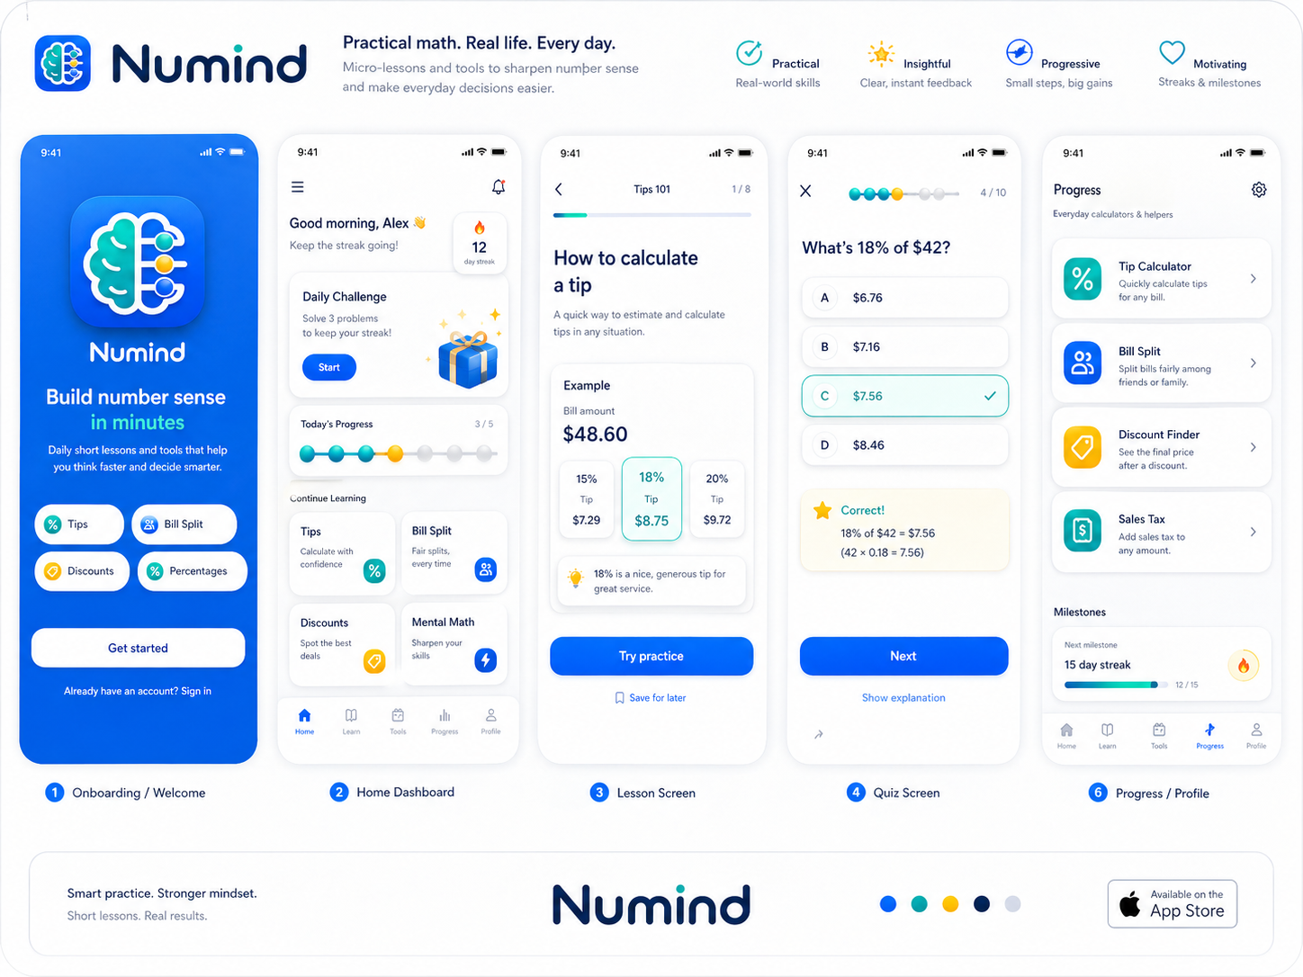
Light mode direction: clean, practical, App Store-friendly.
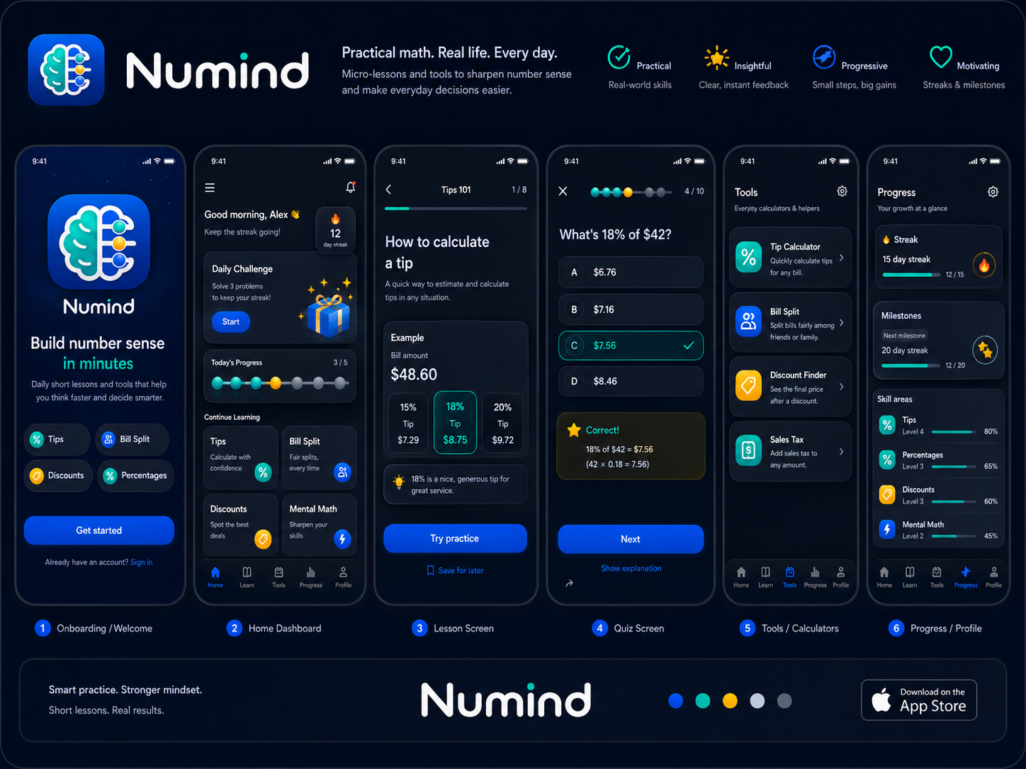
Dark mode direction: focused, premium, evening-practice feel.

V1 build checklist
Lock production logo assets: primary badge, dark badge, light badge, icon-only mark, wordmark, horizontal lockup.
Define design tokens: colors, type scale, radius, shadows, spacing, button states.
Create core components: buttons, lesson cards, quiz answer cards, progress beads, module cards, tool cards, bottom nav.
Build App Store kit: icon, screenshots, captions, app subtitle, preview templates.
Build social kit: challenge card, score card, video end card, creator overlay/watermark.
Implement motion: bead slide, yellow insight glow, correct bounce, wrong shake, streak stack.
Operating principle: keep the product experience centered on “daily reps for real-world number sense.” Every visual decision should support speed, clarity, and confidence.

