AI Training Coach
Product Requirements Document: a coaching feature inside Hevy
Author | Aditya Nanda Tri Prakoso
Status | Draft for a clickable phone prototype
Date | 21 September 2026
Based on | AI Training Coach Product Discovery (v2). Section numbers in the Source column refer to that document.
Scope | Design-for-one. The user is me. This is an independent concept and is not affiliated with Hevy.

1. Background
AI Training Coach is a proposed feature inside an existing workout tracker, Hevy in my case. Everything here describes what I would consider a solution to my own problem. Whether it works for other lifters is a separate question this document does not answer.
The problem. Hevy records what I did, but I still decide what to do next, set by set. The idea began as a way to stop re-entering AI-generated programmes into Hevy. Challenging it showed that this was not the deepest problem. The deeper one is the mental load of reading my own training data and deciding when to push or hold. The core thesis is: let the AI think about progression so I can think about training.
The payment lens. This started as a search for a problem I would probably pay to solve inside the app. That is one person’s view, so it is treated as an assumption to test (Hypothesis 11 in the discovery document).

What Hevy already shows (from my screenshots)
- The Log Workout screen lists each exercise with a set table. The columns are SET, PREVIOUS (last weight × reps), KG, REPS, RPE and a check.
- Each exercise has its own rest timer. While resting, a bar at the bottom shows -15, the countdown, +15 and Skip.
- The top of the screen shows duration, volume, sets and a muscle map. Each exercise also has a notes field and an Add Set button.
- The Home tab is a social feed of workout summaries with time, volume and records. The post shown is my own. The bottom navigation has Home, Workout and Profile.
- The Workout tab has a Start Empty Workout button, New Routine and Explore buttons, a tip banner, and one card per routine (Leg Day, Pull Day, Push Day). Each routine card has a title, a grey exercise list and a full-width blue Start Routine button.
- None of the screenshots shows any recommendation or guidance about what to do next.

2. Objective
Product objective. Give me clear direction on what to do next during a workout, so I can focus on the exercise while keeping the final decision. The loop is: Observe, Understand, Recommend, I decide, Execute, Learn, Recommend again.
Prototype objective. Build a clickable, phone-sized prototype that follows the look of the Hevy screens and makes this loop felt using mock data. It should help me answer three questions, measured on myself (discovery Section 40):
- Do I follow the recommendations?
- Do I think less about what to do during my workout?
- Would I still pay for it after a training block?

Out of scope
- A live Hevy connection. I have not verified what Hevy lets a third party read or write.
- Creating or editing routines, and generating workouts.
- Smartwatch signals, wearable and sleep integrations, mid-session exercise changes, and automatic routine restructuring (discovery Section 37).
- Pricing and billing.
- Routine rotation. The prototype only shows Push Day.
- A live model inside the prototype. It is an optional milestone in the hand-off.
- A light theme. Hevy lists a dark mode, so a light theme probably exists. This draft covers the dark theme only.

Assumptions
- Portrait phone screen, dark theme like Hevy.
- Mock data only.
- RPE is entered for every set.
- The prototype always shows Push Day.
- The real product uses a live model for the reasoning. In this prototype that layer is scripted so I can test the experience first.
- The AI recommends and I decide. The AI never edits my routine (Section 12).

3. Features & Flow

Flow (MVP order)
- I open Hevy and see Today’s Focus at the top of Home. On the Workout tab, where I start the routine, I see the same card with the plan.
- I start the workout.
- I see direction for the current exercise.
- I log each set in Hevy as normal (kg, reps, RPE, check).
- A signal appears during the rest period only when something meaningful changes.
- I follow or override. Every time my weight differs from the target, I can give a one-tap reason.
- I tap Pain at any point if I need to.
- I finish and read the session recap.
- The next session’s recommendations update automatically.

Where each element sits on the Hevy screens
Element | Screen | Placement | Status
Today’s Focus (hook) | Home tab | A card at the top of Home, below the header and above the feed. Start Routine is a button inside the card. | Proposed
Today’s Focus (plan) | Workout tab | The same card at the top of the tab, below the header and above Start Empty Workout. | Confirmed by you
Exercise direction | Log Workout, each exercise block | One line directly below the Rest Timer line and above the set table header. | Proposed
Signal card | Log Workout | Docked directly above the rest timer bar, or at the bottom when the bar is not showing. | Proposed
Reason chips | Log Workout, during rest | Inside the signal card, below the signal. | Proposed
Pain button | Log Workout, each exercise block | The Add Set row is split into Add Set (about 60%) and Pain (about 40%). | Proposed
Why sheet | Log Workout | A bottom sheet opened from the Why? link on the signal card. | Proposed
Session recap | After Finish | A full screen before returning to Home. | Proposed

Hevy design system alignment
I could not find a public Hevy design system. The values below are measured from your three screenshots, so treat them as close approximations. The typeface is most likely SF Pro, the iPhone system font. That comes from your source and I could not confirm it. The feature must use Hevy’s existing typeface, and the mockups use a similar font only as a stand-in. Every new element copies a pattern that Hevy already uses.
Colour token | Hex | Where Hevy uses it | Use in this feature
Background | #000000 | Screen background | Screen background
Surface | #1C1C1D | Top bar, cards, Add Set, rest timer bar, unchecked cells | Cards, signal card, secondary buttons
Raised | #2C2C2D | -15 and +15 buttons, input borders, timer track | Chips, Dismiss button
Primary text | #FFFFFF | Values and labels | Reasons, values and labels
Secondary text | #84888E | Previous column, notes, table headers, feed labels | Small section labels and notes
Accent blue | #3D8AF7 | Exercise names, Rest Timer line, Skip button, progress bar. The Finish button looks slightly deeper at #377FE5. | Primary button, links, selected state
Completed green | #71BA41 | Check button on completed sets, on a #1C2F0E row | Not used by this feature
Yellow | #FBEEA2 and #F9DF4A | Tip banner and PRO badge on the Workout tab | Not used by this feature
Contrast of the token pairs (WCAG 1.4.3). Text needs 4.5:1, or 3:1 if it is bold 14 pt or larger.
Pair | Ratio | Result | Used for
Primary text on background | 21.0:1 | Passes 4.5:1 | Body and values
Primary text on surface | 17.0:1 | Passes 4.5:1 | Text inside cards
Primary text on raised | 14.0:1 | Passes 4.5:1 | Chip labels
Secondary text on background | 5.9:1 | Passes 4.5:1 | Section labels on the page
Secondary text on surface | 4.8:1 | Passes 4.5:1 | Section labels inside cards
Secondary text on raised | 3.9:1 | Below 4.5:1, so not used | Not used
Accent blue on background | 6.2:1 | Passes 4.5:1 | Links on the page
Accent blue on surface | 5.0:1 | Passes 4.5:1 | Why? link inside a card
Primary text on accent blue | 3.4:1 | Below 4.5:1, so bold 16 pt only | Primary button labels
Layout and type scale (approximate).
Property | Value | Seen on
Screen side margin | 16 pt | All three screenshots
Card corner radius | 10 pt (measured 8 to 12 pt) | Suggested Athletes card, routine cards
Button and cell corner radius | About 7 pt, and about 9 pt on rest timer buttons | Add Set, set cells, -15, +15, Skip
Control heights | Set row 35 pt, rest timer buttons 38 pt, Add Set and Start Routine 40 pt, Start Empty Workout and New Routine 48 pt | Log Workout, Workout tab
Screen title | 24 pt bold | Home
Exercise name | 18 pt medium, blue | Log Workout
Routine card title | 18 pt bold | Workout tab
Routine card exercise list | 15 to 16 pt, grey | Workout tab
Values, buttons, body | 16 pt | Log Workout, Home
Secondary text | 15 pt, grey | Notes, Rest Timer line
Table headers and small labels | 11 to 12 pt, grey, uppercase for headers | Set table, Home stats
Rest timer numerals | 28 pt | Rest timer bar
Icons | Outline, about 2 pt stroke, rounded ends | Timer, bell, chevron, check
Hevy’s own controls measure about 35 to 40 pt tall. The new controls are 44 pt so that they meet the tap-size rule, which makes them slightly larger than their Hevy counterparts on purpose.
How each new element copies Hevy.
New element | Copies | Specification
Cards (Today’s Focus, signal card, direction line, recap rows) | Routine card and Suggested Athletes card | Surface fill, 10 pt radius, 16 pt side margin and inner padding.
Primary button (Start Routine, Done) | Start Routine and Skip buttons | Accent blue fill, white medium 16 pt label, 8 pt radius, at least 44 pt tall.
Secondary button (Pain) | Add Set button | Surface fill, white 16 pt label, 7 pt radius, at least 44 pt tall.
Selected state (Pain reported) | Blue active state | Accent blue fill with a check icon and the words “Pain reported”.
Reason chips | -15 and +15 buttons | Raised fill, white 15 pt label, 9 pt radius, at least 44 pt tall.
Dismiss button | Round back button | A 44 pt circle with a raised fill and an outline X icon.
Why? link | Blue Rest Timer line | Accent blue 16 pt label with an outline info icon and a 44 pt tap area.
Section labels (Target, Next session, What to expect, How to tackle it) | Table headers | 12 pt uppercase secondary text.
Today’s Focus heading | Blue Rest Timer line | 12 pt uppercase accent blue. It catches the eye and has 5.0:1 contrast on surface.

Annotated placement on the Hevy screens
Orange outlines and numbers mark the new elements. Everything else is Hevy’s own UI from the screenshots. Wording and numbers are illustrative.
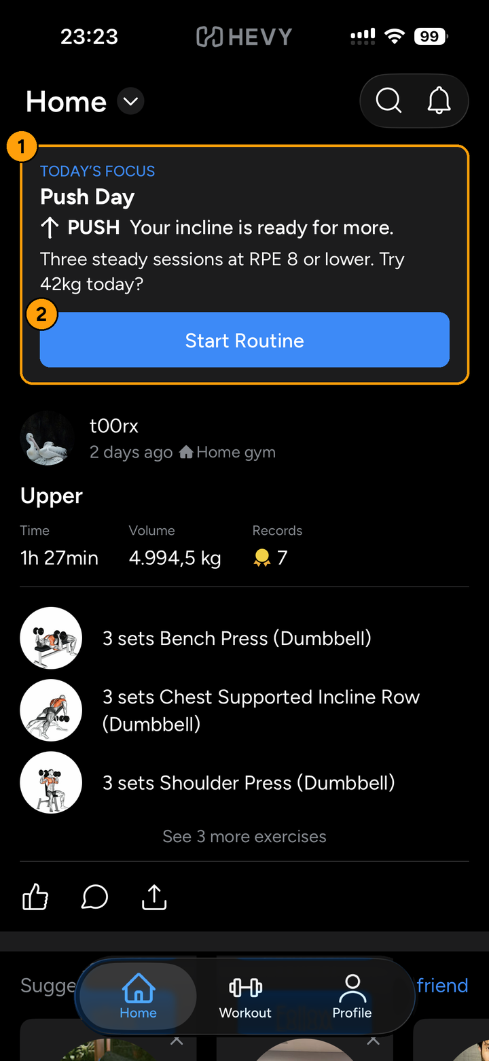  1. Home tab: hook | 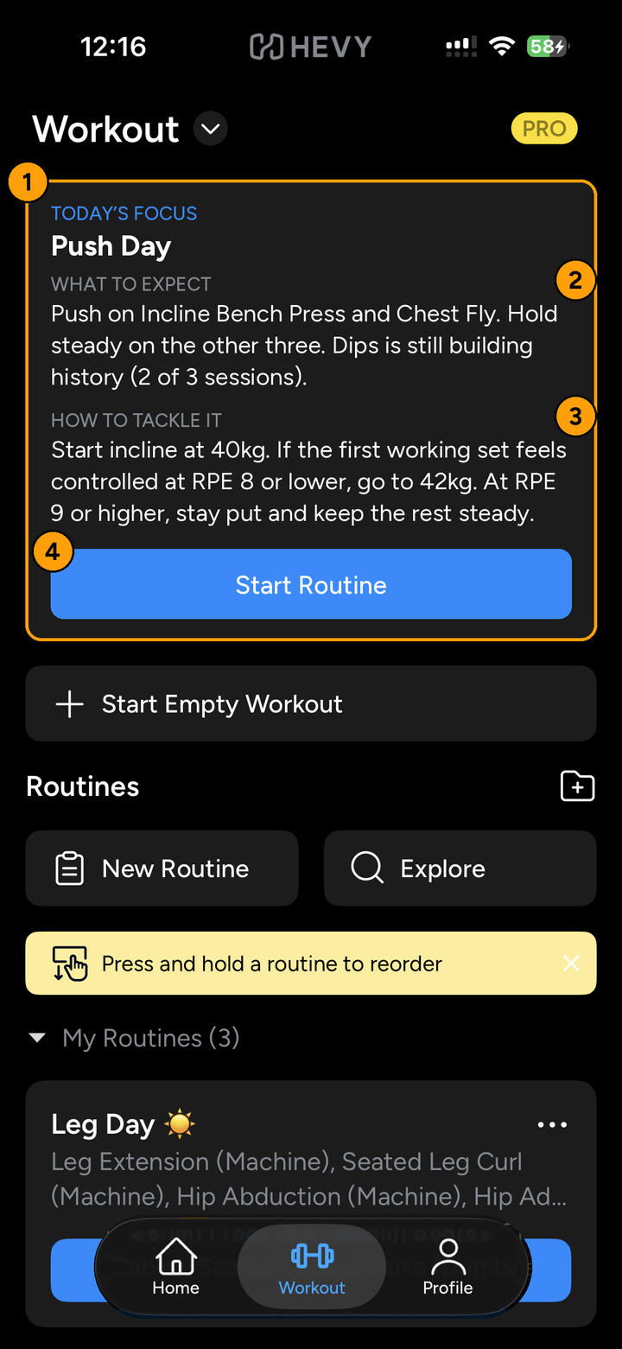  2. Workout tab: plan

# | Element (mockups 1 and 2) | Criteria
Mockup 1: Home tab
1 | Today’s Focus card with the hook wording, at the top of Home | AC-1, AC-3, AC-4, AC-6
2 | Start Routine button inside the card | AC-7
Mockup 2: Workout tab
1 | The same card at the top of the tab, above Start Empty Workout | AC-2, AC-3
2 | What to expect block | AC-5
3 | How to tackle it block | AC-5
4 | Start Routine button | AC-7

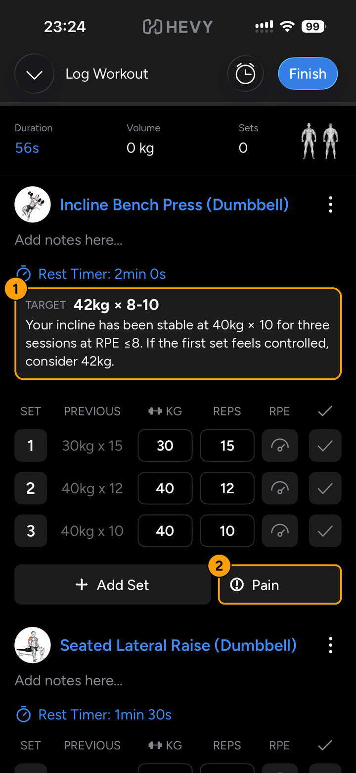  3. Log Workout before the first set | 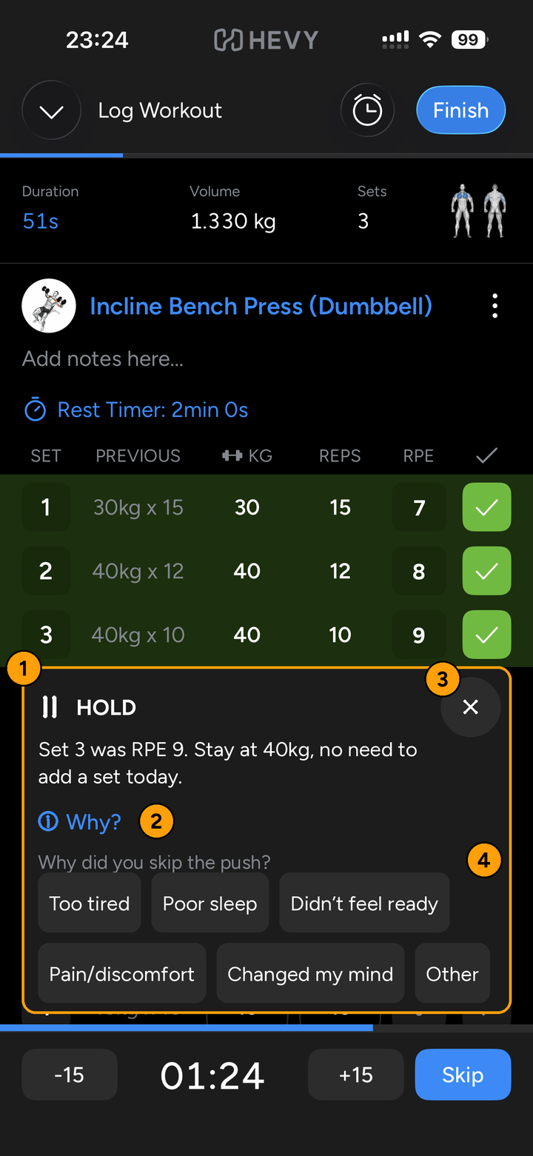  4. Log Workout during rest

# | Element (mockups 3 and 4) | Criteria
Mockup 3: before the first set
1 | Direction line under the Rest Timer line and above the set table | AC-8, AC-9, AC-10
2 | Pain button sharing the Add Set row | AC-27, AC-59
Mockup 4: signal card during rest
1 | Signal card docked above the rest timer bar, with label, icon and reason | AC-13, AC-14, AC-15
2 | Why? link | AC-18
3 | Dismiss button | AC-16
4 | Reason chips in two rows, shown because I checked 40kg and 42kg was recommended | AC-36, AC-37, AC-39

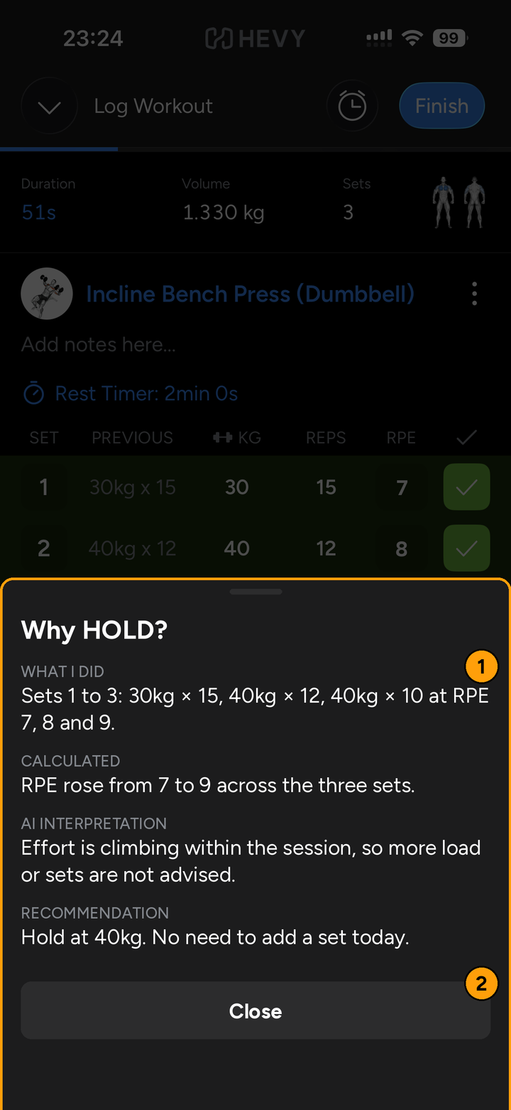  5. Why sheet | 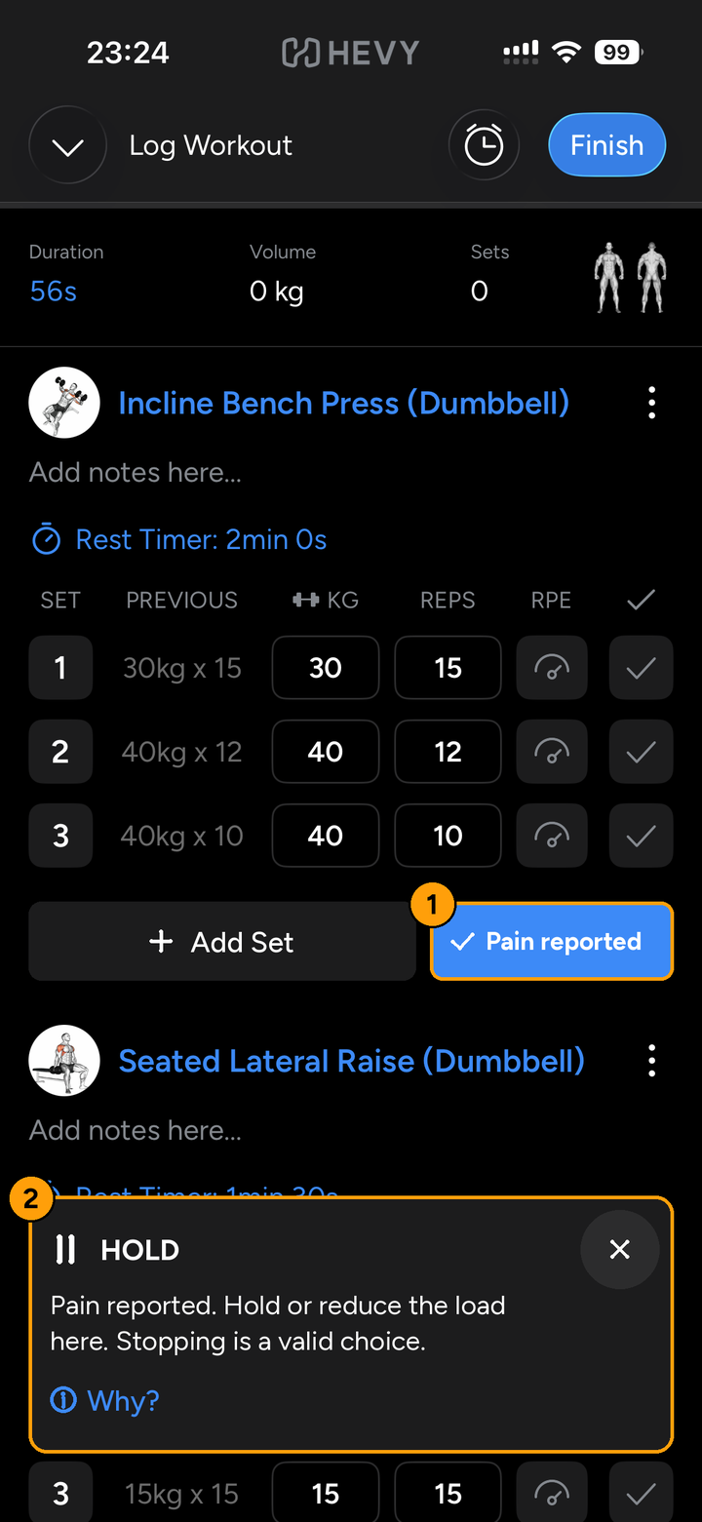  6. Pain reported

# | Element (mockups 5 and 6) | Criteria
Mockup 5: Why sheet
1 | Four labelled blocks: What I did, Calculated, AI interpretation, Recommendation | AC-18
2 | Close button | AC-18, AC-59
Mockup 6: Pain reported
1 | Pain button in its reported state, with a check icon and a filled style | AC-28, AC-32
2 | Signal card with the fixed pain wording, docked at the bottom because no rest bar is showing | AC-13, AC-28, AC-34

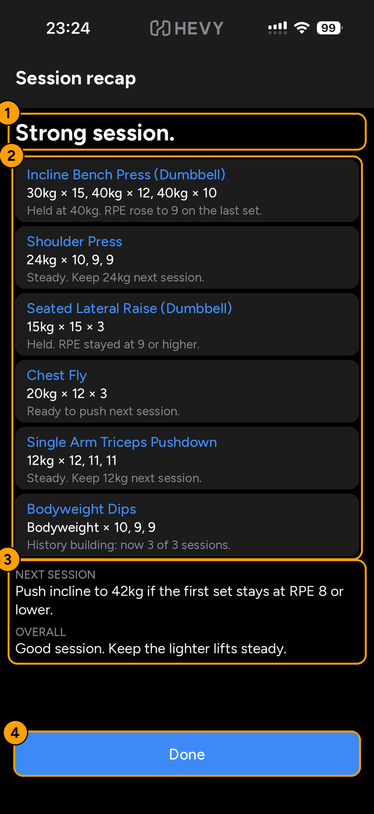
7. Session recap (new screen)

# | Element (mockup 7) | Criteria
1 | Headline of at most 3 words | AC-44
2 | One row per exercise, all six Push Day exercises on one screen | AC-44, AC-45
3 | Next session and Overall lines | AC-44, AC-46
4 | Done button fixed to the bottom | AC-44, AC-61
Notes on the mockups.
- Mockup 2 reuses your Workout tab screenshot with the card added.
- Mockups 3 to 6 reuse your Log Workout screenshots, which show Seated Lateral Raise directly after Incline. Your Push Day list has Shoulder Press second, and the app follows your list.
- Mockup 4 fills in the RPE cells to match the assumption that RPE is entered for every set.
- Mockup 5 dims the Hevy screen behind the sheet.
- Mockup 7 is drawn from scratch. Its statuses are mock results.

3.1 Today’s Focus
Purpose: catch my eye and give me direction before I start. The same card sits on Home and on the Workout tab, where I start the routine. On Home the wording is a hook that makes me want to start. On the Workout tab the wording is a plan: what to expect and how to tackle the goal of pushing or holding steady. Section 13. Criteria: AC-1, AC-2, AC-3, AC-4, AC-5, AC-6, AC-7.
Home wording (illustrative): PUSH. Your incline is ready for more. Three steady sessions at RPE 8 or lower. Try 42kg today?
Workout tab wording (illustrative): What to expect. Push on Incline Bench Press and Chest Fly. Hold steady on the other three. Dips is still building history (2 of 3 sessions). How to tackle it. Start incline at 40kg. If the first working set feels controlled at RPE 8 or lower, go to 42kg. At RPE 9 or higher, stay put and keep the rest steady.

3.2 Exercise direction
Purpose: tell me what I am trying to accomplish right now, narrower than the pre-workout message. Section 14. Criteria: AC-8, AC-9, AC-10, AC-11.
Example wording (numbers illustrative): Incline Dumbbell Press, 28kg × 8-10. Your incline has been stable at 26kg × 10 for three sessions at RPE ≤8, and your bench was strong today, so there is room to challenge your secondary press. Start with 28kg and reassess after the first set.

3.3 Between-set signals
The principle is: signal, action, silence, observe, signal again. The AI stays silent unless something meaningful changes. The closer I am to the physical lift, the shorter the message. Sections 15, 17, 22 and 24. Criteria: AC-12, AC-13, AC-14, AC-15, AC-16, AC-17, AC-18, AC-19, AC-20.
Signal | Icon | Meaning | Example wording
PUSH | Up arrow | Evidence suggests I can increase the challenge. | “You’ve been completing your current weight comfortably for three sessions. Consider increasing today.”
HOLD | Pause bars | The current workload is appropriate. | “You’re already at RPE 9. Stay at this weight and complete the planned work.”
BACK OFF | Down arrow | Effort or fatigue suggests reducing the challenge. | “Your performance has dropped across multiple sets. I’d reduce the load today.”
PR | Star | A meaningful personal best is approaching or achieved. | “You’ve never completed 65kg × 8 before.”
ADAPT | Circular arrows | Recent performance suggests the routine may need adjusting. The AI flags this and never changes the routine. | “Your bench has been stagnant for three sessions while accessory volume continues to increase.”
PROGRESS | Check mark | Progress without a conventional PR. | “You matched last week’s weight with lower RPE.”
The icon shapes are my proposal. The discovery document uses emoji icons, which are not used here.

3.4 Guardrails and who decides
Rules set hard limits the AI cannot cross. Inside those limits, the AI looks at the wider context, chooses the signal and explains it. In this prototype that layer is scripted. The RPE lines are confirmed: 8 or lower supports a push, and 9 or higher means I am still struggling or in low condition. A demanding compound also means RPE 9 or higher. The other limits are assumptions to test on my own training (discovery Section 38). Section 33. Criteria: AC-21, AC-22, AC-23, AC-24, AC-25, AC-26.
- No push without three successful sessions on that exercise at RPE 8 or lower.
- Performance on another exercise or earlier in the session can never unlock a push.
- Consistently high RPE across successful sessions blocks a push.
- Reported pain blocks push and PR recommendations on that exercise and on later exercises sharing its primary muscle groups, for the rest of that session. Shared secondary muscles only change the wording.
- Recommendations stay within the exercises already in my routine.
Deterministic software calculates volume, weekly volume, progression, PRs, RPE averages and trends, rest time and historical comparisons. The AI interprets what a pattern means, how exercises interact, and how to explain the recommendation. The flow is: workout data, deterministic analytics, training state, guardrails, AI reasoning, recommendation, my decision, new workout data.

3.5 Cross-exercise context
Session context adjusts a recommendation but never unlocks one. An accessory still needs its own history before a push. A strong compound day can raise confidence in that push, and a demanding one can turn it into a hold. Hevy tags primary and secondary muscles on its exercises, and this is how related exercises are found. The mock data uses general knowledge for these tags. Section 18. Criteria: AC-24.

3.6 Pain
This is a proposed behaviour of this concept. It is not an existing Hevy feature. I can report pain with one tap at any point in a workout. Section 30. Criteria: AC-27, AC-28, AC-29, AC-30, AC-31, AC-32, AC-33, AC-34.
- On that exercise, the AI stops recommending pushes and PRs for the rest of the session.
- On later exercises with the same primary muscle group, the same block applies, and the wording acknowledges the pain.
- On later exercises that only share secondary muscles, nothing is blocked and the wording is softer.
- The AI recommends holding or reducing the load and says that stopping is a valid choice.
- The AI never diagnoses, explains a cause, suggests treatment or encourages pushing through pain.
Pain is handled for the current session only. It is not tracked across sessions, and it is not recorded as a failed recommendation or a normal override.

3.7 Override and feedback
I can always log any weight and reps. Every time I check a set at a weight different from the target, up or down, the app asks why with one tap: Too tired, Poor sleep, Didn’t feel ready, Pain/discomfort, Changed my mind, or Other. A rejected recommendation is recorded as rejected, not as failed, because I may have simply chosen not to push. Sections 28, 29 and 34. Criteria: AC-35, AC-36, AC-37, AC-39, AC-40, AC-41, AC-42.

3.8 Session recap
After Finish, I see what happened, what it means and what to do next. Section 16. Criteria: AC-43, AC-44, AC-45, AC-46.
Example wording (numbers illustrative): Strong session. Incline: 40kg × 12 and 10, held after RPE 9 on the last set. Next session: push incline to 42kg if the first set stays at RPE 8 or lower.

3.9 UX best practice
These principles shape every screen above.
- Never block the task. Logging a set stays one tap and never waits on the AI (AC-19).
- Glanceable and short. The label comes first, then one short reason with a character limit. The closer to the lift, the less text (AC-15, AC-48).
- Detail on request. The evidence sits behind Why? and not on the main screen (AC-18).
- Forgiving. Every AI element can be dismissed, and a Pain mis-tap can be undone (AC-16, AC-32).
- Immediate feedback. A pressed state within 100 ms and a signal within 1 second (AC-14, AC-47).
- Consistent with Hevy. Same theme, same colours for interactive and completed states, and no change to Hevy’s fields (AC-10, AC-51).
- Thumb-friendly. Primary controls in the lower half of the screen, each at least 44 pt (AC-59, AC-61).

3.10 Accessibility use cases
The target is WCAG 2.2 Level AA. These criteria set the design target. Confirming compliance needs a test with VoiceOver and TalkBack on a real device.
Use case | Design response | Criteria
Blind or low vision, using a screen reader | Signals are announced automatically without moving focus. Every control has a clear name and state, and focus order follows the layout. | AC-62, AC-63, AC-64
Low vision, using large text | Text scales to 200% without clipping. The signal card scrolls inside itself. Contrast is at least 4.5:1. | AC-56, AC-58
Colour vision deficiency | Every signal has a word and a distinct icon shape. Colour is never the only cue. | AC-51, AC-57
Limited dexterity, tremor, sweaty or gloved hands, one-handed use | Large targets with gaps, single-tap actions only, and primary controls within thumb reach. | AC-59, AC-60, AC-61
Motion sensitivity | Short transitions, no flashing, and no motion when reduce motion is on. | AC-50, AC-65
Deaf or hard of hearing, or a noisy gym | Nothing depends on sound. Every alert has visible text. | AC-66
Fatigue and high mental load mid-workout | Short plain wording, a fixed place for each element, no time pressure, and detail only on request. | AC-16, AC-18, AC-49, AC-67
Bright or dim gym lighting | Contrast targets are set for the dark theme. Readability in real gym lighting still needs a check on a device. | AC-56
Voice control or switch access | Visible labels match accessible names, so spoken commands and switch scanning work. | AC-63, AC-64
Different language or number format | Numbers and units follow the device locale. | AC-68

3.11 Data inputs
Read from Hevy: my routine, workout history, weight, reps, sets, RPE, exercise order, rest time and exercise muscle tags. RPE is assumed to be entered for every set. Optional, provided by me: sleep, recovery, and confidence or readiness. The AI weighs evidence in this order: what I actually did, recent training history, what happened earlier in the session, then optional context (discovery Section 21). The prototype uses mock data for all of it.

4. User Story
Main story. When I’m working out, I want to focus entirely on performing the exercise rather than planning and analysing my training, so I can trust that someone or something is taking care of my progression (discovery Section 9).
ID | Story
US-1 | As a lifter about to start a session, I want today’s direction already worked out from my history, so that I start with a clear goal and analyse nothing.
US-2 | As a lifter about to start an exercise, I want to know what I am trying to accomplish right now, so that I can focus on the lift.
US-3 | As a lifter between sets, I want a short signal only when something meaningful changes, so that the app stays present without becoming the workout.
US-4 | As a lifter, I want to know why the app recommends a push or a hold, so that I trust it enough to follow it.
US-5 | As a lifter, I want to override any recommendation and give a reason in one tap, so that I stay in control without filling in a survey.
US-6 | As a lifter, I want to report pain in one tap at any moment, so that the app stops pushing me on that exercise and related ones.
US-7 | As a lifter who has finished, I want to know what happened, what it means and what to do next, so that I leave without analysing anything.
US-8 | As a lifter who uses a screen reader, large text or one hand, I want every signal and control to work for me, so that the coaching is usable in the middle of a workout.

5. Acceptance Criteria
Every criterion is written so I can check it on the prototype. The Source column points to the discovery document or the standard it comes from. Where it says Proposed, the value is my choice and not from the discovery document, so change it if it does not fit.
ID | Criterion | Source
Today’s Focus
AC-1 | Given I open the Home tab, then Today’s Focus is the first element below the Home header and above the feed. It is a full-width card with 16 pt side margins. | Section 13. Placement proposed
AC-2 | Given I open the Workout tab, then the same card is the first element below the Workout header and above Start Empty Workout. It pushes the rest of the tab down. | Placement confirmed by you
AC-3 | Both placements use one card component with the same layout, spacing and style. Only the wording differs. | Proposed
AC-4 | The Home card is a hook. It shows, in this order: a small blue “Today’s Focus” heading, the session name, the signal label with its icon and a hook headline of at most 45 characters, one teaser line of at most 90 characters, and the Start Routine button. | Wording confirmed by you. Limits proposed
AC-5 | The Workout card is a plan. It shows, in this order: the same heading and session name, a “What to expect” block of at most 200 characters that says which lifts to push, which to hold steady and which are still building history, a “How to tackle it” block of at most 200 characters that says where to start and when to move up or stay put, and the Start Routine button. | Wording confirmed by you. Limits proposed
AC-6 | Both cards lead with Incline Bench Press. They use only my own history and today’s routine. I can read them without opening any other screen. | Sections 13, 35
AC-7 | Start Routine is a full-width blue button inside the card, at least 44 pt tall, in Hevy’s primary button style. One tap starts Push Day and opens Log Workout. | Proposed
Exercise direction
AC-8 | In each exercise block, one direction line sits directly below the Rest Timer line and above the set table header. | Section 14. Placement proposed
AC-9 | The line shows the target as weight × rep range in bold 16 pt, then one reason of at most 220 characters at 15 pt. The reason wraps and is never cut off with an ellipsis. | Section 14. Limit proposed
AC-10 | The KG, REPS, RPE and check controls keep their size and position. The AI never changes the values in them. | Sections 12, 35
AC-11 | Given an exercise has fewer than three logged sessions, then the line reads “History building: N of 3 sessions” and no signal is shown for it. | Proposed. Follows Section 33
Signals: display and interaction
AC-12 | Given I check a set, a signal appears only if one of these happened: a push opportunity, unexpected fatigue, a PR opportunity, a performance decline, excessive accumulated volume, meaningful progression, or a need to adapt. Otherwise nothing appears. | Section 24
AC-13 | The signal is a card docked directly above the rest timer bar, or at the bottom of the screen when the bar is not showing. It is full width with 16 pt side margins and at most 40% of the screen height. It never covers the -15, +15 or Skip controls. The page gets bottom padding equal to the card height so no set row stays hidden. | Section 15. Placement proposed. WCAG 2.4.11
AC-14 | The card appears within 1 second of checking the set, with a fade of at most 200 ms. | Proposed
AC-15 | The card shows, in this order: a label (PUSH, HOLD, BACK OFF, PR, ADAPT or PROGRESS) at 16 pt bold with its icon, then a reason of at most 110 characters at 15 pt, then a “Why?” link. | Sections 15, 22. Limit proposed
AC-16 | The card stays until the rest timer reaches 00:00, I check the next set, or I tap Dismiss (a 44 × 44 pt button). It never disappears earlier on its own. | Proposed. WCAG 2.2.1
AC-17 | Only one signal card is visible at a time. A new signal replaces the old one. Dismissing a card is not recorded as an override. | Proposed
AC-18 | Tapping “Why?” opens a bottom sheet with four labelled blocks in this order: What I did (recorded facts), Calculated (metrics), AI interpretation, Recommendation. A Close button (at least 44 pt) closes it and returns me to the card. | Section 35 Transparency
AC-19 | Checking a set is one tap and registers within 100 ms whether or not a signal is produced. If a signal is late or fails, nothing is shown and no error appears during the workout. | Proposed
AC-20 | A recommendation made before the workout is not permanent. Later signals use the sets I have completed. | Section 34
Rules and definitions
AC-21 | A session counts as successful for an exercise when every set at that session’s working weight reaches at least the bottom of the target rep range. Sets I tag as warm-up in Hevy are ignored. | Proposed default. Defines Section 26
AC-22 | PUSH is allowed only when the last three sessions on that exercise were successful at the same working weight and every set in them had RPE 8 or lower. Otherwise the signal is HOLD, BACK OFF or none. | Section 33 rule 1. RPE 8 confirmed by you
AC-23 | If the final set had RPE 9 or higher in each of the last three sessions, the signal is HOLD or BACK OFF, never PUSH. I read RPE 9 or higher as still struggling or in low condition. | Section 33 rule 3. RPE 9 confirmed by you
AC-24 | Performance on another exercise or earlier in the session never makes PUSH possible. If the push rule is already met, a strong compound can be cited as extra confidence. A demanding compound changes PUSH to HOLD. | Sections 18, 33 rule 2
AC-25 | Recommendations only cover exercises already in my routine. The AI never adds, removes or reorders exercises. ADAPT only flags the routine for my review and has no button that edits it. | Sections 12, 22, 33 rule 5
AC-26 | The same data always gives the same set of allowed signals. Only the wording may vary. | Section 35
Pain
AC-27 | On each exercise, the Add Set row is split: Add Set takes about 60% of the width and Pain about 40%. Both are at least 44 pt tall, so the row grows slightly from Hevy’s current height. Pain shows an icon and the word “Pain”. | Section 30. Placement proposed
AC-28 | One tap on Pain, at any time before, between or after sets, changes it to “Pain reported” with a check icon and a filled style, and shows a signal card within 1 second reading: “Pain reported. Hold or reduce the load here. Stopping is a valid choice.” | Section 30. Copy proposed
AC-29 | After pain is reported on an exercise, no PUSH or PR signal appears on it for the rest of the session. | Section 30
AC-30 | Later exercises that share at least one primary muscle with the painful exercise, per Hevy’s muscle tags, get the same block. Their direction line starts with “You reported pain on [exercise] earlier.” | Section 30
AC-31 | Later exercises that share only secondary muscles are not blocked. Their direction line adds “This also loads [muscle], so keep an eye on it.” | Section 30
AC-32 | Tapping “Pain reported” again clears it, announces “Pain cleared”, and restores normal evaluation. This recovers from a mis-tap. | Proposed
AC-33 | Pain is not logged as a failed recommendation or a normal override. It ends when the session ends and does not appear in the next session. | Section 30
AC-34 | No pain message diagnoses, names a cause, suggests treatment, or tells me to push through. | Section 30
Override and reasons
AC-35 | The KG, REPS and RPE fields stay editable at all times. Checking a set with any values always works, whatever the recommendation. | Section 35 User Control
AC-36 | Given I check a set whose weight differs from the target weight, up or down, then reason chips appear in the docked card, below the signal if there is one. This applies to every such set. It does not apply to lighter ramp sets (sets whose Previous weight is below last session’s working weight) or to exercises still building history. | Section 29. Every time confirmed by you. Ramp rule proposed
AC-37 | There are exactly six chips in this order: Too tired, Poor sleep, Didn’t feel ready, Pain/discomfort, Changed my mind, Other. Each has 15 pt text and is at least 44 pt tall with 8 pt gaps, and they wrap to two rows on a 393 pt wide screen. | Section 29
AC-38 | The chips heading reads “Why did you skip the push?” when a push was recommended and I logged less. For any other change it reads “Why did you change the weight?”. | Section 29. Second heading proposed
AC-39 | One tap on a chip selects it and replaces the chips with the line “Reason saved: [reason]”. No second tap or typing is needed. | Section 29
AC-40 | Ignoring the chips has no consequence. They disappear with the card, and the next set checked at a different weight shows them again. | Section 29
AC-41 | Choosing Pain/discomfort triggers the same effects as the Pain button. | Sections 29, 30
AC-42 | A skipped recommendation is recorded as rejected, with the reason if given, and never as failed. | Sections 28, 34
Session recap
AC-43 | The recap is a full screen shown after I confirm Finish and before I return to Home. | Section 16. Placement proposed
AC-44 | It shows, in this order: a headline of at most 3 words, one row per exercise (name, sets summary such as “65kg × 8 × 3”, and a status of at most 60 characters), a “Next session” line of at most 150 characters, an “Overall” line of at most 100 characters, and a Done button fixed to the bottom, full width and at least 44 pt tall. | Section 16. Limits proposed
AC-45 | Push Day has 6 exercises. The recap fits all 6 on one screen without scrolling at the default text size. | Mockup 7. Proposed
AC-46 | The next session’s Today’s Focus reflects this session without any action from me. | Section 36
UX best practice
AC-47 | Every tap shows a visible pressed state within 100 ms. | Proposed. Common response-time guidance
AC-48 | Given a mock scenario, when a signal card is shown for 3 seconds and then hidden, I can state its label and what to do (push, hold or back off) correctly in 5 of 5 scenarios. | Section 35 (within seconds). Numbers proposed
AC-49 | Copy uses short sentences and plain words. The only jargon is RPE and PR, which Hevy already uses. | Proposed
AC-50 | All transitions last at most 200 ms and nothing flashes more than 3 times in any second. | Proposed. WCAG 2.3.1
Hevy design system alignment (values measured from the screenshots)
AC-51 | New elements use only Hevy’s colour tokens: background #000000, surface #1C1C1D, raised #2C2C2D, primary text #FFFFFF, secondary text #84888E and accent blue #3D8AF7. No new colours are added. Signals are told apart by label and icon. | Screenshots
AC-52 | Text uses Hevy’s existing typeface and scale: 16 pt for values, buttons and signal labels (bold), 15 pt for reasons and secondary text, and 12 pt uppercase for small section labels. | Screenshots
AC-53 | Cards use a 10 pt corner radius (measured 8 to 12 pt) and a 16 pt side margin. Buttons and chips use a 7 to 9 pt radius. Icons are outline style with a 2 pt stroke and rounded ends. | Screenshots
AC-54 | Each new element copies an existing Hevy pattern: cards copy the routine card, the primary button copies Start Routine and Skip, the secondary button copies Add Set, chips copy the -15 and +15 buttons, the Dismiss button copies the round back button, and links copy the blue Rest Timer line. | Screenshots
AC-55 | Secondary text (#84888E) is never placed on #2C2C2D. Labels on blue buttons are 16 pt bold. Both rules follow from the contrast table under Hevy design system alignment. | WCAG 1.4.3
Accessibility (target: WCAG 2.2 Level AA)
AC-56 | Text has a contrast ratio of at least 4.5:1 against its background, or 3:1 for text 18 pt or larger (or 14 pt bold). Icons, chip borders and focus indicators have at least 3:1. The token pairs in the contrast table meet this. | WCAG 1.4.3, 1.4.11
AC-57 | Colour is never the only signal. Each signal has a text label and its own icon shape: up arrow for PUSH, pause bars for HOLD, down arrow for BACK OFF, star for PR, circular arrows for ADAPT, check mark for PROGRESS. | WCAG 1.4.1. Icons proposed
AC-58 | At 200% text size, no text is clipped, cut off with an ellipsis or overlapped, no horizontal scrolling is needed, and every control stays reachable. The docked card scrolls inside itself if it grows past 40% of the screen. | WCAG 1.4.4, 1.4.10
AC-59 | Every tappable control this feature adds is at least 44 × 44 pt, with at least 8 pt between neighbouring controls. | Apple guidance. Exceeds WCAG 2.5.8
AC-60 | Every action works with a single tap. No drag, long press or multi-finger gesture is required. Swiping a sheet down also has a Close button. | WCAG 2.5.1
AC-61 | The docked card, its controls (Why?, Dismiss, reason chips) and the recap’s Done button sit in the lower half of the screen so they work one-handed. | Proposed
AC-62 | With VoiceOver or TalkBack on, a new signal card is announced automatically as a polite status message, label first and then the reason. Focus does not move. “Pain reported” and “Pain cleared” are announced the same way. | WCAG 4.1.3
AC-63 | Every control has an accessible name that contains its visible text: Pain, Dismiss, Why, Start Workout, Done, and each chip. The Pain button reports its on or off state. | WCAG 2.5.3, 4.1.2
AC-64 | Focus order follows the visual order from top to bottom, with the docked card after the set table and before the rest timer controls. Sheets keep focus inside and return it to the trigger on close. The focused control is always visible. | WCAG 2.4.3, 2.4.7, 2.4.11
AC-65 | When the device has reduce motion turned on, cards and sheets appear without sliding or fading. | WCAG 2.3.3 (AAA, adopted)
AC-66 | No information is given by sound or vibration alone. Every alert also has visible text. | Proposed
AC-67 | Nothing in this feature requires me to act before a timer runs out. The rest timer is Hevy’s own and is not changed. | WCAG 2.2.1
AC-68 | Numbers and units follow the device locale. Hevy’s screenshots show a comma decimal, for example 4.994,5 kg, so 62.5 kg shows as 62,5 kg on such a device. | Screenshots
Prototype
AC-69 | The prototype runs on a portrait phone screen of 393 × 852 pt, the size of the screenshots. | Screenshots
AC-70 | The prototype uses mock data and a scripted AI layer. It always shows Push Day, and RPE is assumed to be entered for every set. | Assumption

Appendix A. Defaults set in this draft
These are choices I made so the criteria could be definitive. Confirm or change each one.
# | Default in this draft | Criteria affected
1 | Today’s Focus is one card on Home and on the Workout tab. Home has hook wording and the Workout tab has plan wording. On the Workout tab it sits above Start Empty Workout. | AC-1, AC-2, AC-3
2 | A successful session means every set at the working weight reaches the bottom of the rep range. RPE 8 or lower for a push and RPE 9 or higher for high effort are confirmed by you. | AC-21, AC-22, AC-23
3 | The Pain button shares the Add Set row, and tapping it again undoes it. | AC-27, AC-32
4 | Character limits for each block of copy, and the 3-second glance test with 5 of 5 correct. | AC-4, AC-5, AC-9, AC-15, AC-44, AC-48
5 | Mock history of three or more sessions per exercise, agreed before build, with RPE filled for every set. Dips has only two sessions so that it shows the history-building state. | AC-11, AC-70
6 | Design tokens are measured from four screenshots, so they are approximate. Replace them with Hevy’s real tokens if you can get them. | AC-51, AC-52, AC-53, AC-54
7 | Bodyweight dips only show the history-building state. How a push works for a bodyweight exercise, by adding reps or added weight, is not decided. | AC-11
8 | Exercise names and order follow your Push Day list. Incline and Seated Lateral Raise use the full Hevy names from your screenshots. | AC-70
9 | The real product uses a live model for the reasoning layer. The prototype scripts it, and a live-model milestone is optional in the hand-off. | AC-70
10 | Reason chips show every time a set differs from the target, except lighter ramp sets and exercises still building history. The second heading, “Why did you change the weight?”, is my wording. | AC-36, AC-38

Appendix B. Hevy reference screenshots
These are the screenshots I provided. They are the visual reference for the prototype and the source of the Hevy behaviours described above.
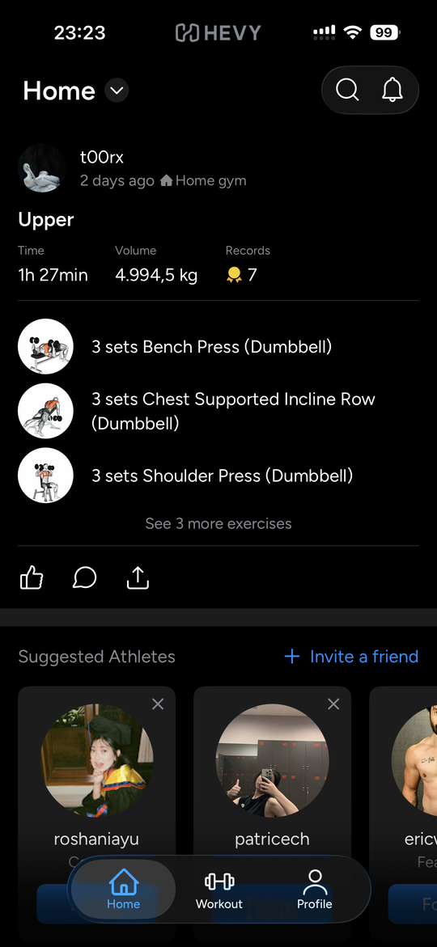  Home tab: social feed of workout summaries | 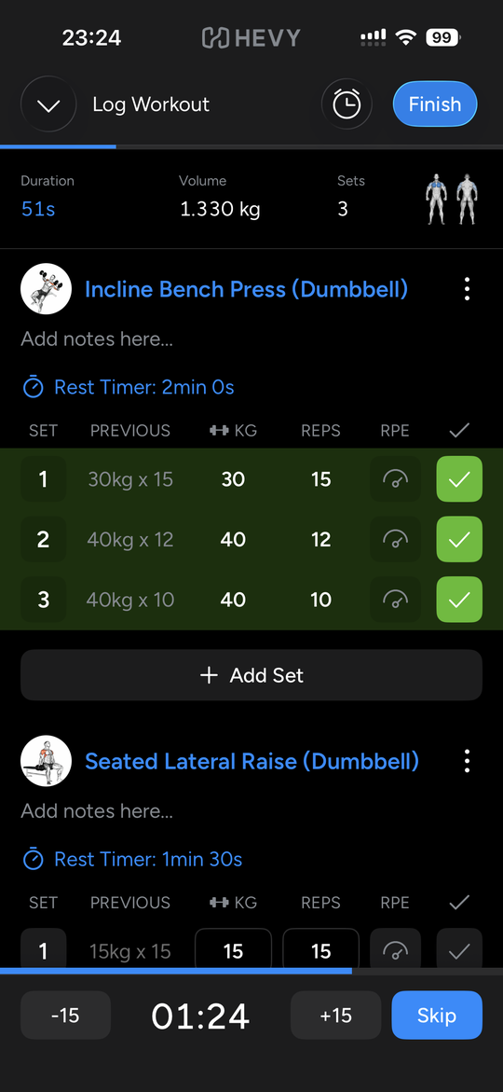  Log Workout: sets checked, rest timer running | 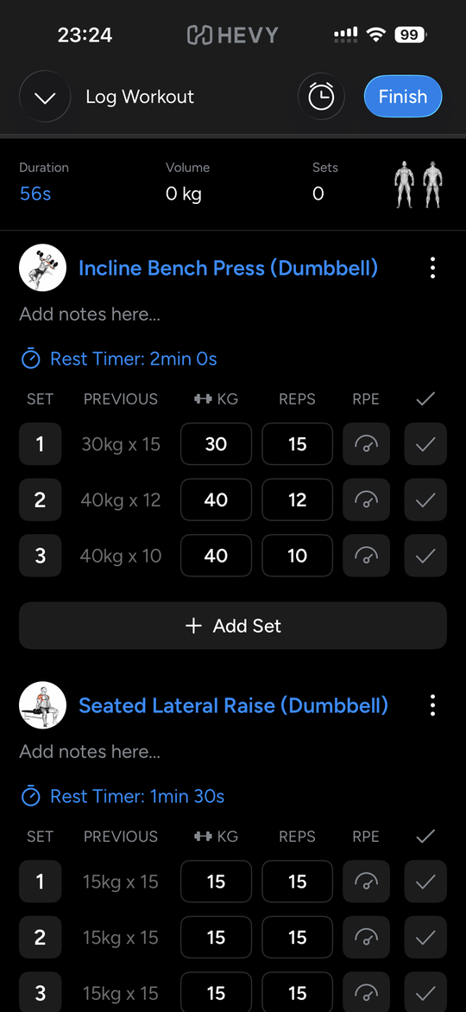  Log Workout: before the first set
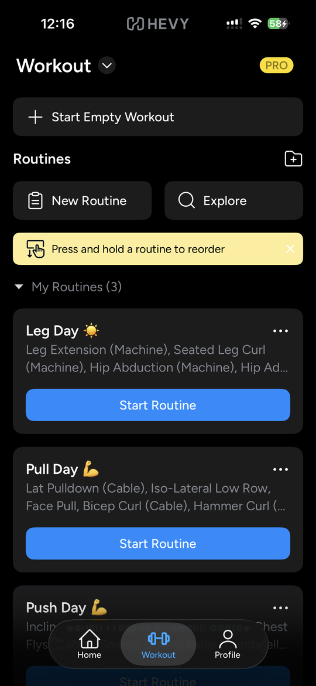
Workout tab: routines list

Appendix C. Reference data
From the screenshots. Only values visible in the screenshots are listed. No history beyond the Previous column is shown, so any three-session history in the prototype is mock data.
Exercise | Previous, by set | Rest timer
Incline Bench Press (Dumbbell) | Set 1: 30kg × 15. Set 2: 40kg × 12. Set 3: 40kg × 10. | 2min 0s
Seated Lateral Raise (Dumbbell) | Sets 1 to 3: 15kg × 15 each. | 1min 30s
Set 1 in the Incline screenshot is a normal set. A warm-up is a tag I set by pressing the set number. The Workout tab card for Push Day is cut off, so the full exercise list comes from me.
Push Day, as I described it. The mock data uses general-knowledge muscle tags, not Hevy’s own.
# | Exercise | Primary muscles | Secondary muscles
1 | Incline Bench Press (Dumbbell) | Chest | Shoulders, triceps
2 | Shoulder Press | Shoulders | Triceps
3 | Seated Lateral Raise (Dumbbell) | Shoulders | None
4 | Chest Fly | Chest | Shoulders
5 | Single Arm Triceps Pushdown | Triceps | None
6 | Bodyweight Dips | Chest, triceps | Shoulders

