BANK MARKETING
CAMPAIGN ANALYTICS
Customer Subscription Analysis for Term Deposit Campaign
DATASET  41,176 | SUBSCRIPTIONS  4,639 | CONVERSION  11.27% | TOOLS  SQL • Python • Power BI

END-TO-END DATA ANALYTICS PROJECT
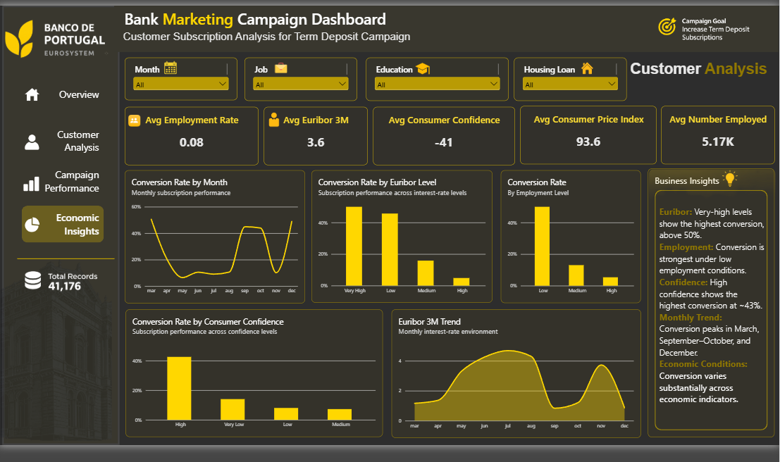
Business-focused analytics portfolio report

1. Executive Summary
A concise business view of campaign performance, customer response, and economic context.
This project analyzes a cleaned bank marketing campaign dataset to understand which customer characteristics, campaign approaches, previous interactions, and economic conditions are associated with term-deposit subscription. The workflow combines data preparation, SQL business analysis, feature engineering, and an interactive four-page Power BI dashboard. The objective is to identify observed patterns that can support better campaign targeting rather than claim causation.
TOTAL RECORDS  41,176 | SUCCESSFUL  4,639 | CONVERSION  11.27% | PREVIOUS CONTACTS  7,124 | AVG CALL  258 sec

Key Business Findings
- Overall campaign conversion is 11.27%, with 4,639 successful subscriptions from 41,176 campaign records.
- Previous campaign success is the strongest observed segment, with conversion of approximately 65.11%.
- Customers aged 65+ show the highest observed age-group conversion, at approximately 47.28%.
- Conversion declines as campaign contact frequency increases, from about 13% after one contact to about 3% after 11+ contacts.
- Cellular contact performs substantially better than telephone contact in the observed dataset.
- Conversion varies materially across months and economic-condition groups, making timing and macro context useful supporting signals.
Management Takeaway
Core opportunity
Prioritize customers with positive previous campaign outcomes, use effective contact channels, avoid excessive repeated contacts, and use timing/economic context as supporting signals when planning future campaigns.

Important Analytical Caveat
The dataset contains campaign-contact records rather than a unique customer identifier. Results therefore describe observed campaign records and associations and should not be interpreted as proof that a customer attribute or economic variable causes conversion.

2. Data Preparation & Analytical Methodology
From raw campaign records to validated analytical data.
Dataset & Structure
The selected Bank Marketing full additional dataset contained 41,188 records and 21 columns. After exact-duplicate removal, the final analytical dataset contains 41,176 records and 26 columns after feature engineering.
Area | Details
Raw records | 41,188
Final records | 41,176
Columns after engineering | 26
Target | subscribed (yes / no)
Campaign fields | contact, month, day_of_week, duration, campaign
History fields | pdays, previous, previous_campaign_outcome
Economic fields | emp_var_rate, cons_price_idx, cons_conf_idx, euribor3m, nr_employed
Customer profile | age, job, marital, education, default, housing, loan

Data Cleaning & Validation
- Removed 12 exact duplicate records from the raw dataset.
- Validated numeric ranges and retained valid negative economic values such as employment variation rate and consumer confidence index.
- Retained unknown categorical values instead of treating them as missing customer information.
- Preserved pdays = 999 as the special indicator for no previous campaign contact.
- Added previously_contacted, age_group, campaign_contact_group, previous_contact_recency_group, and loan_status.
- Loaded the cleaned 41,176-row dataset into MySQL and validated the imported row count.
- Final SQL validation returned zero NULLs and zero exact duplicate rows.
Analytical Workflow
Stage | Purpose | Technology
1. Cleaning | Remove duplicates, validate types, engineer fields | Excel / Power Query
2. SQL analysis | KPIs, conversion, campaign patterns | MySQL / SQL
3. Deeper analysis | Business interpretation and exploration | Python / Pandas
4. Visualization | Interactive filtering and storytelling | Power BI
5. Reporting | Translate evidence into actions | Business report

Modeling caution
Call duration is a post-contact variable. It is useful for campaign analysis, but it should not automatically be treated as a pre-call targeting feature because its value is only known after the interaction.

3. Business Analysis & Dashboard Story
Four dashboard pages organized around management questions.
Page 1 — Executive Overview
Answers: What happened in the campaign?
- Tracks total contacts, successful subscriptions, conversion rate, previous contacts, and average call duration.
- Shows monthly conversion, subscription distribution, age-group performance, previous campaign outcome, and contact-type performance.
Page 2 — Customer Analysis
Answers: Who are the customers and which profiles show stronger response?
- Examines job distribution, marital status, housing-loan performance, education-level conversion, and average call duration by campaign contacts.
- Uses Job, Age Group, Education, and Marital Status slicers to support customer-segment exploration.
Page 3 — Campaign Performance
Answers: Which campaign approaches are associated with stronger conversion?
- Analyzes campaign-contact frequency, day of week, contact method, previous contacts, and default status.
- Shows declining conversion at higher contact frequency and stronger observed cellular performance.
Page 4 — Economic Insights
Answers: What economic conditions surround campaign response?
- Tracks average employment variation, Euribor 3M, consumer confidence, consumer price index, and number employed.
- Compares conversion across Euribor, employment, and consumer-confidence groups and uses the Euribor trend for economic context.
Core KPI Snapshot
Metric | Observed Result | Business Meaning
Total contacts | 41,176 | Scale of analyzed campaign records
Successful subscriptions | 4,639 | Observed campaign successes
Conversion rate | 11.27% | Overall subscription response
Previous contacts | 7,124 | Records involving prior campaign contact
Average call duration | 258 sec | Average recorded call duration

4. Key Insights, Problems & Recommendations
Turning analytical evidence into practical campaign decisions.
Five Priority Insights
- Previous Campaign Success — Previous success converts at approximately 65.11%, making positive historical response a strong prioritization signal.
- Age Profile — The 65+ group has the highest observed conversion at approximately 47.28%.
- Contact Frequency — Conversion decreases from roughly 13% after one contact to roughly 3% after 11+ contacts, indicating diminishing returns from repeated outreach.
- Contact Method — Cellular contact has a substantially higher observed conversion rate than telephone contact.
- Economic Context — Conversion changes across Euribor, consumer-confidence, employment, and monthly groups, so macro conditions can provide useful campaign context.
Business Problems Identified
- Repeated contacts can consume campaign capacity while showing lower observed conversion at higher contact frequencies.
- The overall 11.27% conversion rate leaves room for improved targeting and campaign efficiency.
- Contact-channel performance is uneven, suggesting channel allocation should be evidence-led.
- Economic and seasonal variation can make a single static campaign strategy less effective across the entire campaign period.
- Some categories contain very small samples; for example, default = yes has only three records, so conclusions for that group should not be generalized.
Recommended Actions
Priority | Action | Expected Benefit
1 | Prioritize customers with successful previous campaign outcomes. | Focus effort on higher observed response segments.
2 | Reduce excessive repeated outreach and introduce contact-frequency rules. | Improve efficiency and reduce wasted contacts.
3 | Prefer cellular contact where operationally appropriate. | Align channel allocation with observed conversion.
4 | Use high-response age groups as one targeting signal. | Improve prioritization while avoiding over-targeting.
5 | Use monthly and economic indicators as contextual signals. | Improve campaign timing and planning.
6 | Track performance continuously by segment and channel. | Create a feedback loop for future campaigns.

Interpretation principle
Recommendations are based on observed associations. They should be validated with controlled campaign tests before being treated as causal rules.

5. Next Actions & Project Conclusion
A practical 90-day roadmap for turning analysis into repeatable campaign intelligence.
90-Day Action Plan
Phase | Timeline | Action
Phase 1 | Days 1–30 | Prioritize previous-success segments; review channel allocation; introduce contact-frequency monitoring.
Phase 2 | Days 31–60 | Test segment-specific messaging and timing; compare cellular vs telephone; monitor conversion by month.
Phase 3 | Days 61–90 | Evaluate tests, refine targeting rules, and establish recurring dashboard reviews.

Recommended Performance Monitoring
- Conversion rate by campaign contact frequency.
- Conversion rate by contact method and day of week.
- Conversion by previous campaign outcome.
- Conversion by key customer segments such as age, job, education, and loan status.
- Monthly conversion alongside Euribor, consumer confidence, employment variation, and consumer price index.
- Sample-size checks before acting on small or rare categories.
Technical Deliverables
Deliverable | Output
Cleaned dataset | 41,176-row analytical table with engineered features
MySQL database | bank_marketing_analytics
SQL analysis | Business KPIs, conversion analysis and campaign patterns
Power BI | Four-page interactive dashboard
Business insights | Page-level insight panels and recommendations
Project report | Professional business report

Conclusion
This project demonstrates an end-to-end data analytics workflow: data cleaning and validation, SQL-based business analysis, feature engineering, interactive Power BI reporting, and business recommendation. The central finding is that campaign response is not uniform: previous campaign success, customer profile, contact channel, contact frequency, timing, and economic context are all associated with meaningful differences in observed subscription rates.
The strongest next step is to convert dashboard findings into measurable campaign tests, track the results, and continuously update targeting rules based on evidence. This turns the project from a static analysis into a repeatable decision-support process.
Final takeaway
Use the dashboard to decide where to focus campaign effort, use SQL and Python to investigate patterns, and use controlled testing to determine which interventions actually improve conversion.

