**x** – Denotes a column vector

- Denotes a row vector

**M** – Denotes a matrix

- Denotes a row vector with M elements

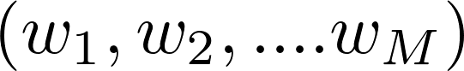

- Denotes a column vector with M elements

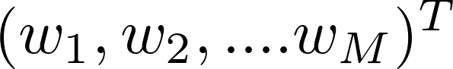

[a, b] - Denotes the closed interval from a to b, that is the interval including the values a, b themselves.

(a, b) – Denotes an open interval, that is the interval excluding a, b

[a, b) – An interval that includes a and excludes b

- Denotes an identity matrix (unit matrix)

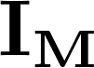

- Denotes an expectation of a function with respect to a random variable

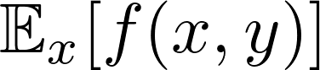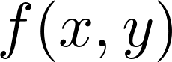

- Denotes conditional expectation if the distribution of is conditioned on another variable

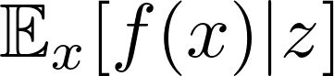

- Denotes the variance of a function

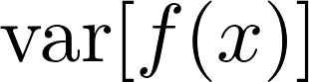

- Denotes the covariance of the vector variable

