**Experiment 1**

Submitted by Aditya Singh 2K19/EP/005

**Aim** - Verification of Truth Tables of Various Logic Gates.

**Theory** - The digital circuit which either allows a signal to pass through or stops it is called a gate. Gates which allow a signal to pass through only when some logical conditions are satisfied are called logic gates. Logic gates usually combine one or more logic variables input to produce an output. All of the possible combinations of the input variables and the corresponding outputs are normally listed in a table called a truth table.

**AND GATE**

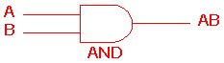 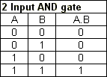

The AND gate is an electronic circuit that gives a **high** output (1) only if **all** its inputs are high. A dot (.) is used to show the AND operation i.e. A.B. Bear in mind that this dot is sometimes omitted i.e. AB.

Design :

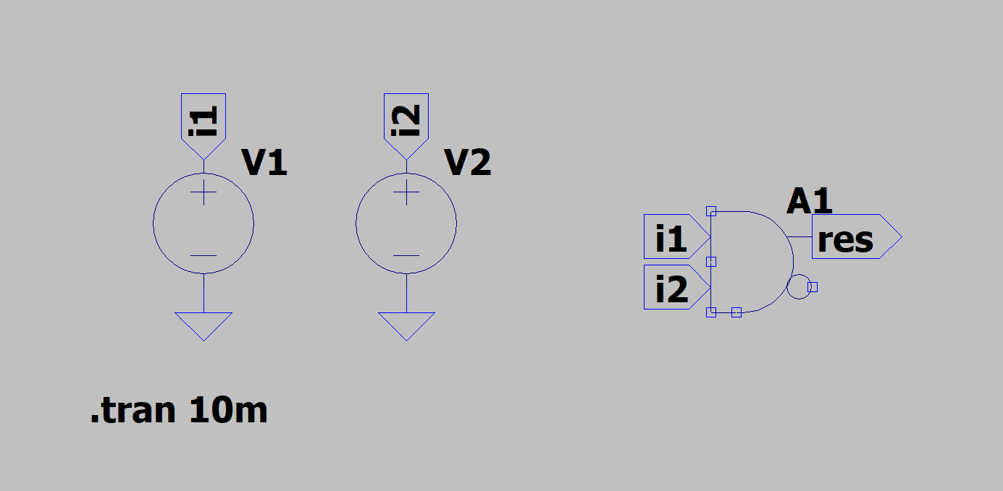

Result:

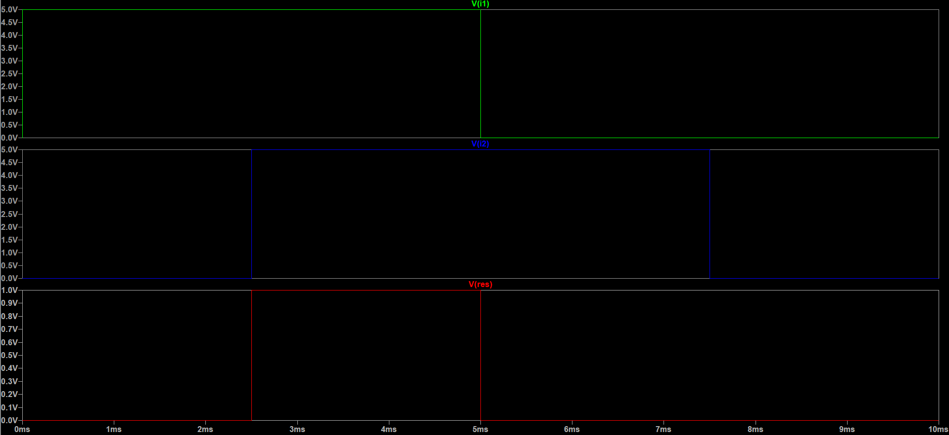

**OR GATE**

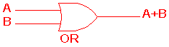 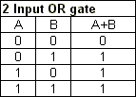

The OR gate is an electronic circuit that gives a high output (1) if **one or more** of its inputs are high. A plus (+) is used to show the OR operation.

Design:

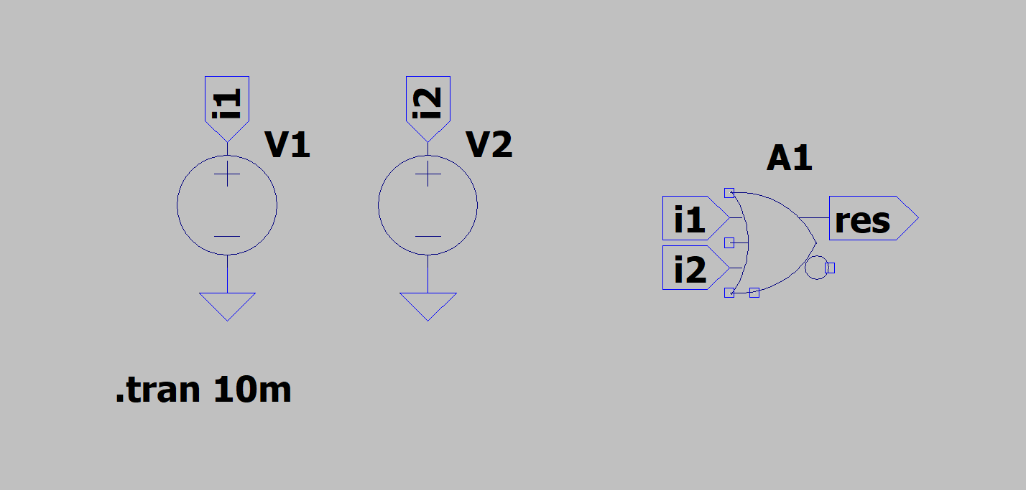

Result:

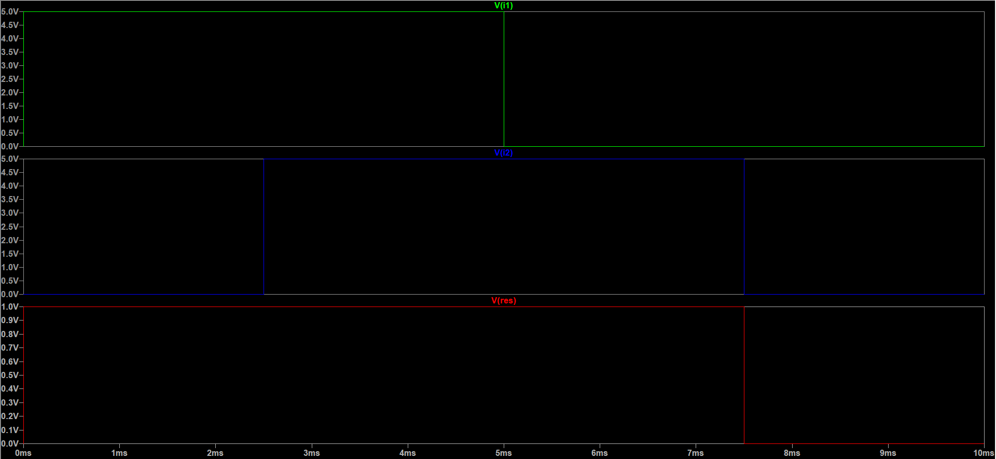

**NOT GATE**

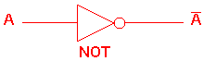 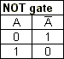

The NOT gate is an electronic circuit that produces an inverted version of the input at its output. It is also known as an *inverter*. If the input variable is A, the inverted output is known as NOT A. This is also shown as A', or A with a bar over the top, as shown at the outputs. The diagrams below show two ways that the NAND logic gate can be configured to produce a NOT gate. It can also be done using NOR logic gates in the same way.

Design:

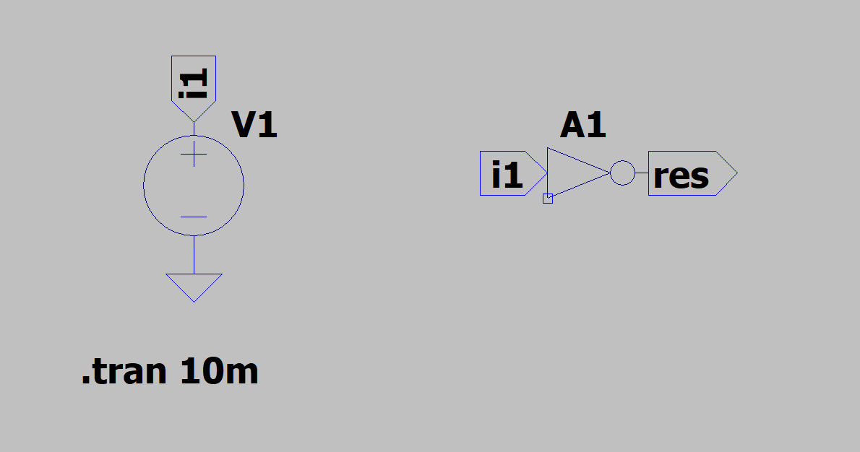

Result:

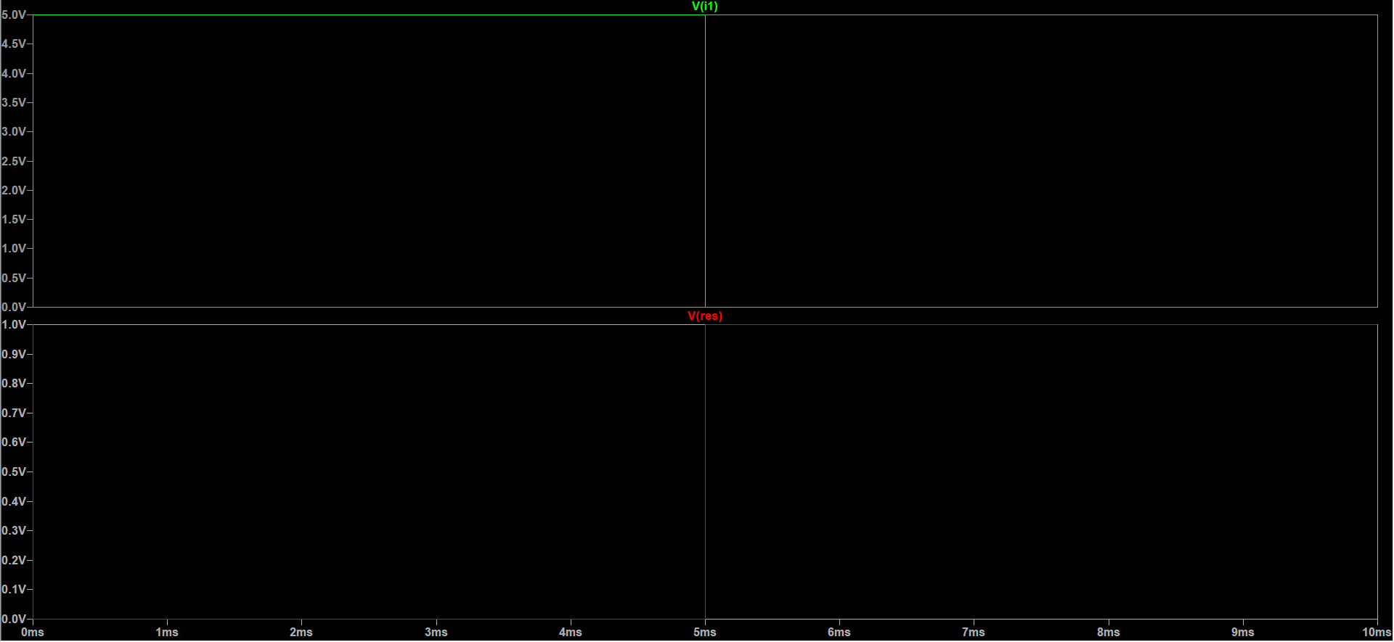

**NAND GATE**

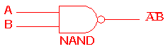 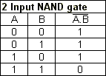

This is a NOT-AND gate which is equal to an AND gate followed by a NOT gate. The outputs of all NAND gates are high if **any** of the inputs are low. The symbol is an AND gate with a small circle on the output. The small circle represents inversion.

Design:

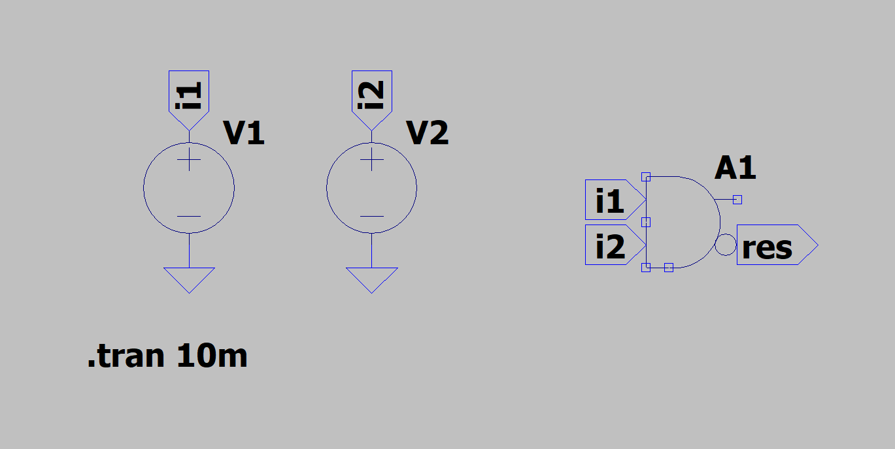

Result:

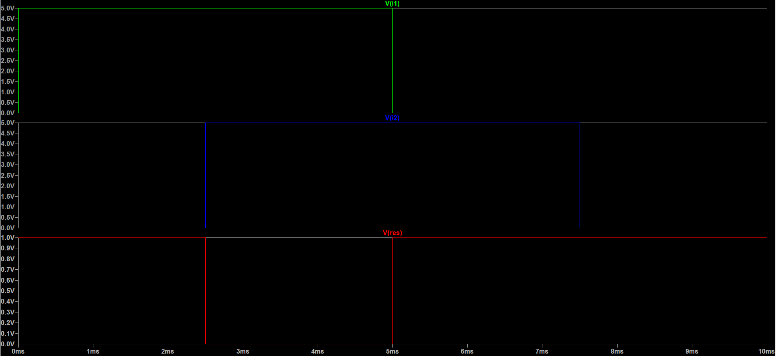

**NOR GATE**

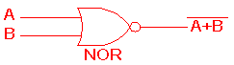 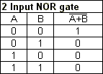

This is a NOT-OR gate which is equal to an OR gate followed by a NOT gate. The outputs of all NOR gates are low if **any** of the inputs are high.

The symbol is an OR gate with a small circle on the output. The small circle represents inversion.

Design:

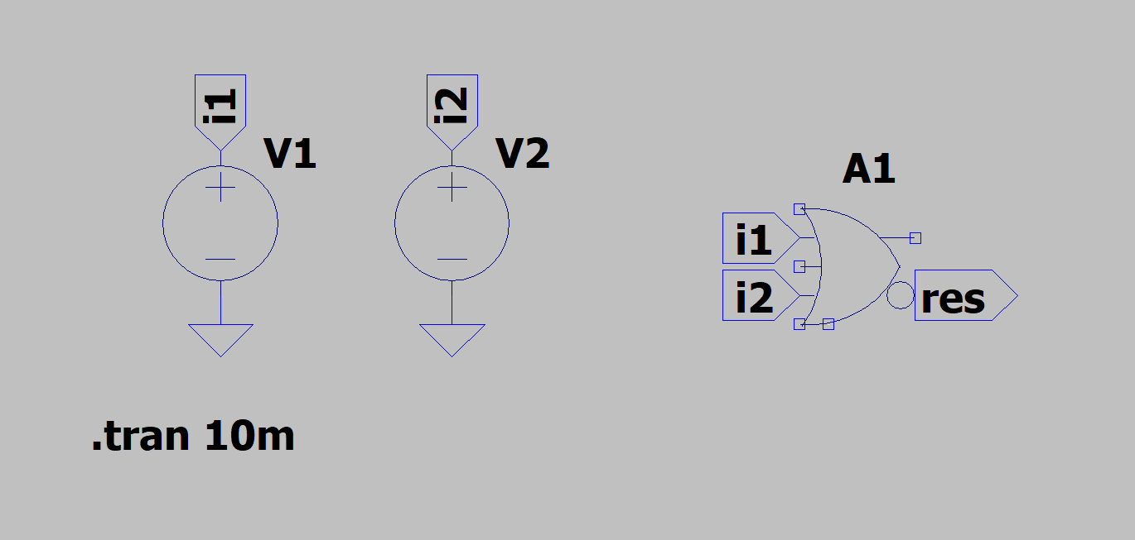

Result:

