**Experiment - 10**

Submitted by ADITYA SINGH 2K19/EP/005

**Aim** - To design and implement the operation of Ring Counter and Johnson Counter using D-FFs.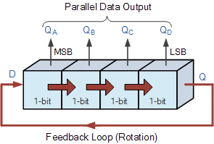

**Theory -**

## **Ring Counter**

The serial movement of data through the resistor occurs after a preset number of clock cycles thereby allowing the SISO register to act as a sort of time delay circuit to the original input data signal.

But what if we were to connect the output of this shift register back to its input so that the output from the last flip-flop, QD becomes the input of the first flip-flop, QA. We would then have a closed loop circuit that “recirculates” the same bit of DATA around a continuous loop for every state of its sequence, and this is the principal operation of a Ring Counter.

## **Gray to Binary Code**

The Johnson Ring Counter or “Twisted Ring Counters”, is another shift register with feedback exactly the same as the standard *Ring Counter* above, except that this time the inverted output Q of the last flip-flop is now connected back to the input D of the first flip-flop as shown below.

The main advantage of this type of ring counter is that it only needs half the number of flip-flops compared to the standard ring counter then its modulo number is halved. So a “n-stage” Johnson counter will circulate a single data bit giving a sequence of 2n different states and can therefore be considered as a “mod-2n counter”.

**Circuit Diagram**

1. Ring Counter

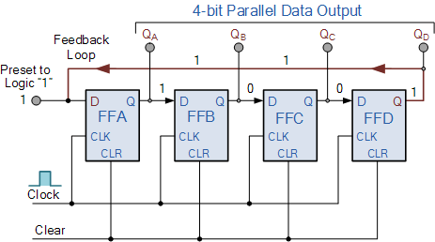

1. Johnson Counter

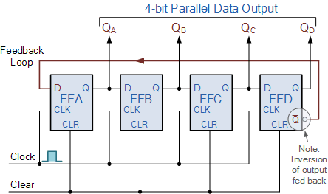

**Truth Tables**

1. Ring Counter

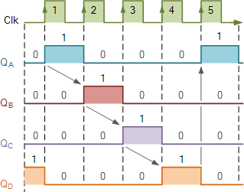

1. Johnson Counter

|  |  |  |  |  |
| --- | --- | --- | --- | --- |
| Clock | A | B | C | D |
| 0 | 0 | 0 | 0 | 0 |
| 1 | **1** | 0 | 0 | 0 |
| 2 | **1** | **1** | 0 | 0 |
| 3 | **1** | **1** | **1** | 0 |
| 4 | **1** | **1** | **1** | **1** |
| 5 | 0 | **1** | **1** | **1** |
| 6 | 0 | 0 | **1** | **1** |
| 7 | 0 | 0 | 0 | **1** |

**Design**

1. Ring Counter

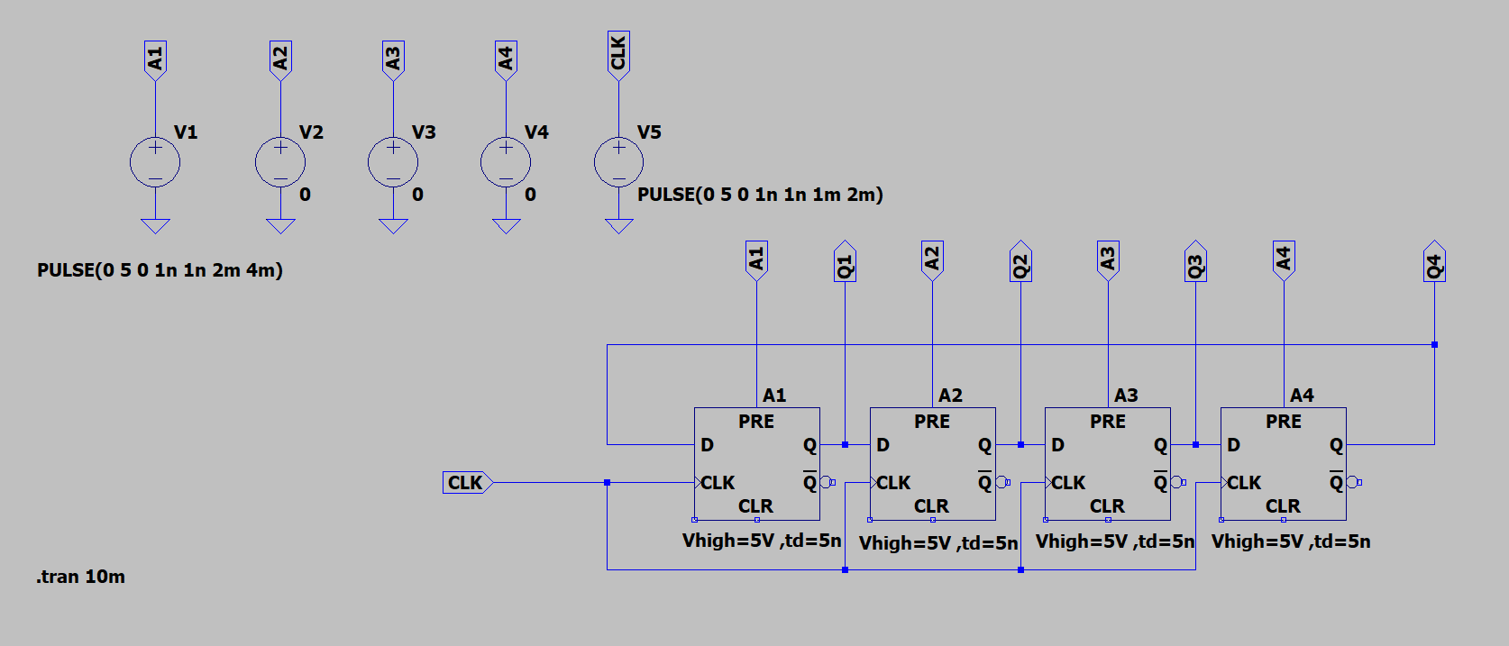

1. Johnson Counter

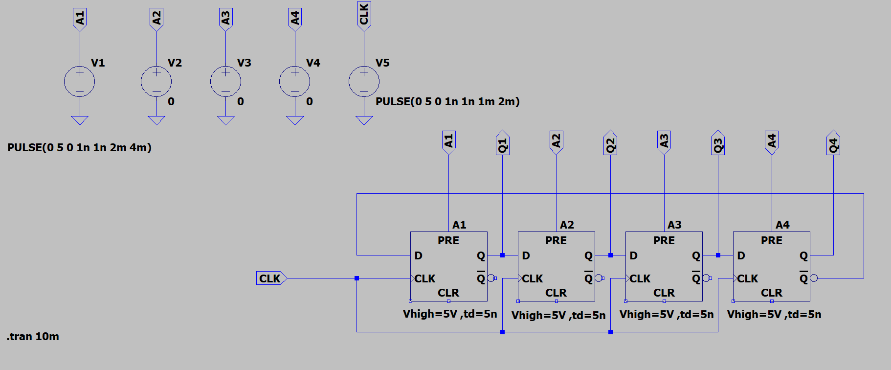

**Results**

1. Ring Counter

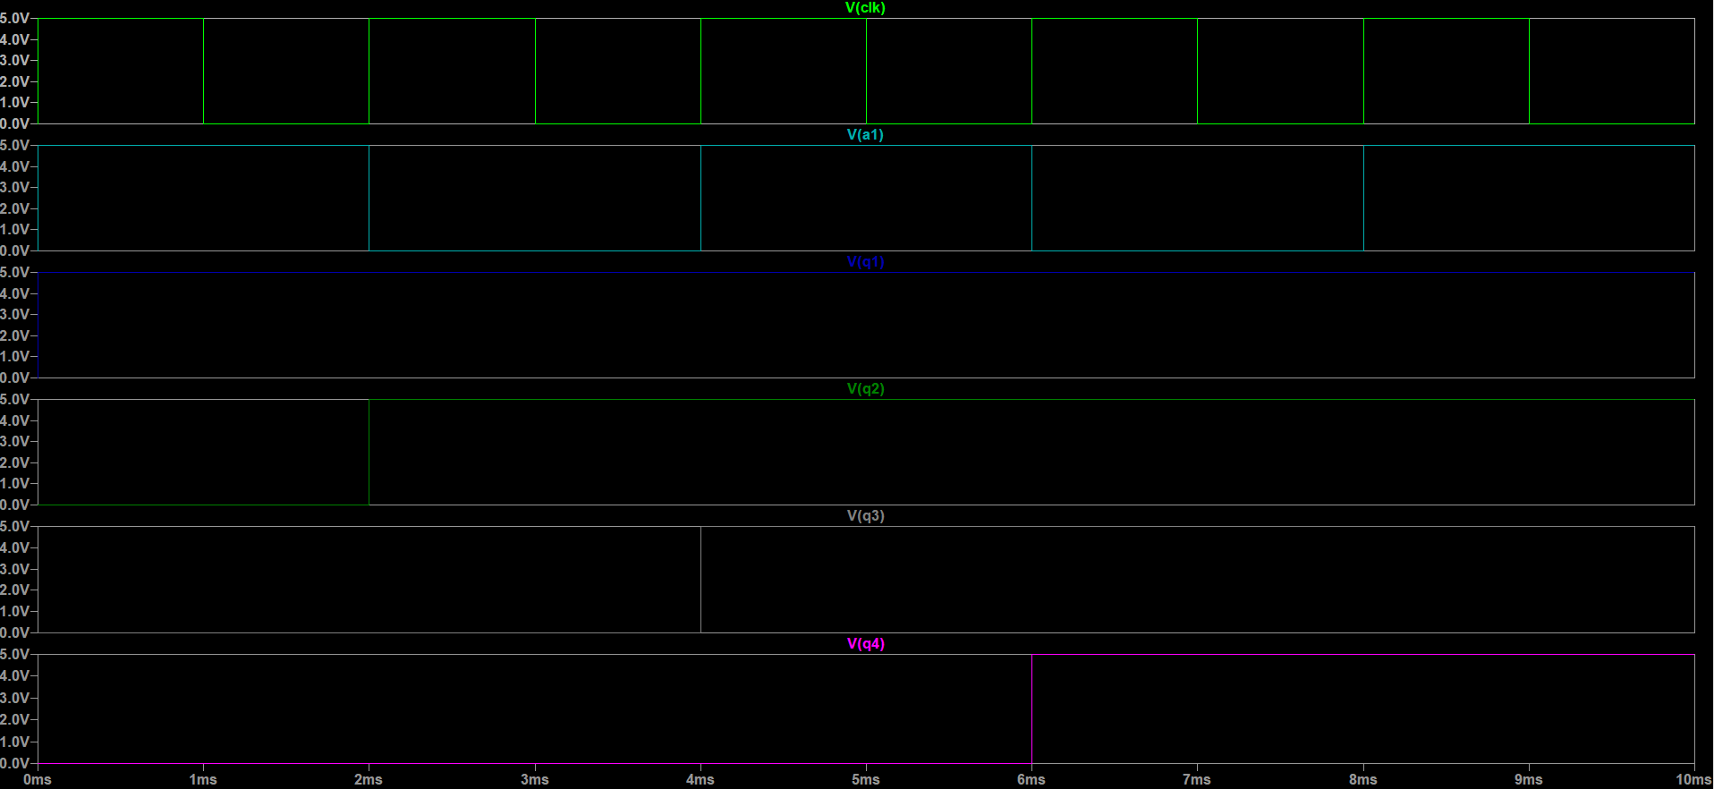

1. Johnson Counter

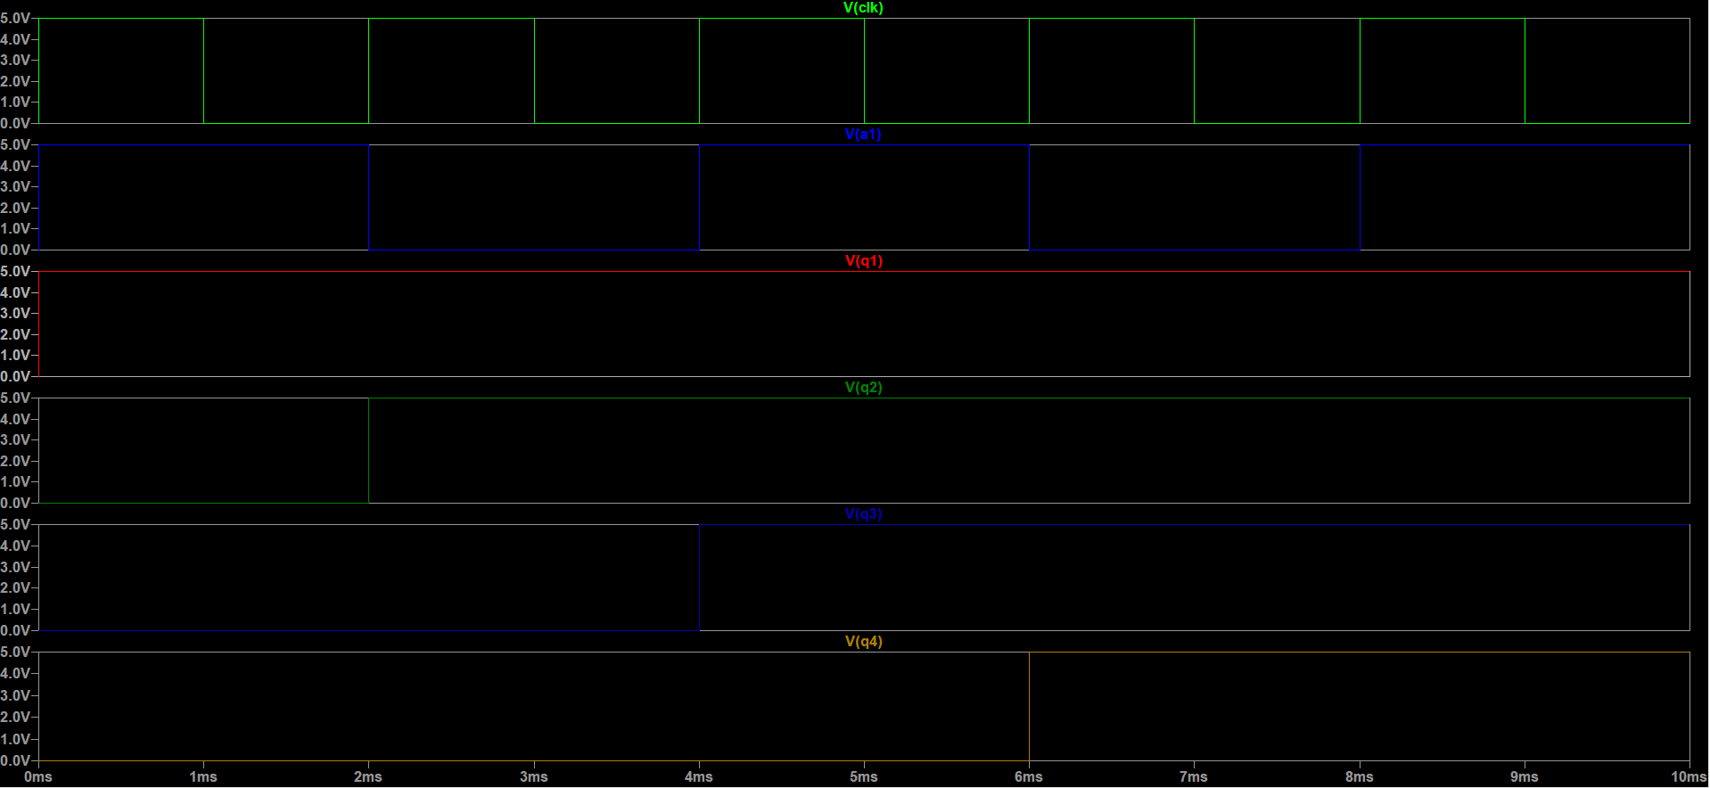

**END**