Experiment - 2

Submitted by ADITYA SINGH 2K19/EP/005

**Aim** - To verify the truth table of Half Adder and Full Adder.

**Theory** - **Half adder** is a combinational arithmetic circuit that adds two numbers and produces a sum bit (S) and carry bit (C) as the output. If A and B are the input bits, then sum bit (S) is the X-OR of A and B and the carry bit (C) will be the AND of A and B.

**Full Adder** is the **adder** which adds three inputs and produces two outputs. The first two inputs are A and B and the third input is an input carry as C-IN. The output carry is designated as C-OUT and the normal output is designated as S which is SUM.

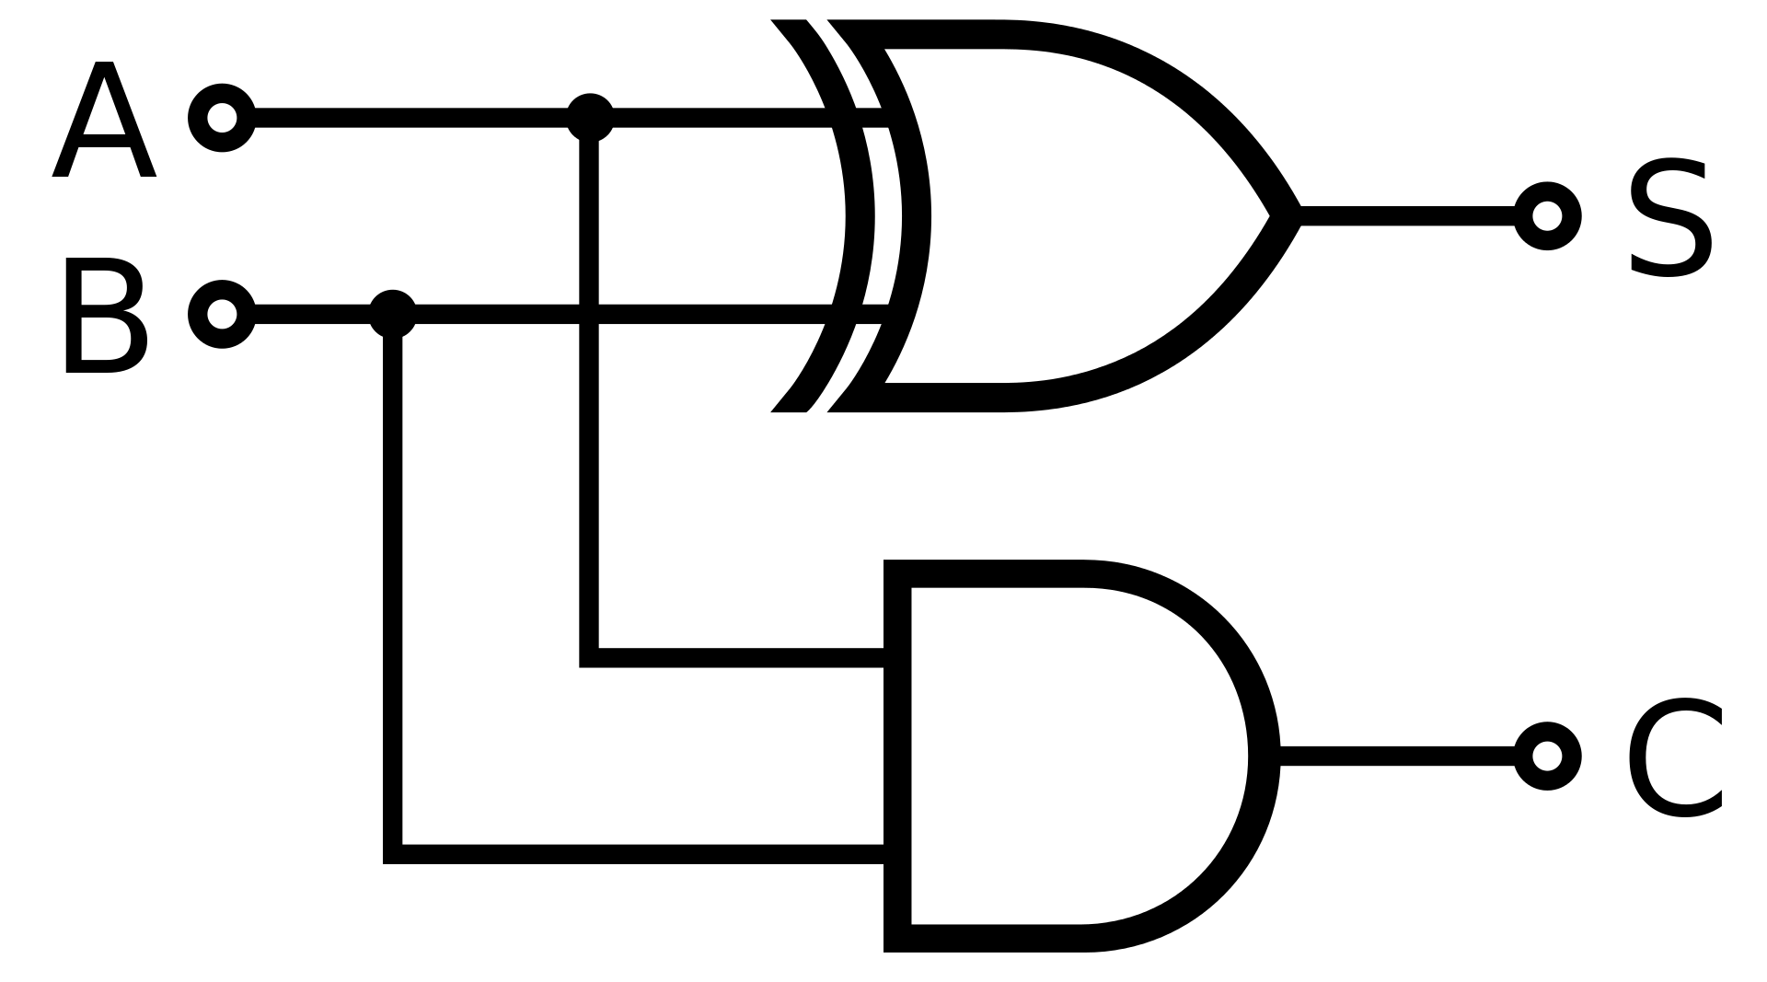

**Circuit Diagram** -

1. Half Adder

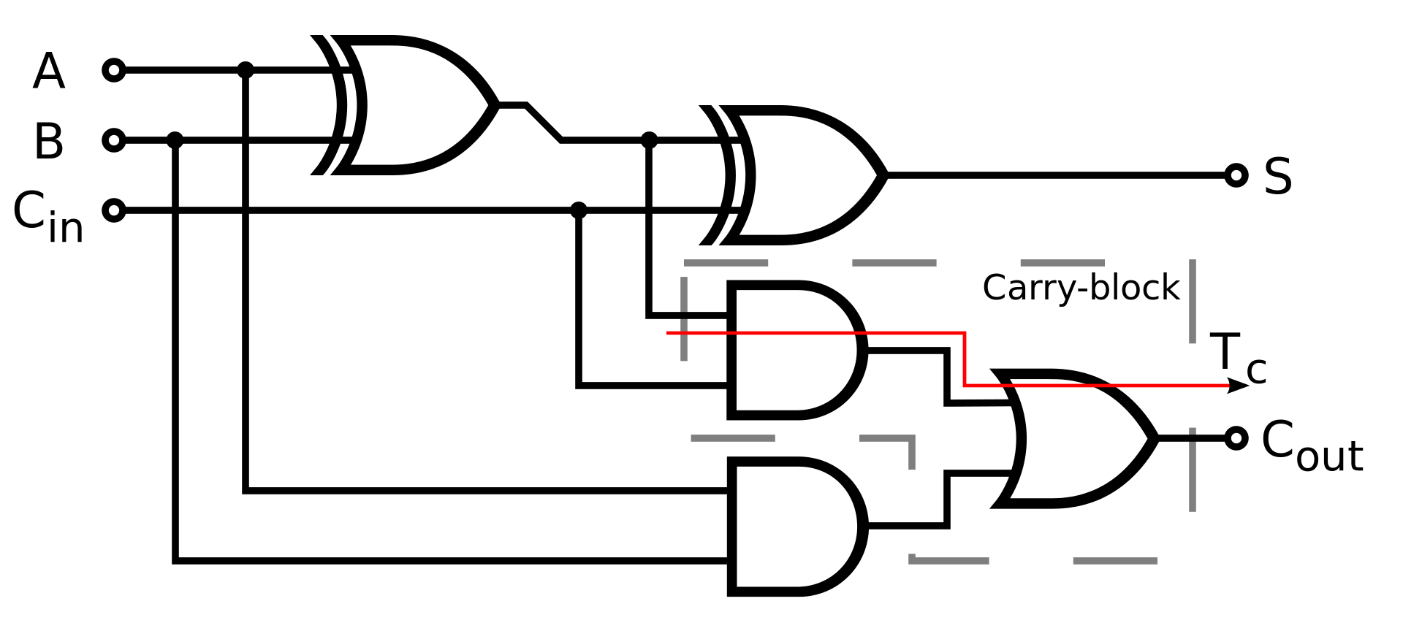

1. Full Adder

**Truth Tables** -

1. Half adder

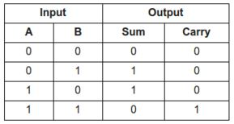

1. Full adder

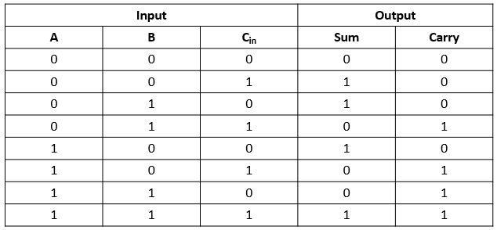

**K-Map Expressions-**

1. Half Adder

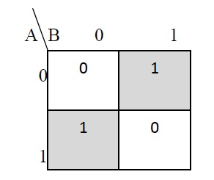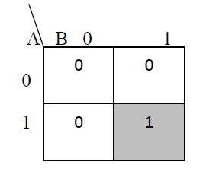

Sum = A B ̅ + A ̅ B Carry = AB

1. Full Adder

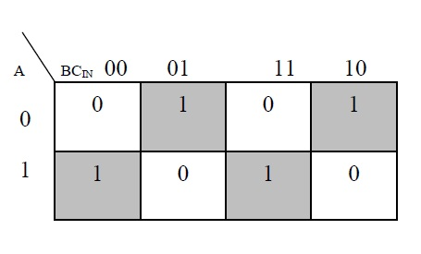

Sum = A ̅ B ̅ Cin + A ̅ BC ̅ in + ABCin

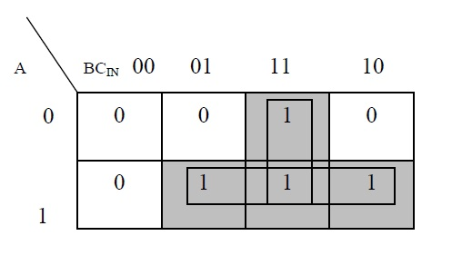

Carry = AB + ACin + BCin

**Design-**

1. Half Adder

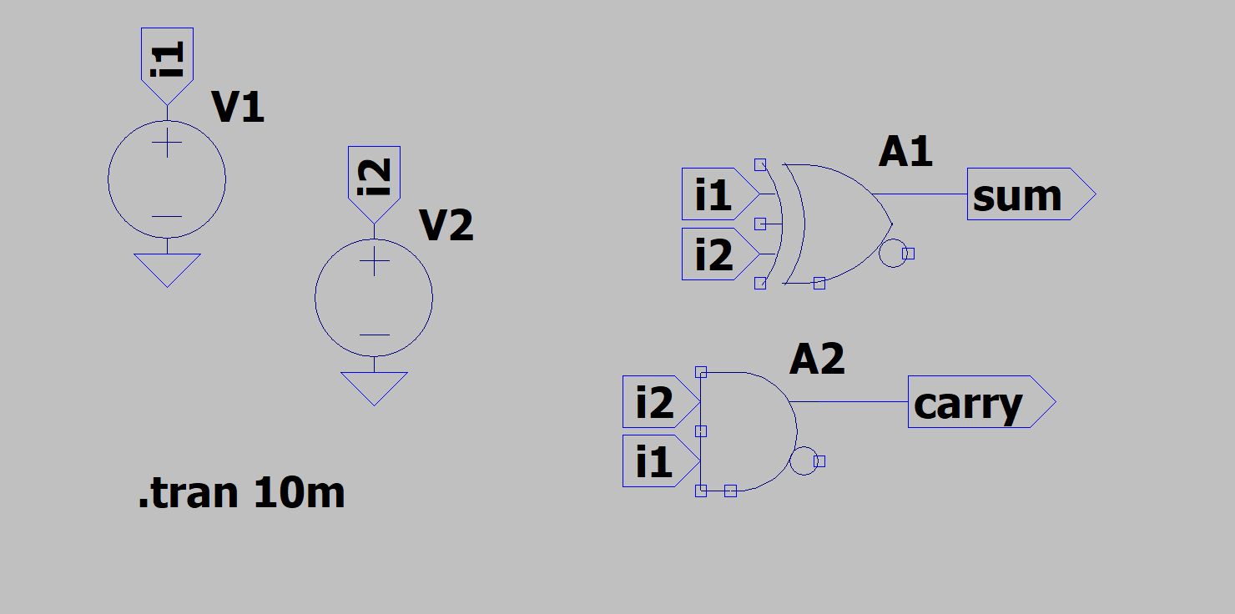

1. Full Adder

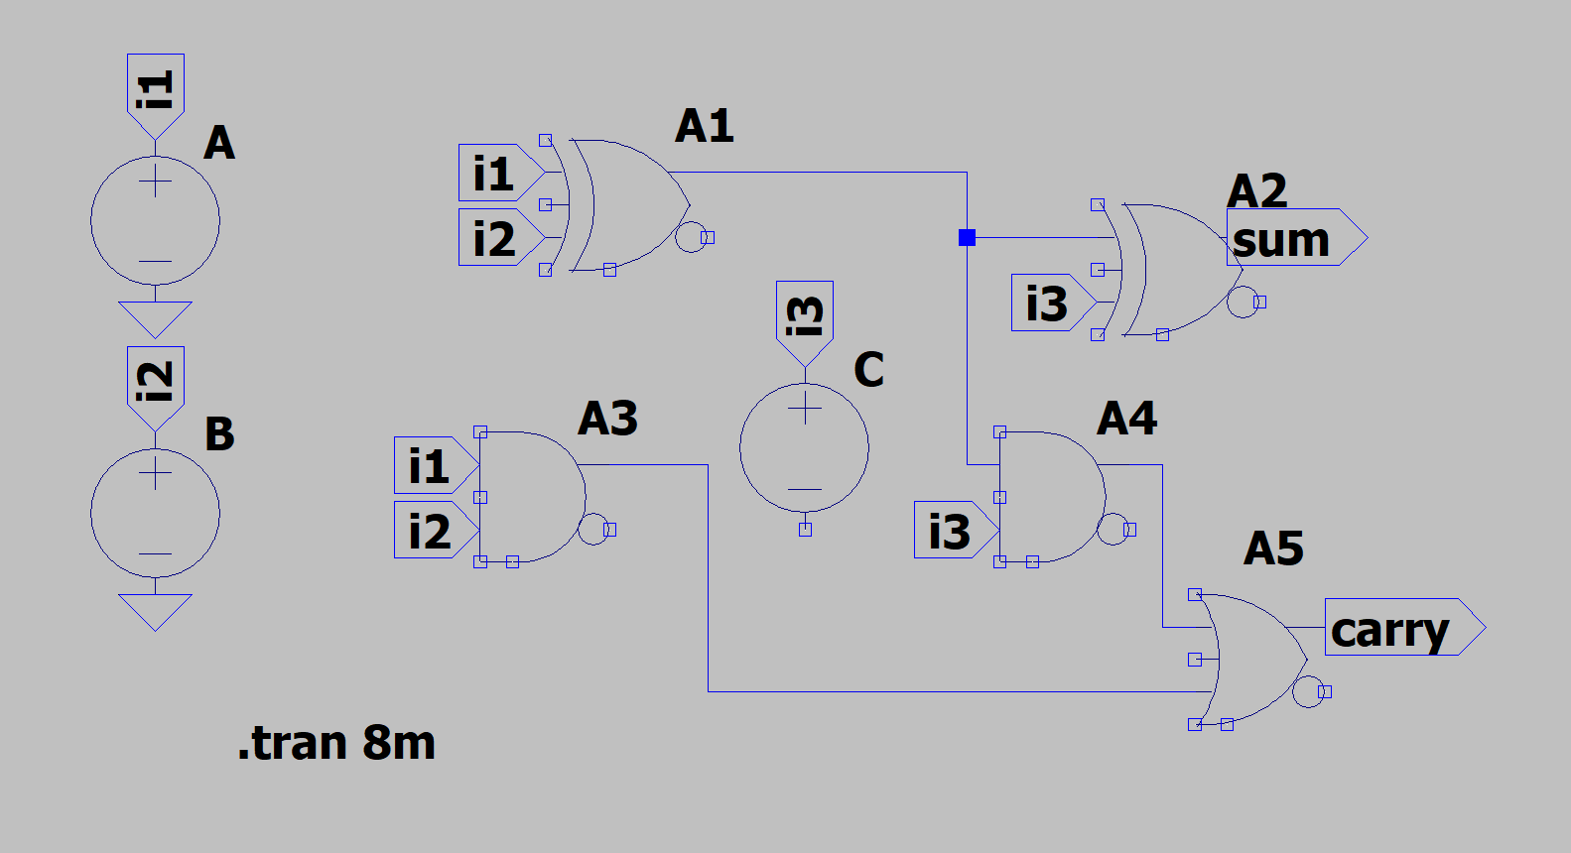

**Results-**

1. Half Adder

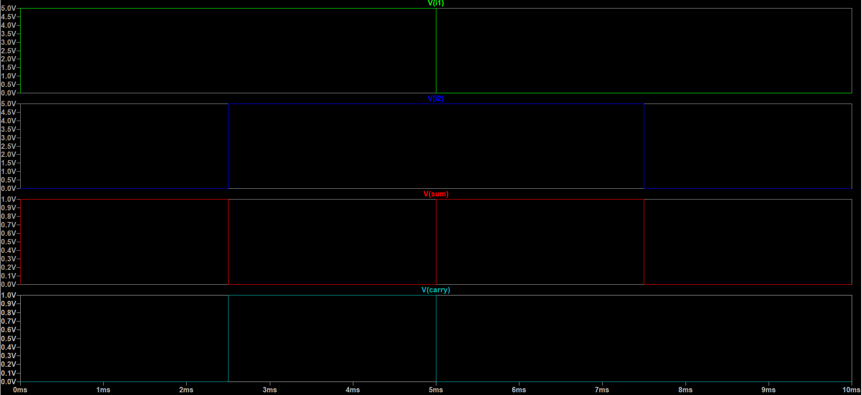

1. Full Adder

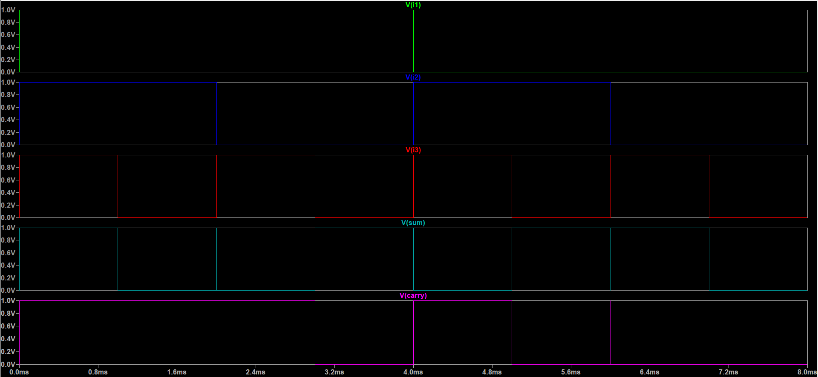

END