**Experiment - 3**

Submitted by ADITYA SINGH 2K19/EP/005

**Aim** - To study and verify the operation of 3 to 8 line decoder and 4 to 1 line multiplexer (74138, 74153).

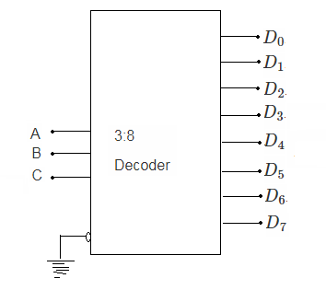

**Theory**

3 to 8 Decoder

* A 3 to 8 decoder has three inputs (A,B,C) and eight outputs (DO to D7).
* Based on the 3 inputs one of the eight outputs is selected.
* From the truth table, it is seen that only one of eight outputs (DO to D7) is selected based on three select inputs.

4 to 1 Line Multiplexer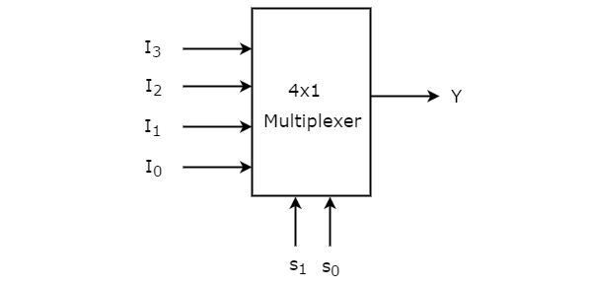

The multiplexer or MUX is a digital switch, also called a data selector. It is a combinational circuit with more than one input line, one output line and more than one select line.

It allows the binary information from several input lines or sources and depending on the set of select lines , a particular input line is routed onto a single output line.

**Circuit Diagram**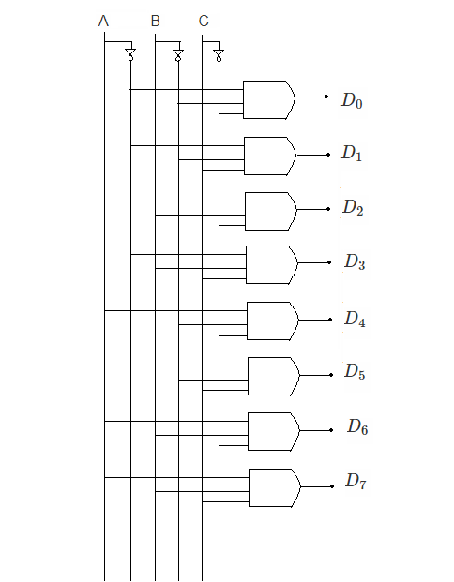

1. 3 to 8 Decoder
2. 4 to 1 Multiplexer

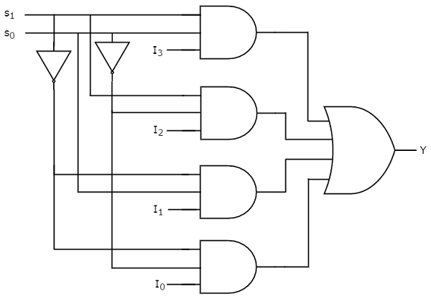

**Truth Tables**

1. 3 to 8 Decoder

|  |  |  |  |  |  |  |  |  |  |  |
| --- | --- | --- | --- | --- | --- | --- | --- | --- | --- | --- |
| A | B | C | D0 | D1 | D2 | D3 | D4 | D5 | D6 | D7 |
| 0 | 0 | 0 | 1 | 0 | 0 | 0 | 0 | 0 | 0 | 0 |
| 0 | 0 | 1 | 0 | 1 | 0 | 0 | 0 | 0 | 0 | 0 |
| 0 | 1 | 0 | 0 | 0 | 1 | 0 | 0 | 0 | 0 | 0 |
| 0 | 1 | 1 | 0 | 0 | 0 | 1 | 0 | 0 | 0 | 0 |
| 1 | 0 | 0 | 0 | 0 | 0 | 0 | 1 | 0 | 0 | 0 |
| 1 | 0 | 1 | 0 | 0 | 0 | 0 | 0 | 1 | 0 | 0 |
| 1 | 1 | 0 | 0 | 0 | 0 | 0 | 0 | 0 | 1 | 0 |
| 1 | 1 | 1 | 0 | 0 | 0 | 0 | 0 | 0 | 0 | 1 |

1. 4 to 1 Multiplexer

|  |  |  |
| --- | --- | --- |
| S1 | S2 | Y(Output) |
| 0 | 0 | D0 |
| 0 | 1 | D1 |
| 1 | 0 | D2 |
| 1 | 1 | D3 |

**Expressions**

1. 3 to 8 Decoder

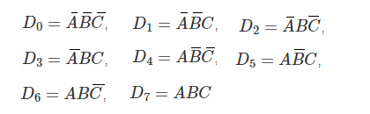

Using the above expressions, the circuit of a 3 to 8 decoder can be implemented using three NOT gates and eight 3-input AND gates.

1. 4 to 1 Multiplexer

From the above truth table, we can write the output expressions as



**Design**

1. 3 to 8 Decoder

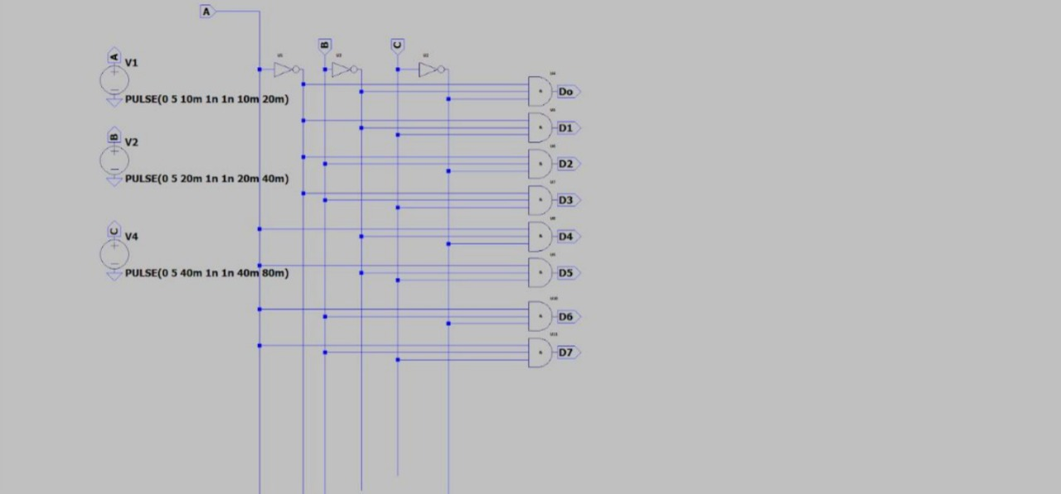

1. 4 to 1 Multiplexer

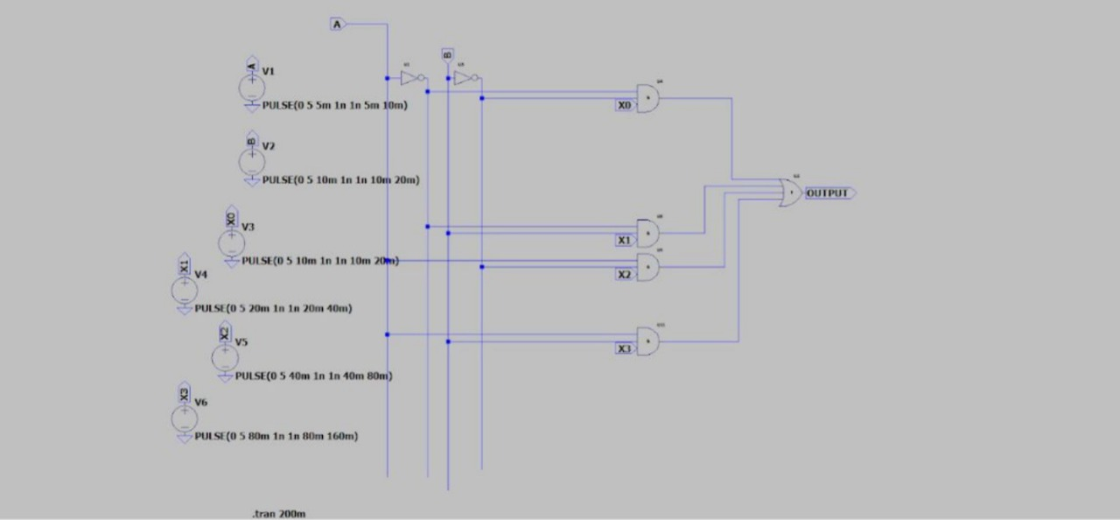

**Results**

1. 3 to 8 Decoder

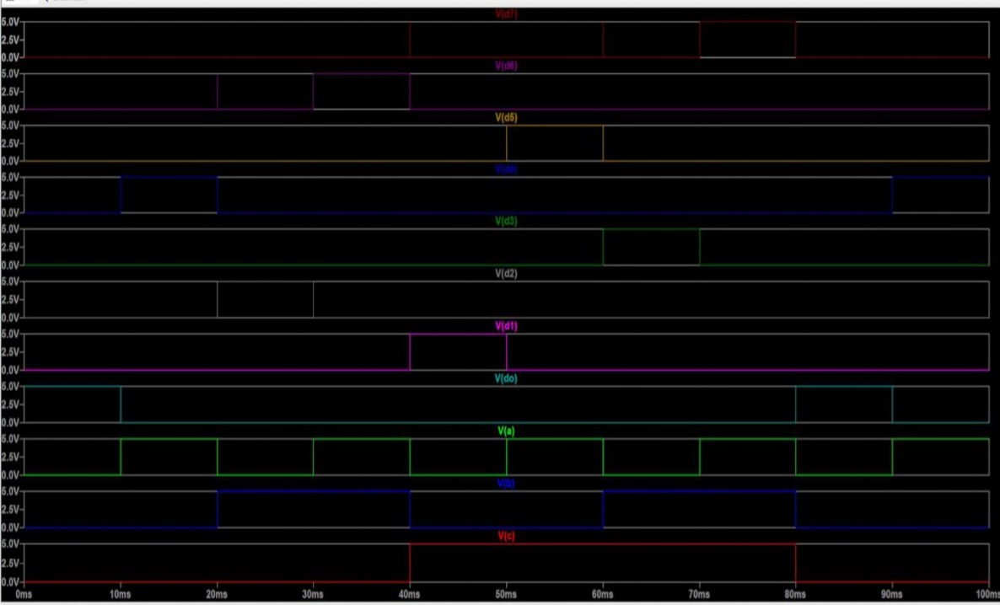

1. 4 to 1 Multiplexer

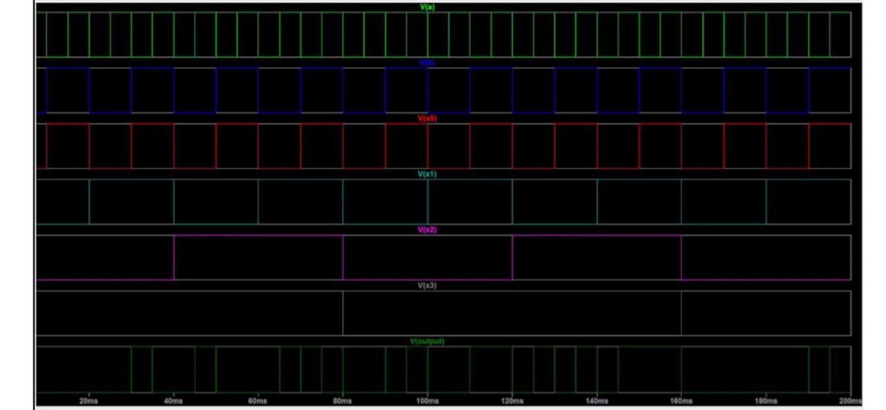

END