**Experiment - 6**

Submitted by ADITYA SINGH 2K19/EP/005

**Aim** - To verify the operation of a decade counter (5490 AJ)

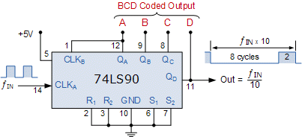

**Theory**

A decade counter is one that counts in decimal digits, rather than binary.

A decade counter may have each (that is, it may count in [binary-coded decimal](https://en.wikipedia.org/wiki/Binary-coded_decimal), as the [7490](https://en.wikipedia.org/wiki/List_of_7400_series_integrated_circuits) integrated circuit did) or other binary encodings. A decade counter is a binary counter that is designed to count to 1010 (decimal 10).

**Circuit Diagram**

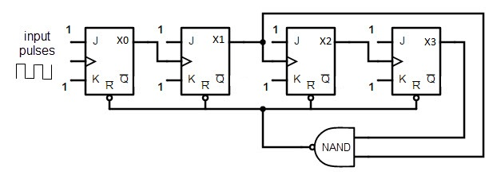

**Truth Tables**

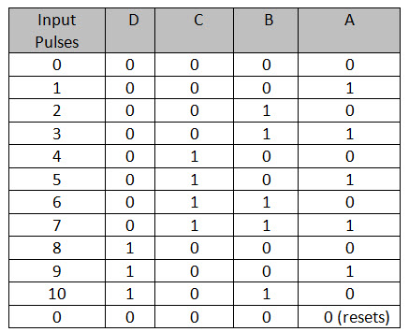

**CLOCK CYCLES**

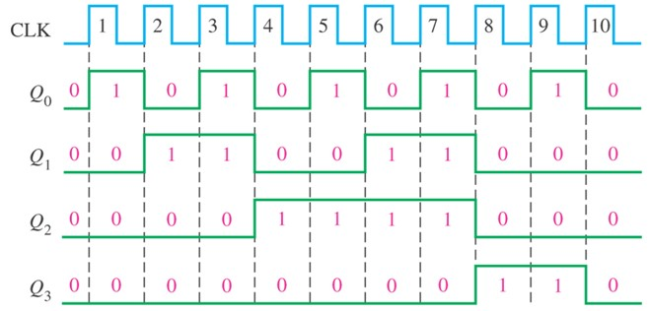

**Design**

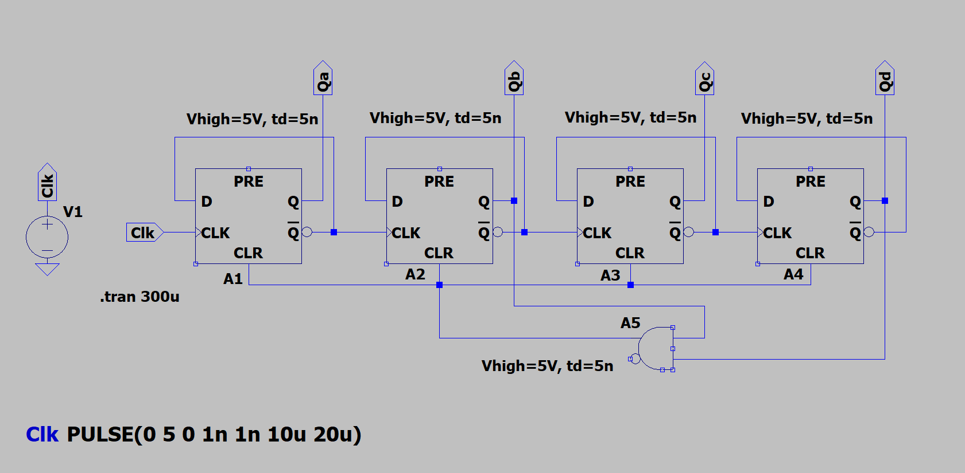

**Results**

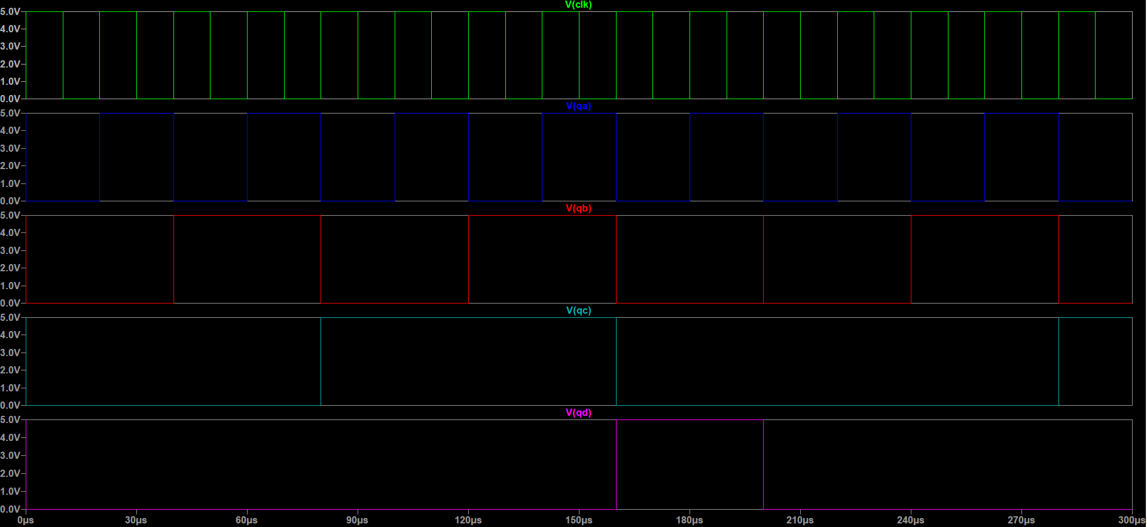

END