**Experiment - 9**

Submitted by ADITYA SINGH 2K19/EP/005

**Aim** - To Perform Code Conversion (7486): a. Binary to Gray, b. Gray to Binary.

**Theory -**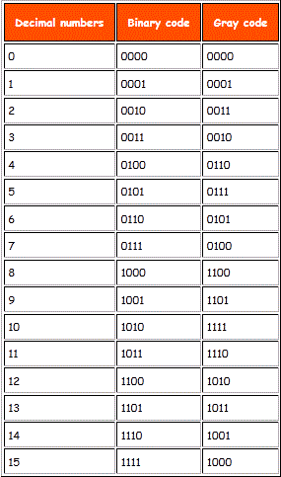

## **Binary to Gray Code**

The logical circuit which converts the binary code to equivalent gray code is known as binary to gray code converter.

An n-bit gray code can be obtained by reflecting an n-1 bit code about an axis after 2n-1 rows and putting the MSB (Most Significant Bit) of 0 above the axis and the MSB of 1 below the axis.

## **Gray to Binary Code**

The MSB of the binary number will be equal to the MSB of the given gray code.

Now if the second gray bit is 0, then the second binary bit will be the same as the previous or the first bit. If the gray bit is 1 the second binary bit will alter. If it was 1 it will be 0 and if it was 0 it will be 1.

This step is continued for all the bits to do Gray code to binary conversion.

**Circuit Diagram**

1. Binary to Gray

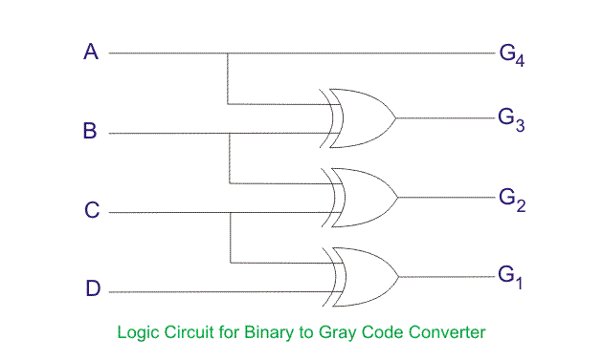

1. Gray to Binary

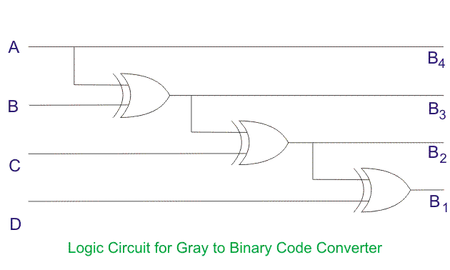

**Truth Tables**

1. Binary to Gray

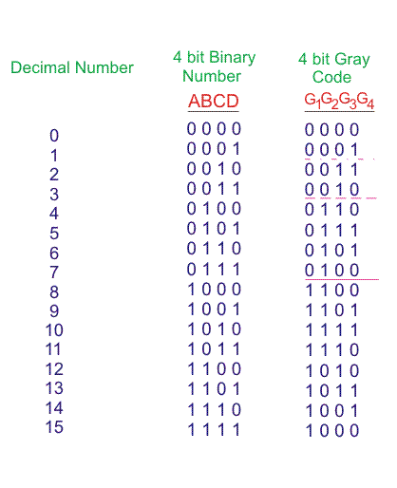

1. Gray to Binary

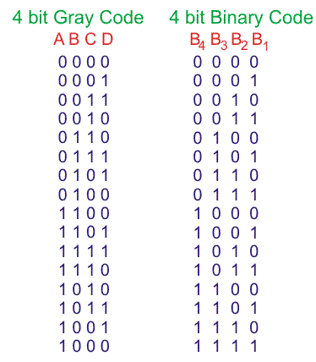

**Expressions**

1. Binary to Gray

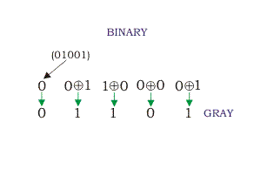

1. Gray to Binary

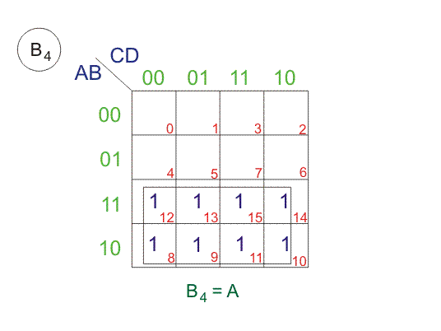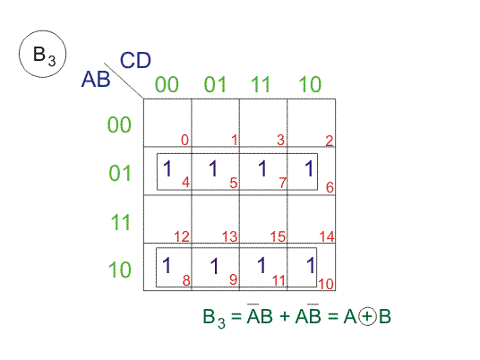

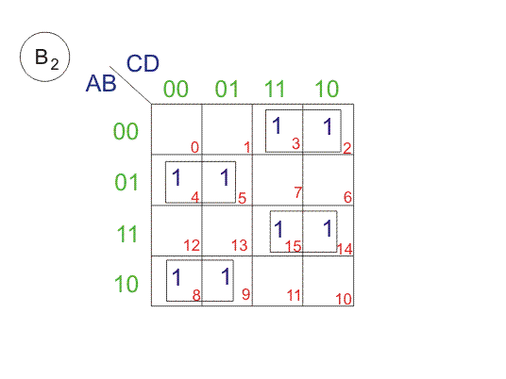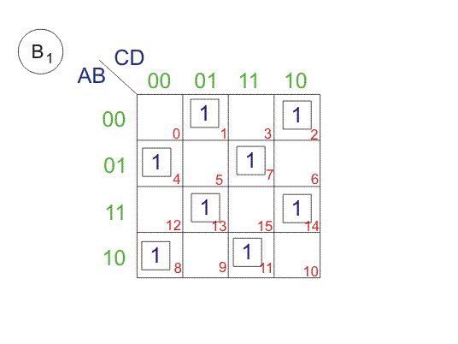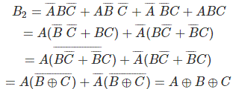

**Design**

1. Binary to Gray

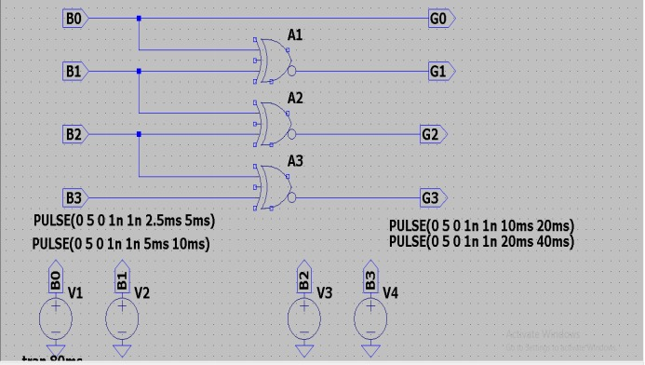

1. Gray to Binary

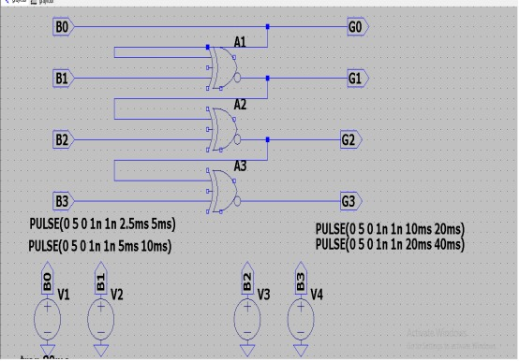

**Results**

1. Binary to Gray

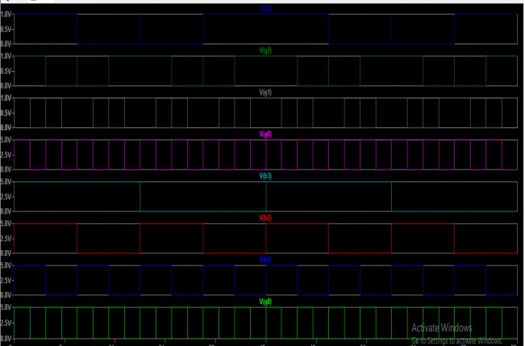

1. Gray to Binary

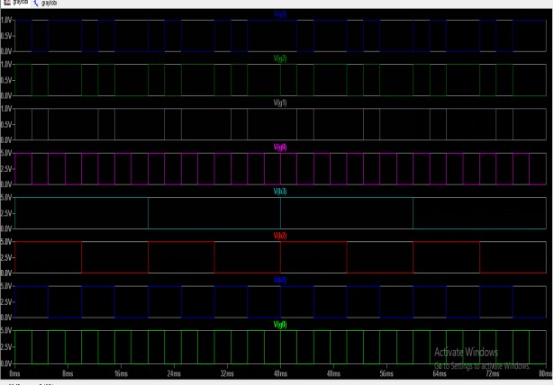**END**