CONDENSED MATTER PHYSICS EP-202

**NANOSTRUCTURES AND ITS APPLICATIONS**

horizontal line

# 

# INNOVATIVE MID-TERM PROJECT

BY **ADITYA SINGH 2K19/EP/005**

AND **ANSHUL SATIJA 2K19/EP/018**

# TABLE OF CONTENTS

1. Definition
2. Why they are Important
3. Size Properties
   1. Volume
   2. Surface Area
4. Melting Point
5. Crystal Structure
   1. Lattices
   2. Magic Number
6. Wolf Crystal Shapes
7. Optical Properties
   1. Surface Plasmons
   2. Absorption Spectra
   3. Energy Level Spacing
8. Electrical Properties
   1. Scattering
9. Applications of Nanomaterials

# 

# 

# 

# DEFINITION

The term ‘nano-material’ usually implies that one or more of the components which make up the material are nanosized. Nanostructures are the structures, whose sizes are within a few nanometers (<100 nm) and can comprise of either single material or multiple material.

Examples:

Nature has many examples of nanostructures such as hydrophobic leaves, iridescent butterfly wings, and the gecko’s foot.

Sphere-like particles: Ag nanoparticles, buckyballs

Rod-like particles : Si & Ni nanowires

Tube-like particles: Carbon nanotubes, TiO2 nanotubes

**Why Nano-Materials are Important**

The study of nanomaterials has extended the frontiers of science and has warranted the existence of a new domain of research called nanoscience.

Nanotechnology is the application of the principles of nanoscience into useful deliverables. This includes the application of nanostructures/nanomaterials into useful nanoscale devices and components.

Concepts of nanoscience, nanotechnology aims at improving the lifestyle of the human race. Due to the ability to generate the materials in a particular way to play a specific role, the use of nanomaterials spans across various industries, from healthcare and cosmetics to environmental preservation and air purification.

**PROPERTIES**

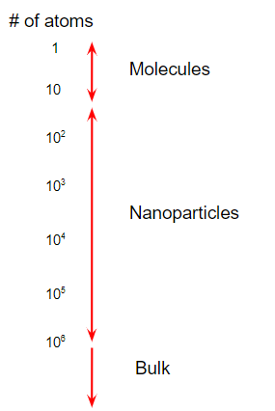

**Size**

* Molecules, nanoparticles, and bulk materials can be distinguished by the number of atoms comprising each type of material.
* Nanoparticles exhibit unique properties due to their high surface area to volume ratio.
* As the percentage of atoms at the surface increases, the mechanical, optical, electrical, chemical, and magnetic properties change.
* Nanoparticles exhibit unique properties due to their high surface area to volume ratio.
* A spherical particle has a diameter (D) of 100nm.

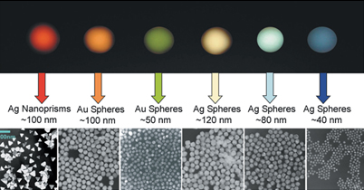

**Volume**

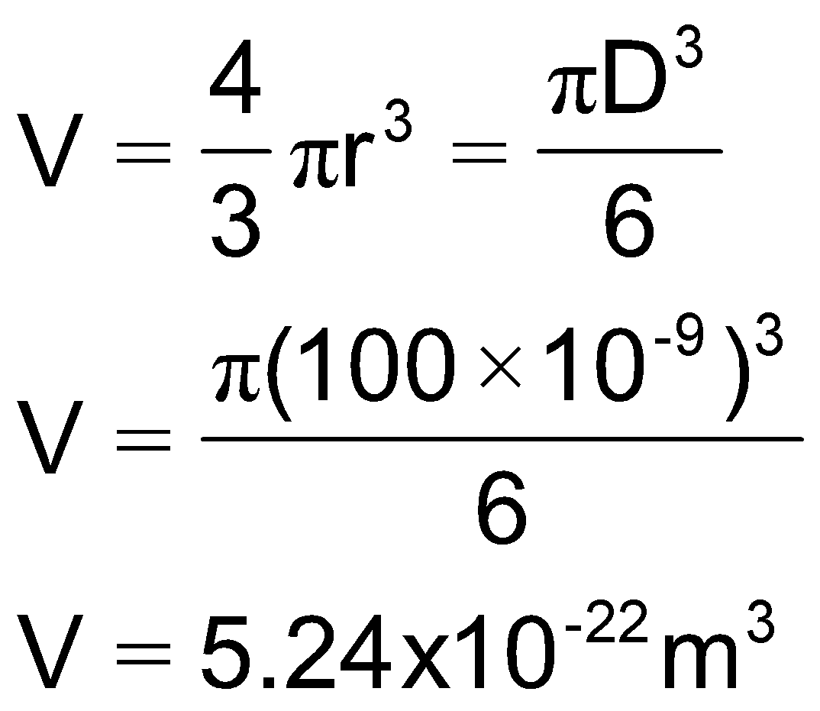

**Surface Area**

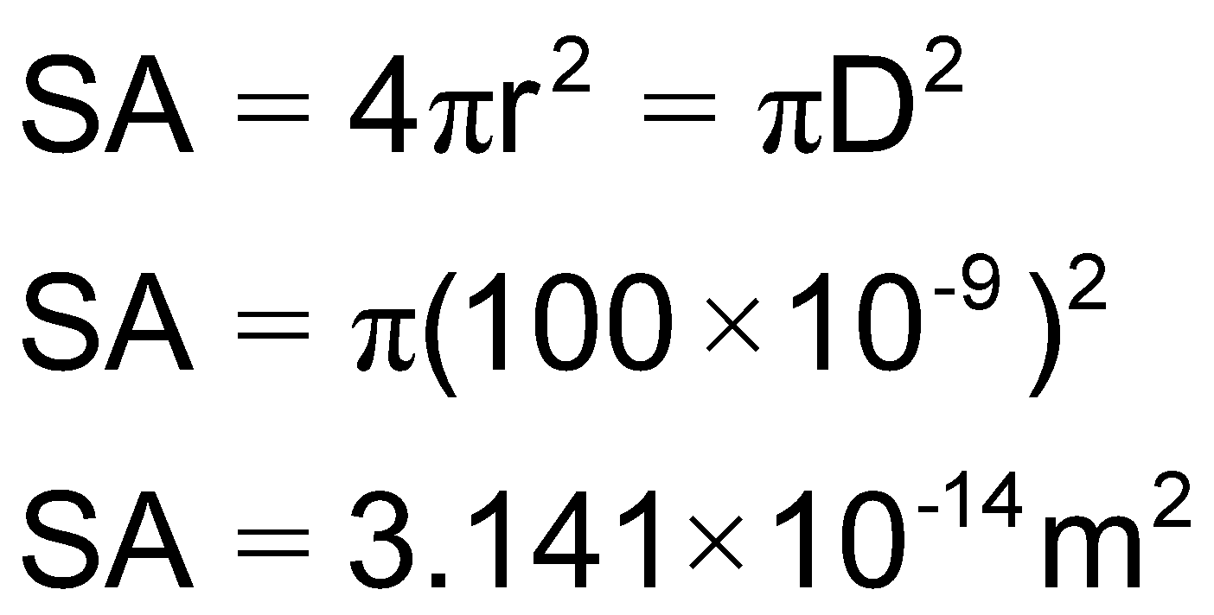

This gives an approximate surface area to volume ratio of >107:1 which is significantly larger than a macro sized particle. As the surface area to volume ratio increases so does the percentage of atoms at the surface and surface forces become more dominant.

Generally accepted material properties are derived from the bulk, where the percentage of atoms at the surface is miniscule. These properties change at the nanoscale.

As a particle decreases in size, a greater proportion of atoms are found at the surface compared to those inside.

With decrease in size, the surface area and surface energy increases exponentially.

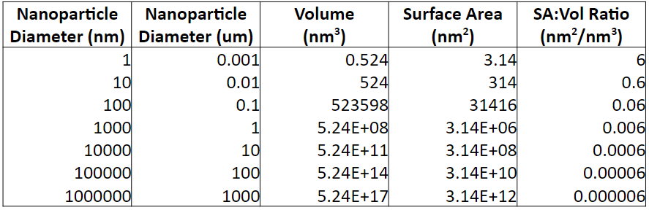

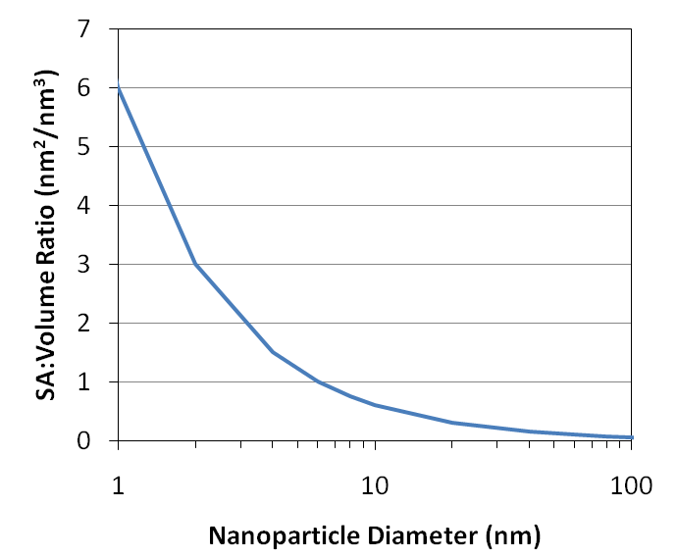

The ratio increases dramatically when the nanoparticle diameter drops below about 100 nm

**MELTING POINT**

Nanoparticles have a lower melting point than their bulk counterparts.

Particles: May sinter together at lower than expected temperature.

Rods: Can melt and form spherical droplets if heated too high.

Films: Thin films can form pin-holes. Continued heating can lead to de-wetting behavior and island formation.

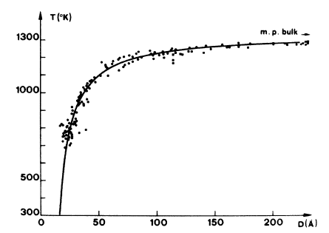

**Other Physical Characteristics**

* Large surface to volume ratio
* High percentage of atoms/molecules on the surface
* Surface forces are very important, while bulk forces are not as important.
* Metal nanoparticles have unique light scattering properties and exhibit plasmon resonance.
* Semiconductor nanoparticles may exhibit confined energy states in their electronic band structure (e.g., quantum dots)
* Can have unique chemical and physical properties
* Same size scale as many biological structures

**What actually defines these properties**

* + Size
  + Shape (spheres, rods, platelets, etc.)
  + Composition
  + Crystal Structure (FCC, BCC, etc.)
  + Surface ligands or capping agents
  + The medium in which they are dispersed

**CRYSTAL STRUCTURE**

Most solids are crystalline with their atoms arranged in a regular manner. This arrangement of atoms impacts the functionality of the material. Some solids have this order presented over a long range as in a crystal.

Amorphous materials such as glass and wax lack long range order, but they can have a limited short range order, defined as the local environment that each atom experiences.

The spatial arrangement of atoms in a crystal lattice is described by its unit cell.

The unit cell is the smallest possible volume that displays the full symmetry of the crystal. Many materials have a “preferred” unit cell.

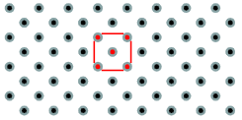

Most metals in the solid form close packed lattices

* Ag, Al, Cu, Co, Pb, Pt, Rh are Face Centered Cubic (FCC)
* Mg, Nd, Os, Re, Ru, Y, Zn are Hexagonal Close Packed (HCP)
* Cr, Li, Sr can form Body Centered Cubic (BCC) as well as (FCC) and (HCP) depending upon formation energy

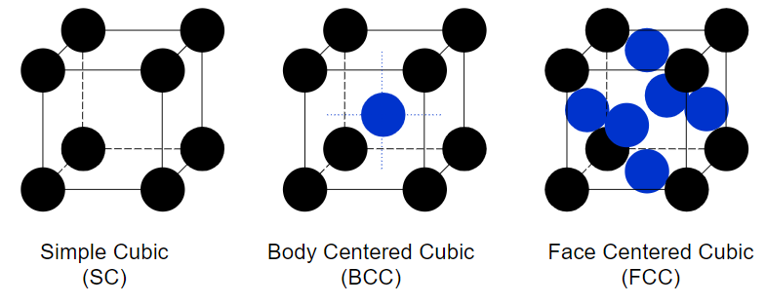

**Magic Number**

Nanoparticles have a “structural magic number”, that is, the optimum number of atoms that leads to a stable configuration while maintaining a specific structure.

* Structural magic number = minimum volume and maximum density configuration
* If the crystal structure is known, then the number of atoms per particle can be calculated.

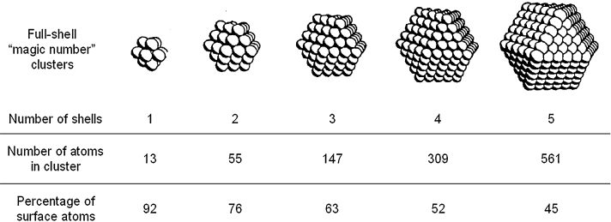

Magic Number = Cluster has a complete, regular outer geometry formed by successively packing layers around a single metal atom.

Number of atoms (y) in shell (n): y = 10n2 + 2 (n = 1,2,3…)

Percentage of surface atoms decreases as cluster grows

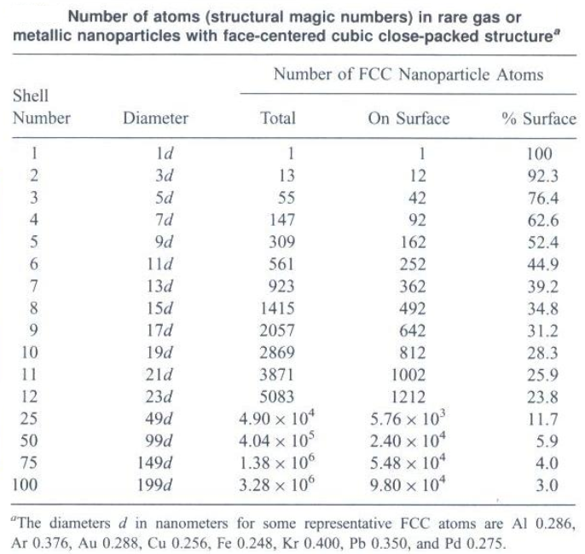

For n layers, the number of atoms N in an approximately spherical FCC nanoparticle is given by the following formula:

**N = 1/3[10n3 – 15n2 + 11n - 3]**

The number of atoms on the surface,

**NSurf = 10n2 – 20n +12**

**WULFF CRYSTAL SHAPES**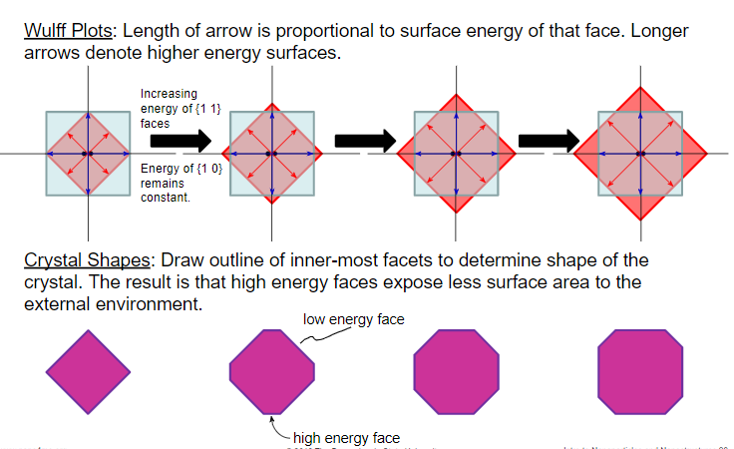

It is used to determine the shape of a crystal when formed under thermodynamic equilibrium conditions. Surfaces are basically areas of high energy. Different faces have different surface energies.

The shape of an [equilibrium](http://www.scholarpedia.org/article/Equilibrium) crystal is obtained minimizing the total surface free energy associated with the crystal-medium interface.

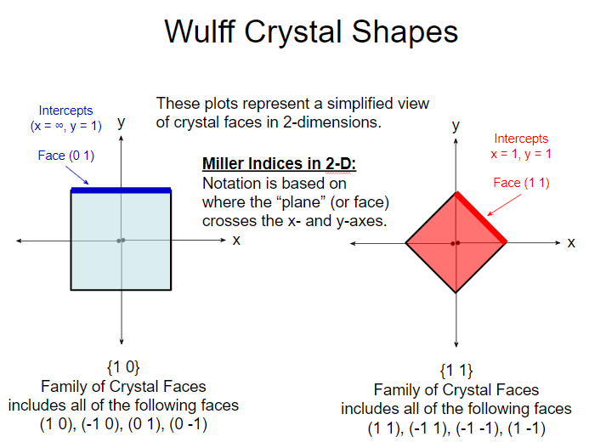

**OPTICAL PROPERTIES**

The size dependence on the optical properties of nanoparticles is the result of two distinct phenomena :

* + Surface plasmon resonance for metals
  + Increased energy level spacing due to the confinement of delocalized energy states. Most prominent in semiconductors

**Surface Plasmons**

* + Metals can be modeled as an arrangement of positive ions surrounded by a sea of free electrons.

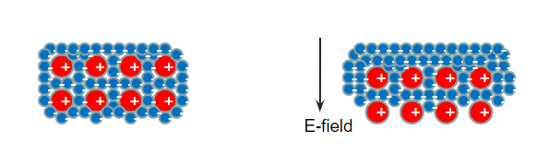

* + If the electric field is oscillating (like a photon), then the sea of electrons will oscillate too. These oscillations are quantized and resonate at a specific frequency. Such oscillations are called plasmons.
  + The plasmon resonance frequency (f) depends on particle size, shape, and material type. It is related to the plasmon energy (E) by Planck’s constant.
  + The sea of electrons behaves like a fluid and will move under the influence of an electric field.
  + Surface plasmons are confined to the surface of the material.
  + The optical properties of metal nanoparticles are dominated by the interaction of surface plasmons with incident photons.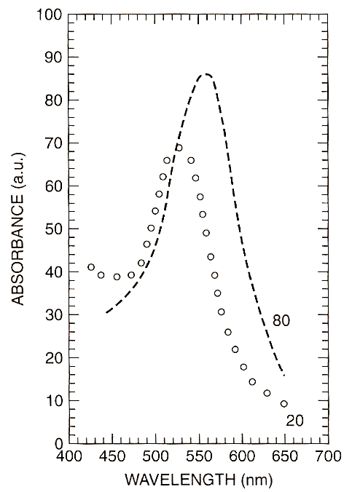

**Absorption spectra of spherical Au Nanoparticles**

* The Pauli Exclusion Principle states that electrons can only exist in unique, discrete energy states.
* In an atom the energy states couple together through spin-orbit interactions to form the energy levels commonly discussed in an introductory chemistry course.
* When atoms are brought together in a bulk material, the energy states form nearly continuous bands of states, or in semiconductors and insulators, nearly continuous bands separated by an energy gap.

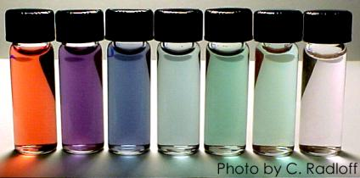

* Energy level spacing and quantum confinement
  + Semiconductor nanoparticles that exhibit 3 dimensional confinement in their electronic band structure are called quantum dots.
* As semiconductor particle size is reduced the band gap is increased.
* Absorbance and luminescence spectra are blue shifted with decreasing particle size.

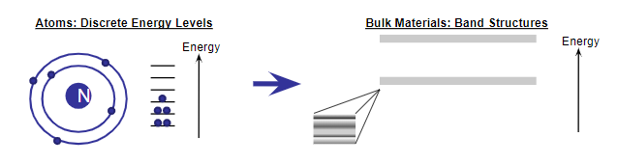

**What does this all mean?**

* Quantum dots are band gap tunable.
* We can engineer their optical properties by controlling their size.
* For this reason quantum dots are highly desirable for biological tagging.

**ELECTRICAL PROPERTIES**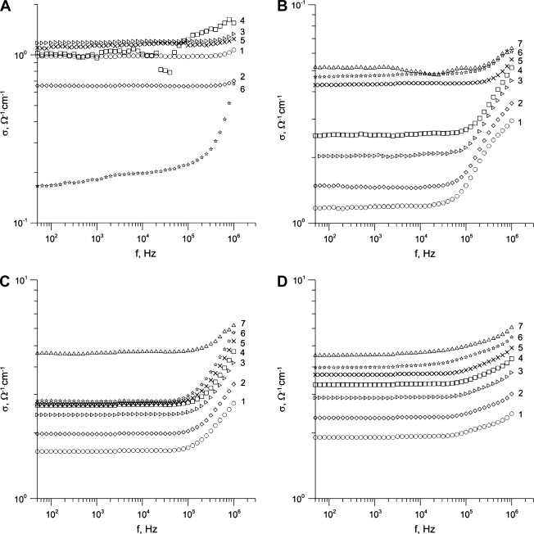

If nanostructures have fewer defects, one would expect increased conductivity vs macroscale

**Surface Scattering**

There are two types of surface scattering: elastic and inelastic. Elastic scattering does not affect conductivity, while inelastic scattering decreases conductivity.

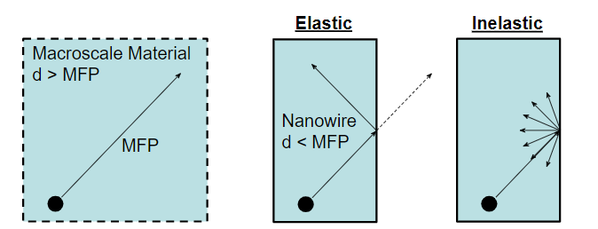

Electrons have a mean-free-path (MFP) in solid state materials. MFP is the distance between scattering events as charge carriers move through the material. In metals, the MFP is on the order of 10’s of nanometers. If the dimensions of a nanostructure are smaller than the electron MFP, then surface scattering becomes a factor.

**APPLICATIONS OF NANOMATERIALS**

**Paints**

Nanoscale titanium dioxide and silicon dioxide are widely used in the paint industry. Nano titanium dioxide is photocatalytic in nature which results in its self-cleaning property and hence being used in coatings. synthetic amorphous silica can improve the hardness, abrasion, scratch and weather resistance of paint.

**Sports Industry**

The sports industry has been producing baseball bats that have been made with carbon nanotubes, making the bats lighter therefore improving their performance. Nanotechnology has also made an impact in football. Nanoclay linings are found in footballs and tennis balls where it acts as a barrier material upholding the pressure inside the ball allowing for longer game play. Sport clothing, particularly football kits, have also benefited from nanotechnology – those smelly socks are a breeding ground for fungi and bacteria. Silver has natural antibacterial and antifungal properties, so clothing is laced with fibres coated in silver nanoparticles.

**Military**

Nanomaterials have also been developed for use in the military. One example is the use of mobile pigment nanoparticles being used to produce a better form of camouflage, through injection of the particles into the material of soldiers’ uniforms. Additionally, the military have developed sensor systems using nanomaterials, such as titanium dioxide, that can detect biological agents.

**Flat-panel Displays**

In today's world demand for flat-panel displays is high. The resolution of these display devices can be easily improved by modern methods of synthesizing nanocrystalline phosphors. These flat-panel displays manufactured using nanomaterials have contrast and brightness compared to the traditional ones due to their improved magnetic and electrical properties.

**Nanomaterials in Biomedical Purposes**

Cancer occurs at a molecular level when multiple subsets of genes undergo genetic alterations, either activation of oncogenes or inactivation of tumor suppressor genes. Nanotechnology can provide rapid and sensitive detection of cancer-related molecules, enabling scientists to detect molecular changes. Nanoscale devices are one hundred to ten thousand times smaller than human cells. They are similar in size to large biological molecules ("biomolecules") such as enzymes and receptors. Because of their small size, nanoscale devices can readily interact with biomolecules on both the surface and inside cells. By gaining access to so many areas of the body, they have the potential to detect disease and deliver treatment in ways unimagined before now.

**END**