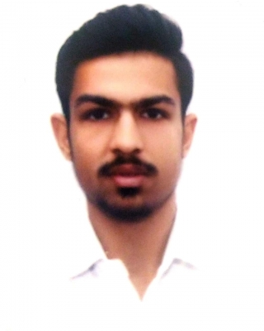Aaditya Muleva

E-mail :

[aadityamuleva@gmail.com](mailto:aadityamuleva@gmail.com)

Phone :

+91-9179719329

Address:

Village - Siwai , Tehsil - Rajpur, District - Barwani, Madhya pradesh, India (451447)

# Work experience

## Philips Innovation campus Bengaluru 15 June 2019 — 16 August 2019

Training

I was under my training period of 3 Months in between my collage semester in philips innovation campus under Mr. Harish Muleva (Sr. Architect, Healthsuite Digital Platform, Philips) in Artificial Intelligence and Machine learning domain.

# Qualifications

### Tchnical Skills:

python Basics of java GitHub Rstudio Spyder Jupyter MongoDB Meteor

### Machine Learning:

Worked with different kinds of models in Supervised, unsupervised learning and Reinforcement learning. I am familier with various libraries and data processing methods.

Hands on experience of machine learning using Pandas, Matplotlib, Scipy, Numpy etc.

# Education

## Class 10 July 2013 — March 2014

Sanmati higher secondary school, Indore, Madhya pradesh, India

Class 12 June 2015 — July 2016

Brilliant higher secondary school, Indore, Madhya pradesh, India

Bachelor of Engineering July 2016 — Present

IPS Academy, IES Indore

Interests

I like playing Cricket and Football. I like to learn new technologies.

I like to run at night.

# References

Mr. Harish Muleva (Sr. Architect, HealthSuite, Digital Platform, Philips)