### **Tugas**

1. Buatlah sebuah program menggabungkan 2 array yang diberikan, dan jangan sampai terdapat nama yang sama di data yang sudah tergabung tadi.  
     
    **Sample Test Cases** Input: ['kazuya', 'jin', 'lee'], ['kazuya', 'feng']  
     
    Output: ['kazuya', 'jin', 'lee', 'feng']  
     
    Input: ['lee', 'jin'], ['kazuya', 'panda']  
     
    Output: ['lee', 'jin', 'kazuya', 'panda']  
   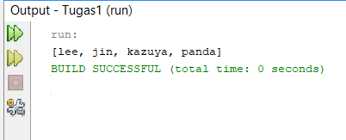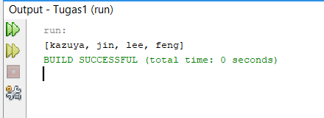
2. Buat program sesuai dengan deskripsi di bawah. Input merupakan variable string berisi kumpulan angka. Output merupakan list / array berisi angka yang hanya muncul 1 kali pada input.  
     
    **Sample Test Case** Input: “76523752”  
     
    Output: [6, 3]  
     
    Input: “1122”  
     
    Output: []  
   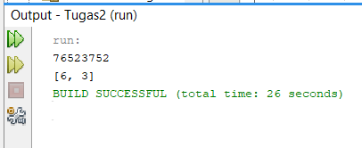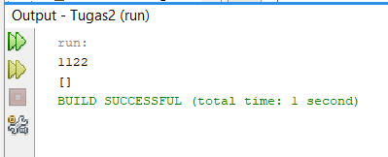
3. Given an array of sorted numbers and a target sum, find a pair in the array whose sum is equal to the given target. Write a function to return the indices of the two numbers (i.e. the pair) such that they add up to the given target.  
     
    **Challenges**:  
     
    Solve with linear complexity O(n), **not** O(n^2) if you can!  
     
    **Sample Test Cases** Input: [1, 2, 3, 4, 6], target=6  
     
    Output: [1, 3]  
     
    Explanation: The numbers at index 1 and 3 add up to 6: 2+4=6  
     
    Input: [2, 5, 9, 11], target=11  
     
    Output: [0, 2]  
     
    Explanation: The numbers at index 0 and 2 add up to 11: 2+9=11  
   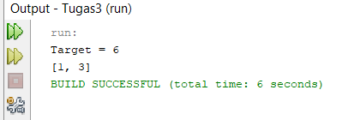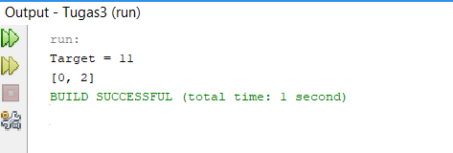
4. Buatlah sebuah program **ArrayUnique** yang menerima 2 parameter berupa array angka. Output adalah program adalah satu array berupa kumpulan angka di array pertama tetapi tidak memiliki duplikasi di di array kedua.  
     
    **Sample Test Case** input: [1, 2, 3, 4] dan [1, 3, 5, 10, 16]  
     
    Output: [2, 4]  
     
    input: [3, 8] dan [2, 8]  
     
    Output: [3]  
   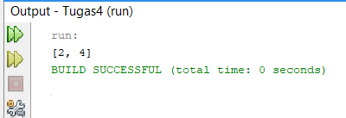

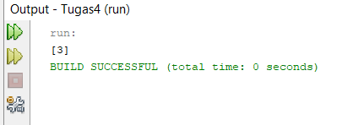

1. Given an array of sorted numbers, remove all duplicates from it. You should not use any extra space; after removing the duplicates in-place return the length of the subarray that has no duplicate in it.  
     
    **Sample Test Case** Input: [2, 3, 3, 3, 6, 9, 9]  
     
    Output: 4  
     
    Explanation: The first four elements after removing the duplicates will be [2, 3, 6, 9].  
     
    Sample Test Case  
     
    Input: [2, 2, 2, 11]  
     
    Output: 2  
     
    Explanation: The first two elements after removing the duplicates will be [2, 11].  
   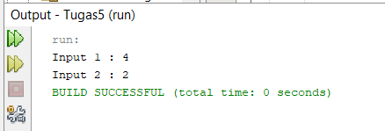
2. [Opsional / Nilai Tambah] Given an array of positive numbers and a positive number ‘k’, find the maximum sum of any contiguous subarray of size ‘k’.  
     
    **Sample Test Case** Input: [2, 1, 5, 1, 3, 2], k=3  
     
    Output: 9  
     
    Explanation: Subarray with maximum sum is [5, 1, 3].  
     
    **Sample Test Case** Input: [2, 3, 4, 1, 5], k=2  
     
    Output: 7  
     
    Explanation: Subarray with maximum sum is [3, 4].  
     
    2, 1, 5, 1, 3, 2

