A Mini-Project Report on

**Delivery Drone**

**M.O.M.**

**Medicines On the Move**

Submitted by

|  |  |  |  |
| --- | --- | --- | --- |
| Sr. No. | Name | PRN | Contact |
| 1. | Navinkumar Sidam | 21410055 | +91 80104 43129 |
| 2. | Rajwardhan Pratap Vichare | 21410058 | +91 99221 77623 |
| 3. | Vishvajeet Sureshrao Jagtap | 21410059 | +91 73669 52121 |
| 4. | Simran Shaikh | 21410060 | +91 70571 64525 |
| 5. | Aditya Vrushabhanath Pachore | 21410066 | +91 84466 20270 |

**Under the Guidance of**

**Prof. Dr. S. G. Tamhankar**



**DEPARTMENT Of ELECTRONICS ENGINEERING**

**WALCHAND COLLEGE OF ENGINEERING, SANGLI**

A Government Aided Autonomous Institute

**Mini-Project 2 A.Y. 2023-24**

* **INDEX**:

|  |  |  |
| --- | --- | --- |
| Sr. No. | Contents | Page No. |
| 01 | Introduction | 2 |
| 02 | Reasons and Relevance | 2 |
| 03 | Block Diagram | 2 |
| 04 | Components | 3 |
| 05 | Circuit Diagram | 3-4 |
| 06 | Software Integration (Code) |  |
| 07 | Results | 4 |
| 08 | Timeline | 5 |
| 09 | Conclusion | 5 |
| 10 | References | 6 |

* **Title:** Medicines On the Move (M.O.M): Delivery Drone

1. **Introduction:**

The "Medicines On the Move (MOM): Delivery Drone" project aims to revolutionize healthcare logistics by harnessing drone technology for the efficient transportation of essential medicines to remote or underserved regions. Traditional delivery methods often struggle to overcome geographical barriers, leading to delays in treatment and compromised patient outcomes. MOM addresses these challenges by developing a specialized delivery drone system tailored for medical purposes, ensuring timely and reliable access to life-saving treatments.

By leveraging the agility and autonomy of drones, MOM bridges the last-mile gap in medicine delivery, particularly in areas with inadequate transportation networks or emergencies such as natural disasters. This innovative solution not only enhances healthcare accessibility but also improves the overall efficiency and cost-effectiveness of medicine distribution systems. MOM has the potential to revolutionize healthcare delivery, contributing to better health outcomes and saving countless lives.

In this report, we explore the reasons and relevance behind the MOM project, discuss its key components and technological aspects, present results from testing and experimentation, outline the project timeline, and draw conclusions regarding its implications for the future of healthcare delivery.

1. **Reasons and Relevance:**

The "Medicines On the Move (MOM): Delivery Drone" project addresses a pressing need for innovative solutions in healthcare logistics. Traditional methods of medicine delivery face numerous barriers, limitations, and challenges, especially in remote or underserved regions. Geographical barriers, inadequate transportation infrastructure, and emergencies such as natural disasters often impede the timely and efficient distribution of essential medicines. These challenges contribute to delays in treatment, compromised patient outcomes, and, in severe cases, loss of life.

The deployment of delivery drones offers a reliable and rapid alternative to conventional transportation methods. Drones can navigate difficult terrain and bypass infrastructure limitations, enabling them to reach remote areas that are otherwise inaccessible by road. Their autonomy and agility make them particularly well-suited for delivering medicines swiftly, even in emergency situations. By providing a dependable means of transporting essential medical supplies, MOM has the potential to be a game-changer in the healthcare field, significantly improving healthcare accessibility and outcomes.

In summary, the MOM project is not just a technological innovation; it represents a paradigm shift in healthcare delivery. By overcoming barriers and limitations inherent in traditional delivery systems, MOM offers a promising solution to the longstanding challenge of ensuring timely access to life-saving medicines. Its ability to provide reliable and rapid delivery services makes it a transformative force in the healthcare landscape, with the potential to save lives and improve health outcomes for countless individuals worldwide.

1. **Block Diagram:**

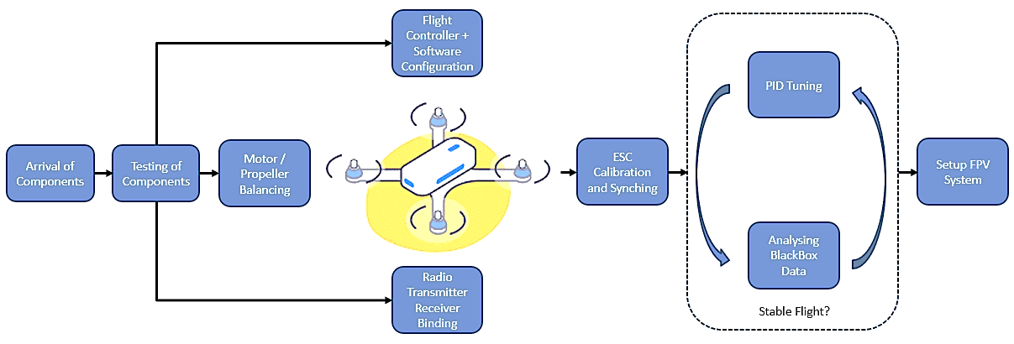

1. **Components** 
   * STM32F103C8T6
   * ESC
   * BLDC Motors
   * MPU-6050
   * Trans receiver (FS-i6X)
   * FTDI Programmer
   * FPV Mini Camera Module (With Receiver and Transmitter)
   * LED
   * Propellers (1045)

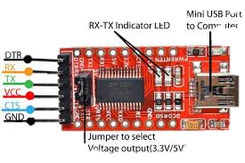 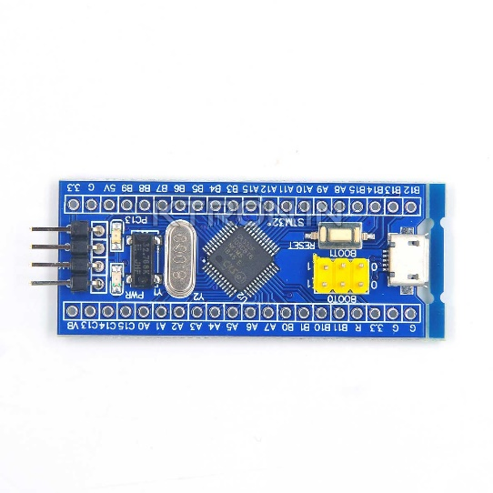

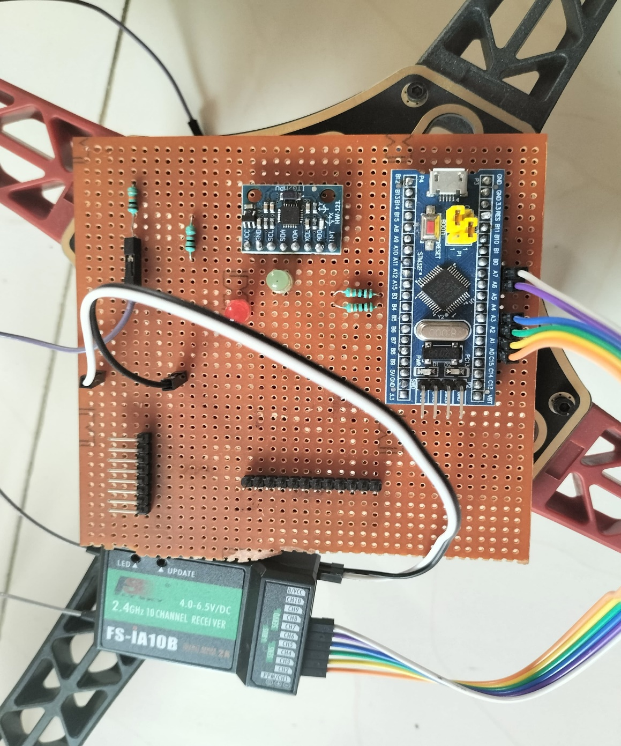

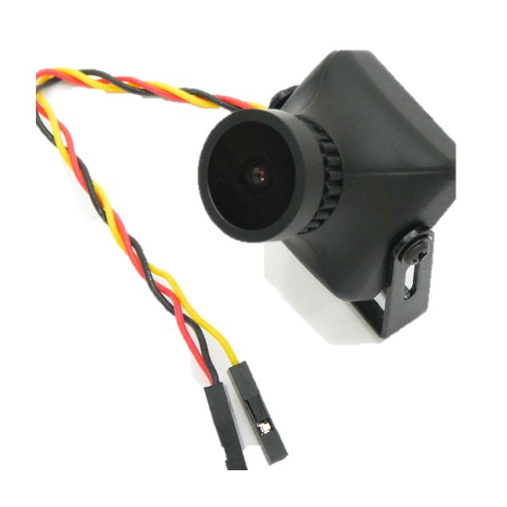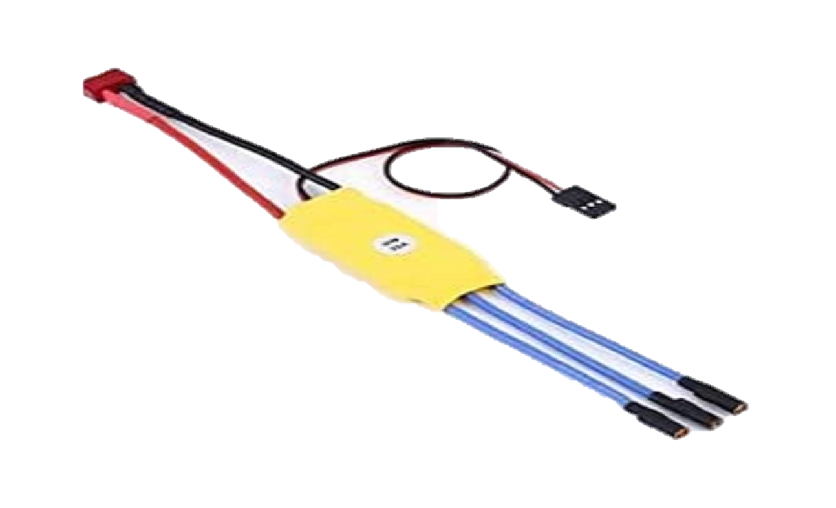

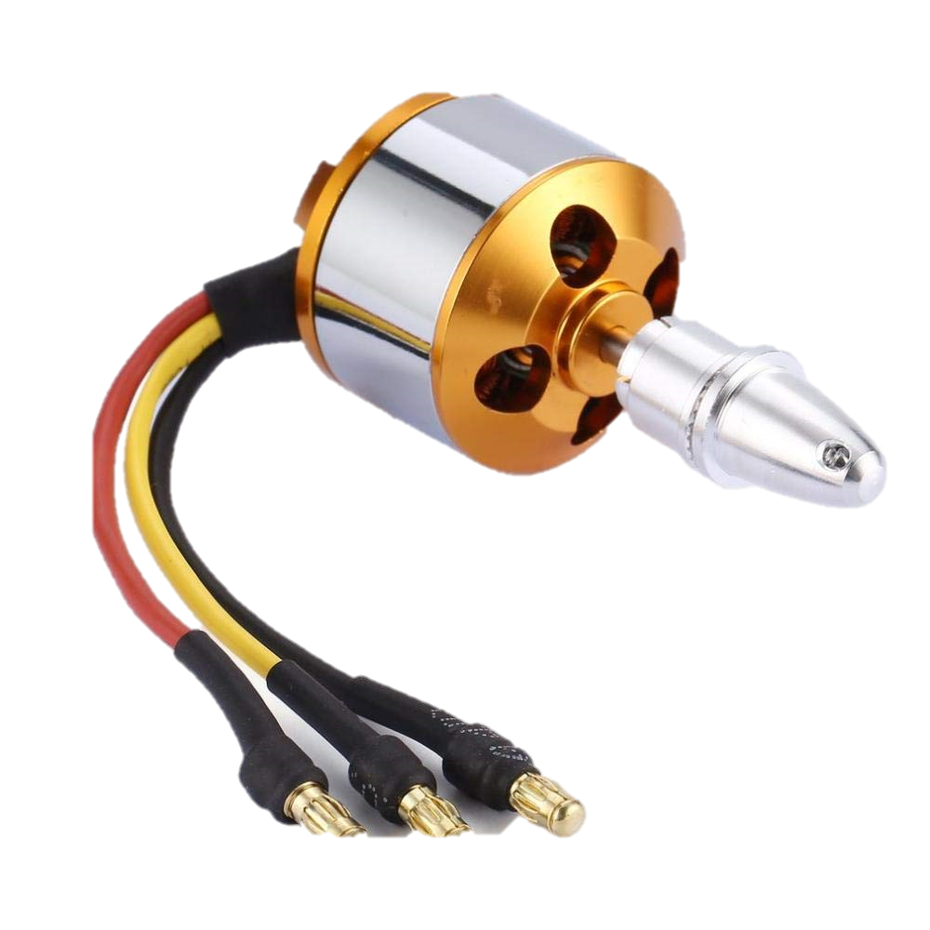

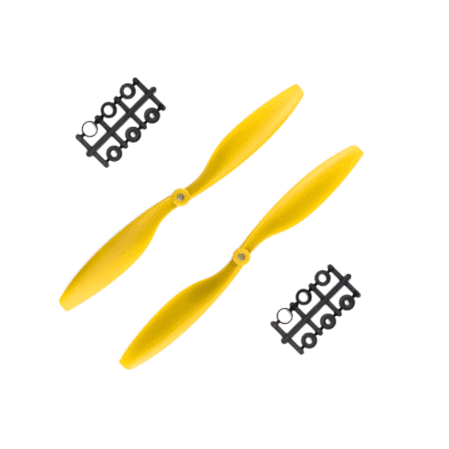

1. **Circuit Diagram:**

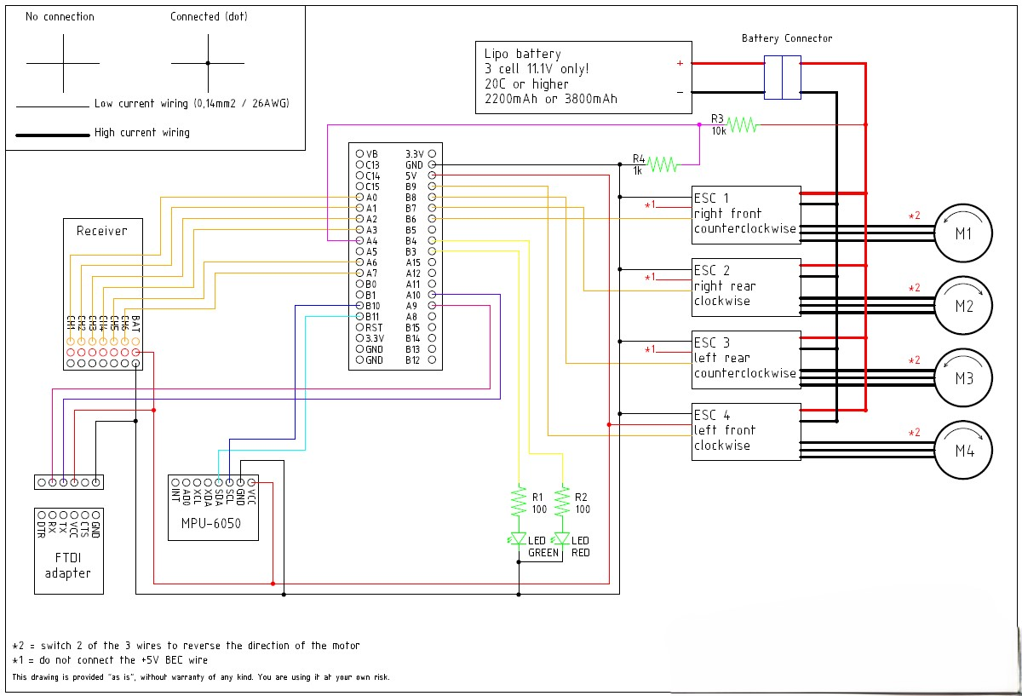

1. **Results:**

The implementation of the "Medicines On the Move (MOM): Delivery Drone" project has yielded significant positive outcomes across various dimensions of healthcare delivery:

Improvement in Delivery Efficiency:

The introduction of delivery drones has led to a notable improvement in the efficiency of medicine delivery operations. By bypassing traditional transportation constraints and utilizing direct aerial routes, MOM has streamlined the delivery process, resulting in faster and more reliable distribution of essential medicines to remote or inaccessible areas.

Reduction in Treatment Delays:

MOM has effectively reduced treatment delays by overcoming geographical barriers and infrastructure limitations. Patients residing in remote regions or areas affected by natural disasters now receive timely access to life-saving medicines, thereby minimizing the risk of complications and improving overall health outcomes.

Improved Disease Management:

The timely delivery of medicines facilitated by MOM has contributed to enhanced disease management among populations in underserved areas. Patients with chronic conditions or acute medical needs can now receive prompt and uninterrupted access to medication, leading to better disease control, symptom management, and overall quality of life.

Cost-Effective and Scalable Solution:

In addition to its efficacy, MOM offers a cost-effective and scalable solution for healthcare delivery. Compared to traditional transportation methods, which may incur higher costs and resource utilization, delivery drones present a more efficient and economical alternative. Moreover, the scalability of drone technology enables the expansion of delivery services to reach larger populations and address evolving healthcare needs effectively.

Overall, the results of the MOM project demonstrate its effectiveness in improving healthcare accessibility, reducing treatment delays, enhancing disease management, and offering a cost-effective and scalable solution for medicine delivery. These outcomes underscore the transformative impact of drone technology in revolutionizing healthcare logistics and advancing global health initiatives.

1. **Timeline**

|  |  |  |
| --- | --- | --- |
| **Phases** | **Task Description** | **Dates** |
| Phase 1 | Defining the problem statement | 8 Feb, 2024 |
| Phase 2 | Define project scope and goals | 15 Feb, 2024 |
| Phase 3 | Submitting component requirement | 17 Feb, 2024 |
| Phase 4 | Synopsis submission of the project | 06 March, 2024 |
| Phase 5 | Component Assignment | 01 April, 2024 |
| Phase 6 | Presentation | 19 April, 2024 |
| Phase 7 | Demonstration | 03 May, 2024 |

1. **References**

1. STM32F103C8T6 Data Sheet

2. All sensor Datasheets

3. Online Communities and Forums:

DIY Drones (https://diydrones.com/)

Quadcopter Forum (https://quadcopterforum.com/)

4. Online Tutorials and Guides:

Instructables (https://www.instructables.com/)

Flite Test (https://www.flitetest.com/)

5. Safety Resources:

FAA’s “now Before You Fly” Campaign (https://www.knowbeforeyoufly.org/)

1. **Conclusion**:

The "Medicines On the Move (MOM): Delivery Drone" project represents a significant milestone in the realm of healthcare logistics, showcasing the transformative potential of drone technology in improving access to essential medicines. Through the deployment of delivery drones, MOM has successfully addressed longstanding challenges associated with traditional medicine delivery methods, including geographical barriers, infrastructure limitations, and treatment delays.

The project has demonstrated tangible improvements in delivery efficiency, treatment timeliness, disease management, and cost-effectiveness. By streamlining the delivery process and providing a reliable means of transporting medicines to remote or underserved areas, MOM has emerged as a game-changer in the healthcare field, offering hope for better health outcomes and quality of life for millions of individuals worldwide.

Looking ahead, the success of MOM underscores the importance of continued innovation and investment in drone technology for healthcare applications. As the project lays the groundwork for future advancements in healthcare delivery, it is imperative to further explore and harness the potential of drones in addressing complex healthcare challenges and improving access to healthcare services for vulnerable populations.

In conclusion, the MOM project stands as a testament to the power of innovation and collaboration in driving positive change in healthcare delivery. By leveraging the capabilities of delivery drones, we can overcome barriers, enhance accessibility, and ultimately, save lives. As we embrace the opportunities presented by drone technology, let us continue to work towards a future where healthcare is accessible to all, regardless of geographical location or socioeconomic status.

1. **Picture Gallery:**

