SMART LIBRARY
MANAGEMENT PLATFORM
GitHub Repository: https://github.com/adityapaithankar25uml-debug/DevOps-Assignments
Detailed DevOps Project Report

Student Name | Aditya Viresh Paithankar
Programme | B.Tech – Computer Science and Engineering (AI & ML)
Year | Second Year
University | Sanjivani University, Kopargaon
Project | Smart Library Management Platform
Repository | https://github.com/adityapaithankar25uml-debug/DevOps-Assignments
Project Folder | Assignment-Unit-4-Smart-Library
Live Application | http://13.235.33.235/
Health Endpoint | http://13.235.33.235/health
Prepared as a practical record of the project implementation, deployment, and verification.

Abstract
The Smart Library Management Platform is a web-based application for maintaining a small library collection. It provides a dashboard, book search and listing, adding books, and borrowing/returning actions. The application is implemented with Python Flask and SQLite, packaged in Docker, served through Gunicorn, and exposed publicly through Nginx on an AWS EC2 instance. Terraform is used to define and provision the AWS infrastructure, while Ansible automates server configuration and application deployment. A scheduled backup script creates verified SQLite database backups and uploads them to Amazon S3. S3 bucket versioning, server-side encryption, and public access blocking were checked during implementation.

1. Objectives
- Build a working library management web application with persistent book data.
- Containerize the Flask application using Docker and run it as a non-root application user.
- Provision the required AWS network, security group, EC2 instance, and S3 backup bucket using Terraform.
- Automate server preparation, application deployment, and Nginx configuration with Ansible.
- Expose the application over HTTP through an Nginx reverse proxy while keeping the application port bound to localhost.
- Schedule database backups and verify that backup files are uploaded to Amazon S3.
- Validate the live application and publish the source code and documentation to GitHub.

2. Tools and Technologies
Technology | Purpose
Python / Flask | Application routes and web interface integration
SQLite | Persistent storage for book records
HTML / CSS | Responsive library dashboard and collection interface
Docker | Container image and runtime isolation
Gunicorn | WSGI application server inside the container
Nginx | Public HTTP entry point and reverse proxy
AWS EC2 | Cloud virtual machine hosting the application
Amazon S3 | Remote storage for database backups
Terraform | Infrastructure as code for AWS resources
Ansible | Repeatable host setup and deployment automation
Ubuntu Linux | Operating system for development and application hosts
Git / GitHub | Version control and source-code publication

3. Repository and Project Structure
The project was added to the existing DevOps-Assignments repository without removing the earlier assignment folders.
DevOps-Assignments/
├── Assignment-Docker-Python/
├── Assignment-Kubernetes/
├── Assignment-Maven-Java/
├── Assignment-Terraform-AWS/
├── Assignment-Unit-4-Smart-Library/
│ ├── app/
│ │ ├── app.py
│ │ ├── requirements.txt
│ │ ├── Dockerfile
│ │ ├── .dockerignore
│ │ ├── templates/index.html
│ │ └── static/css/style.css
│ ├── terraform/
│ │ ├── main.tf
│ │ ├── variables.tf
│ │ ├── outputs.tf
│ │ ├── versions.tf
│ │ ├── iam.tf
│ │ └── .terraform.lock.hcl
│ ├── ansible/
│ │ ├── deploy.yml
│ │ ├── deploy-app.yml
│ │ ├── inventory.example.ini
│ │ └── smart-library-nginx.conf
│ ├── docs/DEPLOYMENT.md
│ ├── screenshots/
│ └── README.md
├── .gitignore
└── Jenkinsfile
Security note: the live Ansible inventory, private SSH key, Terraform state files, tfvars files, plan files, local virtual environment, and local SQLite database are excluded from the Git commit. The repository contains an example inventory instead of machine-specific private connection details.

4. AWS Account and Region Preparation
AWS CLI v2 was installed on the development EC2 host and configured to use the ap-south-1 region. The AWS identity was checked with STS before provisioning. The account number and any access keys are intentionally not reproduced in this report. IAM permissions were configured for the deployment workflow. Credentials and private keys must not be committed to GitHub or copied into the application container.
aws --version
aws configure list
aws sts get-caller-identity
The commands above are verification examples; they should be run only in an authenticated shell with the intended AWS profile.

5. Provisioning AWS Infrastructure with Terraform
Terraform configuration was organized in the terraform/ directory. The configuration uses the AWS provider and variables for region, project settings, AMI, instance type, and SSH access CIDR. Terraform formatting and validation were run successfully before the repository was pushed.

5.1 Resources provisioned
- VPC with CIDR 10.20.0.0/16.
- Public subnet with CIDR 10.20.1.0/24.
- Internet gateway and public route table with subnet association.
- Security group allowing HTTP on port 80 and SSH on port 22 restricted to the configured allowed CIDR.
- Ubuntu EC2 application instance (instance type configured as t3.micro), with encrypted gp3 root storage and IMDSv2 required.
- Amazon S3 backup bucket with versioning, server-side encryption (AES256), and all S3 Block Public Access settings enabled.

5.2 Terraform verification
cd Assignment-Unit-4-Smart-Library/terraform
terraform fmt -check
terraform validate
terraform output
Observed verification: `terraform validate` returned “Success! The configuration is valid.” The deployed application infrastructure included VPC vpc-06491ade200cfd511, subnet subnet-0c106ad815e402a8f, security group sg-024010725470b4ee6, and EC2 instance i-0a9264dc192417631 during the deployment. The application instance was later reachable at the current public endpoint documented on the cover. Public IPs can change if an instance is replaced, so the live URL should be checked before submission.
Important: `terraform plan` previews changes; `terraform apply` creates or changes resources. Terraform state and plan files may contain sensitive infrastructure data and were excluded from version control.

6. Application Development
The Flask application is stored under app/. It uses SQLite for persistence and initializes sample records when the database is first created. The interface includes a dashboard with total, available, and borrowed counts, a searchable book collection, a form to add a book, and actions to borrow or return a book. A `/health` route provides a lightweight health response.

6.1 Application dependencies
Flask>=3,<4
gunicorn>=22,<24

6.2 Health route
GET /health
Response:
{"status":"healthy"}
The application uses the DATA_DIR environment variable (defaulting to a data directory) so the SQLite database can be stored in a persistent host directory mounted into the container.

7. Containerization with Docker
The Dockerfile uses the python:3.12-slim base image, installs requirements, creates a dedicated non-root appuser, sets DATA_DIR=/data, exposes container port 5000, and starts Gunicorn with two workers. The application container is named `smart-library-app` and the image tag used is `smart-library:1.0`. Port 5000 is bound to 127.0.0.1 on the host so external traffic reaches the application through Nginx rather than connecting directly to Gunicorn.
# Verification commands on the application EC2 instance
sudo docker ps
curl -sS --max-time 10 http://127.0.0.1:5000/health
Observed result: the `smart-library-app` container was Up and the direct health request returned `{"status":"healthy"}`. The SQLite data directory was assigned to UID/GID 10001 to permit the non-root container user to write persistent data.

8. Automated Server Configuration and Deployment with Ansible
Ansible playbooks are stored in ansible/. The base playbook installs and starts the required services, including Docker and Nginx, and prepares the application/data directories. The application playbook synchronizes the application source to the target, builds the Docker image, replaces the application container, installs the Nginx site configuration, validates the Nginx configuration, and checks the application health endpoint.
# Example syntax; use a local inventory file that is not committed
ansible -i ansible/inventory.ini smart_library -m ping
ansible-playbook -i ansible/inventory.ini ansible/deploy.yml
ansible-playbook -i ansible/inventory.ini ansible/deploy-app.yml
The repository includes `ansible/inventory.example.ini` as a template. The working inventory with the real host address and private-key path is intentionally ignored by Git. Ansible deployment required a permission correction on the persistent data directory so that the container's non-root user could initialize and update the SQLite database.

9. Nginx Reverse Proxy and Public Access
Nginx listens on port 80 and proxies incoming requests to http://127.0.0.1:5000. Forwarded headers preserve the original host, client IP, forwarding chain, and scheme. The default Nginx site was disabled so that the Smart Library site configuration handles requests. The Nginx configuration was tested and reloaded after changes.
# On the application EC2 instance
sudo nginx -t
sudo systemctl reload nginx
curl -I --max-time 10 http://127.0.0.1/
curl -sS --max-time 10 http://127.0.0.1/health
Observed public verification from the development host and browser: the homepage returned HTTP 200 with the Smart Library dashboard, and the public `/health` endpoint returned `{"status":"healthy"}`. The browser displayed the library dashboard and book collection at the public URL. The endpoint uses HTTP rather than HTTPS; a production deployment should configure TLS.

10. Automated SQLite Backups to Amazon S3
A backup script at `/usr/local/bin/smart-library-backup.sh` was installed on the application instance. A cron entry runs it every 10 minutes. The script creates a timestamped SQLite backup under `/opt/smart-library/backups/`, verifies the database backup, and uploads it to the S3 bucket under the `backups/` prefix. The log is written to `/var/log/smart-library-backup.log`.
# Verification commands on the application EC2 instance
sudo systemctl is-active cron
sudo cat /etc/cron.d/smart-library-backup
sudo tail -n 20 /var/log/smart-library-backup.log
# S3 listing from an AWS-authenticated shell
aws s3 ls s3://smart-library-backups-acfc2463/backups/
Observed result: the cron service was active, the log showed repeated “SQLite backup verified” and “SUCCESS: Backup uploaded to S3” messages, and `aws s3 ls` listed timestamped .db backup objects. The bucket was checked for versioning, AES256 server-side encryption, and full public access blocking.
Restore operations should be performed cautiously: identify the correct backup, preserve the existing database, validate the backup, and only then replace the live database during a controlled maintenance window. The report does not claim a full production disaster-recovery exercise was performed.

11. Public Application Testing
Test | Expected / Observed result | Status
Open public homepage | HTTP 200; Smart Library dashboard rendered in Chrome | Passed
Open public health endpoint | {"status":"healthy"} | Passed
Inspect Docker runtime | `smart-library-app` container shown as Up | Passed
Terraform validation | Success! The configuration is valid. | Passed
Check scheduled backup | Cron active and successful uploads in log | Passed
List S3 backups | Timestamped .db backup objects returned | Passed
Review GitHub project | README, application, Terraform, Ansible and deployment guide visible | Passed

12. GitHub Version Control and Security Hygiene
The project was committed to the `main` branch of the existing repository using the commit message `feat: add Smart Library Management Platform`. The push to origin/main completed successfully. The staged file review and `git diff --cached --check` were run before the commit.
Repository URL: https://github.com/adityapaithankar25uml-debug/DevOps-Assignments
Project folder URL: https://github.com/adityapaithankar25uml-debug/DevOps-Assignments/tree/main/Assignment-Unit-4-Smart-Library
- Private SSH keys and .pem files are excluded.
- Terraform state, state backups, plan files, and tfvars files are excluded.
- The machine-specific Ansible inventory is excluded; an example inventory is committed.
- The local Python virtual environment, bytecode caches, and local SQLite data are excluded.
- AWS credentials must remain outside the repository.

13. Limitations and Further Improvements
- The public endpoint is HTTP-only; add HTTPS using a domain and a TLS certificate for production use.
- The current application is a single-instance deployment using SQLite; consider a managed database for higher concurrency and availability.
- Add automated application tests and a CI pipeline to run tests and validate Terraform on every change.
- Test a documented restore procedure periodically, not just backup creation and upload.
- Consider retention/lifecycle rules for old S3 backups and alerting for failed scheduled jobs.
- Restrict operational access further and review IAM policies for least privilege.

14. Conclusion
The Smart Library Management Platform was implemented and deployed as a cloud-hosted Flask application. Docker runs the application, Nginx provides the public HTTP entry point, Terraform defines the AWS infrastructure, and Ansible automates configuration and deployment. The live homepage and health endpoint were verified, Terraform validation succeeded, and scheduled SQLite backups were observed uploading to an encrypted, versioned S3 bucket with public access blocked. The source code and deployment documentation were published to the existing DevOps-Assignments GitHub repository. Screenshots may be included in the screenshots/ directory as supplementary evidence for submission.

Appendix A — Key URLs
- GitHub repository: https://github.com/adityapaithankar25uml-debug/DevOps-Assignments
- Smart Library project folder: https://github.com/adityapaithankar25uml-debug/DevOps-Assignments/tree/main/Assignment-Unit-4-Smart-Library
- Public application: http://13.235.33.235/
- Public health endpoint: http://13.235.33.235/health

15. Screenshot Evidence — Project from Setup to Deployment
The following screenshots are arranged in the order of the implementation workflow, from AWS infrastructure preparation through deployment, public application testing, backup verification, and GitHub publication. They are actual screenshots captured during the project work. Some terminal screenshots show commands and their outputs; browser screenshots demonstrate the live application.
1. AWS EC2 instance and cloud environment
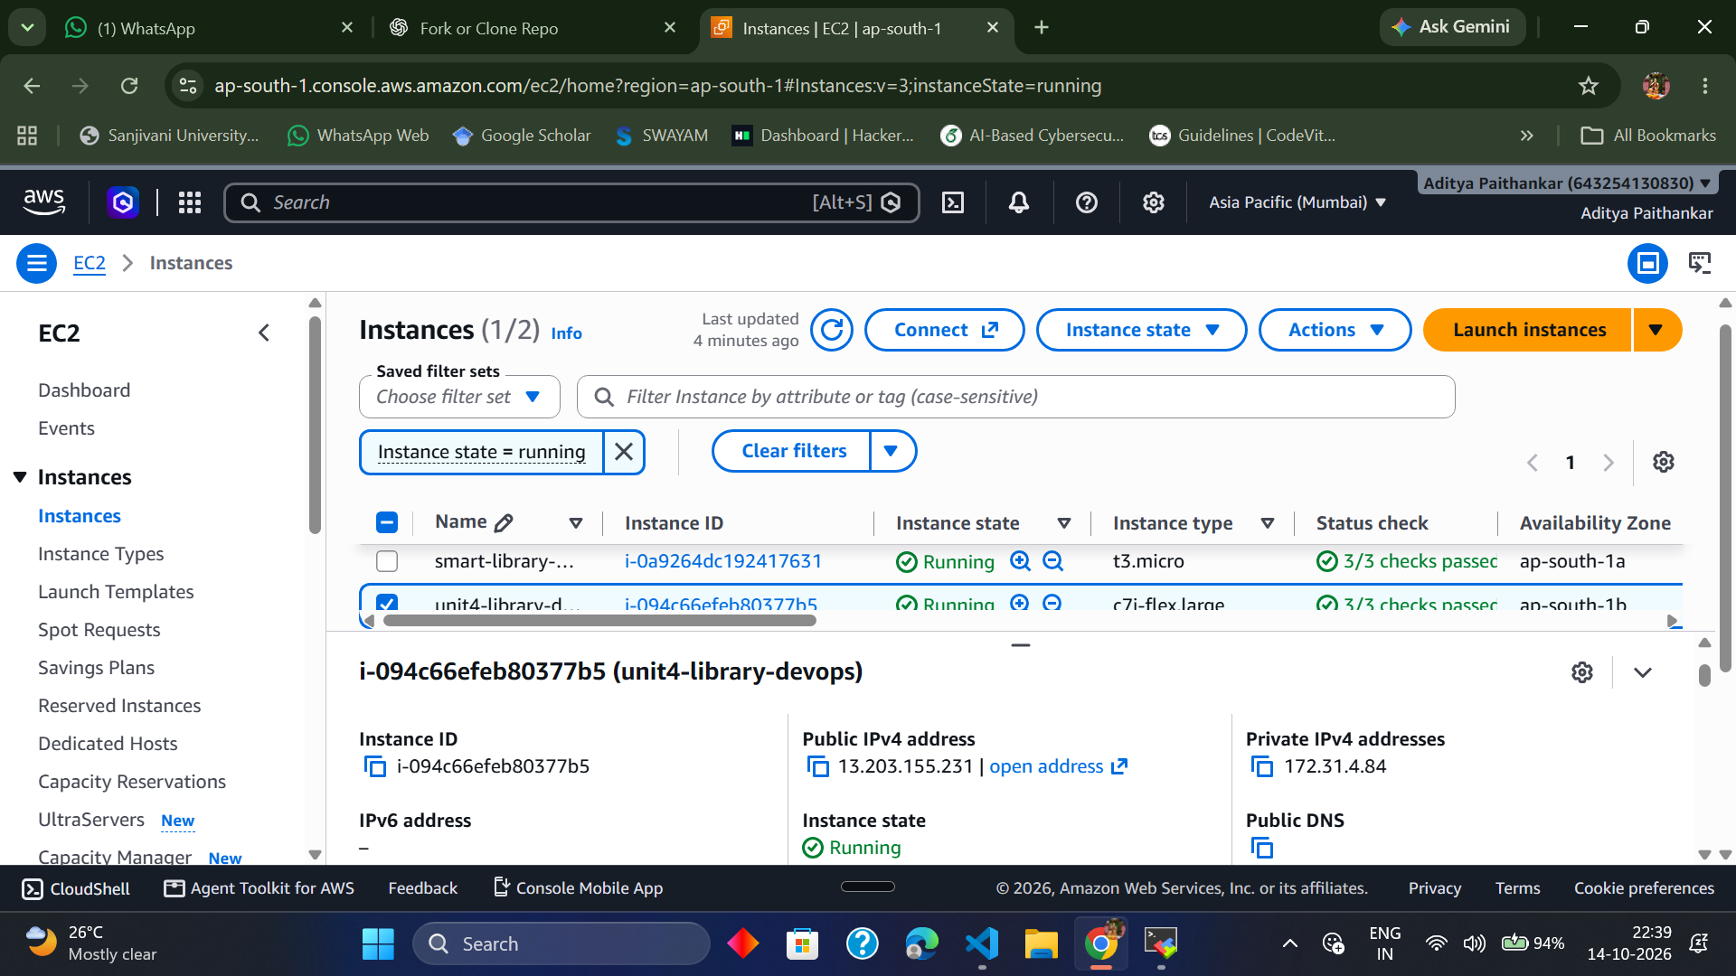
AWS EC2 console in the ap-south-1 region. This is the cloud environment used for the Smart Library deployment.
2. Security group configuration
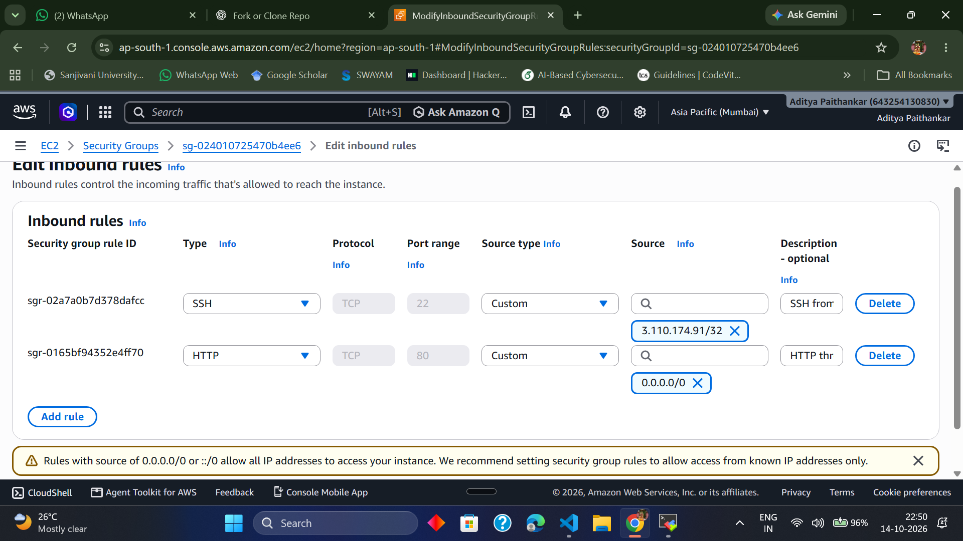
AWS security-group inbound-rule screen used to review network access for the deployed instance.
3. Terraform configuration and validation
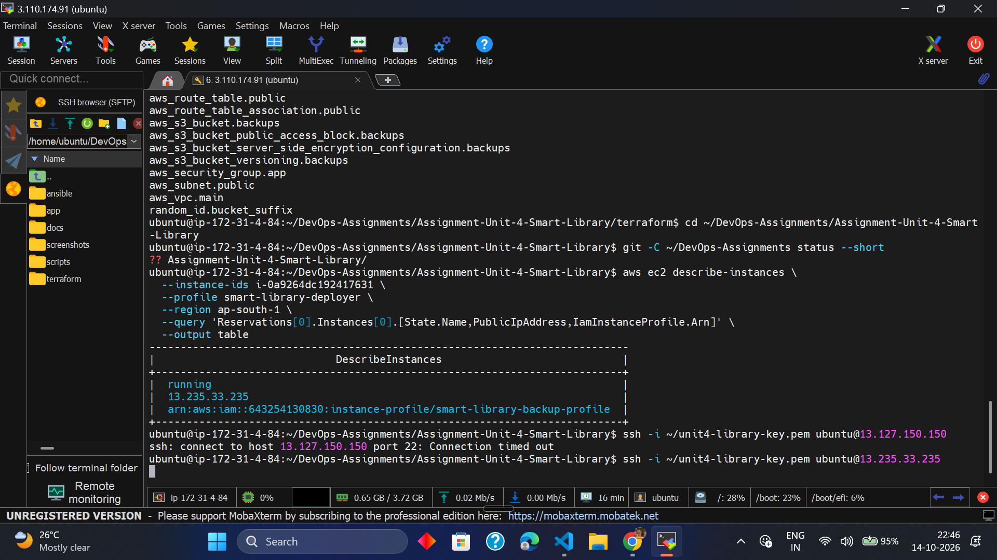
Development terminal during the infrastructure-as-code workflow. Terraform configuration was formatted and validated; the final validation result is recorded in the report.
4. Application deployment and Docker verification
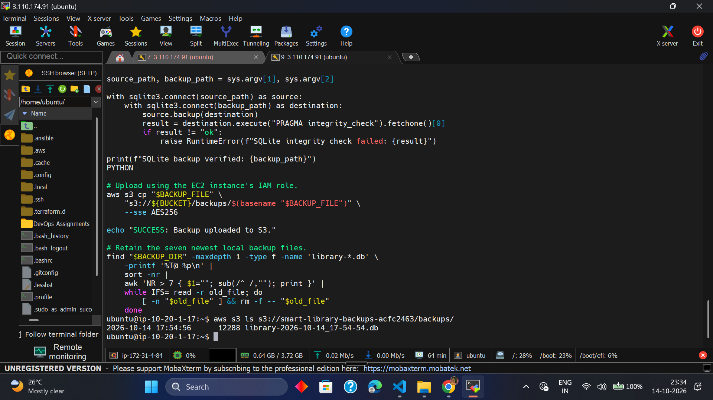
Terminal evidence from the deployment workflow, including application/container checks.
5. Public Smart Library dashboard
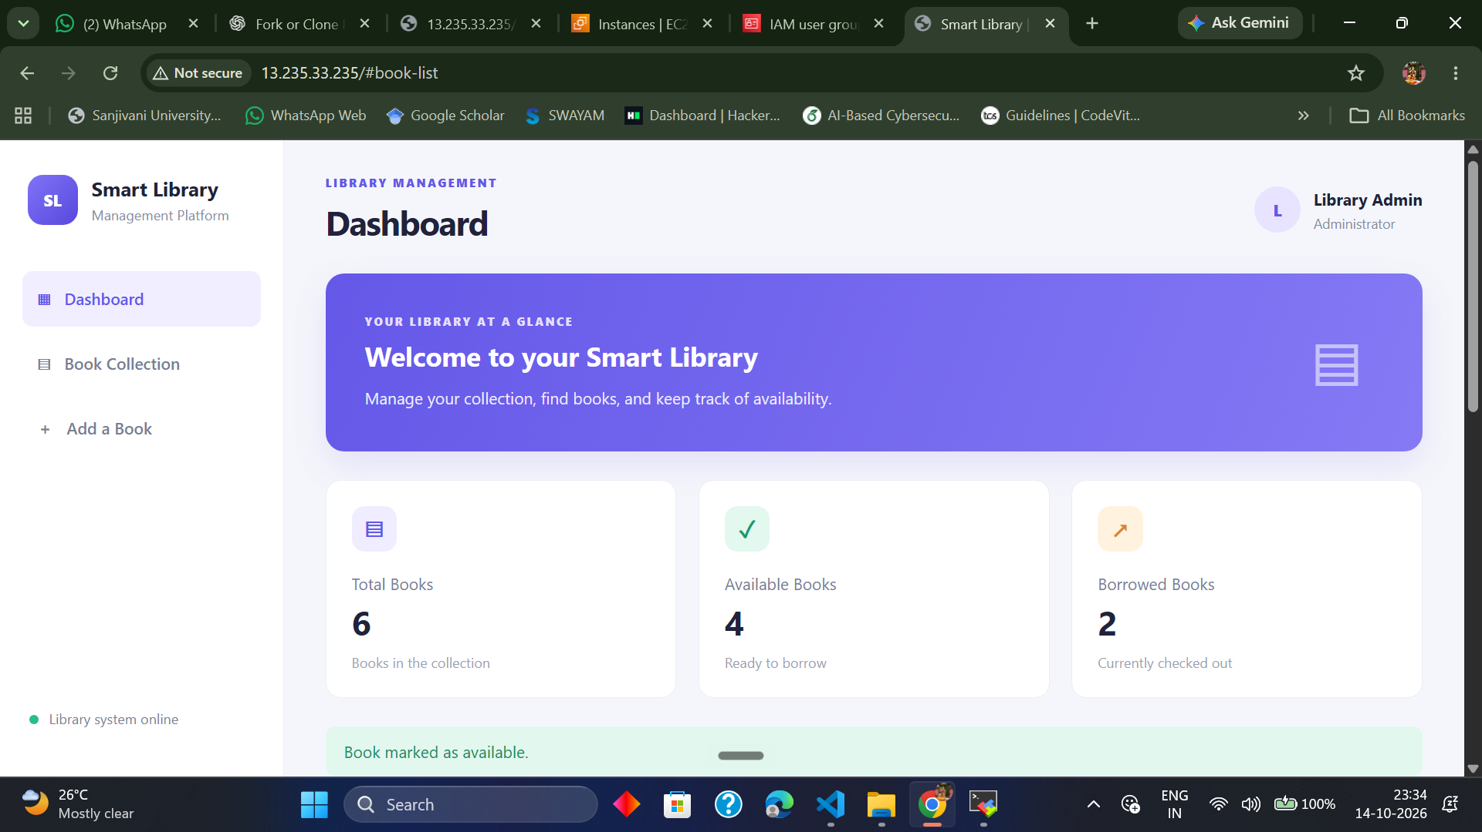
The deployed public web application opened in a browser. The dashboard displays the library overview and total, available, and borrowed book counts.
6. Book collection and library actions
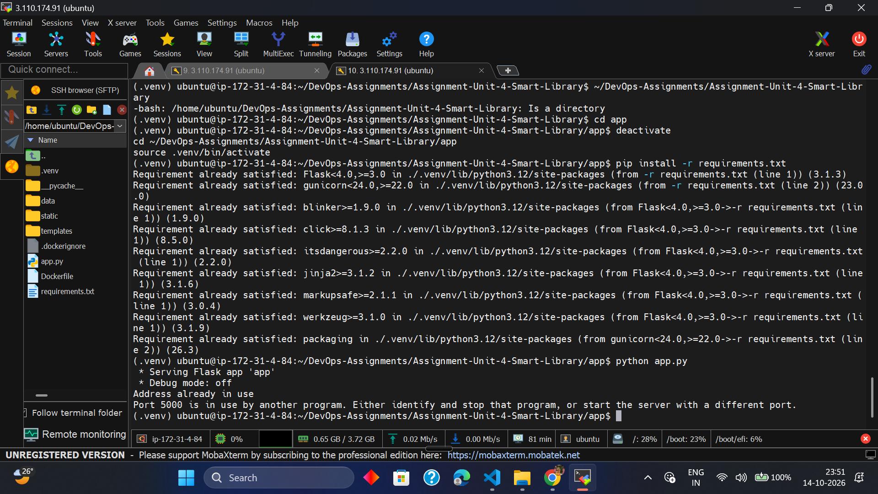
The Book Collection view shows book details, categories, availability, and Borrow/Return actions, alongside the Add a Book form.
7. Public health endpoint
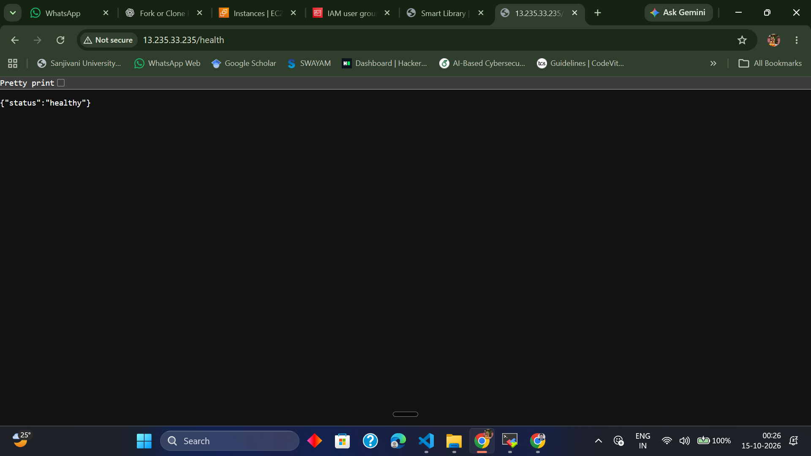
Browser verification of the public /health endpoint. The application returned {"status":"healthy"}.
8. Automated backup verification
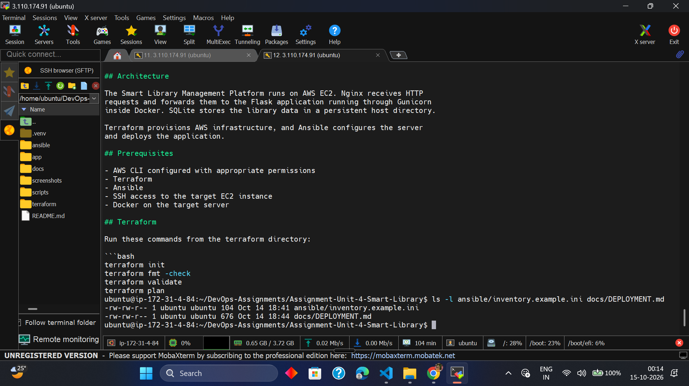
Terminal evidence from the backup workflow. Backup verification and S3 upload messages were recorded in the application server backup log.
9. GitHub project repository
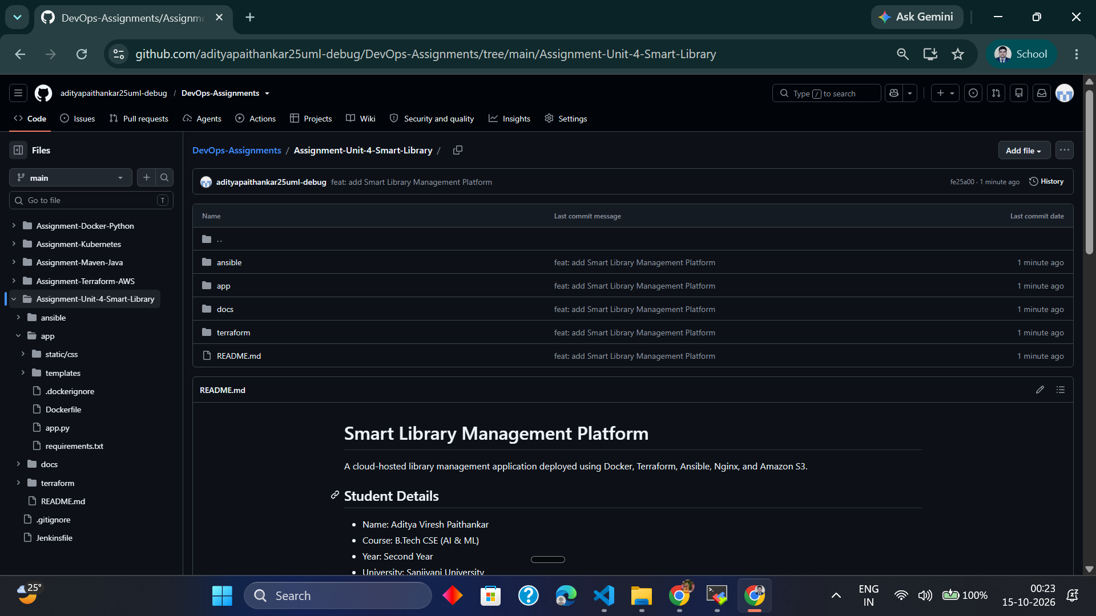
The Smart Library project folder published in the existing DevOps-Assignments GitHub repository.
10. Terraform files published to GitHub
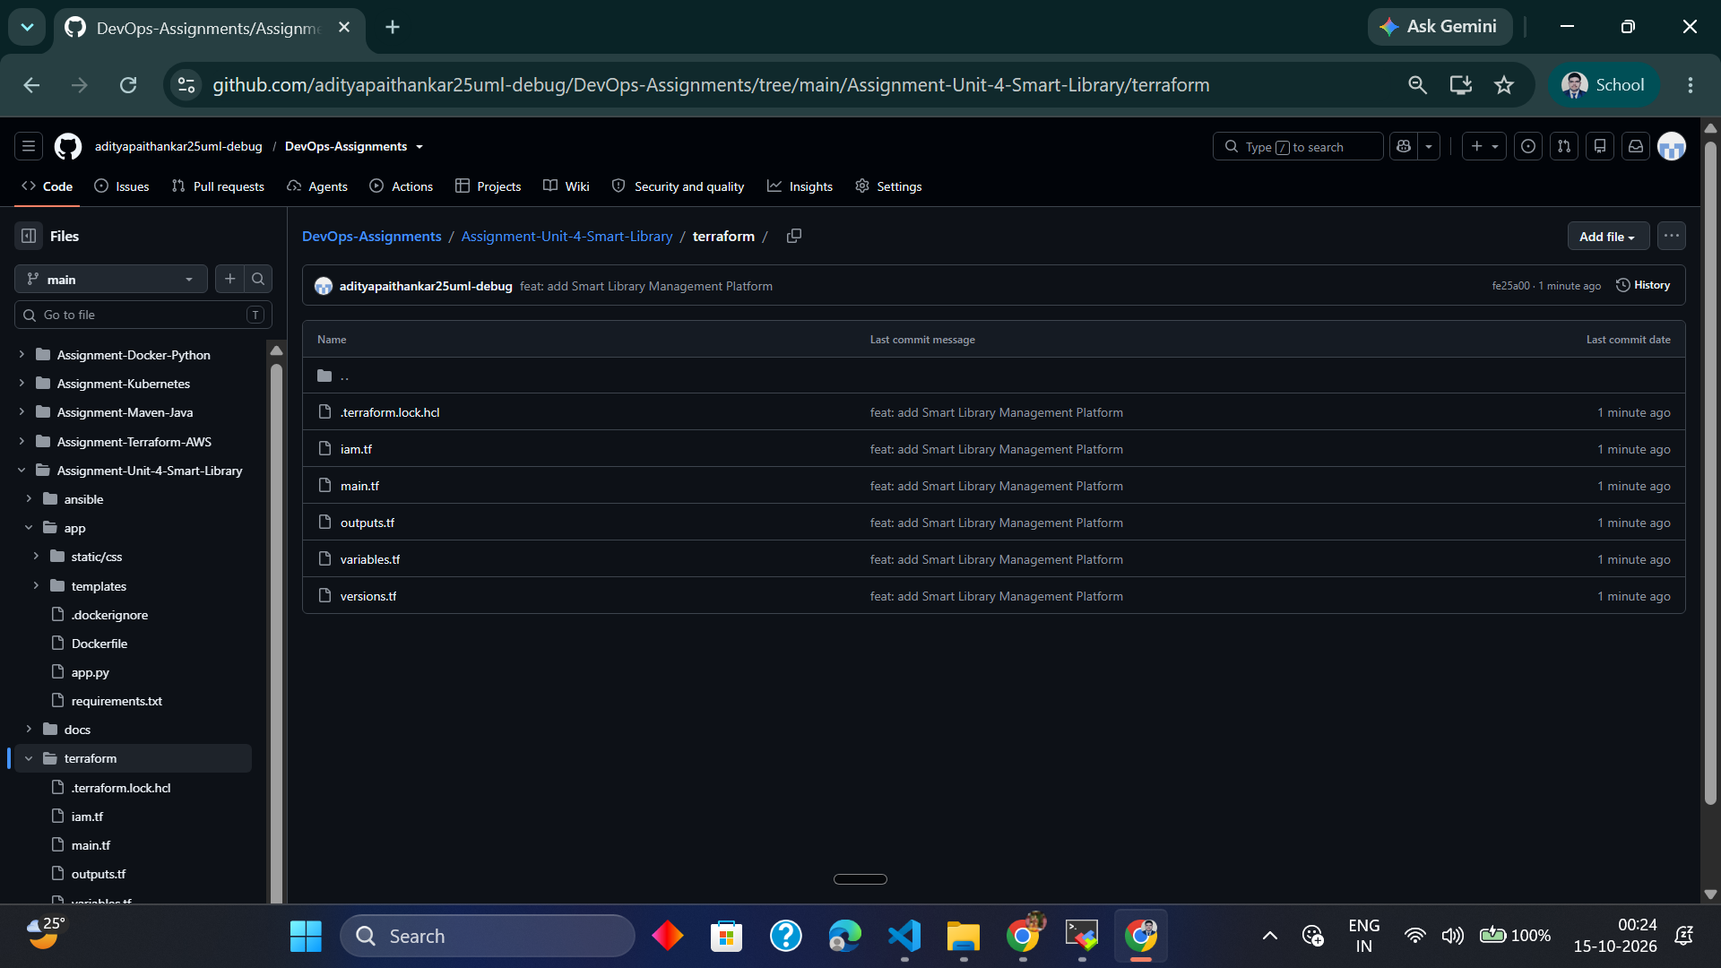
The repository's Terraform folder contains the infrastructure configuration files and provider lock file.
11. Deployment guide published to GitHub
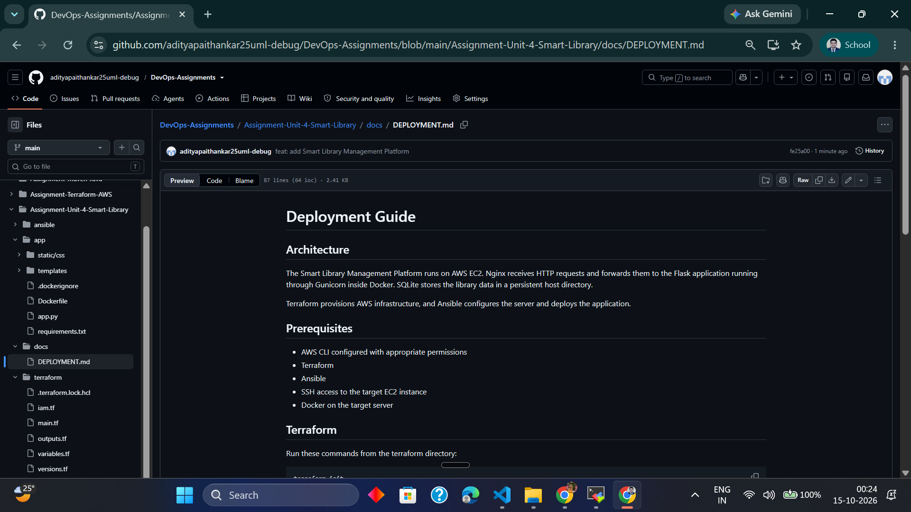
The deployment guide is visible in the GitHub repository, documenting the architecture and key deployment steps.
12. Application source published to GitHub
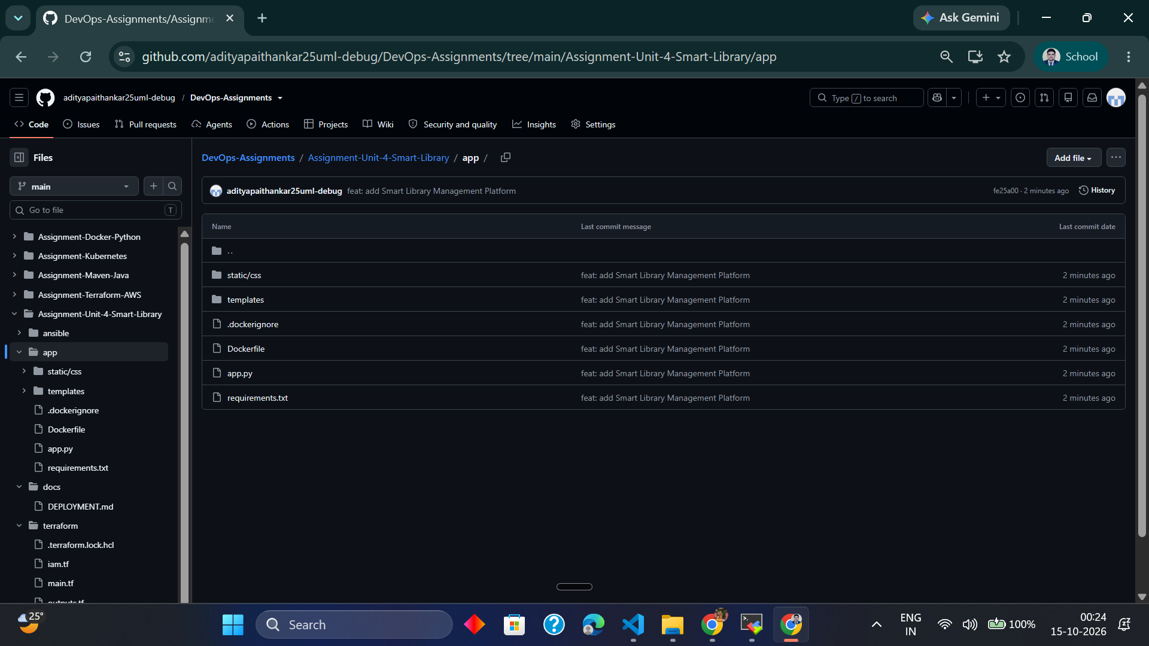
The application source folder, Dockerfile, requirements, static styles, and templates are published in the project repository.
13. Ansible deployment files published to GitHub
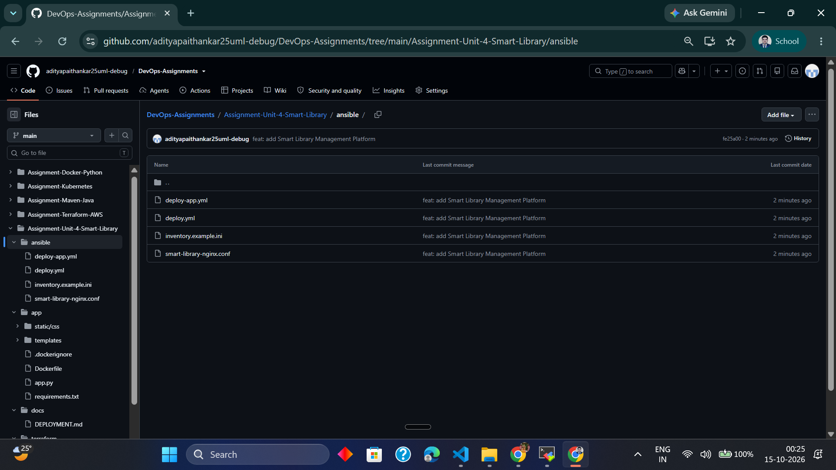
The Ansible folder contains deployment playbooks, an example inventory, and the Nginx reverse-proxy configuration.

Screenshot evidence notes
13 screenshot images were embedded in this report. The screenshots document key stages and final verification. For the final college submission, keep this document together with the GitHub repository link and ensure the public endpoint is still reachable at the time of evaluation.

