WEEK 3 REPORT
Advanced Data Analysis and Visualization in Logistics
DataCo Smart Supply Chain Dataset
Working draft — code screenshots added. Output screenshots and final interpretation will be inserted after the results are shared.

1. Project Definition
The purpose of this week's work is to explore logistics and delivery data using Python, summarize the main patterns, and communicate the results through suitable visualizations. The analysis focuses on actual and scheduled shipping duration, delivery-risk indicators, shipping modes, sales, order profit, and regional delivery performance.
The dataset contains order-item records, so the record count should not automatically be interpreted as the number of unique shipments. This is a descriptive analysis: observed relationships can highlight areas for further investigation, but they do not prove causation.

2. Dataset Overview and KPI Selection
The script loads DataCoSupplyChainDataset.csv with pandas using Latin-1 encoding, then inspects dimensions, columns, data types, missing values, duplicate rows, delivery-status counts, late-delivery-risk values, and shipping-mode counts.
- Days for shipping (real): recorded actual shipping duration.
- Days for shipment (scheduled): scheduled shipping duration.
- Order Item Quantity: quantity associated with an order-item record.
- Sales: sales value, not a direct measure of transportation cost.
- Order Item Discount: recorded discount value.
- Order Profit Per Order: order-level profit measure, not a direct measure of shipping cost.
The script derives Shipping_Delay_Days by subtracting scheduled shipping duration from actual shipping duration. Positive values indicate a longer-than-scheduled duration, zero indicates equal durations, and negative values indicate a shorter-than-scheduled duration. This derived measure should be interpreted alongside Delivery Status and Late_delivery_risk, because these fields may classify records differently.

3. Exploratory Data Analysis

3.1 Descriptive statistics
The code calculates count, mean, standard deviation, minimum, quartiles, and maximum for selected numerical fields. The exact output values and their interpretation will be added after the output screenshots are reviewed.

3.2 Shipping-time difference
The script calculates the difference between actual and scheduled shipping days and prints its average and frequency distribution. This helps distinguish records that took longer than planned from records that matched or beat the scheduled duration.

3.3 Shipping-mode comparison
The script groups records by shipping mode and calculates record count, average actual and scheduled duration, average sales, average order profit, and the percentage with Late_delivery_risk equal to 1. These are descriptive comparisons and do not prove that shipping mode alone caused an outcome.

3.4 Correlation analysis
A correlation matrix is calculated for selected numerical fields and shown as a heatmap. Correlation describes the direction and strength of a linear relationship; it does not establish causation.

4. Visualization Methods and Interpretation
- Histogram of actual shipping duration: shows the frequency of recorded shipping durations.
- Scatter plot of scheduled versus actual shipping duration: uses a random sample of up to 3,000 records to make the pattern easier to inspect.
- Bar chart of average actual shipping duration by shipping mode: compares average duration across service categories.
- Correlation heatmap: displays pairwise linear correlations between selected numerical variables.
- Bar chart of the ten regions with the highest recorded late-delivery-risk percentage: compares risk rates across the highest-ranked regions.
Chart-specific findings will be written after the output screenshots are reviewed; this draft does not assume any chart values or regional rankings.

5. Python Code Illustration
The following screenshots document the code used for dataset inspection, exploratory analysis, visualization, operational summaries, and exporting summary tables.

1. Dataset loading, inspection, and initial data-quality checks
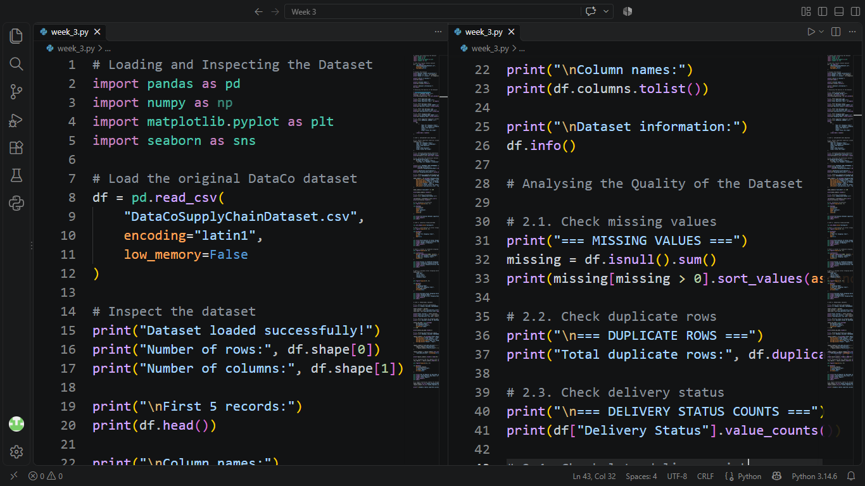

2. Delivery-risk checks, shipping-mode counts, and numerical summary
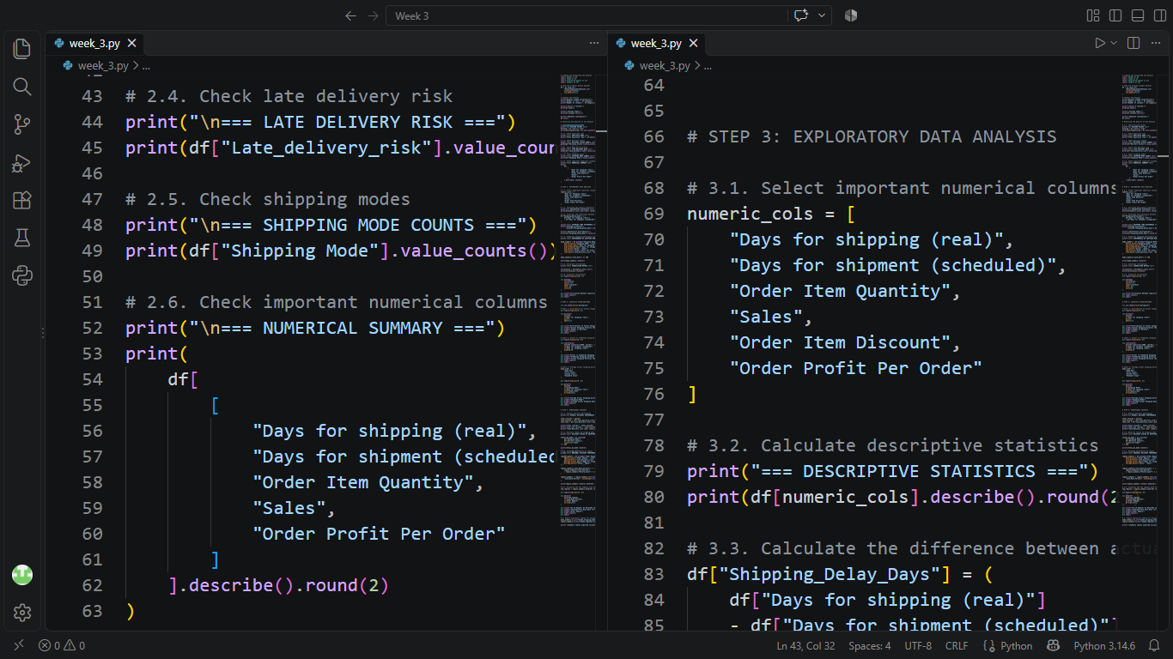

3. Exploratory analysis, shipping-mode summary, and correlations
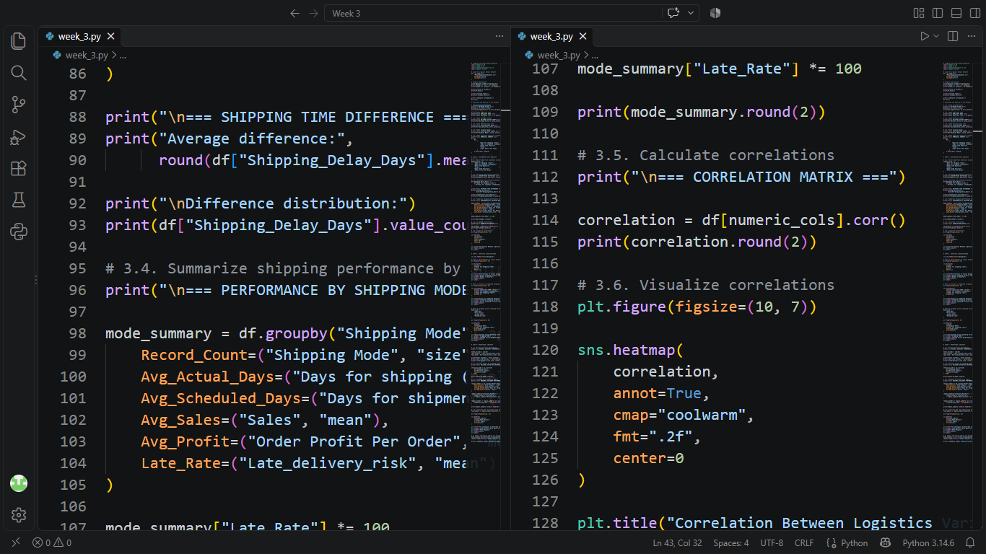

4. Shipping-duration distribution and actual-versus-scheduled plot
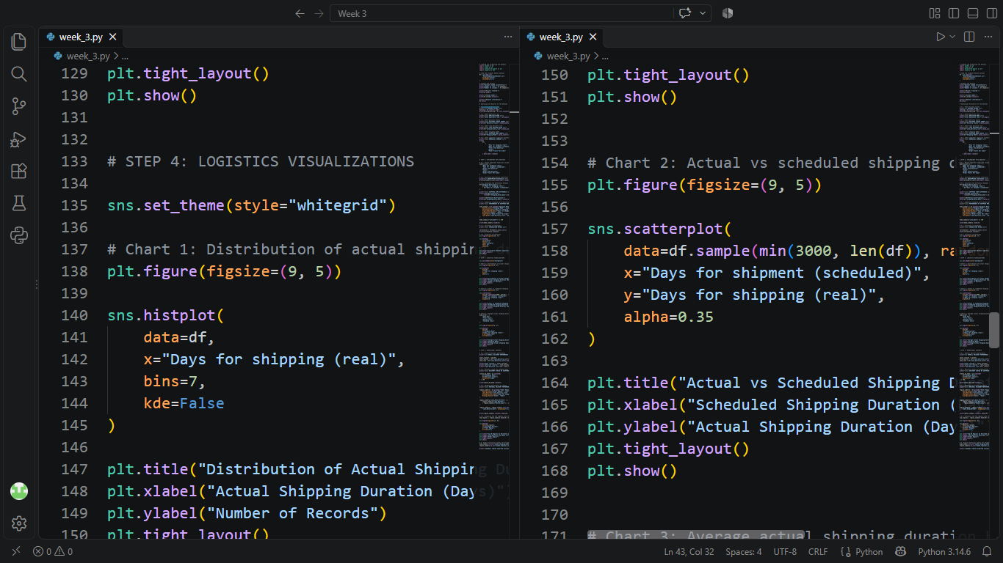

5. Average shipping duration by mode and operational-insights code
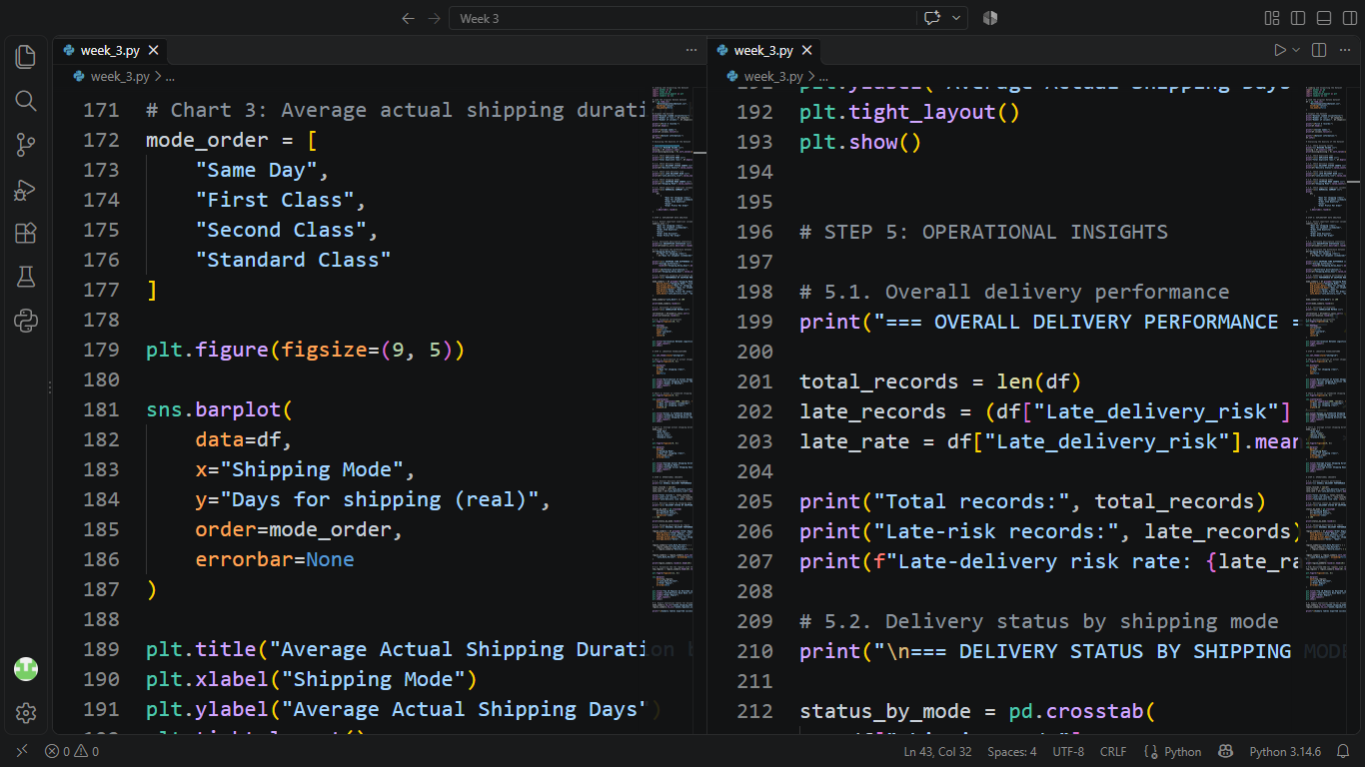

6. Delivery status by mode, regional analysis, and CSV export
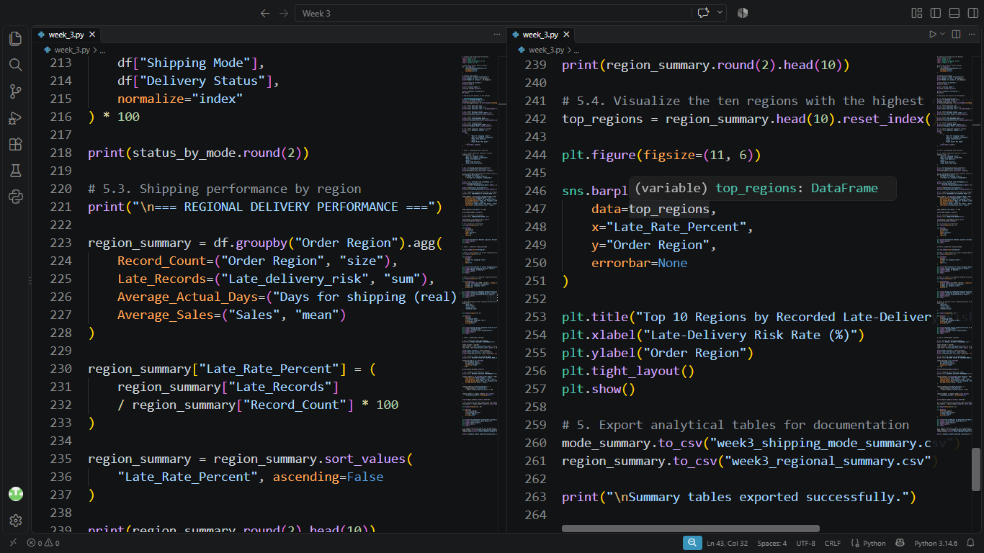

6. Findings and Recommendations
[Pending output screenshots.] This section will summarize the overall late-risk rate, shipping-mode differences, regional patterns, shipping-duration distribution, and relevant correlations. Recommendations will be limited to what the actual outputs support.
The selected fields do not include a clearly identified transportation-cost variable. Sales and order profit will therefore not be described as transportation costs. Order Item Quantity will be treated as an order-item quantity measure rather than confirmed shipment volume.

7. Final Thoughts
This week's workflow moves from dataset checks to descriptive analysis and visual presentation. The combination of summary statistics, grouped comparisons, correlations, and charts can make delivery patterns easier to understand. The report will be finalized once the output screenshots are added and the numerical findings are checked against them.

Appendix A. Output Screenshots to Add
- Descriptive statistics and shipping-time difference output.
- Shipping-mode summary and correlation heatmap.
- Histogram, scatter plot, and average shipping-duration chart.
- Overall delivery-performance output and delivery status by shipping mode.
- Regional summary table and top-10 regional chart.
- Confirmation that both summary CSV files exported successfully.

Appendix B. Python Output Screenshots
These screenshots record the outputs generated by the Week 3 Python script. They provide evidence for the dataset inspection, data-quality checks, descriptive statistics, shipping-mode comparisons, correlation matrix, regional summary, and successful export of summary tables.
Output 1: Dataset loaded successfully, with 180,519 rows and 53 columns; sample records and dataset information.
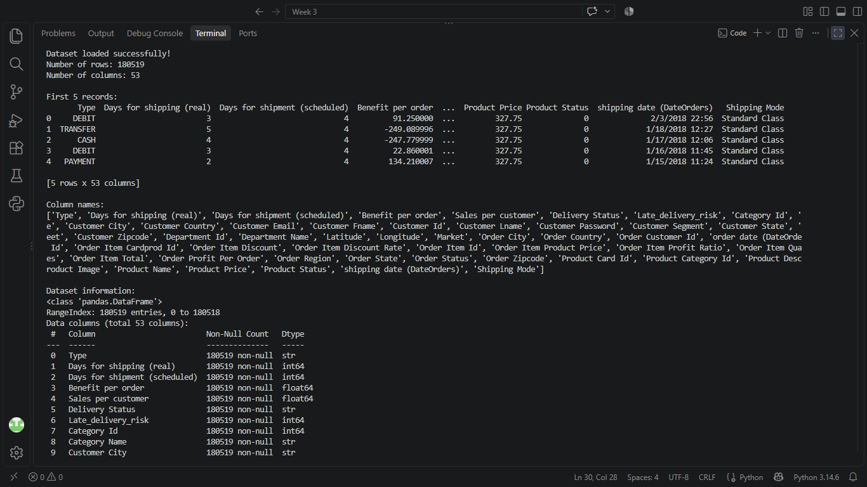
Output 2: Dataset column information and missing-value counts, duplicate-row check, delivery-status counts, late-risk counts, and shipping-mode counts.
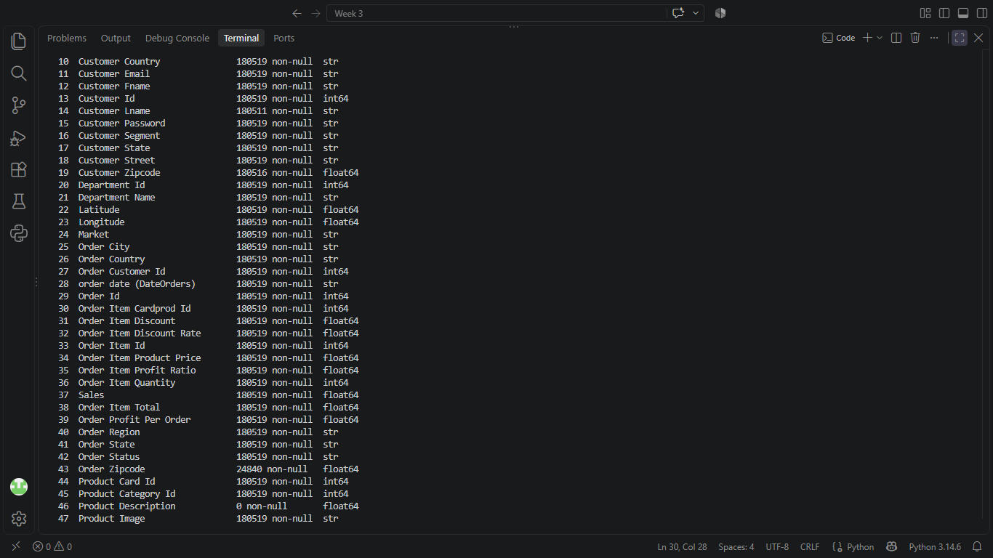

Output 3: Descriptive statistics and distribution of actual-minus-scheduled shipping duration.
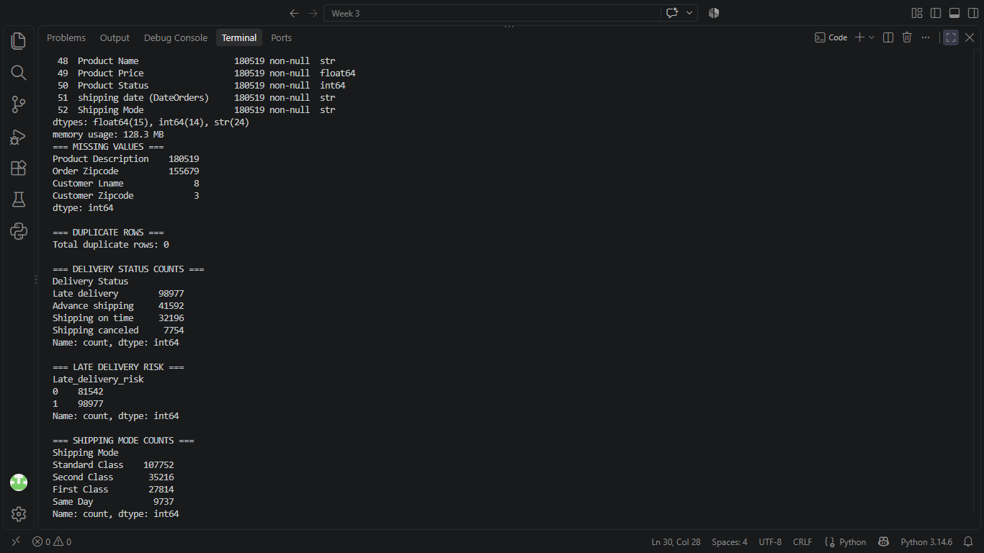

Output 4: Shipping-mode performance summary, correlation matrix, overall late-delivery-risk rate, and delivery status by shipping mode.
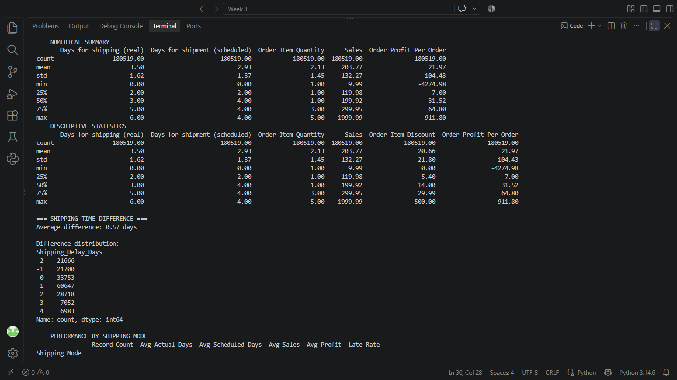

Output 5: Regional delivery-performance summary, including the ten highest late-risk percentages.
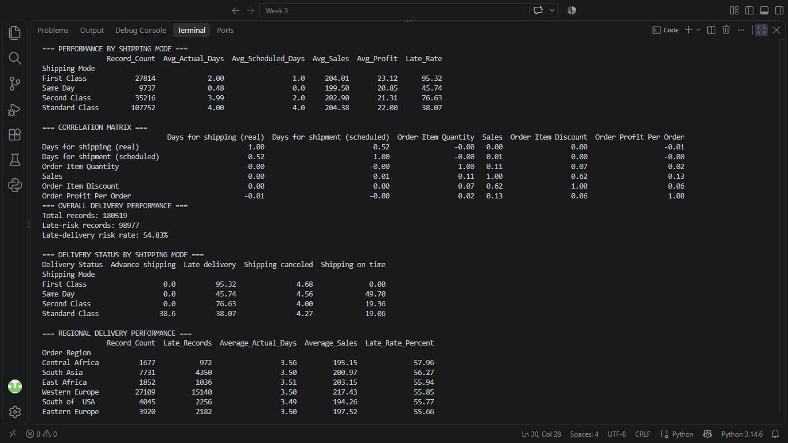

Output 6: Confirmation that the summary CSV files were exported successfully.
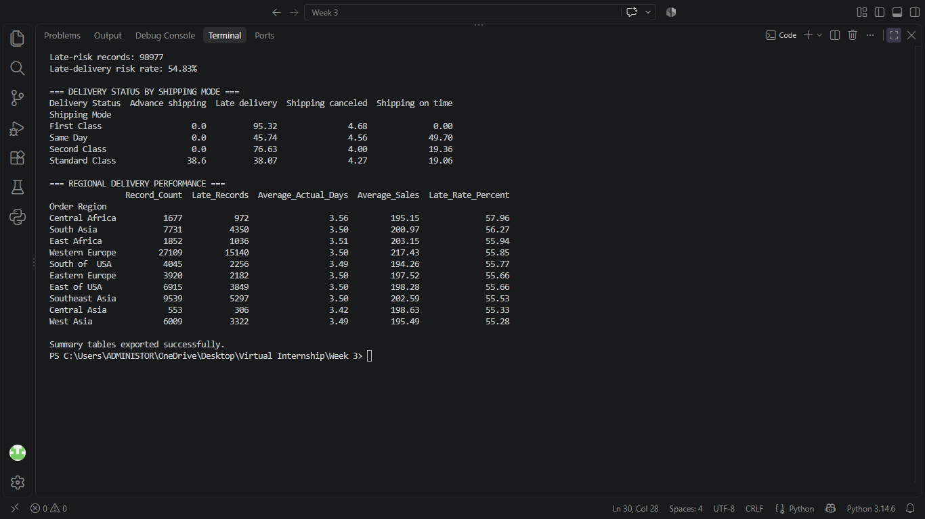

Charts:
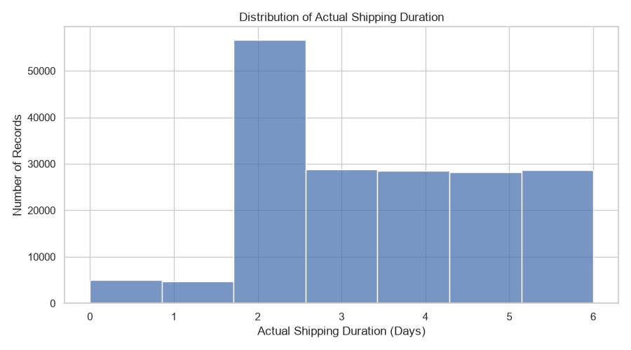
Figure 1: Distribution of Actual Shipping Duration

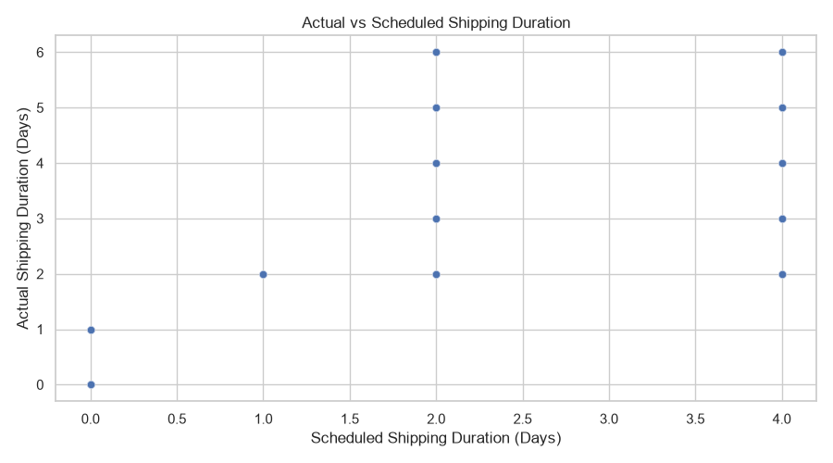
Figure 2: Actual vs Scheduled Shipping Duration

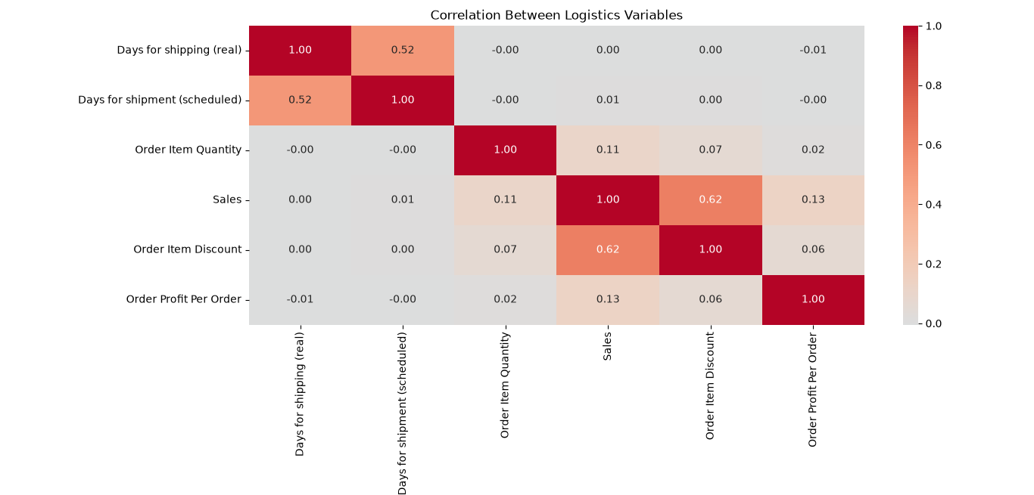
Figure 3: Correlation Between Logistics Variables

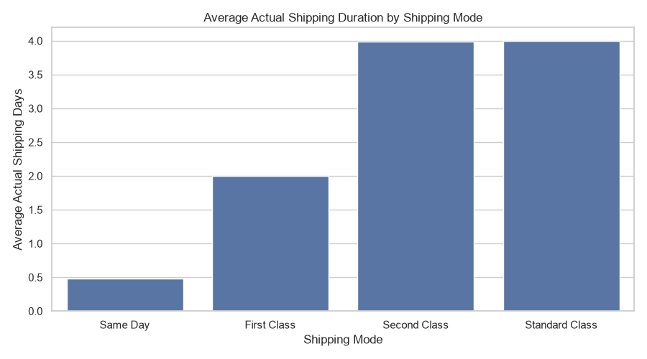
Figure 4: Average Actual Shipping Duration
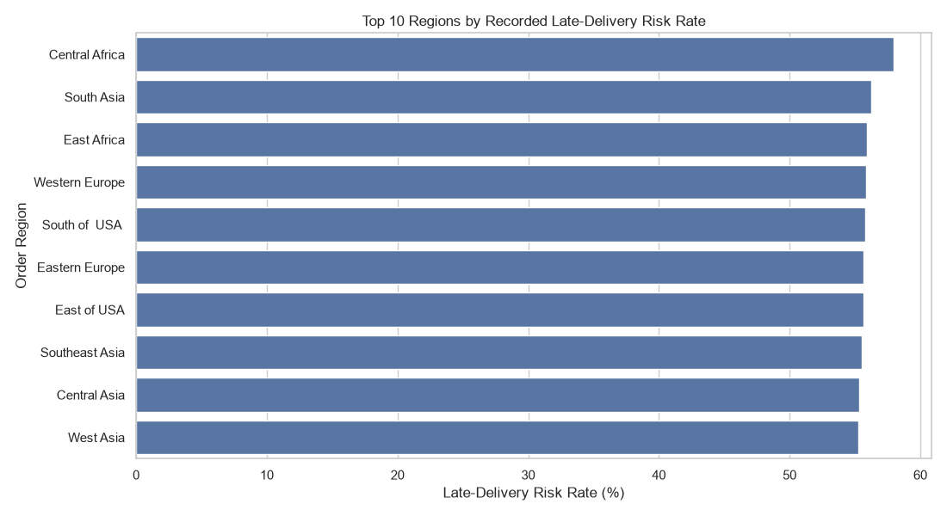
Figure 5: Top 10 Regions by Recorded Late-Delivery Risk Rate

Preliminary Findings from the Supplied Outputs
- The dataset loaded successfully and contains 180,519 records across 53 columns. The records should be treated as order-item records, not automatically as unique shipments.
- The duplicate-row check returned zero exact duplicate rows. Product Description is entirely missing (180,519 values), Order Zipcode has 155,679 missing values, Customer Lname has 8 missing values, and Customer Zipcode has 3 missing values. These fields should be handled according to the analysis purpose rather than filled without justification.
- The Delivery Status output shows 98,977 Late delivery records, 41,592 Advance shipping records, 32,196 Shipping on time records, and 7,754 Shipping canceled records.
- The Late_delivery_risk indicator is 1 for 98,977 records and 0 for 81,542 records. The overall late-delivery-risk rate printed by the script is 54.83%. This risk indicator is not identical to counting positive actual-minus-scheduled shipping-day differences.
- The average actual shipping duration is 3.50 days, compared with an average scheduled duration of 2.93 days. The mean actual-minus-scheduled difference is 0.57 days.
- By shipping mode, the recorded late-risk rates are First Class 95.32%, Second Class 76.63%, Same Day 45.74%, and Standard Class 38.07%. These are descriptive rates in this dataset and do not prove that shipping mode alone caused late delivery.
- The correlation matrix shows a moderate positive correlation between actual and scheduled shipping duration (0.52), and a stronger positive correlation between Sales and Order Item Discount (0.62). Sales and Order Profit Per Order have a weak positive correlation (0.13); actual shipping duration and Order Profit Per Order have a near-zero correlation (-0.01). Correlation does not establish causation.
- The regional table ranks Central Africa highest among the displayed ten regions at 57.96% late-delivery risk, followed by South Asia at 56.27% and East Africa at 55.94%. Regional rates should be considered alongside record counts, since region sizes differ.
- The terminal confirms that the summary tables were exported successfully. The selected variables do not include a clearly identified transportation-cost field, so Sales and Order Profit Per Order should not be described as transportation costs.
Note: Chart screenshots are still pending and will be added in the next revision. The visual interpretations and recommendations will be finalized after reviewing those charts.

