WEEK 4 REPORT
Predictive Modeling and Optimization in Logistics Systems
DataCo Smart Supply Chain Dataset
Completed report — Python code screenshots, terminal outputs, model evaluation results, and optimization recommendations included.

1. Problem Definition and Dataset Overview
The goal of this week's task is to build a predictive model in Python to estimate actual shipping duration and use the resulting error patterns and regional summaries to suggest practical logistics improvements. Continuing from Week 3, the script uses DataCoSupplyChainDataset.csv (180,519 rows and 53 columns) loaded with Latin-1 encoding. As noted in the previous report, rows in this file represent order-item records rather than unique shipments, so counts and averages should be read at the order-item level.
The target variable selected for forecasting is Days for shipping (real), which records the actual number of days taken to ship an order item. Across all 180,519 records, the target variable has a mean of 3.50 days, a standard deviation of 1.62 days, a minimum of 0 days, a median of 3.00 days (interquartile range from 2.00 to 5.00 days), and a maximum of 6.00 days.
In Step 4, the script inspects eight candidate columns alongside the target variable and checks them for missing values:
- Days for shipment (scheduled): planned shipping duration in days (int64, 0 missing values).
- Benefit per order: recorded benefit/profit per order (float64, 0 missing values).
- Sales per customer: sales amount associated with the customer order (float64, 0 missing values).
- Order Item Quantity: unit quantity for the order item (int64, 0 missing values).
- Order Item Product Price: listed product price for the item (float64, 0 missing values).
- Shipping Mode: service tier such as Standard Class, Second Class, First Class, or Same Day (str, 0 missing values).
- Market: broad geographic market grouping (str, 0 missing values).
- Order Region: specific geographic order region (str, 0 missing values).
In Step 5, the modeling input matrix X is constructed using seven features: four numerical features (Benefit per order, Sales per customer, Order Item Quantity, and Order Item Product Price) and three categorical features (Shipping Mode, Market, and Order Region). The dataset is then divided into an 80/20 train-test split using random_state=42, resulting in 144,415 training records and 36,104 testing records.

2. Model Selection and Implementation
A Random Forest Regressor (RandomForestRegressor from scikit-learn) was chosen for predicting actual shipping days. Random Forest is an ensemble tree-based method that averages predictions from multiple decision trees. It works well for tabular logistics data because it can capture non-linear relationships and interactions between categorical service tiers, geographic regions, and order values without assuming a strictly linear form.

2.1 Preprocessing pipeline
To keep data preparation consistent between training, testing, and cross-validation, the script uses a ColumnTransformer wrapped inside a scikit-learn Pipeline:
- Numerical preprocessing: SimpleImputer(strategy='median') is applied to the four numerical features to guard against any unexpected missing values during deployment.
- Categorical preprocessing: A sub-pipeline applies SimpleImputer(strategy='most_frequent') followed by OneHotEncoder(handle_unknown='ignore') to convert Shipping Mode, Market, and Order Region into binary indicator columns.

2.2 Model configuration
The RandomForestRegressor is configured with n_estimators=100 trees, max_depth=15 to limit tree complexity and reduce overfitting on the 144,415-row training set, random_state=42 for reproducibility, and n_jobs=-1 to run tree construction in parallel.

3. Model Evaluation and Cross-Validation

3.1 Test-set evaluation metrics
After fitting the pipeline on the training set (144,415 records), predictions were generated for the held-out test set (36,104 records) and evaluated with three standard regression metrics:
- Mean Absolute Error (MAE): 0.9846 days. On average, the model's predicted shipping duration differs from the recorded actual duration by just under one day.
- Root Mean Squared Error (RMSE): 1.2671 days. Because RMSE squares errors before averaging, its higher value relative to MAE reflects the presence of multi-day errors (up to 2.84 days) on certain Standard Class and Second Class records.
- R-squared (R²): 0.3910. The seven selected features explain 39.10% of the variance in actual shipping duration. This moderate R-squared is expected because shipping mode alone pins down much of the baseline duration, while the remaining day-to-day variation (such as whether a Standard Class order takes 2, 3, 4, 5, or 6 days) is not fully captured by item price, quantity, or broad region labels.

3.2 Three-fold cross-validation
To check whether test performance depends on a single random split, the script runs 3-fold cross-validation (KFold with n_splits=3, shuffle=True, random_state=42) across the full dataset using negative MAE scoring:
- Fold 1 MAE: 0.9843 days
- Fold 2 MAE: 0.9882 days
- Fold 3 MAE: 0.9838 days
- Average CV MAE: 0.9854 days (Standard Deviation: 0.0020 days)
The very small standard deviation across folds (0.0020 days) and the close alignment with the test-set MAE (0.9846 days) confirm that the model generalizes consistently across different partitions of the dataset.

4. Optimization Analysis and Operational Insights
In Step 8, the script combines actual and predicted test-set durations with Shipping Mode, Market, and Order Region to examine where prediction errors and long transit times occur.

4.1 Prediction performance by shipping mode
Grouping the 36,104 test records by Shipping Mode reveals a sharp contrast in predictability across service tiers:
- First Class (5,531 test records): Average actual duration is 2.00 days, average predicted duration is 2.00 days, and Average Absolute Error is 0.00 days. In this dataset, First Class records consistently record a 2-day actual shipping time.
- Same Day (1,961 test records): Average actual duration is 0.48 days, average predicted duration is 0.48 days, and Average Absolute Error is 0.50 days (reflecting binary 0-day vs. 1-day actual durations around a ~0.48-day mean).
- Second Class (7,026 test records): Average actual duration is 3.97 days, average predicted duration is 4.00 days, and Average Absolute Error is 1.21 days.
- Standard Class (21,586 test records): Average actual duration is 4.00 days, average predicted duration is 3.99 days, and Average Absolute Error is 1.21 days.
The top 10 largest individual prediction errors in the test set range from 2.52 to 2.84 days (for example, an actual duration of 2 days vs. a predicted 4.84 days in Standard Class for Canada, or an actual duration of 6 days vs. a predicted 3.17 days in Standard Class for Central Africa). Virtually all large residuals occur in Standard Class and Second Class, where actual shipping times span 2 to 6 days around a 4-day average.

4.2 Regional delivery duration comparison
Grouping the test sample by Order Region shows that region-level average actual shipping durations lie within a narrow band between 3.28 days and 3.66 days:
- Longest average delivery durations: South of USA (3.66 days across 815 records), Eastern Asia (3.61 days across 1,413 records), Eastern Europe (3.59 days across 800 records), South Asia (3.54 days across 1,556 records), and Caribbean (3.53 days across 1,627 records).
- Shortest average delivery durations: Central Asia (3.28 days across 108 records), Canada (3.34 days across 190 records), Southern Africa (3.38 days across 213 records), and North Africa (3.42 days across 641 records).
The script exports the detailed test-set predictions, the shipping-mode summary, and the regional summary to week4_prediction_results.csv, week4_shipping_mode_analysis.csv, and week4_regional_analysis.csv for downstream reporting.

5. Python Code Illustration
The following screenshots show the complete Week 4 Python script (week_4.py) used for loading the dataset, checking features, building the preprocessing and Random Forest pipeline, running cross-validation, analyzing errors by mode and region, and generating recommendations.

1. Dataset loading, target and feature inspection, missing-value check, and train-test split
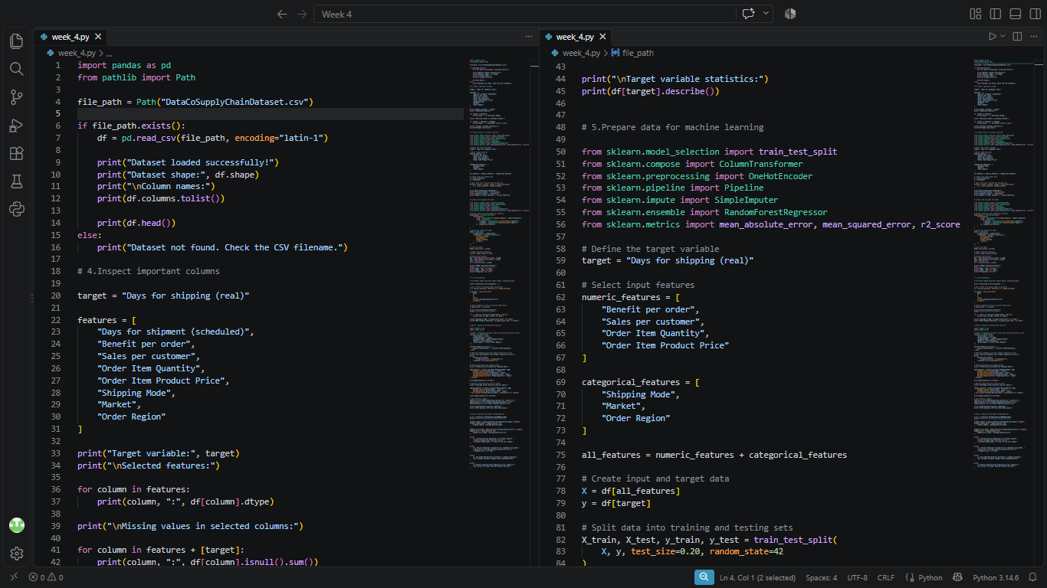

2. Preprocessing pipeline, Random Forest training, test evaluation, and 3-fold cross-validation setup
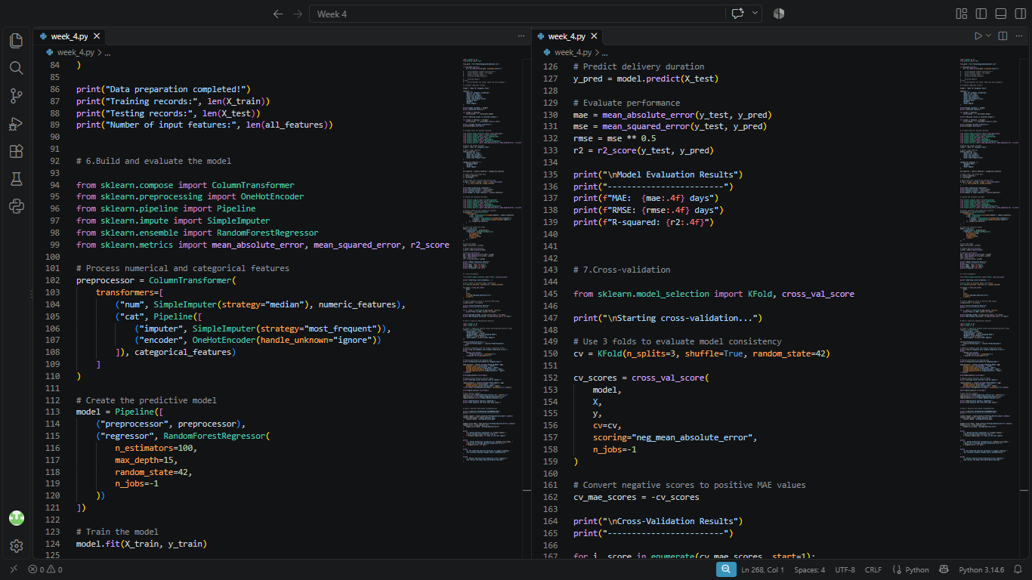

3. Cross-validation summary, prediction error analysis, mode and regional grouping, and CSV exports
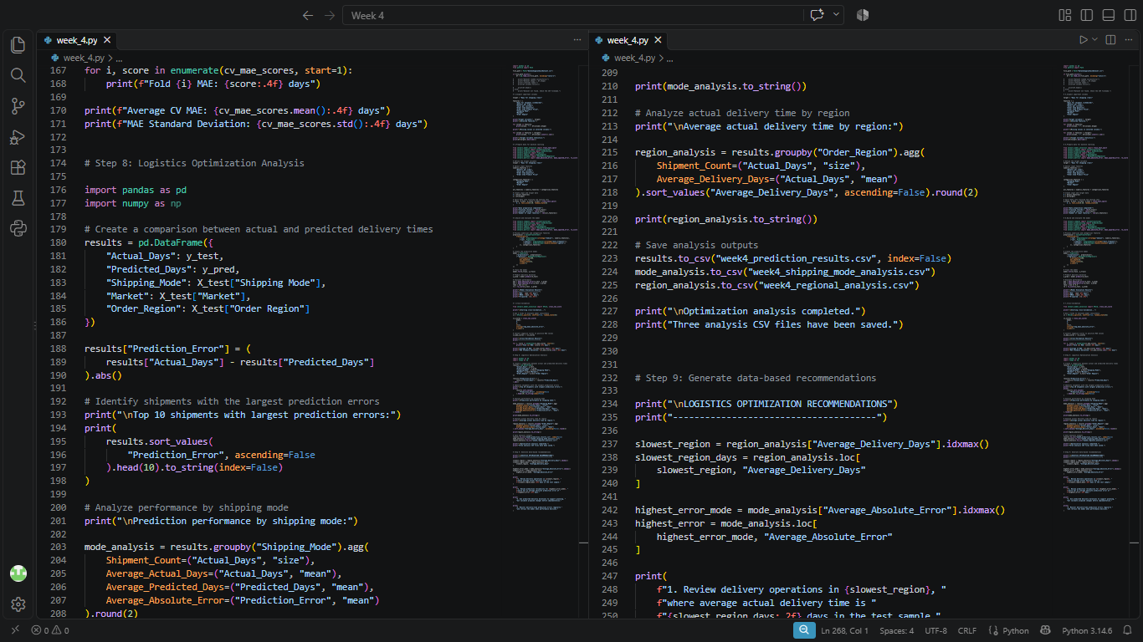

4. Automated generation of data-driven logistics optimization recommendations
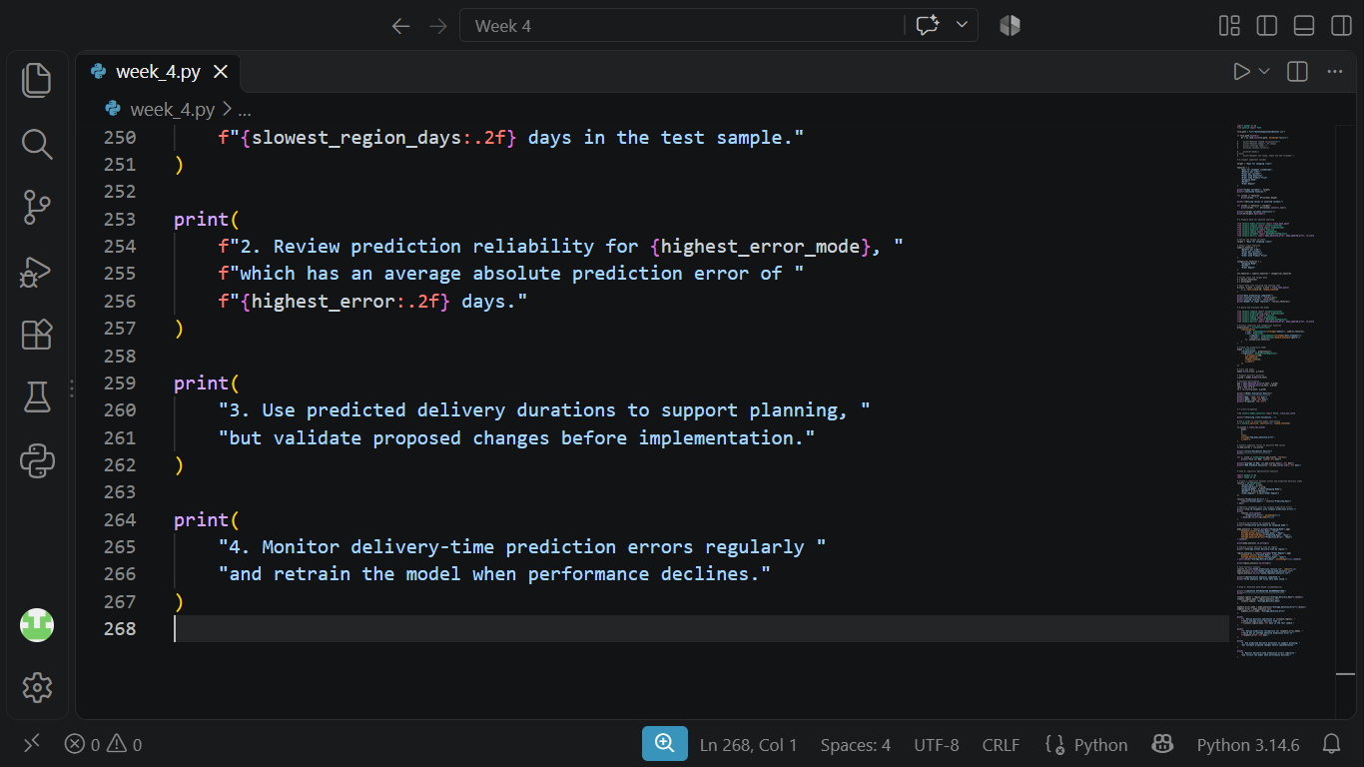

6. Findings and Optimization Recommendations
Based on the model evaluation outputs and the grouped error analysis, four practical recommendations are supported by the results:
- 1. Investigate slower transit times in top-ranked regions (starting with South of USA): In the test sample, South of USA recorded the highest average actual delivery duration at 3.66 days (815 records), followed closely by Eastern Asia (3.61 days) and Eastern Europe (3.59 days). Reviewing regional hub handoffs, carrier allocation, and dispatch schedules in these slower regions can help bring their transit times closer to the overall 3.50-day mean.
- 2. Improve schedule consistency and feature tracking for Second Class and Standard Class: Both Second Class and Standard Class show an average absolute prediction error of 1.21 days because actual durations fluctuate between 2 and 6 days regardless of order value or broad region. Adding operational predictors—such as warehouse dispatch delay, carrier identifier, origin-destination distance, or day-of-week dispatch—would improve model accuracy and help operations teams pinpoint the cause of multi-day variance.
- 3. Use predicted durations as a planning baseline alongside Week 3 late-risk indicators: As seen in Week 3, First Class had a 2.00-day actual duration against a 1.00-day scheduled duration (resulting in a 95.32% late-delivery risk), whereas in Week 4 the model predicts the 2.00-day actual duration for First Class with 0.00 MAE. Combining realistic transit-time predictions with scheduled SLA targets allows planners to set more accurate customer delivery promises before orders ship.
- 4. Monitor prediction errors over time and retrain when distribution shifts occur: With a baseline test MAE of 0.9846 days and cross-validation MAE of 0.9854 days, operations teams should track rolling MAE by shipping mode and region, retraining the pipeline when seasonal volume spikes or carrier changes push errors above historical thresholds.

7. Final Thoughts
This week's workflow extends the Week 3 exploratory analysis into a reproducible machine learning pipeline. While the Random Forest model captures the baseline differences between shipping modes well and achieves a stable sub-one-day MAE (0.9846 days) across folds, the error breakdown shows that most remaining uncertainty sits within Standard Class and Second Class shipments. Pairing this predictive pipeline with more granular operational features is the clearest next step toward tighter delivery-time forecasting.

Appendix A. Python Terminal Output Screenshots
These screenshots record the console outputs generated by running week_4.py. They verify dataset loading, feature types, missing-value counts, target summary statistics, train/test split sizes, model evaluation metrics, 3-fold cross-validation results, shipping-mode and regional breakdowns, CSV exports, and printed recommendations.

Output 1: Script execution, dataset shape (180,519 x 53), sample records, selected features, and missing-value check
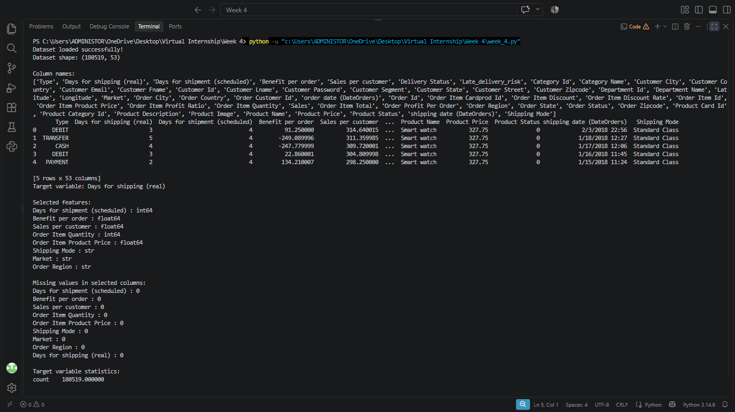

Output 2: Selected feature types, zero missing-value confirmation, and target variable descriptive statistics
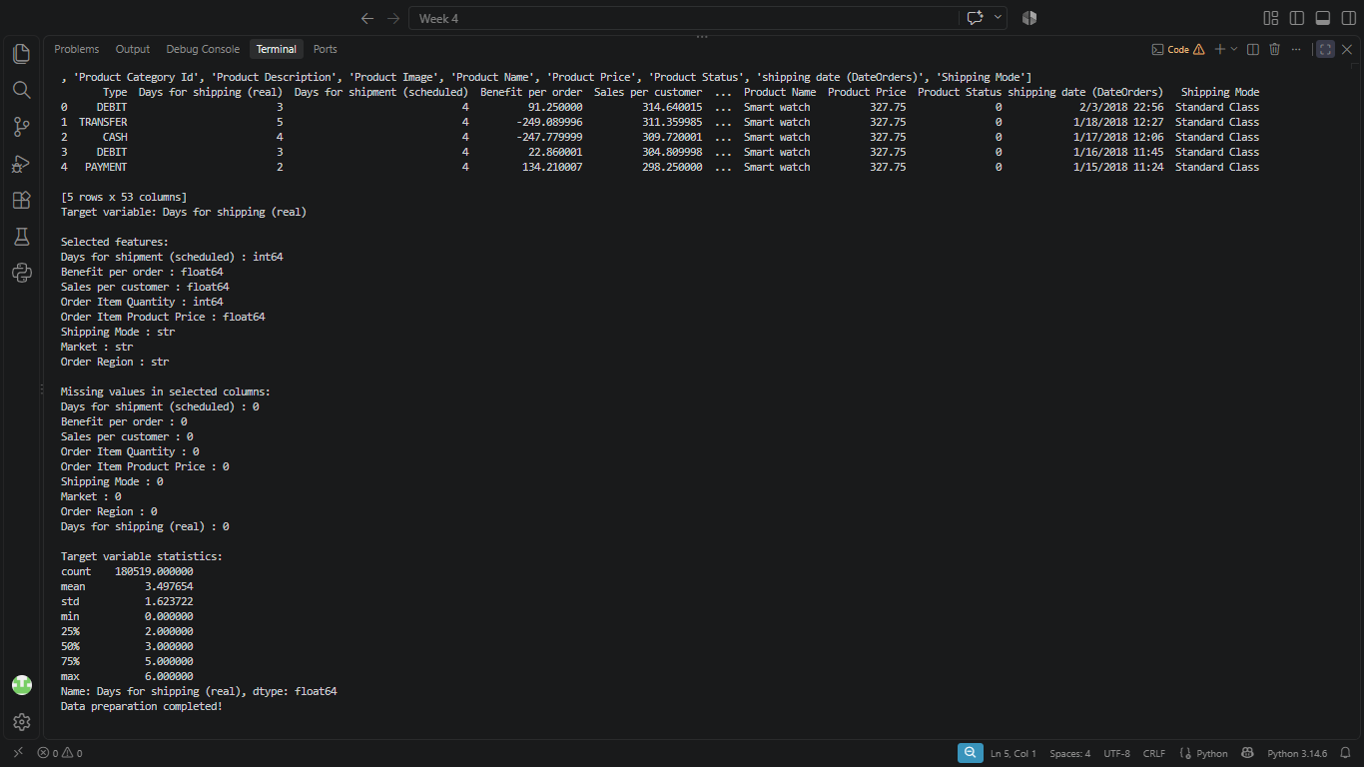

Output 3: Train/test record counts, test-set evaluation metrics (MAE, RMSE, R²), 3-fold cross-validation results, and top 10 prediction errors
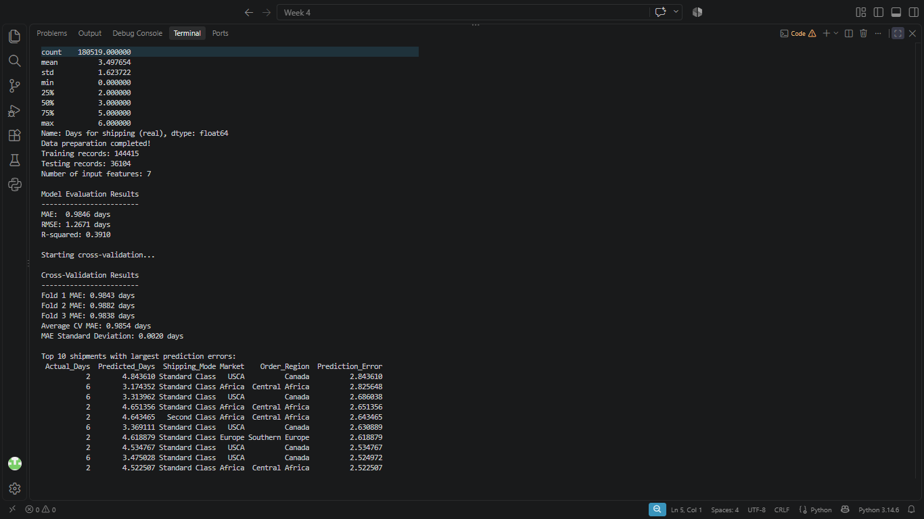

Output 4: Prediction performance by shipping mode, regional average delivery days, CSV export confirmation, and optimization recommendations
