CMPE 273 – Enterprise Distributed Systems
Lab 1 – Using REST (Node.js), HTML 5 and Angular JS

Student ID: 011457368
GitHub project links with access credentials:
https://github.com/nilamdeka23/Lab1-Ebay.git
https://github.com/nilamdeka23/Lab1-Cal.git
username: nilamdeka23
password: 14Github23
Part 1 – Calculator
Introduction:
Calculator to demonstrate stateless web services
The server includes the following functionalities:
1. Addition
2. Subtraction
3. Multiplication
4. Division
and takes care of exceptions.
Calculator Client uses features of HTML5.

System Design:
Fairly simple design comprises of client of a single page application where the most of the input processing takes place and where each calculator input number is made up of input type buttons and 'onclick' event of each number button the parameters are distinguished at client end itself and relayed to server for the arithmetic processing.
For example if a user clicks a number and then clicks on an operator, the second number input is taken as the second parameter and on subsequent press of operator the parameters are sent to server making http POST calls for processing which on success sends back the result for the calculator to display.

In my design I have used a switch case branching in ascertaining the flow of operation types and a no. of flags to distinguish among numbers, operators and parameters.

Output screenshot:
client:
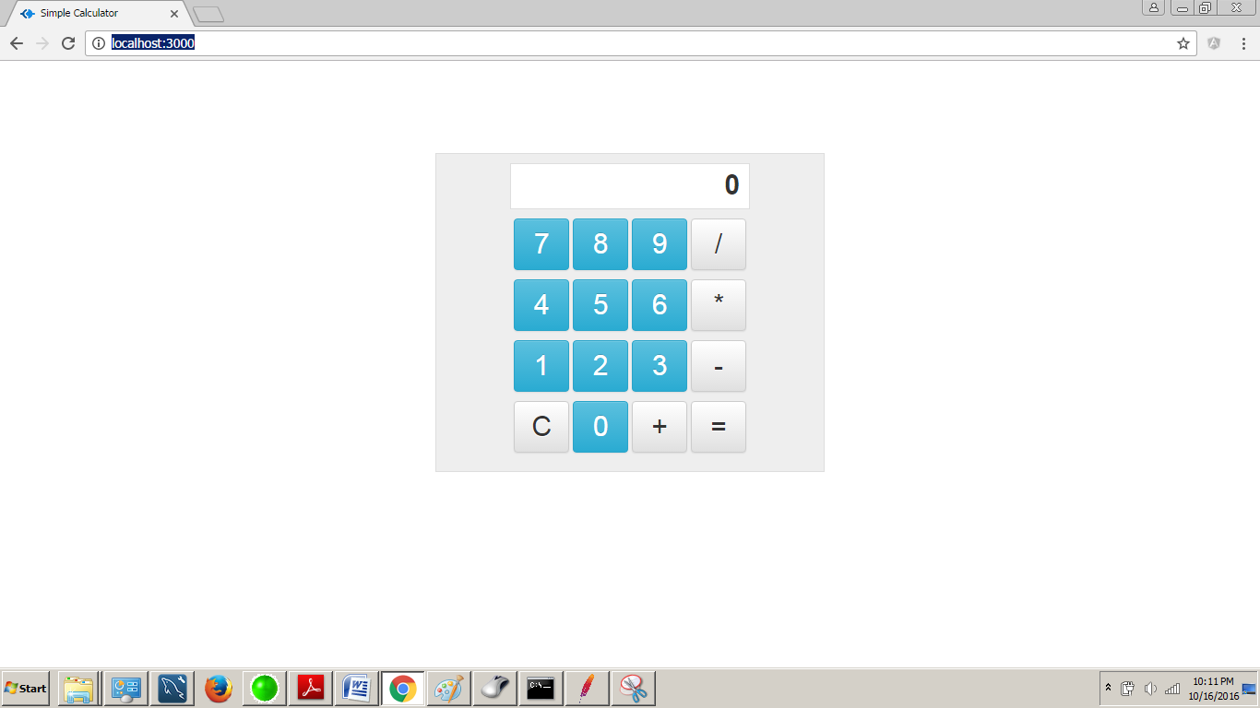

server:
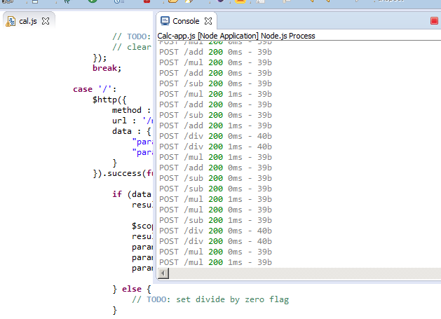

Testing done using JMeter:
Invoke 1000 calls on randomly selected tasks
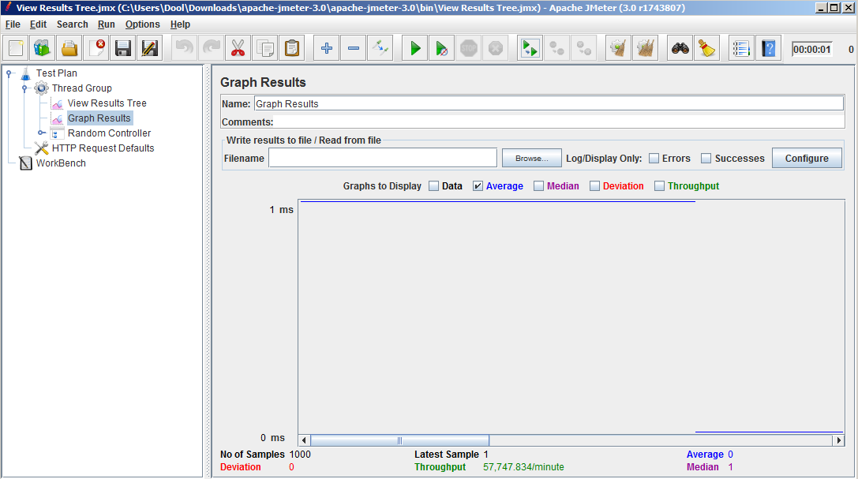

Invoke 5000 calls on randomly selected tasks
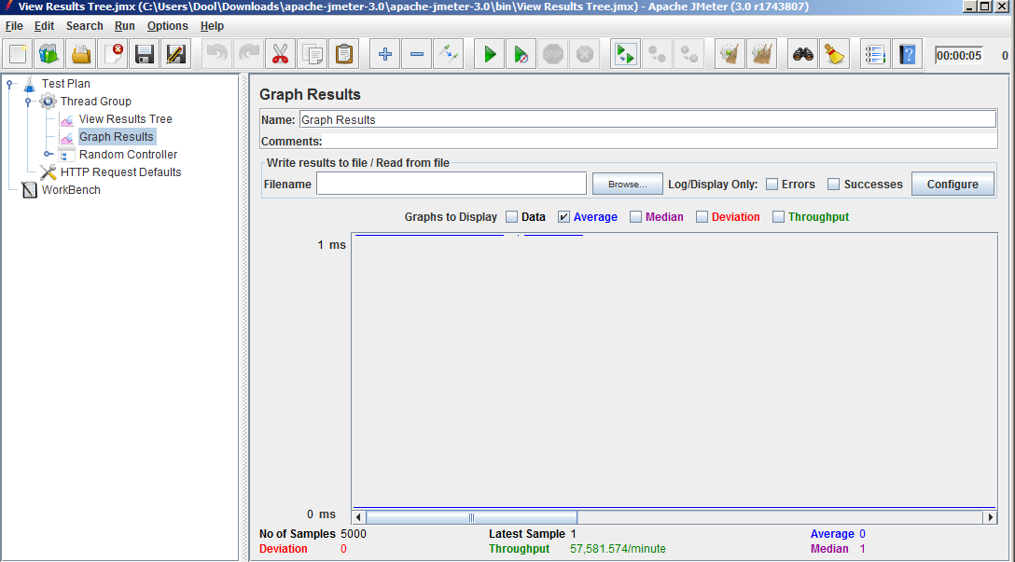

Invoke 100 concurrent users with 1000 calls on randomly selected tasks
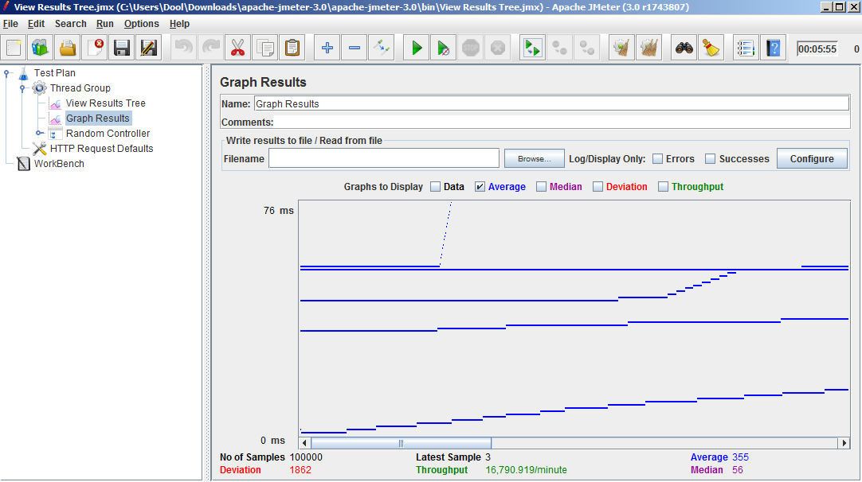

Compare the server results and discuss in brief:
Form the graphs, we can observe that my server handles multiple requests just fine untill the requests become concurrent, that overloads the server and we can observe some latency after a while.

Part 2: Ebay Marketplace Application
Introduction: Goal is to develop “Simple Market Place” like Ebay, both client and server side.
The client side complements various server functionalities like buy, sell, add to cart, make an order , etc using Node.js, Angular.js and mySQL.
System Design: The following are the snapshots of the database design underlay of my ebay implementation.
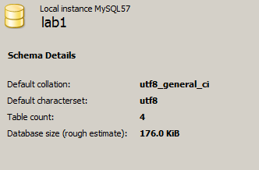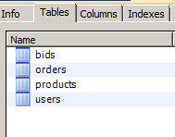
Tables info
Example: users table, products table
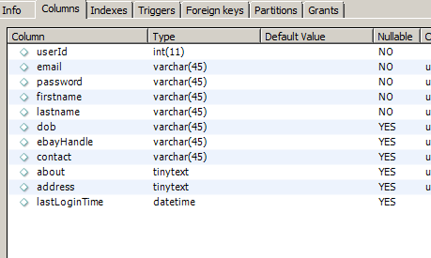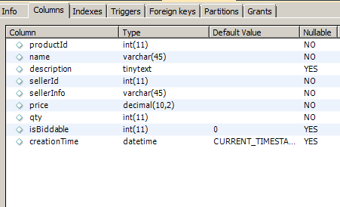

Output screenshots:
a. Sign up the new users (First name, Last name, Email, Password). Passwords have to be encrypted
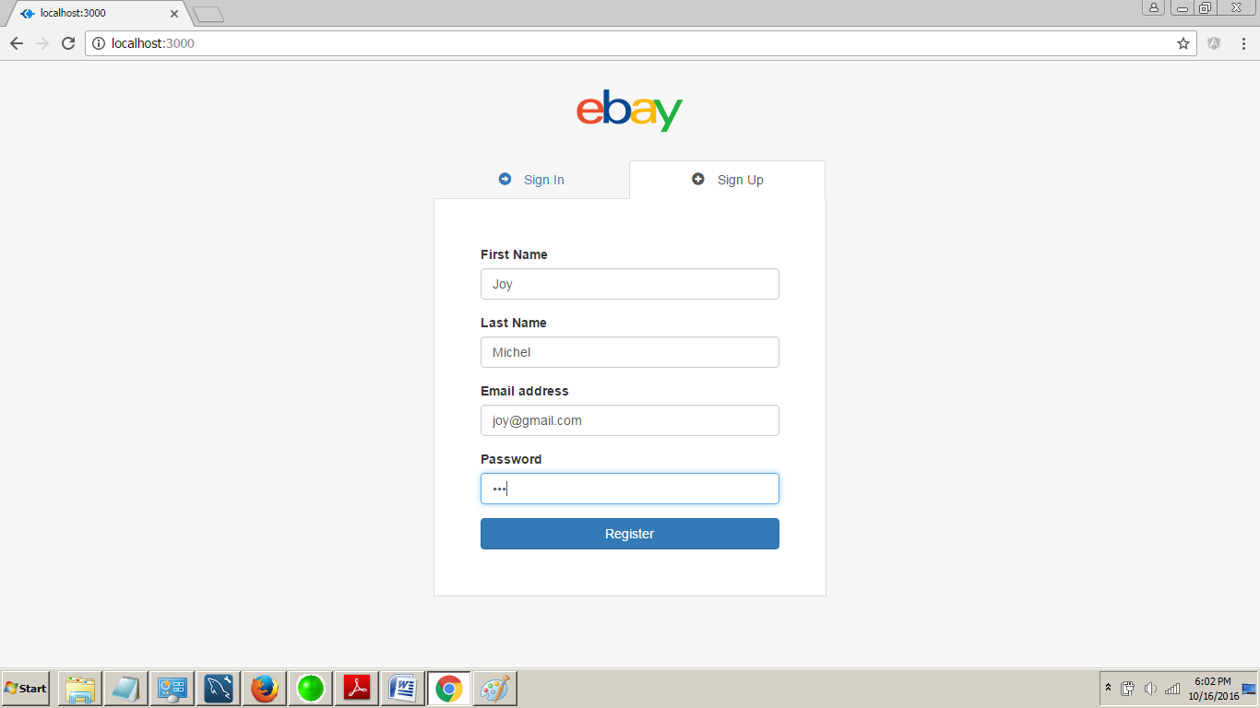
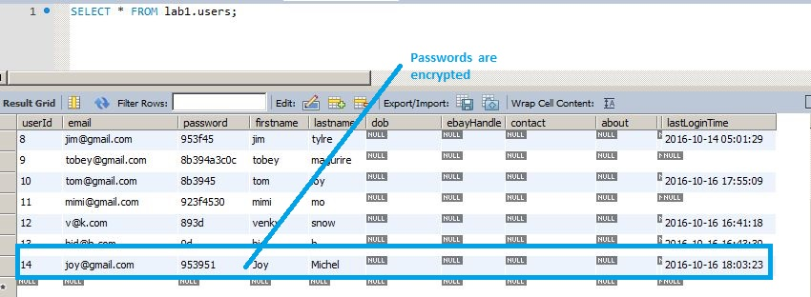

b. Sign in with existing users
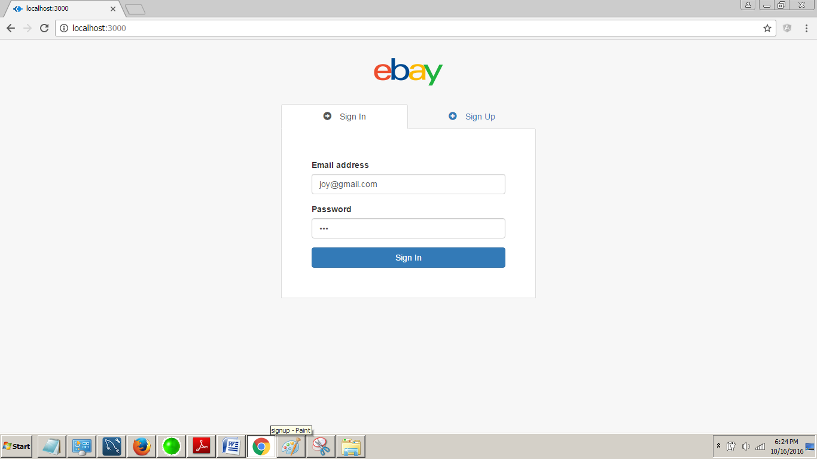

c. Sign out
i. Should maintain time last logged in and should be returned back when user logs in.
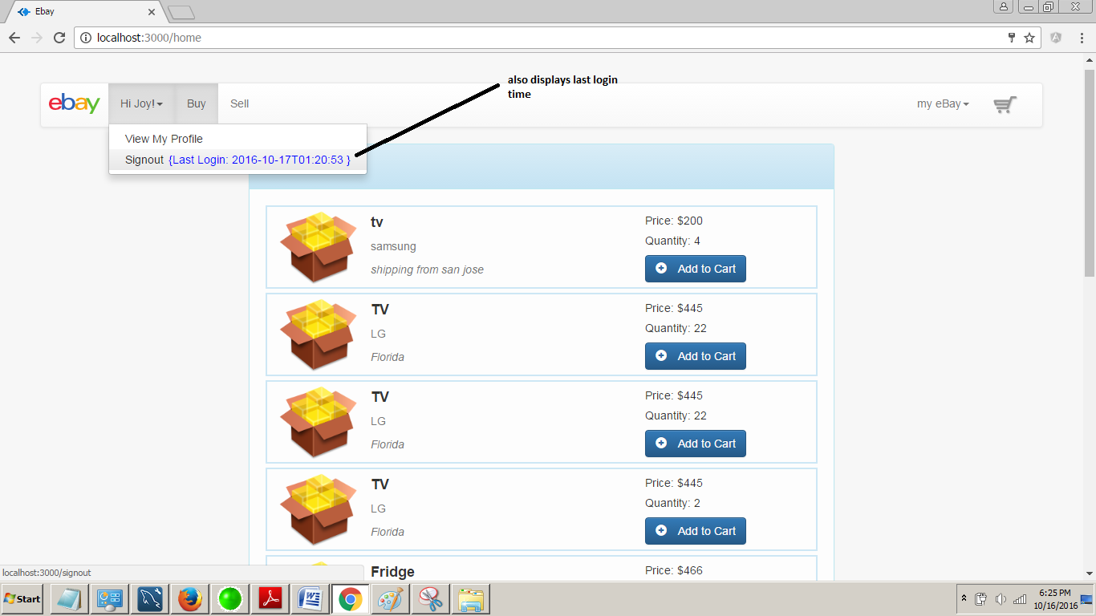

2. Profile:
a. About: Birthday, Ebay handle, contact information and location
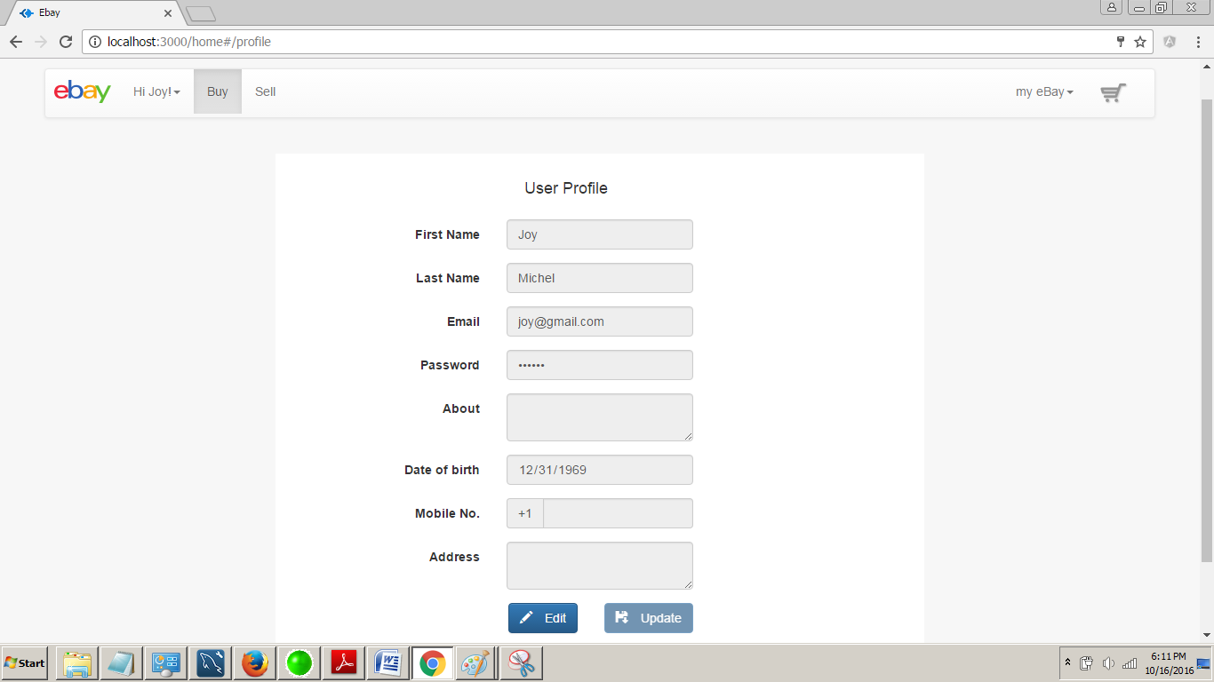

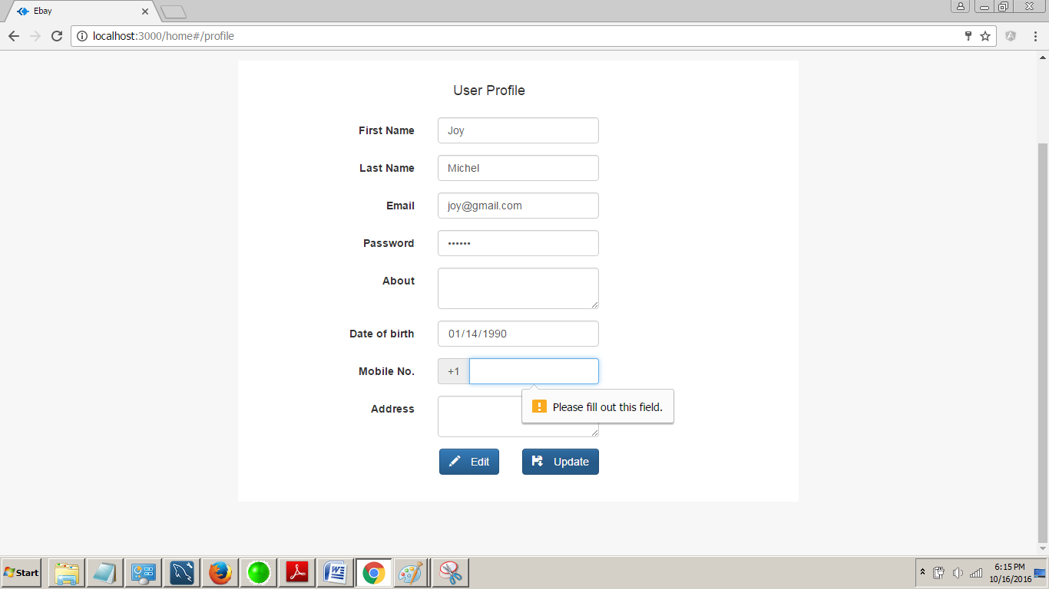

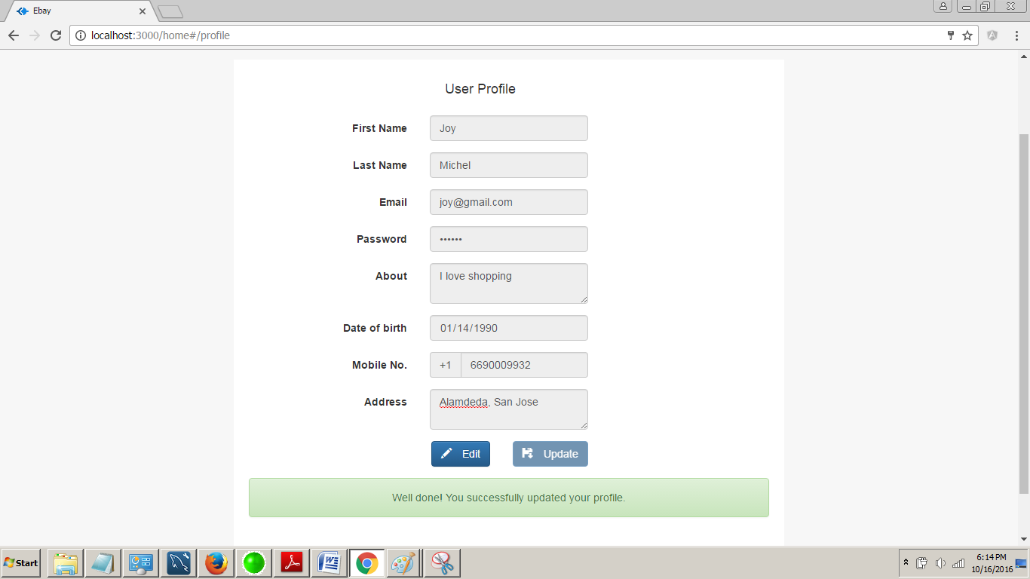

b. Should be able to store user’s advertisements for others to read. This should at-least includes the item name, item description, seller information, item price and quantity. 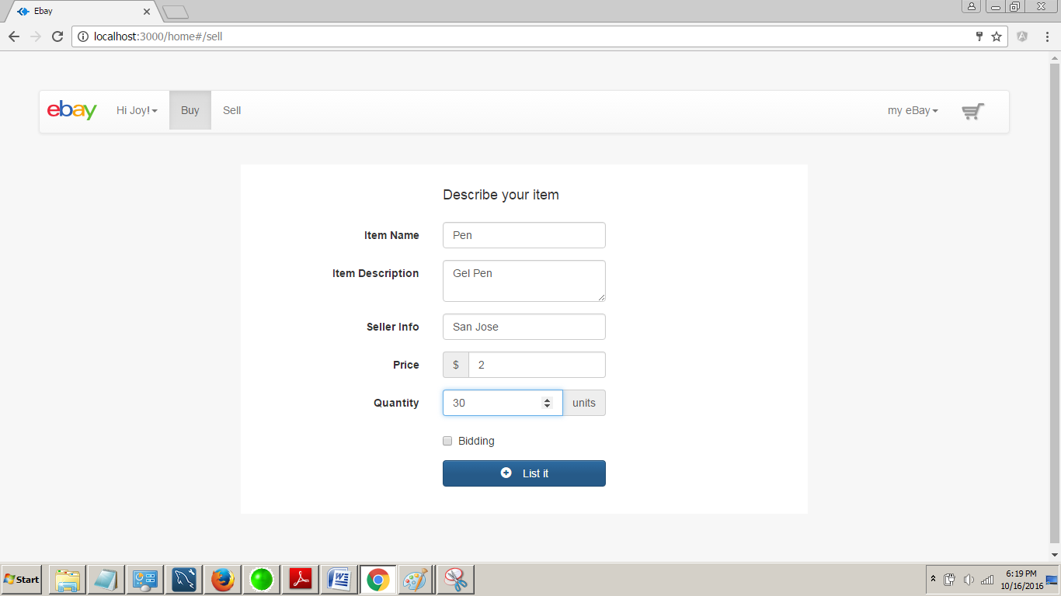

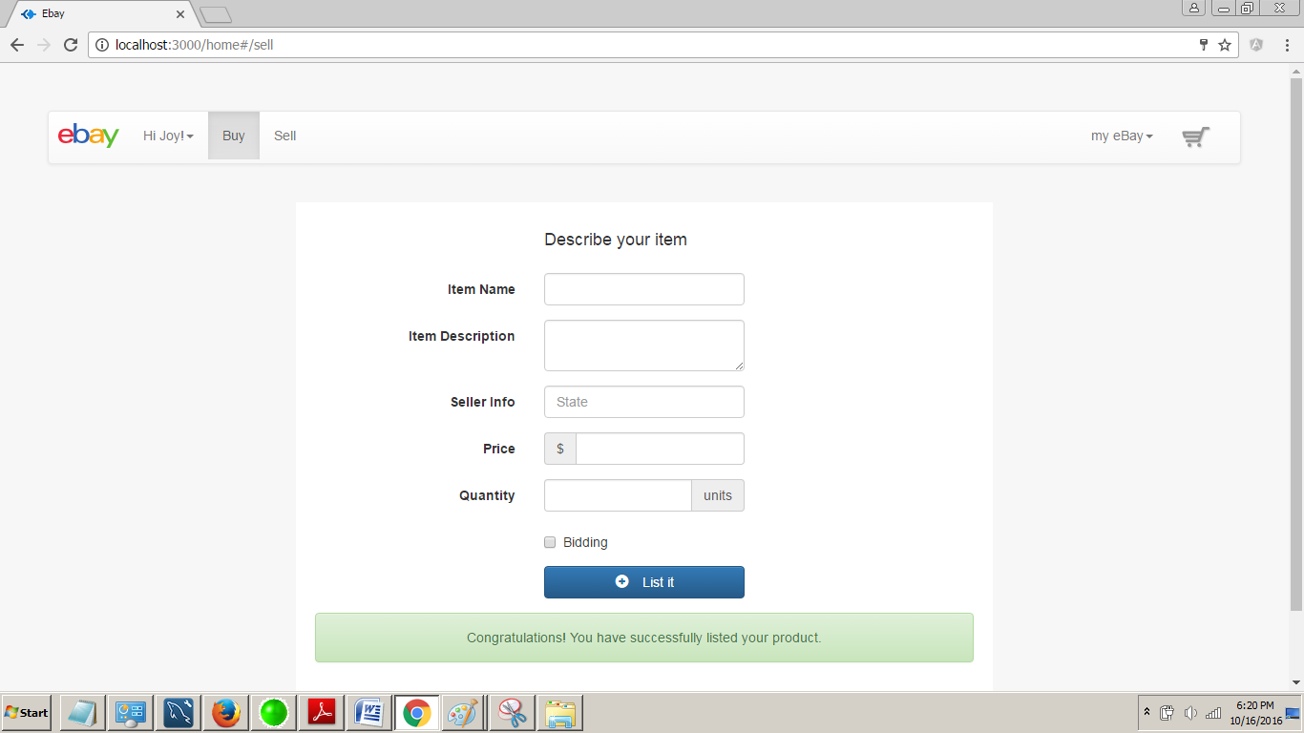

c. Should give all the advertisements details to all the other users.
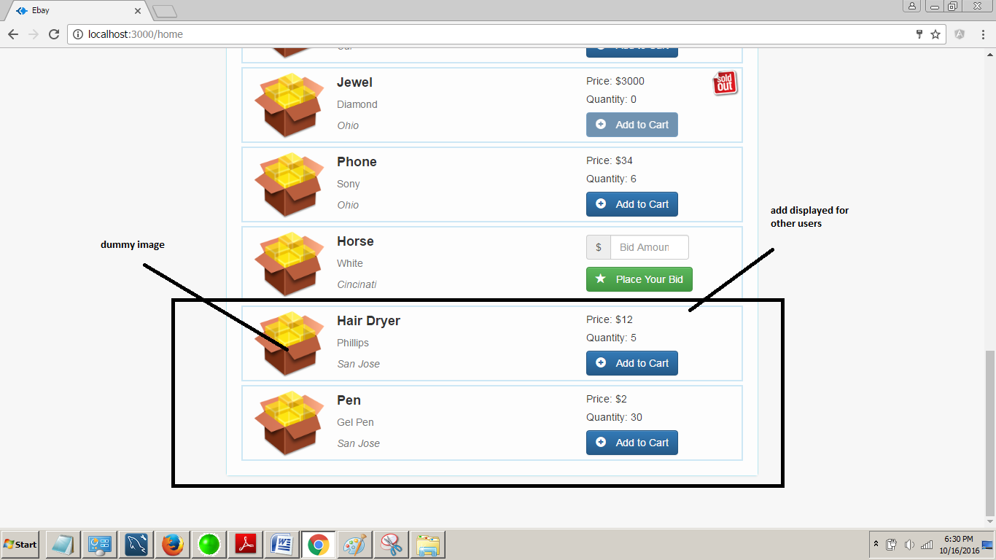

d. Users can bid the product displayed by other users. Bidding takes place over 4 days. For some items, you can purchase without bidding. You should take care of quantities and should respectively reflect user accounts in case of any transaction
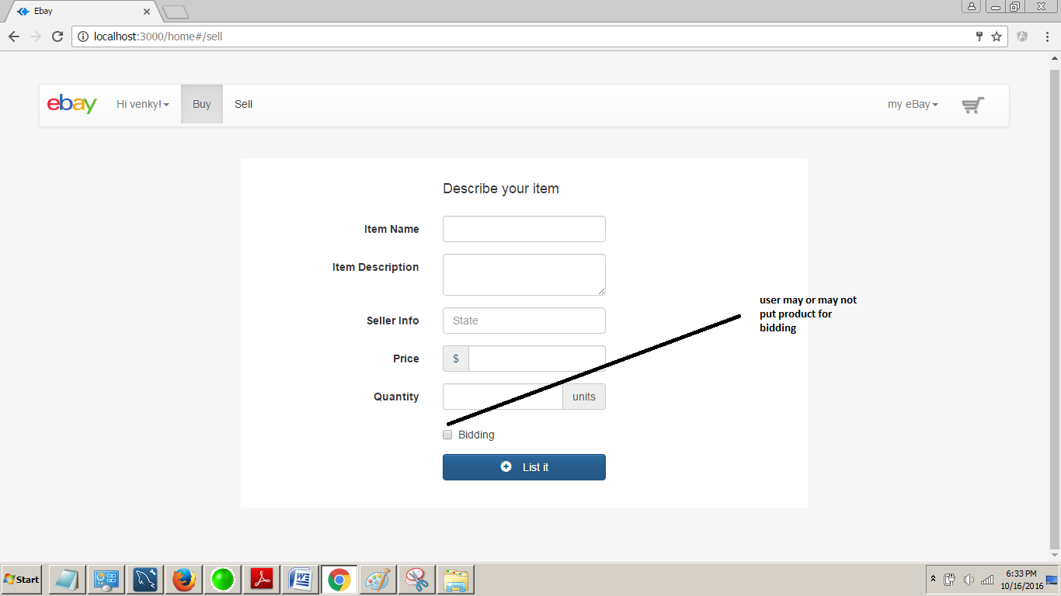

e. Shopping Cart should be maintained which will reflect temporary items. Users should be able to add, remove items from the cart until checkout.
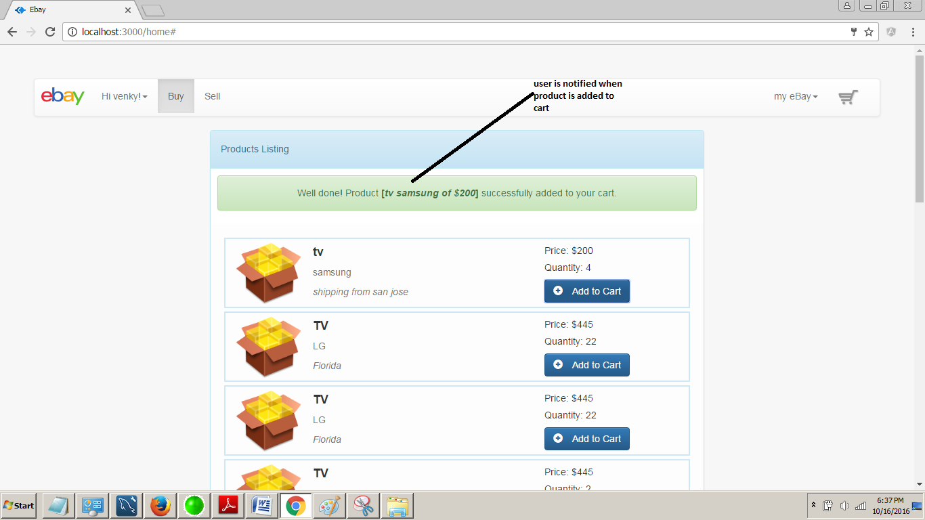

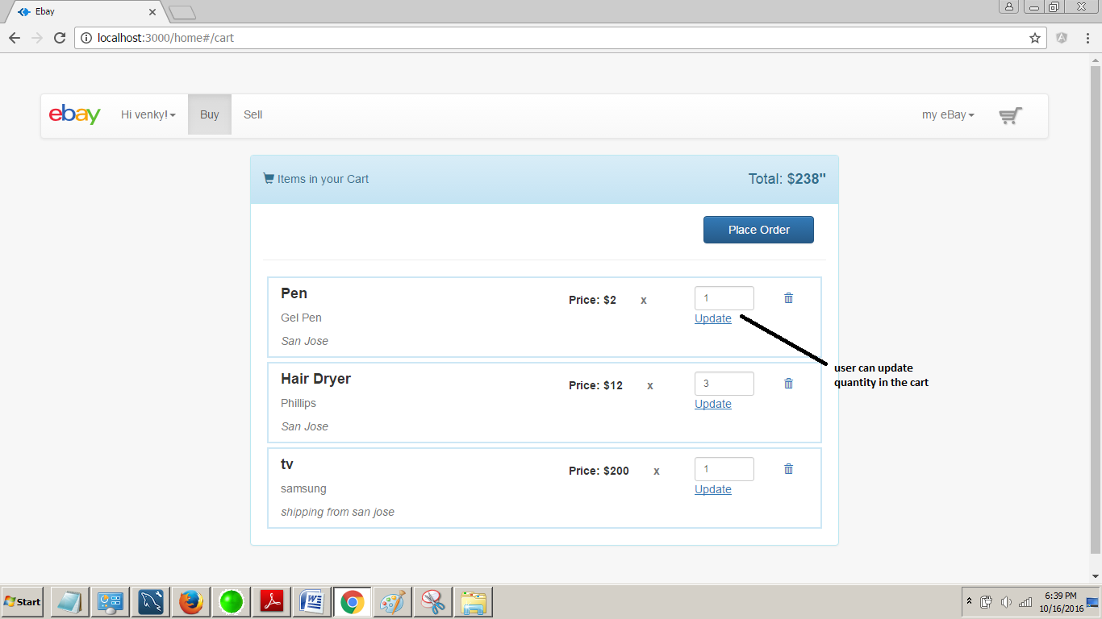
ps: the trash icon deletes the cart item.

f. Checkout should deduct and add items from seller and buyer respectively.
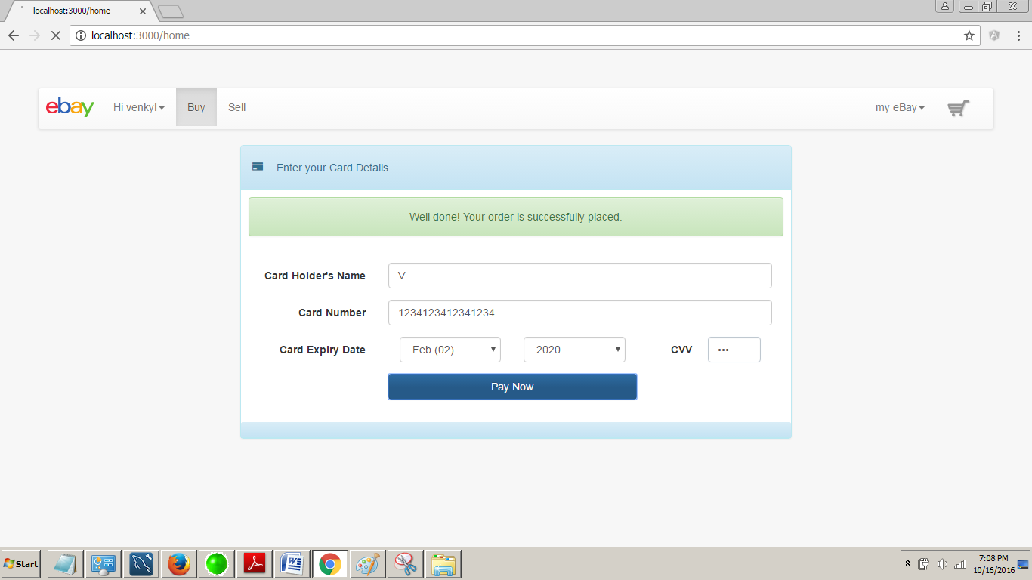

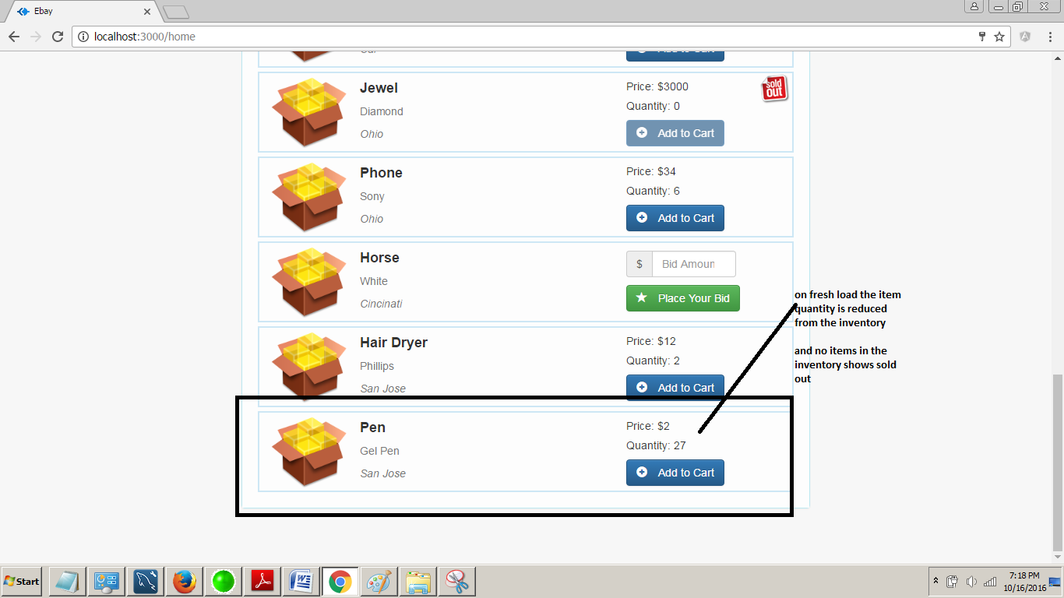

g. Should perform simple credit card validations on payment. 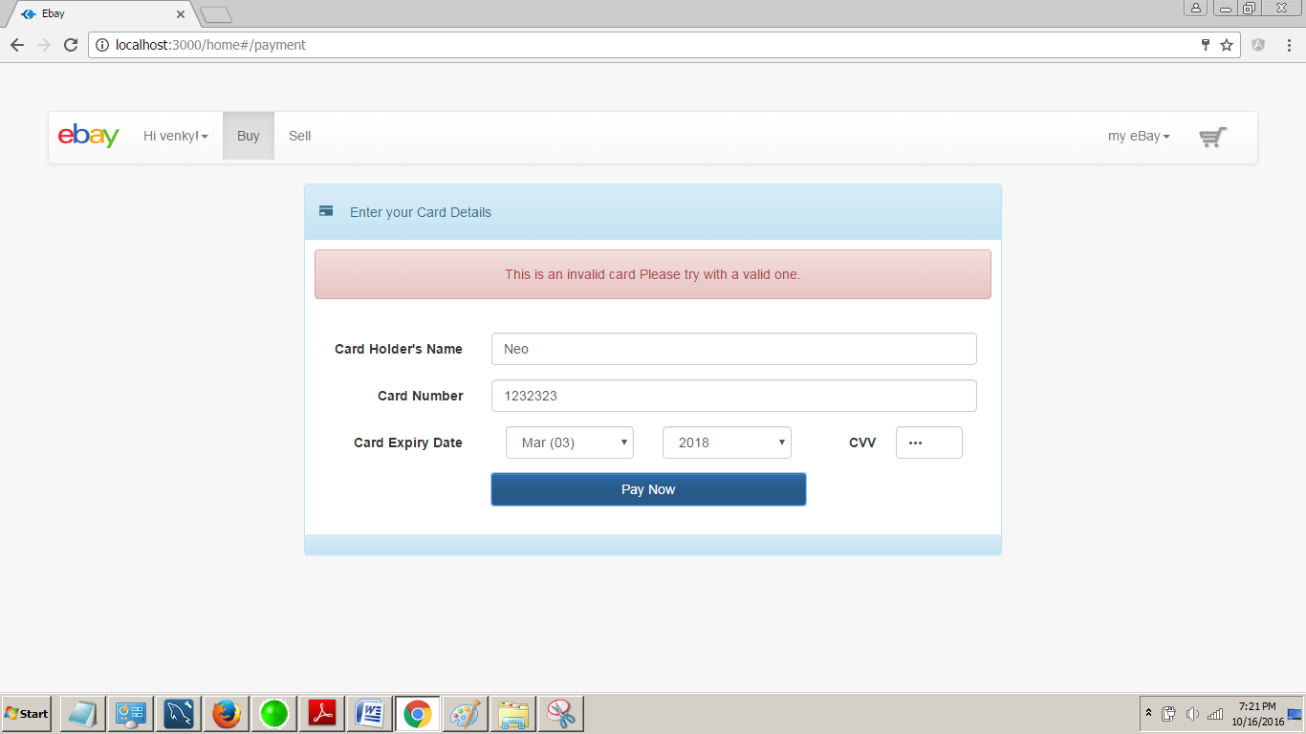

h. Users account should reflect all the bought and sold items.
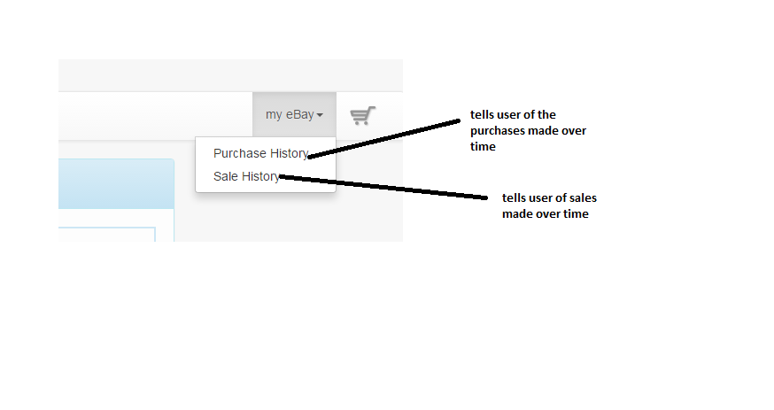
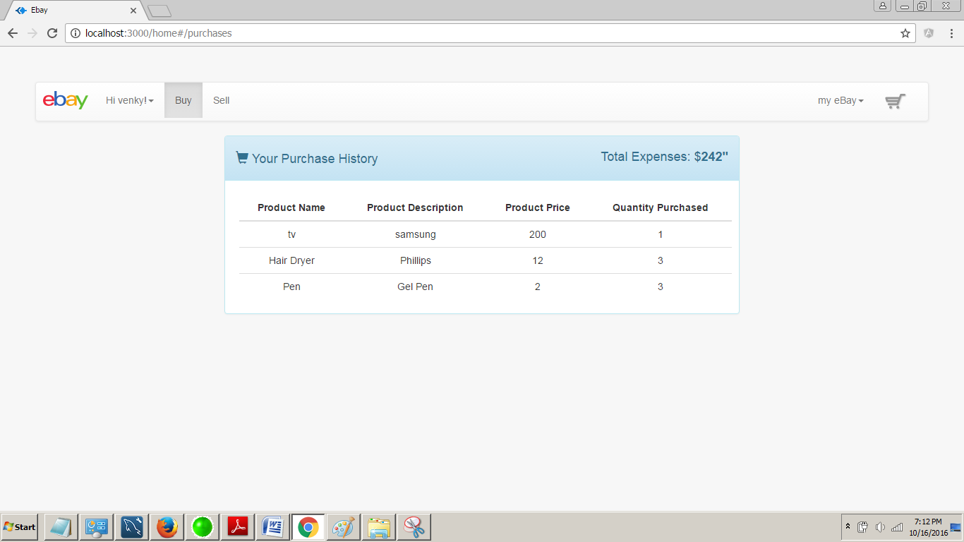


for the seller on the other hand,
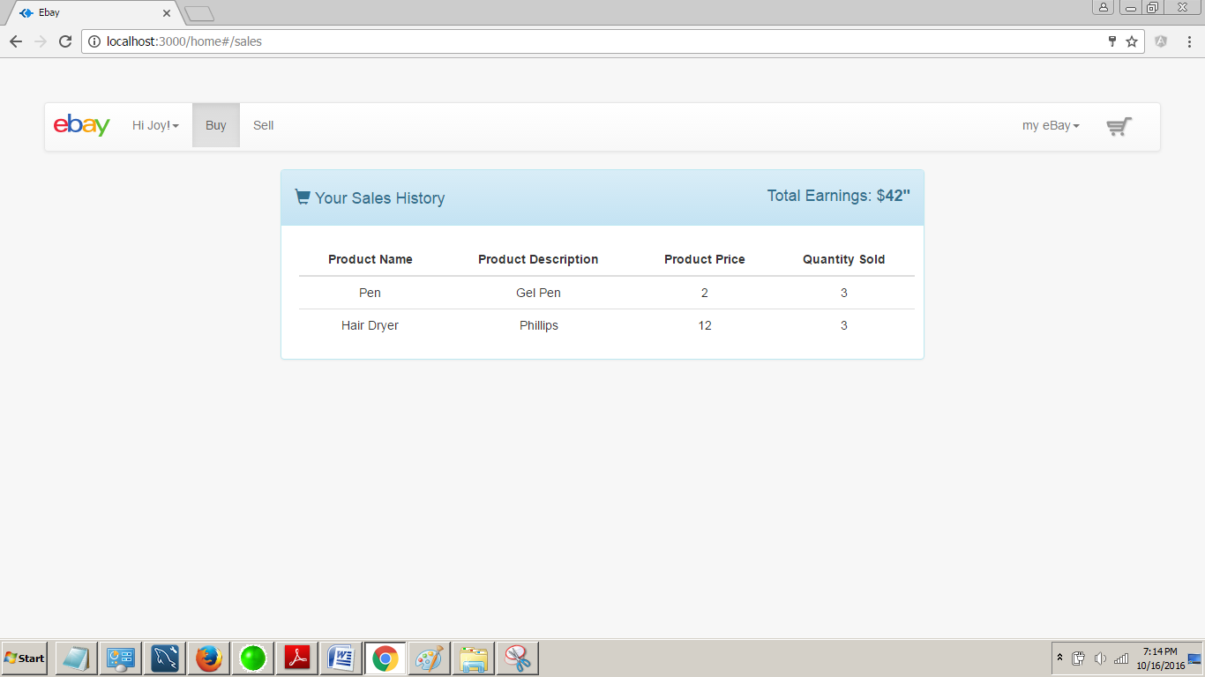

j. User tracking: Generate logs into a file when user clicks any place in the web page. There are generally two major logs. Event Logs: record timestamp, userid, click object id, any descriptions. Bidding Logs (periodic logs of bidding process) timestamp, item id, user id, bid amount.
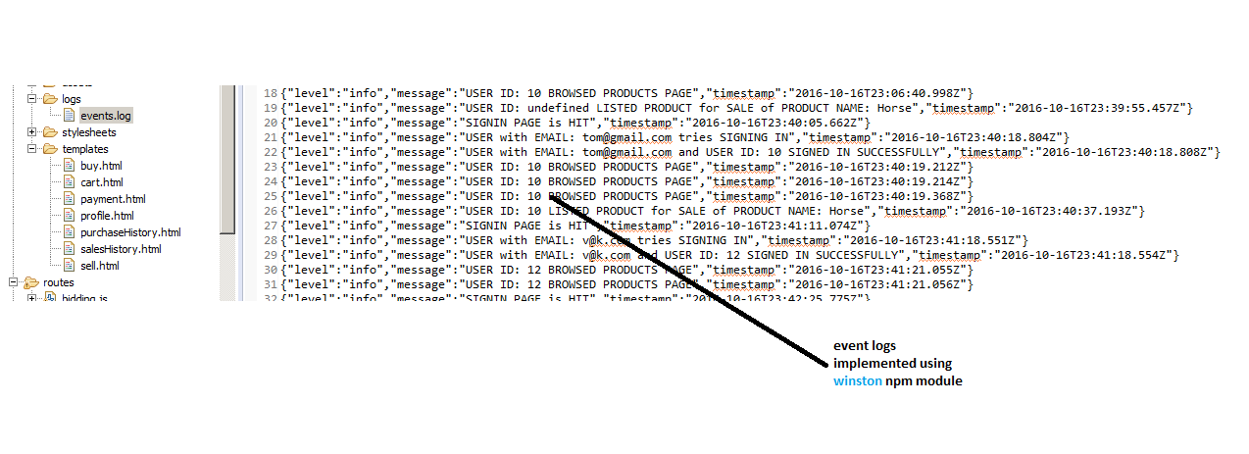

Part 3 – Questions:

1. Explain the encryption algorithm used in your application. Mention different encryption algorithms available and the reason for your selection of the algorithm used.

I have used node.js framework called crypto.js for encryption.

Different encryption algorithms are available RSA, Blowfish, AES, etc.
I used AES-256-CTR algorithm which is good for parallelization, is simple, creates a pseudo random stream that is independent from plaintext, prevents overlapping, encryption is the same as decryption meaning only encryption or decryption required from a cipher block and thus requires less logic.

3. How would you implement Request Caching? Explain in detail. No need to implement a function – use pseudo code or detailed explanation

When a server is hit multiple times with the same request, Request Caching can come handy. Also called web-caching, it primarily means that the web server kind of acts like elastic search engines which themselves keep an image of the last response in memory. By avoiding data base access, this not only saves latency due to disk I/O, also increases server throughput.
I would implement Request Caching using npm-module node-request-caching that is a node.js framework for the same as it features zero configuration and Memory and Redis adapters to cache storage.

