2CS404 :
PROGRAMMING FOR SCIENTIFIC COMPUTING

INNOVATIVE ASSIGNMENT
SEMESTER IV

SELF DRIVING CAR



Prepared By :-
Aditya Patel 21bce009
Aditya Bhatt 21bce010
Jenil Akhyani 21bce013

REINFORCEMENT LEARNING USING NEAT AND DQCN

1. Dependencies

1. tensorflow (install using pip install tensorflow)
2. numpy (install using pip install numpy)
3. matplotlib (install using pip install matplotlib)
4. neat (install using pip install neat-python)
5. os (in-built)
6. csv (in-built)
7. pygame (install using pip install pygame)
8. math (in-built)
9. sys (in-built)
10. random (in-built)

2. Introduction
Every year, traffic accidents account for 2.2% of global deaths. From distracted driving to drunk driving to reckless driving to careless driving, one poor or inattentive decision could be the difference between a typical drive and a life-threatening situation. But what if we could neutralize human error from the equation?
“Autonomous cars are no longer beholden to Hollywood sci-fi films” — Elon Musk, the founder of Tesla Inc. and SpaceX believes within a decade, self-driving cars will be as common as elevators.
Industry experts say the technology is going to disrupt and revolutionize the future of transportation as we know it.
Training an end-to-end deep learning model that would let a car drive by itself around the track in a driving simulator.
Autonomous cars create and maintain a map of their surroundings based on a variety of sensors situated in different parts of the vehicle. Radar sensors monitor the position of nearby vehicles.

2. Project Description

The project contains 2 main files that are neat.py and dqcn.ipynb (both files are independent of each other). neat.py file implements neat library for making CNN models, the configurations for the neural network and other details like the. dqcn.ipynb uses tenserflow.compat.v1 library for making the CNN model. The CNN model contains 2 dense layers.

1. NEAT
In this program simultaneously 30 cars are trained and tested. The best models are selected and passed on to another cars to improve their performance. Gradually, species are formed with different characteristics.

2. DQCN
In this program at a time 1 car is trained and tested. All the moves that the car makes are stored and prioritized according to the reward given. The model is retrained again with the best moves and tested again.

The reward in both the cases are given according to the distances travelled.

3. Ouput

1.NEAT

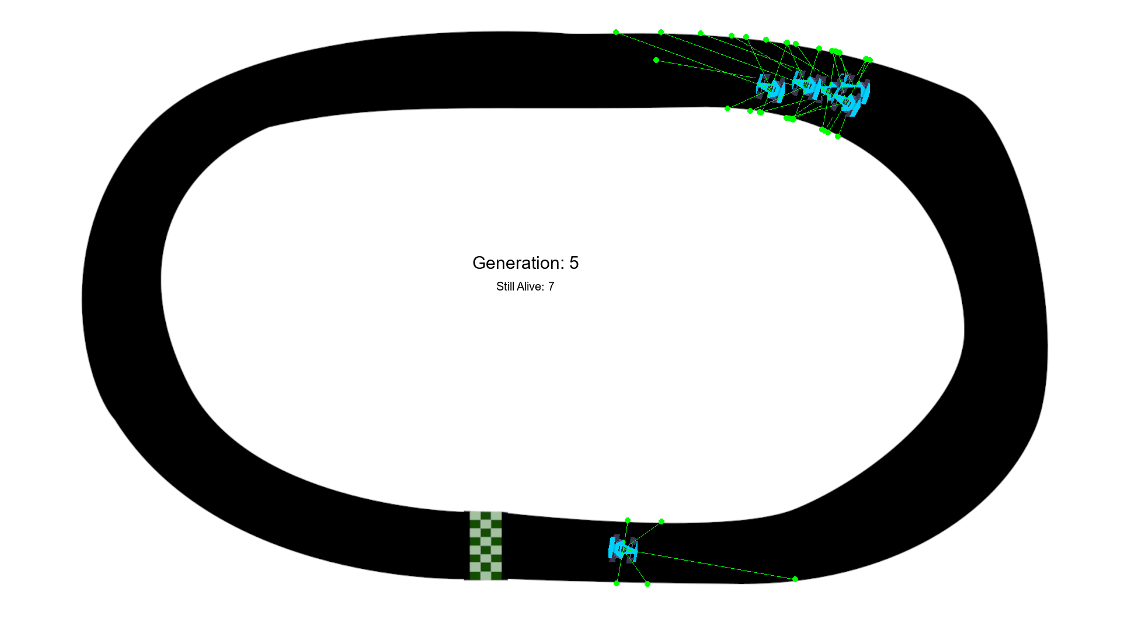

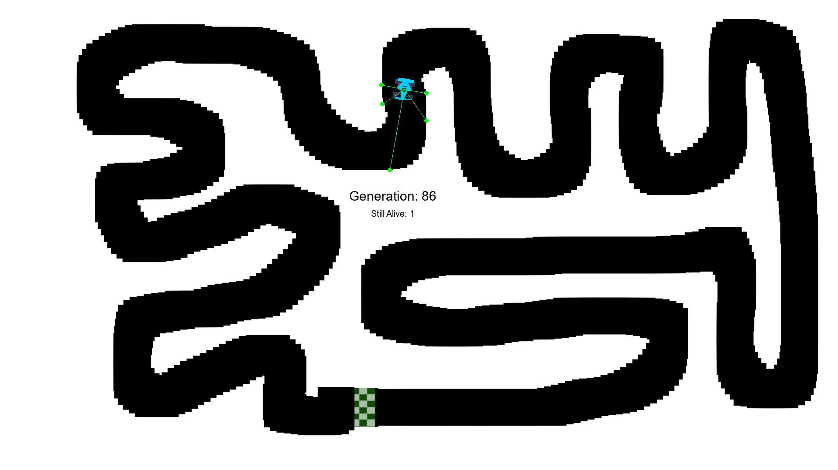

2. DQCN

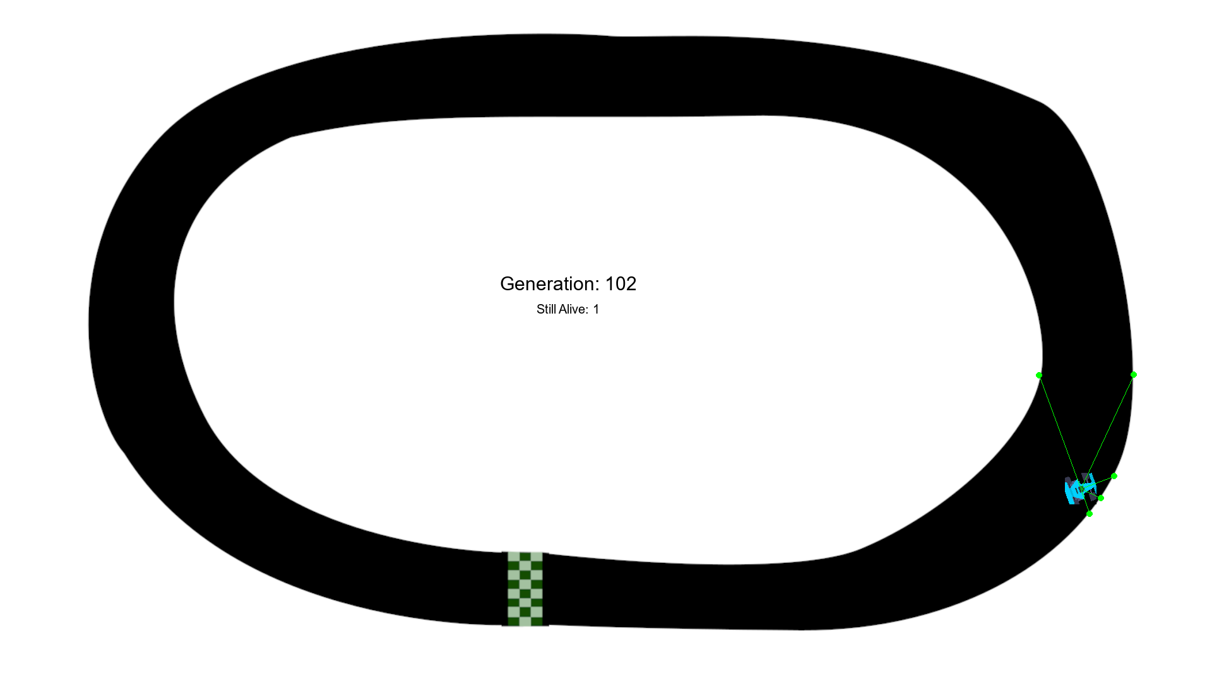

**THE VIDEO RECORDING HAS BEEN MAILED

