FSD Assignment -2

*By- Aditya N. Patil*

*Roll No- PA-30*

*Batch-2 Panel-1*

*TY-CSF*

**Aim**: Design and develop a responsive web page using Bootstrap front end framework.

**Objectives:**

1. To understand HTML tags

2. To learn the styling of web pages using CSS

3. To learn Bootstrap Front End Framework.

**Theory:**

1. **Bootstrap Grid System.** - Bootstrap Grid System allows up to 12 columns across the page. You can use each of them individually or merge them together for wider columns. You can use all combinations of values summing up to 12. You can use 12 columns each of width 1, or use 4 columns each of width 3 or any other combination

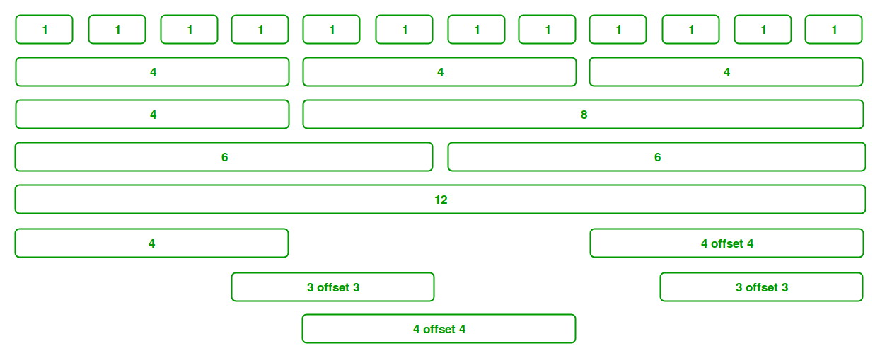

1. **Bootstrap .container and .container-fluid class. -**

In bootstrap, the container is used to set the content’s margin. It contains row elements and the row elements are containers of columns. This is known as the grid system.   
There are two container classes in bootstrap:

1. .container - .container: The .container class provides a responsive fixed width container.  
   In the below example, the div with class “container” will have a fixed left and right margin and will not take the complete width of its parent or the viewport.
2. .container-fluid- The .container-fluid class provides a full-width container which spans the entire width of the viewport. In the below example, the div with class “container-fluid” will take up the complete width of the viewport and will expand or shrink whenever the viewport is resized.

FAQ:

1. **What is a responsive website?**

Responsive web design is about creating web pages that look good on all devices! A responsive web design will automatically adjust for different screen sizes and viewports. Responsive Web Design is about using HTML and CSS to automatically resize, hide, shrink, or enlarge, a website, to make it look good on all devices (desktops, tablets, and phones):

**<meta name="viewport" content="width=device-width, initial-scale=1.0">**

This will set the viewport of your page, which will give the browser instructions on how to control the page's dimensions and scaling.

1. **How Bootstrap helps to design a responsive website?**

As the name suggests, Responsive Web Design is the technique for developing websites and web portals in a more interactive way with the robust CX/UX (customer/user experience) optimal view solutions on a web page with the best browser compatibility that can run and operate in various types of devices.

Bootstrap’s grid system uses a sequence of containers, rows, and columns to layout and align content. It is constructed with a flexbox and is comprehensively responsive. Below is an example and an in-depth glimpse at how the grid comes together.

Benefits of bootstrap responsive-

1. Open source and free
2. Pre- Defined Features
3. Easy Customization

