Exercise 2:

1. Understanding Asymptotic Notation
Big O notation is used to measure the efficiency of an algorithm by describing how its execution time grows as the input size increases. It helps compare different algorithms and choose the most suitable one for large datasets.
Search Operation Scenarios:
- Best Case: The required element is found immediately.
- Average Case: The element is found after checking some of the elements.
- Worst Case: The element is found at the end of the collection or is not present at all.
For Linear Search:
- Best Case: O(1)
- Average Case: O(n)
- Worst Case: O(n)
For Binary Search:
- Best Case: O(1)
- Average Case: O(log n)
- Worst Case: O(log n)

4. Analysis
Comparison of Search Algorithms
Algorithm | Best Case | Average Case | Worst Case
Linear Search | O(1) | O(n) | O(n)
Binary Search | O(1) | O(log n) | O(log n)
Binary Search is more efficient than Linear Search because it repeatedly divides the search space into halves, reducing the number of comparisons required. However, Binary Search requires the data to be sorted before searching.
For an e-commerce platform with a large number of products, Binary Search is generally more suitable because it provides faster search performance and scales better as the product catalog grows. Linear Search is simpler to implement but becomes inefficient for large datasets.
Output:
Exercise 2: E-commerce Platform Search Function

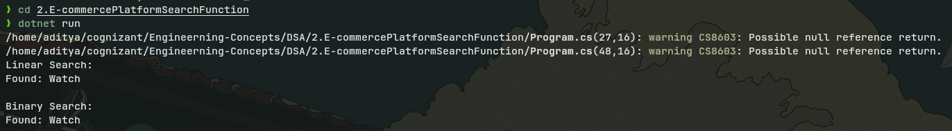

Exercise 7: Financial Forecasting

1. Understanding Recursive Algorithms
Recursion is a programming technique in which a function calls itself to solve a smaller version of the same problem. It simplifies complex problems by breaking them down into smaller, more manageable subproblems. A recursive solution typically consists of a base case and a recursive case.

4. Analysis
In this implementation, the future value is calculated recursively based on a fixed growth rate and the number of years.
- Time Complexity: O(n), where n is the number of years. The function makes one recursive call for each year.
- Space Complexity: O(n), due to the recursive call stack.
To optimize the solution and avoid excessive computation, an iterative approach or a direct mathematical formula can be used. These approaches reduce memory usage and eliminate the overhead of multiple recursive function calls. For large inputs, iterative solutions are generally more efficient and scalable than recursive ones.

