Aditya Pitchuka  
INFO 5502.002 (14676)  
Spring 2020

**Assignment – 3**

Write a Python program to simulate the calculation of π using Monte Carlo method. Your program draws the circle and the square, and plot the random points in the graph as shown in Figure. You need simulate different numbers of points (at least include 10, 500, 1,000, 5,000, 10,000, 50,000, 80,000, 100,000, 200,000) and calculate the value π for each different number of points. Then

draw a line chart to show the change of the accuracy of the value of π calculated when the number of points is increased.

**Approach:**

We draw out a circle of radius 1 unit and a square that fits the circle entirely in itself. We randomly generate values for x and y and determine using the equation of circle to determine if the point (x, y) is inside or on outside of circle. We use Standard circle equation i.e., x2+y2=r2 and determine a parameter, we say d, in this case for every random generated x, y pair values. We plot a scatter points for the points inside and outside with different colours for easy identification. According to Monte Carlo Simulation method, π value can be determined by using the below equation

π = 4 * count_of_inside_points / Total_points

It is 4 times the ratio of inside points and total points.

Now we run this estimation for different simulation values say, 10, 100, 500, 1000, 50000, 100000 and 500000 and see the value of π to correct value of it.

**Visualization Result:**

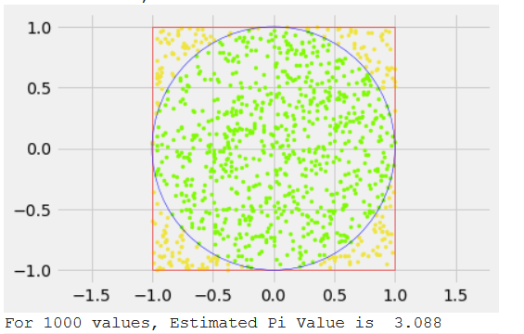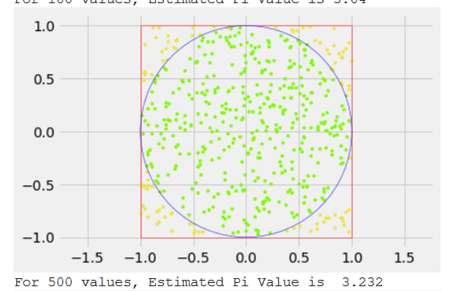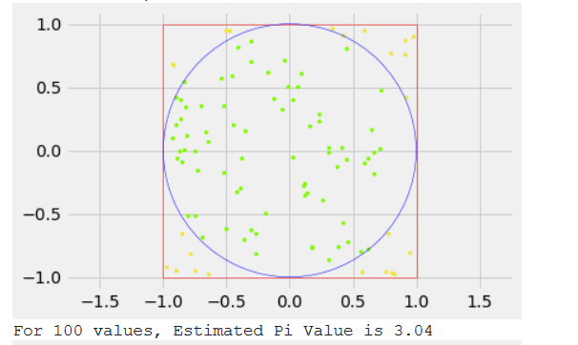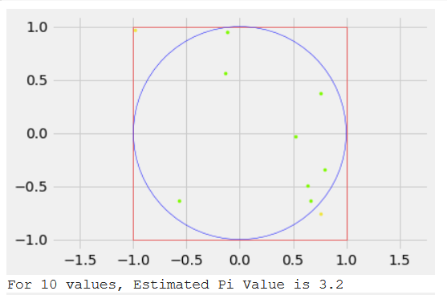

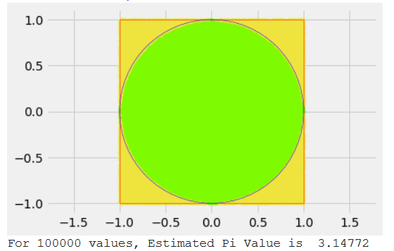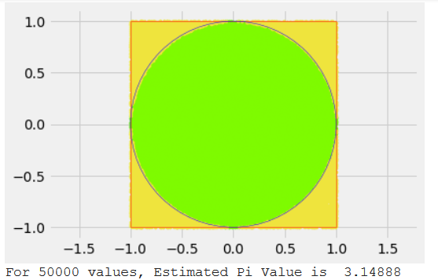

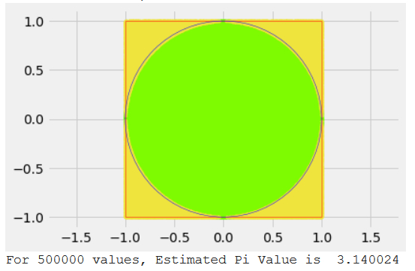

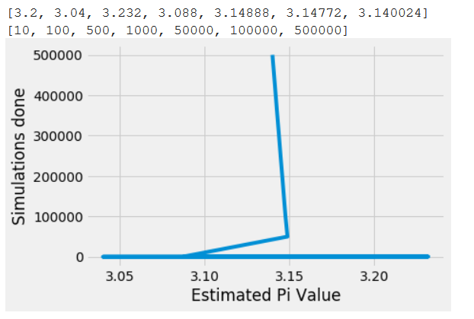

Line Chart with Pi values for different simulations