Waste Classification using Neural Networks

Aditya Pitchuka

College of Information Science, University of North Texas

INFO 5082: Seminar in Research and Research Methodologies

Dr. Stephen Wheeler

04/28/2021

Waste Classification using Neural Networks

## Introduction and Background of the project

Increase in urbanisation and economic development around the world has led to increased waste generation. The United States alone generates 624,700 metric tons of solid waste each day. This resulted in the need for Recycling. The current recycling process requires recycling facilities to sort garbage by hand and use a series of large filters to separate out more defined objects. Waste products can be classified based on various factors, such as consumption, production, chemical and physical properties to allow for effective reuse and recycling. The ability to reduce and recycle waste material more effectively not only reduces the impact on the environment but is also more cost effective. Improper waste management will have enormous adverse impacts on the economy, the public health, and the environment. (Hoornweg & Bhada-Tata, 2012). Municipal solid waste (MSW) recycling has been recognized as the second “most environmentally sound” strategy for dealing with urban waste by the Environmental Protection Agency (EPA) (R. E. Sanderson, 1993). Effective waste recycling is both economic and environmentally beneficial. It can help in recovering raw resource, preserving energy, mitigating greenhouse gaseous emission, water pollution, reducing new landfills, etc.

## Statement of the project problem

The present way of separating waste/garbage is the hand-picking method, whereby someone is employed to separate out the different objects/materials. The person, who separate waste, is prone to diseases due to the harmful substances in the garbage. It is the motivation to develop an automated system which can sort the waste. and this system can take short time to sort the waste, and it will be more accurate in sorting than the manual way. With the system in place, the beneficial separated waste can still be recycled and converted to energy and fuel for the growth of the economy (Johansson & Corvellec, 2018). The system that is developed for the separation of the accumulated waste is based on Convolutional Neural Network deals with recognition and classification.

## Review of Literature

Image classification is one of the major applications of artificial intelligence. Recent image classification models often rely on deep neural networks, specifically Convolutional Neural Networks (CNNs). CNNs are neural network variants that learn by performing convolutions and have shown stellar performance for image classification tasks. Image classification relies on supervised learning, which requires labelled data to train networks. After the network is trained, it can classify images into discrete classes (LeCun et al., 2015). Using image classification, these networks can answer questions related to the visual properties of an image (Shihadeh et al., 2018).

Few researchers have studied the use of CNNs to develop image recognition models for classifying waste. However, there are two examples of waste classifying CNNs. Gary Thung and Mindy Yang built the CNN “TrashNet” to classify waste into five classes of recyclable content and trash (Thung & Yang, 2017). SpotGarbage is a mobile application designed by researchers at the Indian Institute of Technology. This app allows users to identify garbage in the street around India’s urban centres (G. Mittal et al., 2016). SpotGarbage uses a CNN called GarbNet, which has been trained on an annotated dataset called Garbage In Images.

## Objectives of the Study

Through this study, I would like to address about Waste Classification. Few researchers, as discussed above, have studied the use of CNNs to develop image recognition models for classifying waste. The objective of this project is to take images of a single piece of recycling or garbage and classify it into six classes consisting of glass, paper, metal, plastic, cardboard, and trash. The goal is to determine the category of waste for an image based on the features from learned images. Expected to get a list of probabilities for all the image categories and we can determine the class based on the high value of probability.

## Methodology for Data Analytics

The recent progress in deep learning has contributed to unprecedented improvements in computer vision. An automated classification mechanism would solve this problem and encourage user engagement as they would not be worried about placing an item in a recycling bin that could possibly contaminate it. Convolutional neural network (CNN) is one of the most recognized deep-learning algorithms for its wide application in image classification, segmentation, and detection.

### Convolutional Neural Networks (CNN):

CNNs are widely applied in analysing visual image. Generally, CNN takes images containing investigated items as inputs and classify images into different categories. CNN is unique in its 3D volumes of a neuron: width, height, and depth. The CNN consists of a series of convolutional layers, polling layers, fully connected layers, and normalization layers. The neurons in the convolutional layer will only connect to a small region of the previous layer. In fully connected layers, the activation neurons of the layer are fully connected to all activation neurons in the previous layer. The capability of CNN can be controlled by varying dimensional parameters and local architecture structure. In recent years, different CNN architecture variations emerge. In considering the computational cost and in-field application limitations.

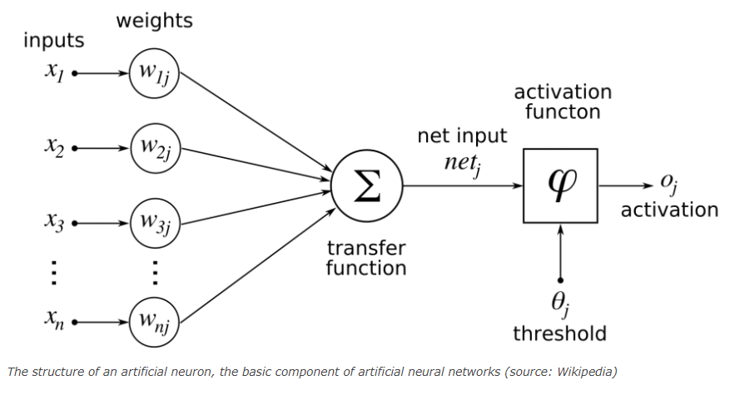

Planning to build a network with three convolutional layers with having max pooling and dropout in between to avoid overfitting of the data. Finally, a Dense to categorize the waste into 6 different labels.

### MobileNet v2:

MobileNet v2 is a convolutional neural network architecture that seeks to perform well on mobile devices. It is based on an inverted residual structure where the residual connections are between the bottleneck layers. The intermediate expansion layer uses lightweight depth wise convolutions to filter features as a source of non-linearity. The architecture of MobileNet v2 contains the initial fully convolution layer with 32 filters, followed by 19 residual bottleneck layers.

MobileNet v2 builds upon the ideas from MobileNet v1, using depthwise separable convolution as efficient building blocks. However, v2 introduces two new features to the architecture:

1) linear bottlenecks between the layers, and

2) shortcut connections between the bottlenecks.

The intuition is that the bottlenecks encode the model’s intermediate inputs and outputs while the inner layer encapsulates the model’s ability to transform from lower-level concepts such as pixels to higher level descriptors such as image categories. Finally, as with traditional residual connections, shortcuts enable faster training and better accuracy.

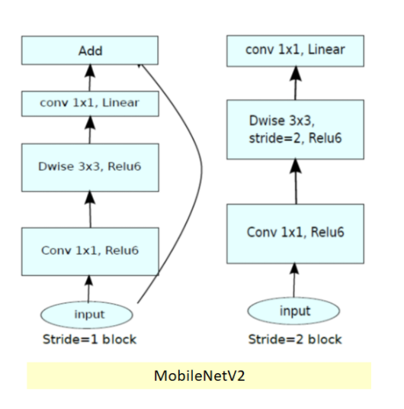

For this project, I’m using a prebuilt CNN model of MobileNet v2 developed by GoogleAI. To this model, I have flattened the layers and added a Dense layer for classifying into six waste Categories.

## Dataset and EDA

For this, I am using a version of trash image dataset which was created by Gary Thung and Mindy Yang. This is a small dataset and consist of 2527 images, which is divided into four different classes glass, paper, plastic, metal, all the pictures of the images are of size 512 x 384. I have resized them to 224 x 224 using the scripts they provided. Few samples of the images are shown below.

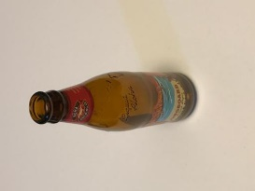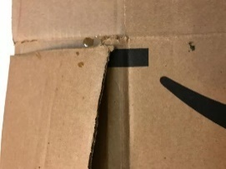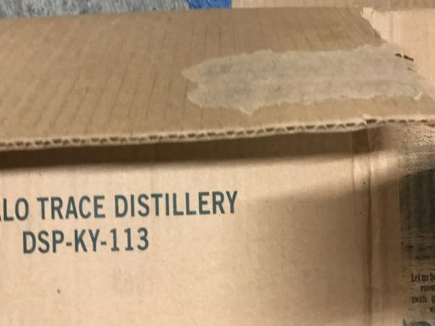

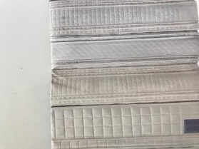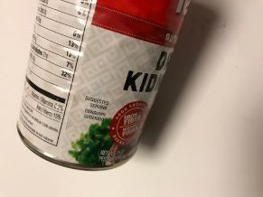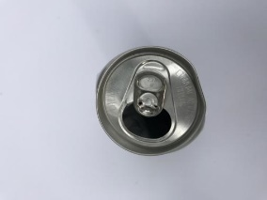a) Cardboard b) Glass

c) Metal d) Paper

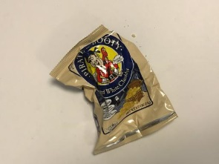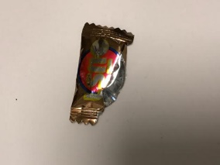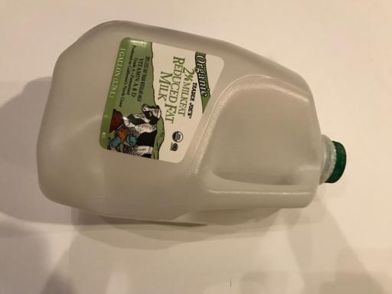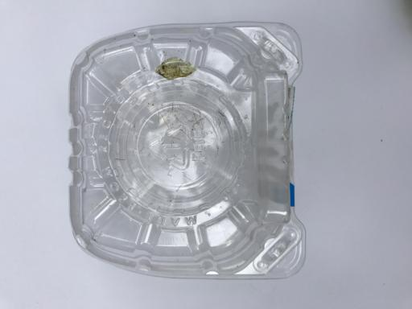

e) Plastic f) Trash

## Results

Running the model, using training data (in batches of 32), for 50 epochs and each epoch taking almost 75 sec to run on Google Colab (on GPU runtime) I got a training accuracy around 90%. Here is a prediction sample for a batch of testing images with the predicted labels with an accuracy of 75%.

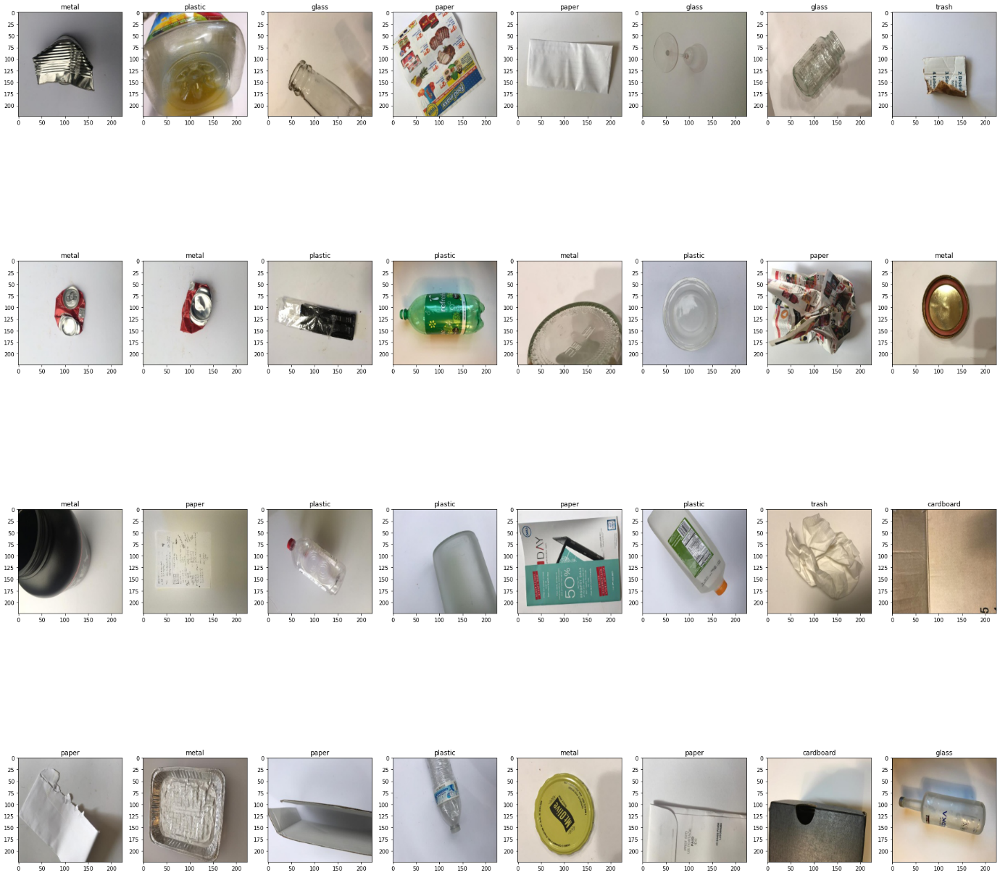

## Conclusion

In conclusion, a waste classification system that can separate different components of waste using the Machine learning tools is proposed. This system can be used to automatically classify waste and help in reducing human intervention and preventing infection and pollution. We can always better the model built using a lot of varied data and having built a standalone system with dedicated infrastructure having enough Memory and Graphics card for better results.

# Bibliography

D. Hoornweg and P. Bhada-Tata, *What a Waste: A Global Review of Solid Waste Management*, World Bank, Washington, DC, USA, 2012.

R. E. Sanderson, *Environmental Protection Agency Office of Federal Activities’ Guidance on Incorporating EPA’s Pollution Prevention Strategy into the Environmental Review Process*, EPA, Washington, DC, USA, 1993.

“The world’s trash crisis, and why many Americans are oblivious,” Apr 2016. [Online]. Available: https://www.latimes.com/world/global-development/ la-fg-global-trash-20160422-20160421-snap-htmlstory.html

Y. LeCun, Y. Bengio, and G. Hinton, “Deep learning,” nature, vol. 521, no. 7553, p. 436, 2015

J. Shihadeh, A. Ansari, and T. Ozunfunmi, “Deep learning based image classification for remote medical diagnosis,” in 2018 IEEE Global Humanitarian Technology Conference. IEEE, 2018, pp. 1–8.

G. Thung and M. Yang, “Trashnet.” [Online]. Available: <https://github.com/garythung/trashnet>

G. Mittal, K. B. Yagnik, M. Garg, and N. C. Krishnan, “Spotgarbage: smartphone app to detect garbage using deep learning,” in Proceedings of the 2016 ACM International Joint Conference on Pervasive and Ubiquitous Computing. ACM, 2016, pp. 940–945.

N. Johansson and H. Corvellec, “Waste policies gone soft: An analysis of European and Swedish waste prevention plans,” Waste Manag., vol. 77, pp. 322–332, 77 (2018) 322-332.

# Python Appendix

Developed the CNN model on Google Colab using below python libraries

TensorFlow  
Keras – ImageDataGenerator, Adam (Optimizer)

OS

NumPy

Conv2D

MobileNetv2

sklearn metrics library is used to measure Accuracy and Classification Report.

