Lab Experiment

Reinforcement Learning - Slot - B21-E14-E22


Submitted by Aditya Pradhan (23BAI10338)

Submitted to Dr Manoj Kumar

Date of submission: 30th March 2026

Aim: To implement the SARSA(λ) reinforcement learning algorithm using eligibility traces to train an agent in OpenAI Gym environments — FrozenLake-v1 (tabular) and CartPole-v1 (tile-coded) — enabling it to learn optimal actions through trial and error, with λ controlling the balance between TD learning and Monte Carlo methods.

Theory:
SARSA(λ) is an on-policy temporal difference (TD) control algorithm that extends plain SARSA by introducing eligibility traces — a short-term memory that tracks recently visited state-action pairs.
Plain SARSA updates only the current state-action pair using the TD error:
δ = r + γ·Q(s', a') − Q(s, a)
SARSA(λ) spreads this update backwards to all recently visited pairs, weighted by their eligibility trace e(s, a). Traces decay by γλ at every step, so recent visits have more influence than older ones.
λ controls the depth of credit assignment:
λ = 0 → pure TD(0), only the current step is updated
λ = 1 → equivalent to Monte Carlo, entire episode is updated
0 < λ < 1 → a blend of both, which is typically the sweet spot
Two types of traces:
Replacing — trace is capped at 1 when revisiting a state
Accumulating — trace keeps adding up on each revisit
For continuous state spaces (like CartPole), the state cannot be stored in a table, so tile coding is used — the continuous state is mapped to a set of binary features (tiles), and Q-values are approximated as a weighted sum of active tiles.
The key advantage of SARSA(λ) over plain SARSA is faster learning — by propagating the TD error through the entire recent history in a single step, rather than waiting for information to slowly back-propagate over many episodes.

Code:
import argparse
import math
import random
from collections import defaultdict

import gymnasium as gym
import matplotlib.pyplot as plt
import numpy as np

class TileCoder:
"""
Converts a continuous state vector into a list of integer tile indices.

How it works
------------
• We lay several overlapping grids (called 'tilings') over the state space.
• Each tiling is slightly offset from the others.
• For a given state, we find which tile it falls into in every tiling.
• The union of those tile indices is the feature representation.

This gives us a sparse, fixed-size binary feature vector — perfect for
linear function approximation with a simple lookup table (our Q-table).
"""

def __init__(self, low, high, num_tilings=8, tiles_per_dim=8):
self.low = np.array(low, dtype=float)
self.high = np.array(high, dtype=float)
self.num_tilings = num_tilings
self.tiles_per_dim = tiles_per_dim
self.n_dims = len(low)

# Total number of unique tiles across all tilings
self.total_tiles = num_tilings * (tiles_per_dim ** self.n_dims)

# Width of one tile in each dimension
self.tile_width = (self.high - self.low) / tiles_per_dim

# Random offsets so tilings don't perfectly overlap
rng = np.random.default_rng(42)
self.offsets = rng.uniform(0, 1, size=(num_tilings, self.n_dims)) * self.tile_width

def encode(self, state: np.ndarray) -> list[int]:
"""Return a list of active tile indices (one per tiling)."""
state = np.clip(state, self.low, self.high)
indices = []
for t in range(self.num_tilings):
shifted = state - self.offsets[t]
tile_coords = np.floor((shifted - self.low) / self.tile_width).astype(int)
tile_coords = np.clip(tile_coords, 0, self.tiles_per_dim - 1)

# Convert multi-dim tile coordinates → single flat index
flat = t
for d in range(self.n_dims):
flat = flat * self.tiles_per_dim + tile_coords[d]
indices.append(flat % self.total_tiles)
return indices

# 2. SARSA(λ) — TABULAR (for discrete state spaces like FrozenLake)

class SarsaLambdaTabular:
"""
Tabular SARSA(λ) for environments with discrete state & action spaces.

Key ideas
---------
Q(s, a) : action-value table — how good is action a in state s?
e(s, a) : eligibility trace — how recently/often was (s,a) visited?

At every step:
1. Compute TD error δ = r + γ·Q(s',a') − Q(s,a)
2. Increase trace for current (s,a)
3. Update ALL (s,a) pairs proportionally to their trace
4. Decay all traces by γ·λ

λ=0 → pure TD(0) / plain SARSA (only current step updated)
λ=1 → Monte Carlo (whole episode updated equally)
"""

def __init__(
self,
n_states: int,
n_actions: int,
alpha: float = 0.1, # learning rate
gamma: float = 0.99, # discount factor
epsilon: float = 1.0, # initial exploration rate
epsilon_min: float = 0.01,
epsilon_decay: float = 0.995,
lam: float = 0.8, # trace decay (λ)
trace_type: str = "replacing", # "replacing" | "accumulating"
):
self.n_states = n_states
self.n_actions = n_actions
self.alpha = alpha
self.gamma = gamma
self.epsilon = epsilon
self.epsilon_min = epsilon_min
self.epsilon_decay = epsilon_decay
self.lam = lam
self.trace_type = trace_type

# Q-table: shape (states × actions), initialised to zero
self.Q = np.zeros((n_states, n_actions))

# ── Action selection

def choose_action(self, state: int) -> int:
"""ε-greedy: explore randomly with probability ε, else pick best action."""
if random.random() < self.epsilon:
return random.randrange(self.n_actions)
return int(np.argmax(self.Q[state]))

# ── One full episode

def run_episode(self, env: gym.Env) -> float:
"""Run one episode; return total undiscounted reward."""
obs, _ = env.reset()
state = int(obs)
action = self.choose_action(state)

# Eligibility traces — reset at the start of every episode
e = np.zeros_like(self.Q)

total_reward = 0.0

while True:
next_obs, reward, terminated, truncated, _ = env.step(action)
done = terminated or truncated
next_state = int(next_obs)
next_action = self.choose_action(next_state)

# ── TD error
target = (0.0 if done else self.gamma * self.Q[next_state, next_action])
delta = reward + target - self.Q[state, action]

# ── Update eligibility trace
if self.trace_type == "replacing":
e[state, action] = 1.0 # cap at 1 (replacing)
else:
e[state, action] += 1.0 # accumulate

# ── Update Q for every (s,a) weighted by its trace
self.Q += self.alpha * delta * e

# ── Decay all traces
e *= self.gamma * self.lam

total_reward += reward
state, action = next_state, next_action

if done:
break

# Decay exploration rate
self.epsilon = max(self.epsilon_min, self.epsilon * self.epsilon_decay)
return total_reward

# ── Training loop

def train(self, env: gym.Env, episodes: int) -> list[float]:
rewards = []
for ep in range(1, episodes + 1):
r = self.run_episode(env)
rewards.append(r)
if ep % max(1, episodes // 10) == 0:
avg = np.mean(rewards[-100:])
print(f" Episode {ep:>5}/{episodes} | "
f"ε={self.epsilon:.3f} | Avg reward (last 100): {avg:.3f}")
return rewards

# 3. SARSA(λ) — FUNCTION APPROXIMATION (for CartPole)

class SarsaLambdaFA:
"""
SARSA(λ) with linear function approximation + tile coding.

Instead of a table indexed by discrete state, we use:
Q(s, a) ≈ Σ w[i] for all active tiles i in tiling(s)

i.e. Q is the sum of weights of active tiles.
The weight vector w is updated via gradient descent on the TD error.

Eligibility traces e[i] track how recently tile i was active.
"""

def __init__(
self,
tile_coder: TileCoder,
n_actions: int,
alpha: float = 0.01,
gamma: float = 0.99,
epsilon: float = 1.0,
epsilon_min: float = 0.01,
epsilon_decay: float = 0.995,
lam: float = 0.9,
):
self.tc = tile_coder
self.n_actions = n_actions
self.alpha = alpha / tile_coder.num_tilings # scale α by tilings
self.gamma = gamma
self.epsilon = epsilon
self.epsilon_min = epsilon_min
self.epsilon_decay = epsilon_decay
self.lam = lam

# Weight vector: one weight per (tile, action)
size = tile_coder.total_tiles * n_actions
self.w = np.zeros(size)

def _indices(self, tiles: list[int], action: int) -> list[int]:
offset = action * self.tc.total_tiles
return [offset + t for t in tiles]

# ── Q-value estimate

def q_value(self, tiles: list[int], action: int) -> float:
return float(np.sum(self.w[self._indices(tiles, action)]))

# ── Action selection

def choose_action(self, tiles: list[int]) -> int:
if random.random() < self.epsilon:
return random.randrange(self.n_actions)
values = [self.q_value(tiles, a) for a in range(self.n_actions)]
return int(np.argmax(values))

# ── One full episode ──────────────────────────────────────────────────────

def run_episode(self, env: gym.Env) -> float:
obs, _ = env.reset()
tiles = self.tc.encode(obs)
action = self.choose_action(tiles)

# Eligibility traces (sparse dict for efficiency)
e = defaultdict(float)

total_reward = 0.0

while True:
next_obs, reward, terminated, truncated, _ = env.step(action)
done = terminated or truncated
next_tiles = self.tc.encode(next_obs)
next_action = self.choose_action(next_tiles)

q_curr = self.q_value(tiles, action)
q_next = 0.0 if done else self.q_value(next_tiles, next_action)
delta = reward + self.gamma * q_next - q_curr

for idx in self._indices(tiles, action):
e[idx] = 1.0 # replacing traces

for idx, trace_val in e.items():
self.w[idx] += self.alpha * delta * trace_val

decayed = {}
for idx, trace_val in e.items():
new_val = self.gamma * self.lam * trace_val
if new_val > 1e-6: # prune near-zero traces
decayed[idx] = new_val
e = decayed

total_reward += reward
tiles, action = next_tiles, next_action

if done:
break

self.epsilon = max(self.epsilon_min, self.epsilon * self.epsilon_decay)
return total_reward

# ── Training loop

def train(self, env: gym.Env, episodes: int) -> list[float]:
rewards = []
for ep in range(1, episodes + 1):
r = self.run_episode(env)
rewards.append(r)
if ep % max(1, episodes // 10) == 0:
avg = np.mean(rewards[-100:])
print(f" Episode {ep:>5}/{episodes} | "
f"ε={self.epsilon:.3f} | Avg reward (last 100): {avg:.1f}")
return rewards

# 4. PLOTTING HELPERS

def smooth(data: list[float], window: int = 50) -> np.ndarray:
"""Simple moving average for smoother reward curves."""
kernel = np.ones(window) / window
return np.convolve(data, kernel, mode="valid")

def plot_rewards(rewards: list[float], env_name: str, lam: float):
fig, axes = plt.subplots(1, 2, figsize=(13, 4))
fig.suptitle(f"SARSA(λ={lam}) — {env_name}", fontsize=14, fontweight="bold")

# Raw rewards
axes[0].plot(rewards, alpha=0.4, color="steelblue", linewidth=0.7, label="Raw")
if len(rewards) >= 50:
s = smooth(rewards, window=50)
x = range(49, len(rewards))
axes[0].plot(x, s, color="darkorange", linewidth=2, label="50-ep moving avg")
axes[0].set_xlabel("Episode")
axes[0].set_ylabel("Total Reward")
axes[0].set_title("Reward per Episode")
axes[0].legend()
axes[0].grid(alpha=0.3)

# Cumulative average
cum_avg = np.cumsum(rewards) / (np.arange(len(rewards)) + 1)
axes[1].plot(cum_avg, color="seagreen", linewidth=2)
axes[1].set_xlabel("Episode")
axes[1].set_ylabel("Cumulative Average Reward")
axes[1].set_title("Learning Progress (Cumulative Avg)")
axes[1].grid(alpha=0.3)

plt.tight_layout()
fname = f"sarsa_lambda_{env_name.replace('-', '_')}.png"
plt.savefig(fname, dpi=120)
print(f"\n 📊 Plot saved → {fname}")
plt.show()

# 5. MAIN — entry point

def parse_args():
p = argparse.ArgumentParser(description="SARSA(λ) — OpenAI Gym")
p.add_argument("--env", default="FrozenLake-v1",
choices=["FrozenLake-v1", "CartPole-v1"],
help="Gym environment to use")
p.add_argument("--episodes", type=int, default=3000, help="Number of training episodes")
p.add_argument("--lam", type=float, default=0.8, help="Lambda (trace decay, 0–1)")
p.add_argument("--alpha", type=float, default=None, help="Learning rate (default per env)")
p.add_argument("--gamma", type=float, default=0.99, help="Discount factor")
p.add_argument("--epsilon", type=float, default=1.0, help="Initial epsilon (exploration)")
p.add_argument("--trace", default="replacing",
choices=["replacing", "accumulating"],
help="Eligibility trace type (tabular only)")
p.add_argument("--no-plot", action="store_true", help="Disable reward plot")
return p.parse_args()

def run_frozen_lake(args):
print("\n" + "="*60)
print(f" SARSA(λ={args.lam}) — FrozenLake-v1 (Tabular)")
print("="*60)

env = gym.make("FrozenLake-v1", is_slippery=True)
n_states = env.observation_space.n
n_actions = env.action_space.n
alpha = args.alpha if args.alpha else 0.1

print(f"\n States: {n_states} | Actions: {n_actions}")
print(f" α={alpha} γ={args.gamma} λ={args.lam} "
f"ε-start={args.epsilon} trace={args.trace}")
print(f" Episodes: {args.episodes}\n")

agent = SarsaLambdaTabular(
n_states=n_states,
n_actions=n_actions,
alpha=alpha,
gamma=args.gamma,
epsilon=args.epsilon,
lam=args.lam,
trace_type=args.trace,
)

rewards = agent.train(env, args.episodes)
env.close()

# Final stats
last_100 = rewards[-100:]
win_rate = sum(r > 0 for r in last_100)
print(f"\n ✅ Training complete!")
print(f" Win rate (last 100 episodes): {win_rate}/100")
print(f" Avg reward (last 100): {np.mean(last_100):.3f}")

if not args.no_plot:
plot_rewards(rewards, "FrozenLake-v1", args.lam)

def run_cartpole(args):
print("\n" + "="*60)
print(f" SARSA(λ={args.lam}) — CartPole-v1 (Tile Coding FA)")
print("="*60)

env = gym.make("CartPole-v1")

# CartPole observation: [cart_pos, cart_vel, pole_angle, pole_vel]
# Clip velocity dims to avoid huge ranges
low = [-4.8, -3.0, -0.42, -3.5]
high = [ 4.8, 3.0, 0.42, 3.5]

tc = TileCoder(low, high, num_tilings=8, tiles_per_dim=8)
n_actions = env.action_space.n
alpha = args.alpha if args.alpha else 0.05

print(f"\n Tile coder: {tc.num_tilings} tilings × {tc.tiles_per_dim}^4 tiles "
f"= {tc.total_tiles:,} total tiles")
print(f" α={alpha} (scaled by tilings) γ={args.gamma} λ={args.lam}")
print(f" Episodes: {args.episodes}\n")

agent = SarsaLambdaFA(
tile_coder=tc,
n_actions=n_actions,
alpha=alpha,
gamma=args.gamma,
epsilon=args.epsilon,
lam=args.lam,
)

rewards = agent.train(env, args.episodes)
env.close()

last_100 = rewards[-100:]
print(f"\n ✅ Training complete!")
print(f" Avg reward (last 100 episodes): {np.mean(last_100):.1f}")
print(f" Max reward seen: {max(rewards):.1f}")
print(f" (CartPole max = 500)")

if not args.no_plot:
plot_rewards(rewards, "CartPole-v1", args.lam)

def main():
args = parse_args()
if args.env == "FrozenLake-v1":
run_frozen_lake(args)
else:
run_cartpole(args)

# Commands to run the application
# python sarsa_lambda.py --env FrozenLake-v1
# python sarsa_lambda.py --env CartPole-v1 --episodes 1000 --lam 0.9 --alpha 0.05

if __name__ == "__main__":
main()

Screenshots of output:

- Frozen Lake environment:
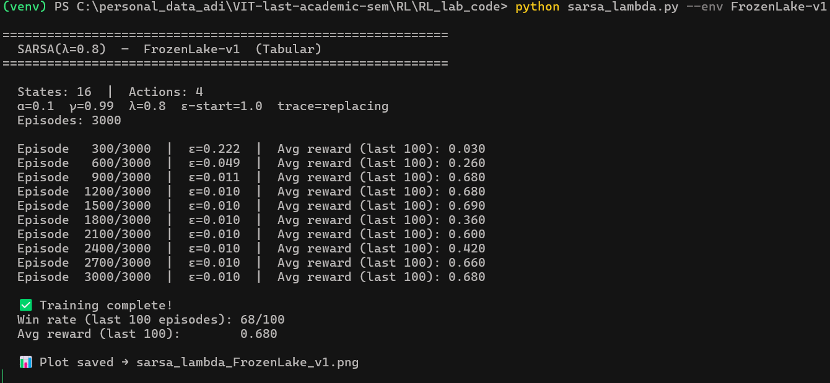
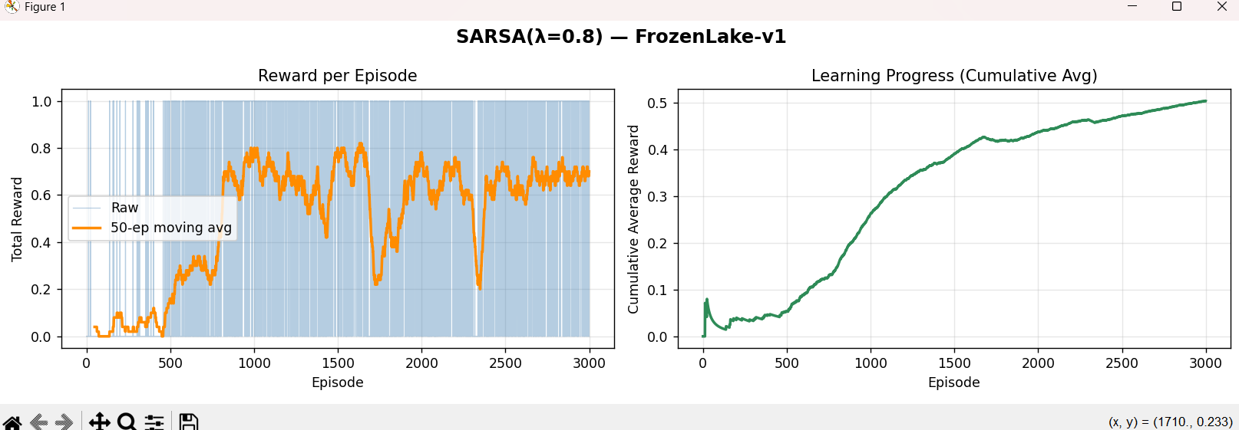

- CartPole environment:
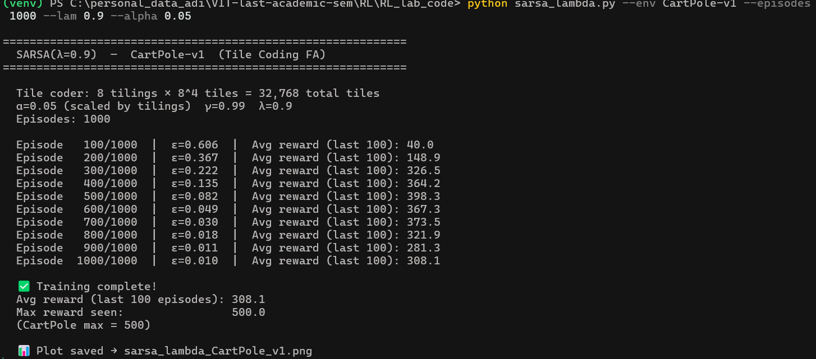
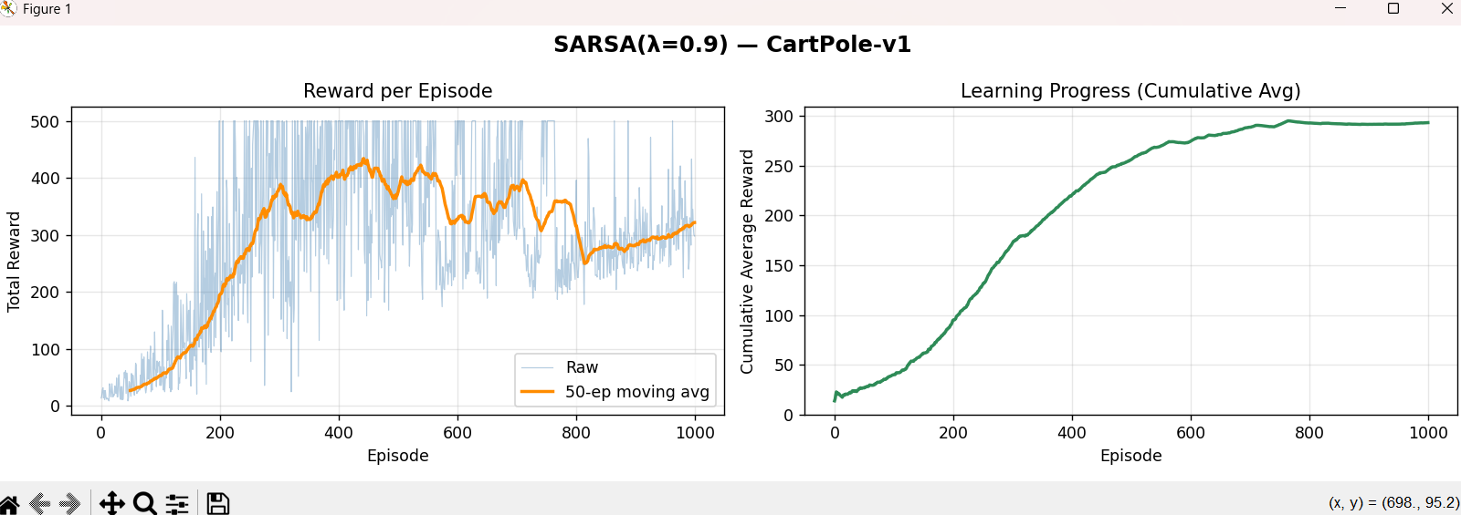

Conclusion:

In this project, the SARSA(λ) reinforcement learning algorithm was successfully implemented and trained on two OpenAI Gym environments — FrozenLake-v1 using a tabular approach and CartPole-v1 using tile-coded function approximation. Eligibility traces allowed the agent to assign credit across recent state-action pairs, resulting in faster and more stable learning compared to standard SARSA.
The visualizations of reward per episode demonstrate a clear upward learning trend, with the agent transitioning from random exploration in early episodes to consistent reward maximization as training progressed — validating the effectiveness of the λ parameter in accelerating policy improvement.
Overall, SARSA(λ) proved capable of handling both discrete and continuous environments effectively, confirming that eligibility traces are a valuable mechanism for improving reinforcement learning performance in practice.

