PIZZA SALES SQL QUERIES

A.KPI’s
1.Total Revenue-
SELECT SUM(total_price) AS Total_Revenue FROM pizza_sales;
Output-
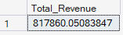
2.Average Order Value-
SELECT SUM(total_price) / COUNT(DISTINCT order_id) AS Avg_Order_Value FROM pizza_sales;
Output-
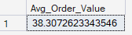
3.Total Pizza Sold-
SELECT SUM(total_price) AS Total_Pizza_Sold FROM pizza_sales;
Output-
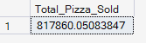
4.Total Orders-
SELECT COUNT(DISTINCT Order_id) AS Total_Order FROM pizza_sales;
Output-
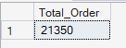
5.Average Price Per Order-
SELECT CAST(SUM(quantity) AS DECIMAL(10,2))/
CAST(COUNT(DISTINCT Order_id) AS DECIMAL(10,2)) AS DECIMAL(10,2))
AS Avg_Pizzas_per_order
FROM pizza_sales;
Output-
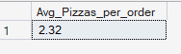

B. Daily Trend for Total Orders
SELECT DATENAME(DW, order_date) AS order_day,
COUNT(DISTINCT order_id) AS total_orders
FROM pizza_sales
GROUP BY DATENAME(DW, order_date);
Output-

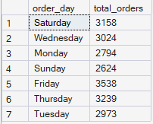

B. Daily Trend for Total Orders
SELECT DATEPART (HOUR,order_time) AS order_hours ,
COUNT(DISTINCT order_id) AS total_order
FROM pizza_sales
GROUP BY DATEPART(HOUR,order_time)
ORDER BY DATEPART(HOUR,order_time);
Output-

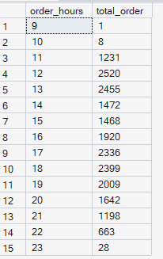

D. % of Sales by Pizza Category
SELECT pizza_category, CAST(SUM(total_price) AS DECIMAL(10,2)) as total_revenue,
CAST(SUM(total_price) * 100 / (SELECT SUM(total_price) from pizza_sales) AS DECIMAL(10,2)) AS PCT
FROM pizza_sales
GROUP BY pizza_category
Output-

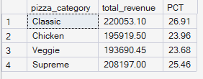

E. % of Sales by Pizza Size
SELECT pizza_size, CAST(SUM(total_price) AS DECIMAL(10,2)) as total_revenue,
CAST(SUM(total_price) * 100 / (SELECT SUM(total_price) from pizza_sales) AS DECIMAL(10,2)) AS PCT
FROM pizza_sales
GROUP BY pizza_size
ORDER BY pizza_size

Output-
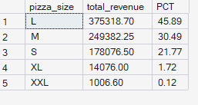
F. Total Pizzas Sold by Pizza Category
SELECT pizza_category, SUM(quantity) as Total_Quantity_Sold
FROM pizza_sales
WHERE MONTH(order_date) = 2
GROUP BY pizza_category
ORDER BY Total_Quantity_Sold DESC
OUTPUT-
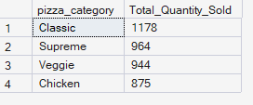

G. Top 5 Best Sellers by Total Pizzas Sold
SELECT Top 5 pizza_name, SUM(quantity) AS Total_Pizza_Sold
FROM pizza_sales
GROUP BY pizza_name
ORDER BY Total_Pizza_Sold DESC
OUTPUT-
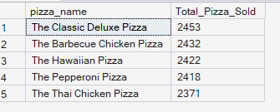

H. Bottom 5 Best Sellers by Total Pizzas Sold
SELECT TOP 5 pizza_name, SUM(quantity) AS Total_Pizza_Sold
FROM pizza_sales
GROUP BY pizza_name
ORDER BY Total_Pizza_Sold ASC
OUTPUT-
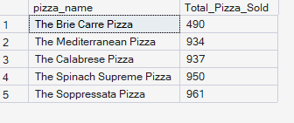

NOTE
If you want to apply the Month, Quarter, Week filters to the above queries you can use WHERE clause. Follow some of below examples
SELECT DATENAME(DW, order_date) AS order_day, COUNT(DISTINCT order_id) AS total_orders
FROM pizza_sales
WHERE MONTH(order_date) = 1
GROUP BY DATENAME(DW, order_date)

*Here MONTH(order_date) = 1 indicates that the output is for the month of January. MONTH(order_date) = 4 indicates output for Month of April.

SELECT DATENAME(DW, order_date) AS order_day, COUNT(DISTINCT order_id) AS total_orders
FROM pizza_sales
WHERE DATEPART(QUARTER, order_date) = 1
GROUP BY DATENAME(DW, order_date)

*Here DATEPART(QUARTER, order_date) = 1 indicates that the output is for the Quarter 1. MONTH(order_date) = 3 indicates output for Quarter 3.

