Marketing Performance Dashboard
Data Analytics Capstone Project Report
SkillOrbit
Submitted by: ____________________

1. Introduction
The Marketing Performance Dashboard is a data analytics application that tracks, analyses and visualises marketing campaign performance across channels. It helps a business measure campaign effectiveness, customer engagement and return on investment through an interactive dashboard, automatic insights and downloadable reports.

Objectives
- Analyse marketing campaign data
- Track customer engagement metrics
- Monitor campaign performance
- Compare marketing channels
- Generate reports and business insights

2. Tech Stack
Area | Tool
Language | Python 3.10+
Libraries | Pandas, NumPy, Plotly, openpyxl
Dashboard | Streamlit
Database | SQLite
Testing | pytest
Deployment | Streamlit Cloud

3. Workflow
The project follows the six-stage workflow from the brief: data collection, cleaning and processing, KPI analysis, dashboard visualisation, insight generation and report creation. Each stage is a separate Python script in the src/ folder, so the whole pipeline can be rebuilt from scratch.

4. Data Collection
A public dataset could not be downloaded, so a dataset was generated with a Python script (generate_data.py, fixed random seed 42). It models 24 campaigns across 6 channels (Google Ads, Facebook, Instagram, Email, YouTube, LinkedIn) during 2025, with weekday patterns and a festive-season boost in October to December. Each row is one campaign on one day.
Columns: date, campaign, channel, impressions, clicks, conversions, spend, revenue, engagement, reach.
The raw file was deliberately made messy so that the cleaning step has real work to do.

5. Data Cleaning
clean_data.py fixes the problems below and writes a log (docs/cleaning_log.txt) with the number of rows fixed at each step.
Problem in raw data | How it was fixed
Two date formats (YYYY-MM-DD and DD/MM/YYYY, about 6% of rows) | Parsed both and converted to one format
Channel and campaign names with mixed casing and extra spaces | Trimmed spaces and mapped every variant to one standard spelling
Missing clicks, spend, revenue, engagement and reach (2% to 4% each) | Filled using each campaign's own typical ratio (for example spend from cost per click)
Negative spend values | Treated as sign errors and made positive
Clicks greater than impressions | Set to missing, then refilled from the campaign's typical click-through rate
Exact duplicate rows (about 2%) and repeated date + campaign rows | Removed

Final validation: no null values, no duplicates, no negative numbers, no row with clicks above impressions. The clean file has 4,503 rows covering 9 Jan 2025 to 30 Dec 2025.

6. Database
The clean data is loaded into SQLite (marketing.db) using three tables: channels, campaigns and daily_performance, joined by a view called v_marketing. The dashboard reads from this view. Five sample SQL queries (saved in src/sample_queries.sql) cover ROI by channel, top campaigns by revenue, monthly impressions and conversions, conversion rate by channel, and campaigns with above-average ROI.

7. KPI Analysis
All ratios are calculated from summed totals, never by averaging row-level ratios, which would give wrong results.
KPI | Formula
CTR | clicks / impressions
Conversion rate | conversions / clicks
CPC | spend / clicks
CPA | spend / conversions
ROI % | (revenue - spend) / spend x 100
ROAS | revenue / spend
Engagement rate | engagement / impressions

Overall results
Metric | Value
Spend | ₹40,129,125
Revenue | ₹538,912,554
ROI / ROAS | 1,243% / 13.43x
Impressions / Clicks / Conversions | 106,174,173 / 3,085,508 / 212,981
CTR / Conversion rate | 2.91% / 6.90%
CPC / CPA | ₹13.01 / ₹188.42
Engagement rate | 5.11%

Channel performance (ranked by ROI)
Channel | Spend (₹) | Revenue (₹) | Conv. rate % | CPA (₹) | ROI %
Email | 3,161,498 | 291,182,585 | 10.41 | 29 | 9,110
Google Ads | 18,908,282 | 155,283,729 | 7.49 | 292 | 721
Facebook | 3,860,645 | 24,684,778 | 3.70 | 299 | 539
LinkedIn | 6,337,861 | 32,331,887 | 4.60 | 829 | 410
Instagram | 5,611,344 | 25,388,713 | 3.01 | 469 | 352
YouTube | 2,249,495 | 10,040,862 | 2.24 | 405 | 346

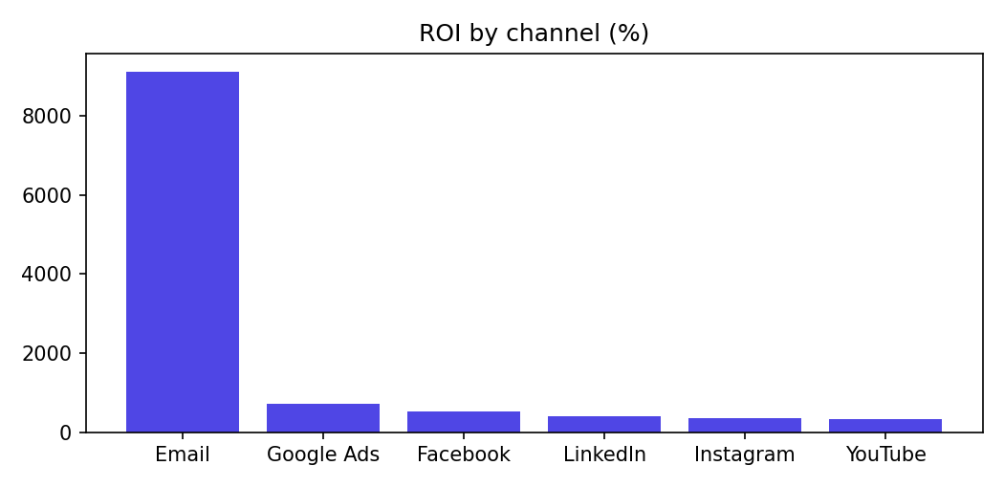
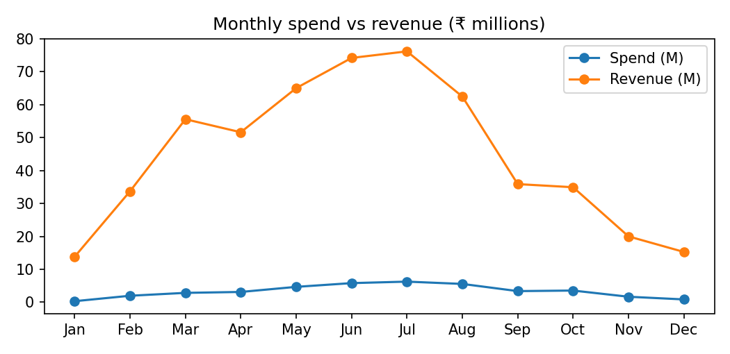

8. Dashboard
The Streamlit dashboard (app.py) has sidebar filters for date range, channel and campaign, a row of KPI cards, and six tabs:
- Trends: monthly spend vs revenue, engagement rate trend, monthly conversions
- Channels: ROI and conversion rate by channel, plus a comparison table
- Campaigns: top 10 campaigns by revenue, ROI or conversions, plus a full table
- Funnel: impressions to clicks to conversions
- Insights: automatic business insights and a spend share vs revenue share chart
- Reports: download buttons for all reports
Every chart, KPI card, insight and report responds to the sidebar filters.

9. Business Insights and Recommendations
Insights are generated by code (insights.py) from the data, so they stay correct when filters change.

Findings
- Best campaigns by ROI: Loyalty Rewards (Email) 11,368%, Cart Abandonment (Email) 8,738%, Monthly Newsletter (Email) 7,273%.
- Best campaign by revenue: Loyalty Rewards (Email), ₹131.3M.
- Weakest campaigns: Shopping Ads Q4 (Google Ads) 226%, Unboxing Series (YouTube) 243%, Lookalike Audience (Facebook) 260%.
- Email converts best (10.41% of clicks, CPA ₹29). YouTube converts least (2.24%). LinkedIn has the most expensive customers (CPA ₹829).
- Instagram has the highest engagement rate (7.86%). Overall engagement rose from 4.73% in the first 3 months to 5.66% in the last 3 months, peaking in November 2025 (5.99%).
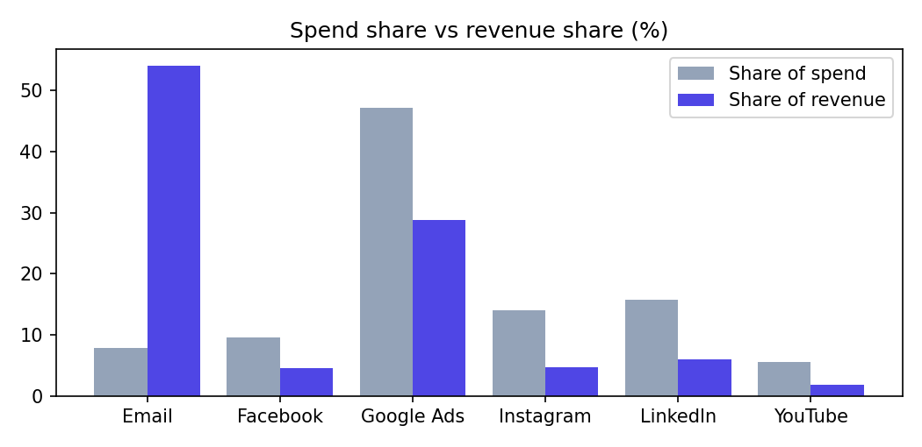

Recommendations
- Shift budget towards Email. It gets 8% of spend but earns 54% of revenue.
- Review spend on Google Ads. It takes 47% of spend but returns only 29% of revenue. Cut low-ROI campaigns before cutting the channel.
- Fix or pause Shopping Ads Q4, the lowest-ROI campaign, by testing new creatives or targeting.
- Turn Instagram engagement into sales with clearer calls-to-action and shoppable links.
- Reduce LinkedIn acquisition cost with tighter targeting and better landing pages.

10. Report Generation
reports.py creates the three reports required by the brief, all available as downloads in the Reports tab and respecting the sidebar filters:
- Campaign report (CSV): one row per campaign with all KPIs, revenue rank and ROI rank
- Monthly analytics report (CSV): one row per month with all KPIs and month-over-month change in spend, revenue and conversions
- Marketing summary (Markdown): headline KPIs, channel table and key insights
- Full Excel workbook: Overview, Channels, Campaigns and Monthly sheets

11. Testing and Validation
tests/test_kpis.py contains 18 automated tests, and all 18 pass. They cover:
- KPI math checked against a small dataset with hand-calculated answers, including a test that proves ratios come from sums
- Data quality: no nulls, no duplicates, no negative values, clicks not above impressions, consistent channel names, 6 channels, one channel per campaign
- Consistency: channel totals match overall totals; share table adds up to 100%
- Reports: campaign, monthly, channel, summary and Excel outputs, including filtered data

12. Limitations and Future Work
- The dataset is self-generated, so absolute values (for example Email ROAS of about 92x) are unrealistically high. The method and rankings are what matter. With real data the same code would work after matching the column names.
- The app reads a static database and does not update in real time, in line with the project scope.
- Possible extensions: real data sources, budget forecasting, and A/B test analysis.

13. Conclusion
The project delivers a complete analytics workflow: data generation, cleaning, a SQLite database, KPI analysis, an interactive dashboard, automatic insights, reports and tests. It shows how a business can use data to decide where to put marketing budget and which campaigns to fix.

