Assignment: Alteryx Data Preparation & Data Profiling Intro using San Francisco Trees

## SF_Trees:

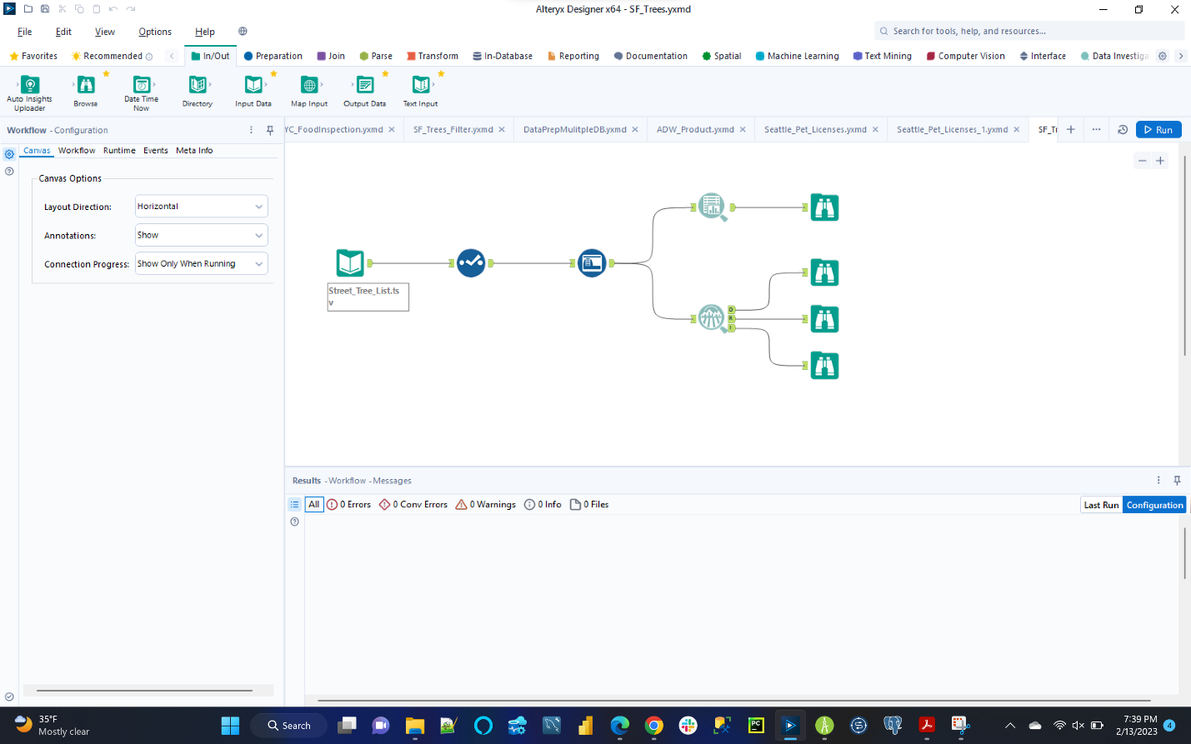

## SF_Trees_Runtime:

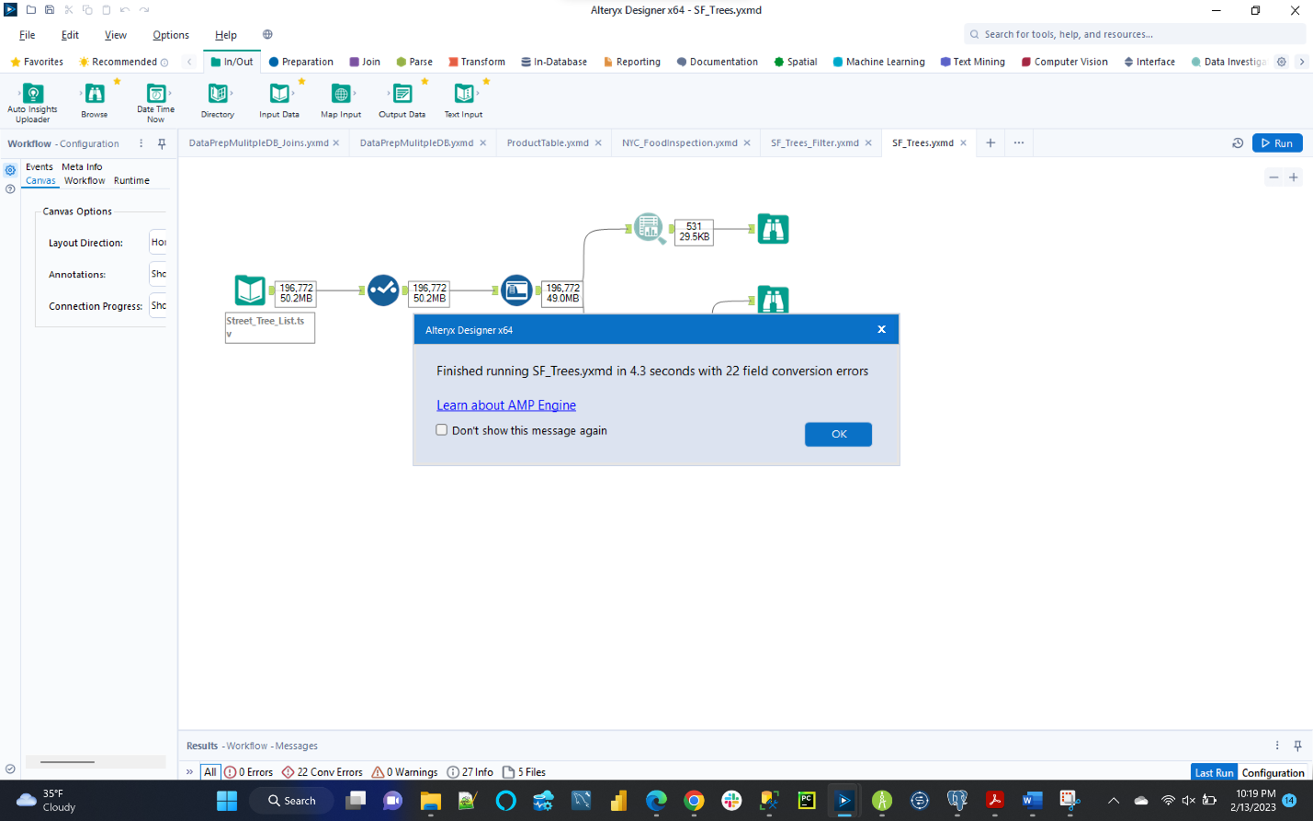

## SF_Trees_Filter:

## SF_Trees_Filter_Runtime:

