BlockPort AI
Blockchain-Enabled Green Maritime Intelligence for Smart Port Operations

Abstract
While the global trade ecosystem is a fundamental pillar of the modern economy, port operations tend to be fragmented, complicated, data intensive, and susceptible to congestion, delays, inefficient resource use, and environmental pressures. How can existing methods be rethought to realize smarter and more sustainable ports?
BlockPort AI is an intelligent operating platform that enables traditional ports to transform into adaptive smart-ports with increased sustainability and efficiency. The proposed system will use AI, IoT, Digital Twin platforms, optimization algorithms, and blockchain to realize a Maritime Intelligence Platform. AI models analyze movements, port calls, berthing allocations, terminal capacities, weather, traffic, energy use, and historical operations to anticipate congestion, estimate time of arrival, optimize berth allocation, schedule ground transportation, and suggest fuel- and emission-saving operations. A Digital Twin of the port enables operators to simulate potential scenarios and evaluate alternative decisions in the physical domain. A blockchain layer adds a trusted and tamper-proof layer to the system, recording relevant events and transactions and verified environmental impact without exposing the system to the need to store large amounts of operational data on-chain.
BlockPort AI brings in a Green Port Intelligence layer that evaluates the environmental impact of different decisions, as well as methods to reduce costs, waiting times, fuel-burning, and CO2 emissions at the same time. An AI Port Copilot provides explainable suggestions to human decision-makers while retaining human-in-the-loop principles for critical operations. The system realizes a closed-loop of predict → simulate → optimize → execute → verify → learn to transform a traditional port into an intelligent, self-learning entity.
The proposed platform will demonstrate how digitalization can be leveraged to improve both economic and environmental performance while building data trust and realizing operational resilience. At a higher level, BlockPort AI will aim to enable the foundational layer for an interoperable maritime intelligence network that realizes trusted information exchange and cooperative optimization between ports, shipping companies, terminals, logistics partners, and regulators, ultimately creating a global maritime operating intelligence layer that makes the movement of goods faster, cleaner, more resilient, and more transparent.

1. Introduction
Maritime transportation plays an important role in the global economy by connecting countries, supporting international trade, and enabling the movement of goods across continents. At the centre of this network are ports, which serve as major points of connection between sea, road, and rail transportation. Their operations extend beyond the arrival and departure of vessels to include berth allocation, cargo handling, container storage, customs procedures, and the coordination of inland logistics. As the demand for maritime trade continues to grow, ports are under increasing pressure to handle operations more efficiently, use available resources effectively, and reduce their environmental impact. Meeting these expectations requires more than expanding physical infrastructure; it also calls for better coordination, timely information, and more informed decision-making.
Managing a port is a complex task because its activities are closely connected. A delay in the arrival of one vessel can affect berth availability, cargo-handling schedules, equipment allocation, and the movement of goods beyond the terminal. Unexpected weather conditions, equipment failures, changes in shipping schedules, and fluctuations in cargo demand can create further disruptions. These challenges become more difficult to manage when operational information is spread across different systems or when decisions are made without a complete picture of current conditions. Conventional planning methods and fixed schedules remain useful, but they may not always provide the flexibility needed to respond to rapidly changing circumstances. The result can be longer vessel waiting times, inefficient resource utilization, increased operating costs, and avoidable pressure on port infrastructure. This creates a need for a more connected approach in which information from different operational activities can be used to anticipate problems and support timely decisions.
Advances in digital technology offer new ways to address these challenges. The Internet of Things (IoT) can provide information from connected sensors, vessels, equipment, and transportation systems, helping operators maintain a clearer view of ongoing activities. Artificial intelligence (AI) can use this information, together with historical records and external conditions, to estimate vessel arrival times, identify potential congestion, and support berth allocation and resource scheduling. Digital Twin technology can extend this capability by representing relevant port operations in a virtual environment, where alternative schedules and responses to disruptions can be examined before they are implemented. However, the value of these technologies depends not only on their individual capabilities but also on how effectively they work together. Predictions are of limited use if they cannot inform operational decisions, while simulations may produce misleading results if the underlying data is incomplete, outdated, or unreliable.
Information sharing presents another challenge in the maritime sector. Port authorities, shipping companies, terminal operators, logistics providers, and regulatory bodies often work with separate systems and maintain their own operational records. When information passes between these organizations, questions can arise about its accuracy, origin, and whether it has been altered. Establishing a reliable record of shared events is particularly important when operational decisions or environmental claims need to be reviewed by multiple parties. Blockchain technology offers a possible way to strengthen this process by maintaining a traceable and tamper-evident record of selected transactions and events. Nevertheless, recording every sensor reading and operational document directly on a blockchain would be impractical for a system that handles large and continuously changing datasets. A more suitable approach is to retain detailed operational data in conventional databases or other off-chain storage systems while recording selected cryptographic hashes, references, approvals, and verification records on the blockchain. This arrangement can support traceability without placing the entire data burden on the distributed ledger.
Alongside efficiency and information reliability, environmental sustainability has become an essential consideration in port management. Vessel waiting, unnecessary equipment movements, and poorly coordinated transportation can contribute to additional fuel consumption and emissions. Improving operational performance can help reduce some of these effects, but the relationship is not always straightforward. A scheduling decision that saves time may not necessarily minimize energy use or emissions in every situation. Environmental considerations therefore need to be included when alternative operational plans are evaluated, rather than treated as a separate concern after decisions have been made. Measures such as fuel consumption, energy use, vessel waiting time, and estimated carbon emissions can help port operators understand the trade-offs between cost, efficiency, and environmental performance.
Against this background, this paper proposes BlockPort AI: Blockchain-Enabled Green Maritime Intelligence for Smart Port Operations, an integrated framework intended to bring operational intelligence, environmental assessment, and trusted information exchange into a common decision-support system. The proposed framework combines AI, IoT, Digital Twin technology, optimization algorithms, and blockchain, with each component contributing to a different stage of port management. AI-based models support the prediction of vessel arrivals and potential congestion, while optimization techniques help evaluate berth assignments, terminal resource allocation, and transportation schedules. The Digital Twin provides a virtual environment in which alternative decisions can be examined, allowing their likely operational consequences to be considered before implementation.
A central feature of BlockPort AI is its Green Port Intelligence layer, which incorporates environmental indicators into operational planning. By considering estimated fuel consumption, energy use, and carbon emissions alongside waiting time, cost, and resource availability, the framework aims to help identify solutions that balance operational requirements with sustainability goals. The proposed AI Port Copilot further supports this process by presenting recommendations and explaining the factors that influence them. Human supervision remains important, particularly for decisions involving safety, significant operational changes, or circumstances that cannot be fully captured by the available data. Meanwhile, the blockchain component is intended to improve the traceability of selected operational events and environmental records, with detailed datasets maintained off-chain where appropriate.
The framework connects these capabilities through a continuous process of prediction, simulation, optimization, execution, verification, and learning. Operational results can be compared with earlier predictions to identify discrepancies and inform future planning. For example, differences between expected and actual vessel waiting times may reveal limitations in an arrival prediction or scheduling decision. Such feedback can support improvements to subsequent recommendations, provided that suitable data, evaluation procedures, and learning mechanisms are in place.
The main aim of this research is to examine how these technologies can be brought together to address the connected challenges of port efficiency, environmental sustainability, and information reliability. Rather than considering congestion, emissions, and data trust as separate problems, BlockPort AI proposes a coordinated framework in which they can be considered during the same decision-making process. The proposed approach provides a basis for exploring more intelligent and transparent port operations and for improving coordination among maritime stakeholders. Its practical effectiveness, however, will depend on the quality of available data, the suitability of the models and optimization methods, the reliability of system integration, and evaluation under realistic operating conditions.

2. Scope of the Project
BlockPort AI explores how digital technologies can be brought together to address some of the major challenges in port management. The project focuses on developing an integrated framework that connects artificial intelligence (AI), the Internet of Things (IoT), Digital Twin technology, optimization algorithms, and blockchain to support more efficient, sustainable, and reliable port operations. Rather than treating congestion, resource management, environmental impact, and information sharing as separate problems, the framework considers how these areas influence one another and how coordinated decision-making can help improve overall port performance.
The scope of the project includes collecting and analyzing information related to vessel movements, arrival times, berth availability, terminal capacity, weather conditions, transportation schedules, and energy consumption. AI-based models are intended to use this information to estimate vessel arrival times, identify potential congestion, and anticipate operational delays. Based on these predictions, optimization algorithms can evaluate berth assignments and resource schedules, taking into account practical limitations such as berth availability, vessel requirements, and terminal capacity. The aim is to help port operators make better use of available resources while reducing avoidable waiting times and operational disruptions.
Another part of the project involves using Digital Twin technology to represent relevant port activities in a virtual environment. This allows alternative schedules and possible responses to unexpected events to be examined before decisions are applied to actual operations. The framework also incorporates a Green Port Intelligence layer that considers fuel consumption, energy use, waiting time, and estimated carbon emissions when comparing operational alternatives. In this way, environmental performance becomes part of the planning process rather than being considered only after an operation has been completed.
The project also examines how blockchain can improve the traceability and reliability of information shared among maritime stakeholders. Selected operational events, transaction references, approvals, and environmental verification records may be recorded on the blockchain, while detailed operational datasets remain in off-chain storage. An AI Port Copilot is proposed to bring the results of these analytical processes together and present recommendations with explanations that port operators can assess before taking action. Human supervision remains an important part of the framework, particularly for decisions involving safety and critical port activities.
The intended application of BlockPort AI extends to coordination among port authorities, shipping companies, terminal operators, logistics providers, and regulatory bodies. Its working approach connects prediction, simulation, optimization, execution, verification, and learning, allowing operational outcomes to be compared with earlier expectations and used to improve future decisions.
The project is primarily concerned with the design and evaluation of this integrated framework. It does not assume that all port activities will be fully automated or that existing port management systems will be replaced. The extent to which the proposed approach can improve operational efficiency, reduce environmental impact, and strengthen information reliability will need to be assessed using suitable data, performance indicators, and realistic test scenarios. The overall aim is to establish a practical foundation for future smart-port solutions that are better coordinated, more transparent, and more responsive to changing operational and environmental demands.

3. Project Objectives
The main objective of BlockPort AI is to develop an integrated maritime intelligence framework that can support more efficient port operations, improve the reliability of shared information, and encourage environmentally responsible decision-making. The project explores how artificial intelligence (AI), the Internet of Things (IoT), Digital Twin technology, optimization algorithms, and blockchain can work together to address these challenges. Its effectiveness will be assessed by examining both operational improvements and the reliability of the proposed system.
The specific objectives of the project are as follows:
1. Improve vessel arrival prediction: Develop an AI-based model to estimate vessel arrival times using relevant historical and operational data. The model will be evaluated using mean absolute error (MAE), with a proposed target of achieving an average prediction error of less than 30 minutes on the selected evaluation dataset.
2. Reduce vessel waiting time: Apply optimization techniques to berth allocation and scheduling to reduce the time vessels spend waiting for an available berth. The proposed target is to achieve at least a 10% reduction in average vessel waiting time compared with a defined baseline scheduling method, while respecting operational constraints.
3. Improve port resource utilization: Examine how intelligent scheduling and resource allocation can improve the use of available berths and terminal facilities. The project aims for at least a 10% relative improvement in the selected resource-utilization metric compared with the baseline, without compromising vessel compatibility or operational feasibility.
4. Incorporate environmental sustainability into decision-making: Evaluate the environmental effects of alternative operational decisions by considering fuel consumption, energy use, and estimated carbon emissions. The proposed target is to reduce estimated emissions per unit of cargo handled by at least 5% compared with the baseline scenario, subject to the availability of reliable operational data and suitable emission factors.
5. Evaluate alternative port operating scenarios: Develop a Digital Twin-based simulation workflow to examine at least three scenarios, including alternative berth assignments, unexpected vessel arrival delays, and changes in terminal capacity. The purpose is to compare possible outcomes and understand how different decisions may affect waiting time, resource utilization, and environmental performance.
6. Improve data integrity and traceability: Develop a blockchain-based mechanism for recording selected operational events, transaction references, and verification records. During controlled testing, the framework will aim to achieve 100% successful integrity verification of valid test records and correctly identify deliberately altered records.
7. Support transparent and explainable decisions: Develop a proposed AI Port Copilot that presents operational recommendations along with the factors influencing them. Its performance will be assessed using predefined criteria for recommendation relevance, correctness, clarity, and compliance with operational constraints.
8. Evaluate the overall performance of the framework: Compare BlockPort AI with clearly defined baseline methods using measurable indicators, including vessel arrival prediction error, average waiting time, resource utilization, estimated emissions per unit of cargo, and blockchain verification performance. The evaluation will identify the areas in which the framework provides improvements and any limitations that require further attention.
These objectives will be evaluated using suitable historical or simulated port data, controlled experiments, and clearly defined measurement procedures. The numerical values represent proposed performance targets rather than established outcomes and may require adjustment based on data availability, baseline performance, and implementation constraints. The overall aim is to determine whether integrating predictive analysis, operational simulation, optimization, environmental assessment, and blockchain-based verification can provide measurable benefits over the selected baseline approaches.

4. Terminologies
This section describes the key terms used in the BlockPort AI framework and explains their relevance to the proposed system. Since the project brings together several technologies and operational concepts, understanding these terms helps clarify how the different components contribute to more efficient port operations, reliable information sharing, and environmental sustainability.
4.1. Smart Port
A smart port uses digital technologies and connected systems to manage port activities more effectively. These technologies help improve the coordination of vessel arrivals, cargo handling, resource allocation, and transportation. In BlockPort AI, the smart-port concept involves connecting these activities through a common framework so that decisions can be made using timely and relevant operational information.
4.2. Artificial Intelligence (AI)
Artificial intelligence enables computer systems to analyze information, recognize patterns, and generate predictions or recommendations. In BlockPort AI, AI is intended to help operators anticipate vessel delays, identify potential congestion, estimate arrival times, and make better use of available resources. Its usefulness depends on the quality of the data and the accuracy of the models employed.
4.3. Internet of Things (IoT)
The Internet of Things refers to physical devices that collect and exchange information through connected networks. In a port environment, sensors and connected equipment can provide information about vessel movements, machinery conditions, traffic, and energy consumption. BlockPort AI can use this information to build a more up-to-date picture of port activities and support its predictive and analytical functions.
4.4. Digital Twin
A Digital Twin is a virtual representation of a physical asset or system that can be updated using relevant operational data. In BlockPort AI, it provides a digital environment for examining port activities and testing alternative operating plans. For example, operators could compare different berth assignments or examine the effects of an unexpected vessel delay before deciding how to respond.
4.5. Maritime Intelligence Platform
A Maritime Intelligence Platform brings together operational data, analytical methods, and decision-support tools to improve maritime operations. In BlockPort AI, it serves as the overall framework connecting AI-based predictions, Digital Twin simulations, optimization algorithms, environmental assessment, and blockchain-based verification.
4.6. Estimated Time of Arrival (ETA)
Estimated Time of Arrival is the predicted time at which a vessel is expected to reach a particular destination or location. Reliable ETA estimates help port operators prepare berths, coordinate equipment, and plan cargo-handling activities. BlockPort AI aims to improve arrival predictions by analyzing relevant information such as vessel movements, historical records, and weather conditions.
4.7. Berth Allocation
Berth allocation involves assigning arriving vessels to suitable berthing positions within a port. The process must consider factors such as vessel dimensions, arrival times, berth availability, and operational requirements. BlockPort AI uses predicted arrival information and optimization techniques to evaluate berth assignments, with the aim of reducing waiting time and avoiding conflicts in scheduling.
4.8. Optimization Algorithms
Optimization algorithms are computational methods used to identify suitable solutions while meeting specified objectives and constraints. In port operations, they can help determine vessel schedules, allocate berths, and coordinate available resources. BlockPort AI uses this approach to compare possible operating plans while considering factors such as time, cost, resource availability, and environmental impact.
4.9. Green Port Intelligence
Green Port Intelligence is the proposed component of BlockPort AI that brings environmental considerations into operational planning. It examines indicators such as fuel consumption, energy use, vessel waiting time, and estimated carbon emissions alongside conventional performance measures. This allows the framework to consider whether an operational decision can improve efficiency while also reducing its environmental impact.
4.10. Blockchain Technology
Blockchain is a distributed ledger technology that maintains records across a network according to an agreed set of rules. Its structure and cryptographic mechanisms help make unauthorized alterations to recorded information detectable. In BlockPort AI, blockchain is intended to provide a traceable record of selected transactions and operational events, helping participating organizations verify information shared between them.
4.11. Data Integrity
Data integrity refers to the accuracy, consistency, and reliability of information throughout its collection, storage, and use. It is important in port operations because decisions may depend on records shared by several organizations. BlockPort AI proposes using data validation and blockchain-based verification to help identify unauthorized changes to selected records. However, these mechanisms cannot independently guarantee that the original information was accurate when it was entered into the system.
4.12. Off-Chain Storage
Off-chain storage refers to keeping data outside the blockchain. Port operations can generate large amounts of sensor readings, vessel information, and operational records, making it impractical to store every detail directly on a distributed ledger. BlockPort AI therefore proposes retaining detailed datasets in suitable external storage systems while recording selected cryptographic hashes, data references, and verification records on the blockchain. This approach helps manage storage requirements while supporting data integrity checks.
4.13. Smart Contracts
Smart contracts are programs deployed on a blockchain that execute predefined instructions when specified conditions are satisfied. In BlockPort AI, they could support selected processes, such as recording approvals or managing agreed verification procedures. Their practical application would depend on the chosen blockchain platform, the reliability of the information supplied to them, and the requirements of the system being implemented.
4.14. AI Port Copilot
The AI Port Copilot is a proposed decision-support component designed to help port operators interpret information and assess possible actions. It can present recommendations alongside explanations of the factors that influence them. For example, it could explain why a particular berth assignment is preferred based on expected waiting time, resource availability, and environmental considerations. Its purpose is to assist port personnel rather than replace their responsibility for critical decisions.
4.15. Human-in-the-Loop (HITL)
Human-in-the-Loop refers to an approach in which people remain involved in reviewing, supervising, or approving decisions supported by automated systems. In BlockPort AI, operators can examine AI-generated recommendations, consider circumstances that may not be reflected in the available data, and approve or modify proposed actions when necessary. This is particularly important for decisions involving safety and significant operational consequences.
4.16. Carbon Emissions
Carbon emissions in this project primarily refer to carbon dioxide (CO₂) released through fuel consumption and energy use associated with maritime and port activities. These emissions can be estimated using operational data and appropriate emission factors. BlockPort AI considers estimated emissions when comparing alternative schedules and resource allocation decisions, helping operators examine the environmental consequences of their choices.
4.17. Interoperability
Interoperability is the ability of different systems to exchange information and use that information effectively. Port authorities, shipping companies, terminal operators, and logistics providers may rely on different software platforms and data formats. BlockPort AI aims to support better coordination by enabling relevant information to be exchanged and interpreted across these systems, subject to appropriate integration and access arrangements.
4.18. Closed-Loop Operational Intelligence
Closed-loop operational intelligence involves using the results of previous decisions to improve subsequent planning. In BlockPort AI, this approach follows a continuous cycle of prediction, simulation, optimization, execution, verification, and learning. By comparing actual operational outcomes with earlier predictions, the framework can identify discrepancies and support improvements to future recommendations. Such improvement depends on reliable feedback data and suitable evaluation or model-update procedures.
4.19. Resource Utilization
Resource utilization describes how effectively available resources are used to carry out port activities. These resources may include berths, cargo-handling equipment, terminal facilities, and transportation systems. BlockPort AI aims to support better resource utilization through improved scheduling and allocation, helping reduce avoidable idle time and make better use of available capacity while respecting operational constraints.
4.20. Environmental Verification
Environmental verification involves checking whether environmental measurements and reported outcomes are supported by reliable data, suitable calculation methods, and appropriate evidence. In BlockPort AI, blockchain can help maintain a traceable record of selected environmental data and verification results. However, the credibility of an environmental claim also depends on the accuracy of the original measurements, the suitability of the emission factors used, and independent verification where required.
Taken together, these terms describe the main technological and operational foundations of BlockPort AI. They clarify how the proposed framework brings together predictive analysis, operational simulation, resource optimization, environmental assessment, and blockchain-based verification. Understanding these concepts provides a foundation for examining the system architecture and working methodology presented in the following sections.

5. Working (Theory of the Topic)
BlockPort AI is designed around the idea that port operations become easier to manage when information from different sources is brought together and used to make coordinated decisions. A change in vessel arrival time, for example, can affect berth availability, cargo-handling schedules, terminal resources, and transportation arrangements. Managing each activity independently may overlook these connections and lead to avoidable delays. The proposed framework addresses this problem by combining predictive analysis, virtual simulation, operational optimization, environmental assessment, and blockchain-based verification within a continuous decision-making process.
The system follows a cycle of data collection, prediction, simulation, optimization, execution, verification, and learning. Each stage has a specific role, but the output of one stage becomes the input for the next. This allows operational decisions to be based not only on current conditions but also on anticipated problems and the possible consequences of alternative actions.

5.1. Collection and Integration of Port Data
The process begins with gathering data from the different systems involved in port operations. These sources may include vessel tracking systems, port management software, IoT-enabled equipment, weather services, terminal operating systems, and ground transportation networks. The information may cover vessel positions, estimated arrival times, berth availability, cargo volumes, equipment status, traffic conditions, and energy consumption.
Before the data is used, the framework checks whether it is sufficiently complete, consistent, and up to date. Information from different sources must be aligned so that, for example, a vessel's reported position and its scheduled arrival time refer to compatible timestamps. Missing values, outdated readings, and conflicting records must be handled according to appropriate data validation rules.
This stage establishes a common operational picture of the port. The quality of this information is important because errors at the beginning of the process can affect predictions, simulations, and the decisions made later.

5.2. Prediction of Operational Conditions
Once the data has been prepared, AI-based models analyze historical records and current conditions to estimate what may happen next. These models can be developed to predict vessel arrival times, identify potential congestion, estimate resource demand, and highlight possible disruptions to scheduled activities.
For instance, if several vessels are expected to arrive within a short period, the system can identify a possible shortage of suitable berths before the vessels reach the port. It can also account for relevant factors such as weather conditions, vessel movements, and operational delays when generating predictions.
The purpose of this stage is to give port operators time to respond before a problem becomes more serious. However, a prediction is not a guarantee: unexpected weather changes, equipment failures, or inaccurate input data can affect its reliability. BlockPort AI therefore treats predictions as estimates that guide planning, rather than as automatic instructions to change port operations.

5.3. Digital Twin and Scenario Simulation
The predicted information is then used to examine possible responses through a Digital Twin of the port. The Digital Twin provides a virtual representation of relevant port resources, schedules, and operational constraints. Its purpose is to help evaluate the possible consequences of decisions before they are implemented in the physical environment.
Consider a situation in which two vessels are expected to arrive close together, but only one suitable berth is available at the required time. The system could examine alternative berth assignments, changes to the planned schedules, or adjustments to the allocation of terminal resources. Each scenario can be evaluated against factors such as expected waiting time, berth occupancy, resource availability, and operational delays.
This comparison is important because a decision that benefits one vessel may create delays elsewhere. The simulation stage helps reveal these effects and provides a more complete basis for selecting an operational plan. Its usefulness depends on how accurately the Digital Twin represents the actual port and how frequently its information is updated.

5.4. Optimization of Port Operations
After the alternatives have been evaluated, optimization algorithms help determine which operational plan best satisfies the selected objectives and constraints. These objectives may include reducing vessel waiting time, controlling operating costs, improving berth utilization, and limiting avoidable emissions.
The problem can be represented conceptually as a multi-objective optimization function:
\[
Minimize J = αT + βC + γE
\]
where T represents total vessel waiting time, C represents operating cost, and E represents estimated emissions. The weights α, β, and γ reflect the relative importance assigned to each objective. Their values would need to be selected and justified for the specific port and evaluation scenario.
The optimization process must also respect practical constraints, including berth dimensions, vessel compatibility, berth availability, equipment capacity, and operational schedules. The aim is therefore not simply to produce the fastest schedule, but to identify a feasible plan that balances competing requirements.
The resulting plan is passed to port operators for review. If conditions change significantly, the system can repeat the analysis using updated data and generate revised recommendations.

5.5. Environmental Assessment Through Green Port Intelligence
Environmental considerations are incorporated into planning through the Green Port Intelligence component. Instead of evaluating sustainability only after an operation has been completed, this component helps assess the likely environmental consequences of alternative decisions before they are selected.
Relevant indicators include fuel consumption, energy use, vessel waiting time, and estimated carbon dioxide emissions. For example, a revised berth schedule may reduce the time a vessel waits for a berth and potentially lower fuel consumption, depending on the vessel's operating conditions. Improved coordination of terminal equipment and ground transportation may also reduce unnecessary movements and energy use.
These effects must be estimated using appropriate operational data and emission factors. The system should compare proposed decisions against a clearly defined baseline to establish whether an apparent improvement in efficiency also delivers an environmental benefit. Where reducing cost, saving time, and lowering emissions lead to different choices, the framework makes those trade-offs visible to decision-makers rather than assuming that every improvement occurs simultaneously.

5.6. Blockchain-Based Verification and Information Sharing
Once decisions are approved and relevant operational events occur, the blockchain component supports the traceability of selected records shared among authorized stakeholders. These records may include approvals, schedule changes, transaction references, event timestamps, and environmental verification information.
Storing every sensor reading and operational document directly on the blockchain would be inefficient. BlockPort AI therefore proposes an approach in which detailed operational data remains in suitable off-chain storage, while selected cryptographic hashes, references, and verification records are recorded on the blockchain.
When a record needs to be checked, its current hash can be compared with the hash previously recorded on the blockchain. A mismatch can indicate that the data has changed and requires investigation. This approach helps establish a traceable history of selected information, particularly when several organizations need to rely on shared records.
Blockchain does not, by itself, prove that the original data was accurate or that an environmental claim is correct. Data validation, secure access controls, reliable measurements, and appropriate verification procedures remain necessary. The role of blockchain is to strengthen the integrity and traceability of records within the wider framework.

5.7. AI Port Copilot and Human Decision-Making
The AI Port Copilot presents the results of prediction, simulation, and optimization in a form that port personnel can understand and assess. Rather than providing only a recommended action, it can explain the main factors behind the recommendation and highlight relevant trade-offs.
For example, it could explain why one berth assignment is preferred, how much waiting time it is expected to save, and whether the alternative is estimated to result in lower emissions. It may also identify uncertainties that could affect the outcome.
Port operators remain responsible for reviewing important recommendations and deciding whether to approve, modify, or reject them. This human-in-the-loop approach recognizes that operational experience, safety requirements, and circumstances not fully represented in the available data can influence the final decision. Automation is therefore used to strengthen decision-making, not to remove human responsibility for critical operations.

5.8. Execution, Verification, and Continuous Improvement
After a recommendation has been approved, the resulting operational plan can be communicated to the relevant port systems or personnel, depending on the level of integration available. The system then continues monitoring the operation using updated data.
Actual results, including vessel waiting time, berth utilization, schedule adherence, energy consumption, and estimated emissions, can be compared with the original predictions and targets. If the results differ from expectations, the system can help identify possible causes, such as inaccurate arrival estimates, unexpected disruptions, or limitations in the scheduling model.
These findings can be used to refine future recommendations and, where appropriate, update predictive models. The learning process requires suitable feedback data and evaluation procedures; improvements should be demonstrated through testing rather than assumed automatically.
The complete working principle of BlockPort AI can be summarized as:
Data Collection and Validation → AI-Based Prediction → Digital Twin Simulation → Multi-Objective Optimization → Human Review and Execution → Blockchain-Based Verification → Performance Evaluation and Learning.
Through this connected process, BlockPort AI aims to support a shift from reactive port management towards more predictive, coordinated, and environmentally responsible operations. Its central principle is that operational efficiency, sustainability, and information reliability should be considered together when decisions are made. The practical value of the proposed framework will ultimately depend on the quality of available data, the accuracy of its models, the reliability of system integration, and its performance under realistic operating conditions.

6. Proposed Model: The BlockPort AI Architecture
BlockPort AI is organized as a stack of five loosely coupled layers. Each layer has a distinct responsibility, while information flows between the layers to support coordinated port operations.

6.1. Layer 1: Sensing and Data Ingestion — “Eyes and Ears”
IoT sensors installed on gantry cranes, container handlers, gates, and yard equipment collect operational information. AIS vessel feeds provide vessel-location and movement data, while weather, ocean-current, and tide APIs provide external conditions. Incoming data is validated, timestamps are reconciled, and stale information is discarded.

6.2. Layer 2: Predictive Intelligence Engine — “Forecaster”
Machine-learning models trained on port and historical operational data estimate realistic vessel arrival times using factors such as weather and speed. The engine predicts congestion and possible resource shortages hours or days ahead. It forecasts conditions rather than making operational decisions.

6.3. Layer 3: Digital Twin and Green Optimization Core — “Virtual Sandbox”
A live digital representation of the port allows alternative berth assignments and schedule changes to be tested before implementation. Multi-objective optimization balances vessel waiting time and CO2 emissions rather than optimizing only for speed, cost, or emissions in isolation.

6.4. Layer 4: Blockchain Trust Protocol — “Permanent Record”
The proposed hybrid blockchain approach keeps bulky data such as video and time-series sensor readings in off-chain storage. Cryptographic hashes for selected records—including arrival times, final emissions figures, and approved schedule changes—are recorded on-chain so later checks can reveal possible database tampering.

6.5. Layer 5: AI Port Copilot — “Human Interface”
The AI Port Copilot presents recommendations and explanations to port personnel through a human-in-the-loop interface. For example, it may explain that moving a vessel to another berth reduces truck distance by 12 miles and estimated CO2 emissions by 4%. A human manager reviews and approves or rejects the recommendation.
The summarized flow is: Layer 1 sensors → Layer 2 predictive engine → Layer 3 Digital Twin → Layer 4 blockchain → Layer 5 human manager.

7. Execution: Witnessing BlockPort AI in Operation
A real-world vessel-delay scenario illustrates how the proposed framework could operate.

7.1. Step 1: Sensing the Disruption
A vessel is expected to arrive at Terminal A on Tuesday. Live weather data indicates a headwind, and GPS and speed information suggest that the vessel will arrive later than scheduled.

7.2. Step 2: Predicting the Fallout
The delayed vessel is now expected to arrive at the same time as two other ships. With three vessels competing for two berths, the system anticipates congestion, idle cranes, and trucks burning diesel while waiting.

7.3. Step 3: Simulating a Fix
Option A is to wait at anchor for 12 hours, creating additional cost and emissions. Option B is to move the delayed ship to an available berth at Terminal B and redirect the relevant trucks. Green Port Intelligence estimates that Option B could save hundreds of gallons of fuel and prevent a truck backup.

7.4. Step 4: Human Decision
The Copilot recommends Option B: “Recommendation: Reassign to Terminal B. This prevents a 12-hour anchorage wait, optimizes crane usage, and reduces projected CO2 emissions by 4.2%.” The harbor master reviews and approves the recommendation.

7.5. Step 5: Physical Response
The updated plan is communicated to truck drivers, crane operators, and the vessel captain. The operational change is coordinated before the vessel arrives, helping avert the predicted congestion.

7.6. Step 6: Blockchain Record
The approved schedule time, successful docking time, and predicted fuel saved are bundled into a cryptographic hash and recorded. A regulator or shipping line can later verify the relevant record.
The continuous loop—Sense, Predict, Simulate, Decide, Act, Record—is repeated as conditions change, and outcomes can inform later planning.

8. Analysis and Observations
When the proposed BlockPort AI framework is considered alongside the presented maritime performance and emissions evidence for this project, several operational implications emerge. The sources are kept distinct: the World Bank Container Port Performance Index (CPPI) 2025 PDF is used for the evidence regarding vessel time in port and related port-performance trends; the Sea-Intelligence GLP report material is the source of the schedule-reliability and carrier statistics; and the supplied International Maritime Organization (IMO) Fourth GHG Study material is the source of the shipping-emissions, carbon-intensity, and emissions-projection statistics. These sources describe industry conditions and historical observations; they do not demonstrate that the BlockPort AI has already achieved the proposed performance targets. The four operational observations that follow are interpretations of how the proposed framework could respond to the documented problems.

8.1. Schedule Reliability and Vessel Arrival Uncertainty
The supplied Sea-Intelligence Global Liner Performance (GLP) report issue 181 material states that global schedule reliability dropped to 49.9% in August 2026, a month-on-month drop of 5.9 percentage points and the lowest since September 2022. For vessels arriving late, the average delay rose by 0.60 days month-on-month to 6.81 days, the highest since March 2022; the August 2026 average was 1.92 days higher year-on-year. These figures illustrate why a fixed timetable might not be adequate for port planning: late arrivals and clustered vessel calls might change berth demand and resource needs.
The supplied carrier chart reports Maersk as the most reliable of the top 13 carriers in August 2026 at 67.3%, followed by Hapag-Lloyd at 61.5%, MSC at 55.2%, and CMA CGM at 50.6%. Wan Hai was lowest at 23.2%. No carrier achieved a month-on-month reliability increase; ONE had the smallest drop (-3.5 percentage points), while PIL had the largest (-10.1 points). Year-on-year, none of the 13 carriers improved; Maersk had the smallest drop (-8.9 points), while PIL had the largest (-31.1 points). The supplied material also states that, in July/August 2026, Gemini was the most reliable carrier alliance at 77.8%, followed by MSC at 70.1%, Ocean Alliance at 48.3%, and Premier Alliance at 43.2%.
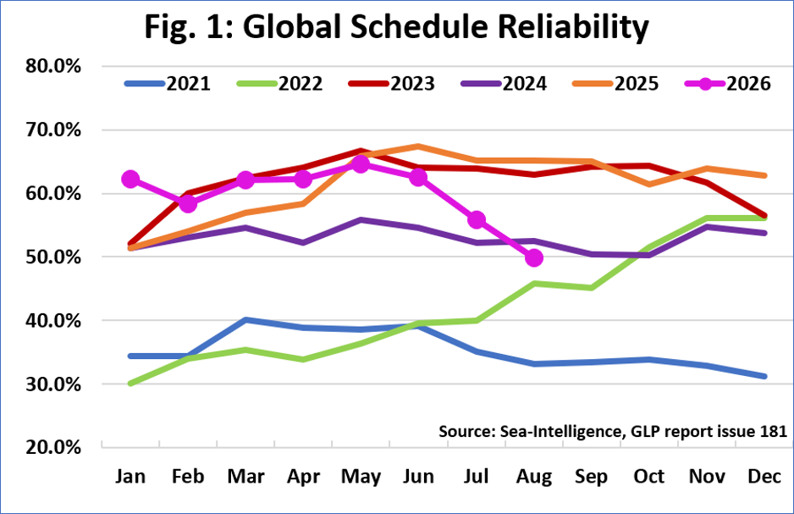
Figure 1. Global schedule reliability by month, 2021–2026 (as supplied). Source: Sea-Intelligence, GLP report issue 181, as cited in the supplied material.
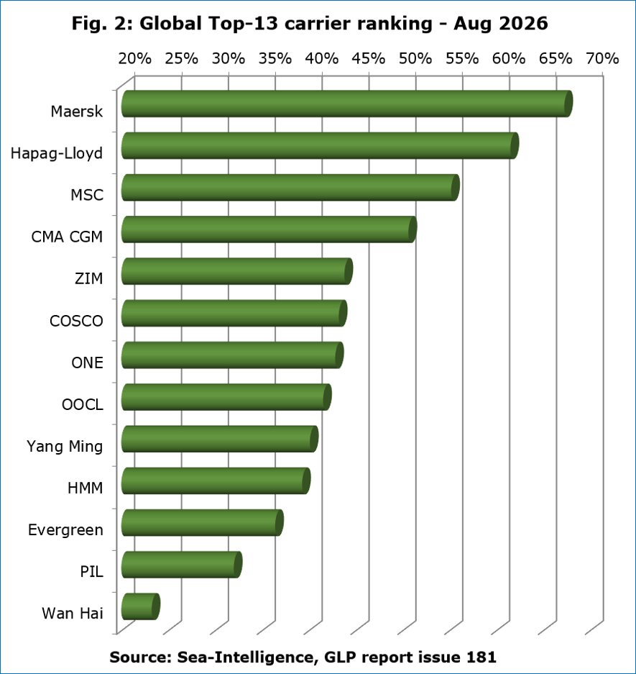
Figure 2. Global top-13 carrier schedule reliability ranking, August 2026 (as supplied). Source: Sea-Intelligence, GLP report issue 181, as cited in the supplied material.

8.2. Port Performance and Supply Chain Stress (World Bank CPPI 2025)
The attached World Bank report titled The Container Port Performance Index 2025 defines port performance by the observed time of vessels in port, adjusted for the size of the vessel and particularities of the port call. Its executive summary reports a slight decrease in the global average CPPI (Container Port Performance Index) in 2025 compared to 2024. In other words, compared to the previous year, ships spent more time in ports in 2025. The report highlights the extent to which the state of port performance and supply chain stress are interrelated, with the ability of both factors to affect each other in either direction. In particular, it is noted that disruptions to supply chains create “burst congestion” as delayed vessels arrive in a tightly grouped timeframe, overwhelming wharves, yard capacity, manpower, equipment, and landside operations.
Furthermore, the report highlights the potential of improved information sharing and planning to allow ports to transition from reactive to predictive operations. This conclusion directly supports the proposed integration of arrival prediction, Digital Twin-based scenario analysis, berth and resource allocation, and human review into the operations of BlockPort AI.
As mentioned in the report, the five best-performing ports in 2025 were Fuzhou, Dalian, Salalah, Mawan, and Chiwan. In particular, they had the CPPI (Container Port Performance Index) scores of 145, 141, 136, 135, and 134, respectively. The report also lists the five best-performing ports in terms of improvements in performance from 2020 to 2025. They were Port Elizabeth (+80 CPPI points), Khalifa Bin Salman Port (+75), Posorja (+70), Goteborg (+68), and Muhammad Bin Qasim (+52).
The CPPI report data on pages 18-19 concern the global average CPPI, the Global Supply Chain Stress Index (GSCSI), average days of delay for vessels, and the percentage of services and carriers that arrived on time for the period of 2020-2025. It states that the two indices are closely related to each other while also emphasizing the absence of a causal relationship between the two.
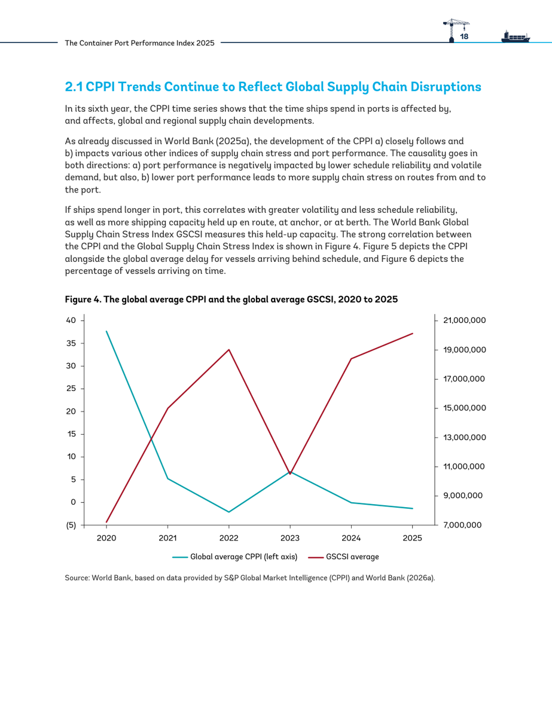
Figure 3. World Bank CPPI 2025 report page 18, including Figure 4: global average CPPI and global average GSCSI, 2020–2025. Source: World Bank, The Container Port Performance Index 2025, p. 18.
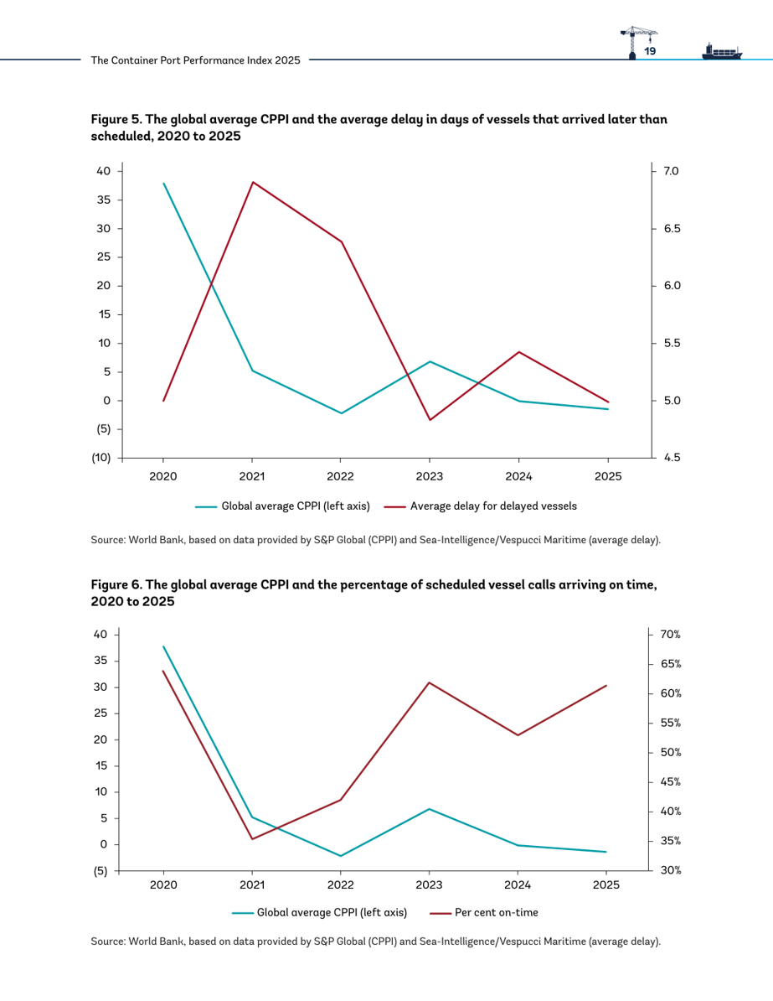
Figure 4. World Bank CPPI 2025 report page 19, including Figures 5 and 6: global average CPPI compared with delay among late vessels and percentage of scheduled calls arriving on time, 2020–2025. Source: World Bank, The Container Port Performance Index 2025, p. 19.

8.3. Shipping Emissions and Carbon-Intensity Evidence
The provided excerpt from the International Maritime Organization’s Fourth IMO GHG Study 2020 offers evidence on the trends in greenhouse-gas emissions from total shipping, including international, domestic, and fishing, in CO 2 -equivalent. Specifically, they increased by 9.6% between 2012 (977Mtoe) and 2018 (1,076Mtoe), with CO 2 emissions rising from 962Mtoe to 1,056Mtoe (+9.3%) and the share of total anthropogenic emissions rising from 2.76% to 2.89%. Under the study’s two voyage-based allocation methods, international shipping CO 2 emissions increased from 701Mtoe to 740Mtoe or 4.3Mtoe per year (5.6%) and 848Mtoe to 919Mtoe (+8.4%) respectively. Moreover, the study notes that in 2018, international shipping’s carbon intensity was about 21% and 29% better than in 2008 (using the two AER methods) and 22% and 32% better (using the two vessel-based allocation methods), with the rate of improvement slowing down after 2015 to approximately 1-2% annually. Finally, the study’s scenarios for 2018–2050 suggest that CO 2 emissions will range between 90-130% of 2008 levels in 2050 depending on economic and energy assumptions but do not provide a single best-guess scenario.
This excerpt provides valuable insights for my work by demonstrating that shipping’s contribution to climate change is non-trivial but manageable. While the industry’s anthropogenic emissions are relatively small (less than 3%), they are growing steadily, with international shipping’s share reaching 2% of total CO 2 emissions in 2018. At the same time, the industry has committed to reducing its emissions footprint by improving its energy efficiency, which has been achieved at a rate of 1-2% per year after 2015. Thus, the industry has the potential to meet its goals under the IMO strategy, but it will require continuous improvements. This evidence directly relates to my work by illustrating the importance of measuring the emissions and time-cost trade-off in operations to improve the efficiency of a shipping company. Specifically, the industry cannot rely on efficiency gains to reduce emissions automatically without measuring and optimizing them directly.
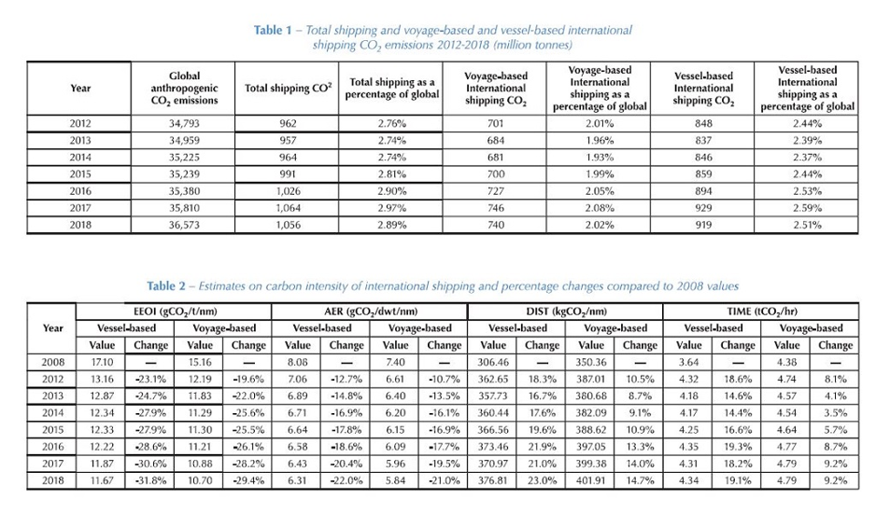
Figure 5. IMO Fourth GHG Study tables: international shipping emissions (2012–2018) and carbon-intensity indicators (2008–2018), as supplied. Source: International Maritime Organization, Fourth IMO GHG Study 2020.
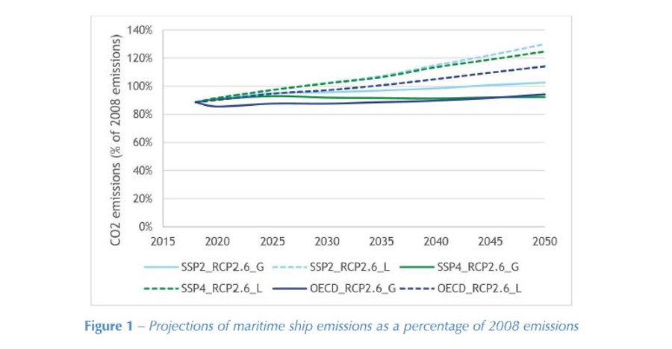
Figure 6. Projections of maritime ship emissions as a percentage of 2008 emissions through 2050, as supplied. Source: International Maritime Organization, Fourth IMO GHG Study 2020.

8.4. Primary Observations from the BlockPort AI Analysis

Observation 1: Less Hurry and Waiting
The obvious benefit from implementing the suggested framework is the ability to reduce waiting time and related costs ahead of a vessel’s arrival at the port. In a reactive mode, a delayed ship departs or occupies a berth or equipment temporarily unavailable for any other vessel, while an incoming ship takes over an unoccupied resource. With access to updated information, the framework would be able to update expectations as to the berth needs in the digital twin and suggest reallocations ahead of time. The main benefit is not necessarily the reduced time between crane movements but the opportunity to reduce overall delays and conflicts due to insufficient or overly optimistic planning in time and resources. This should always be compared to a baseline, ideally the performance of the port before the implementation of the new framework.

Observation 2: Eco-Friendly Output Should Consider Contextual Variables
As per the IMO evidence supplied, shipping emissions are significant and have seen only minor improvements in recent years. As such, the BlockPort AI Green Port Intelligence layer’s consideration of projected fuel consumption and emissions alongside waiting time, costs, and other resource constraints should be a benefit. Finding a berth or anchoring area with reduced waiting time or capacity utilization pressure may well decrease emissions, but the actual benefit depends on the vessel’s specific conditions, equipment, and energy sources, as well as the emission factor of the specific port and related operations. It is important that the framework explicitly reports these projected reductions compared to a particular baseline and is transparent about the assumptions made, rather than suggesting that any time reduction automatically leads to lower emissions.

Observation 3: Blockchain Assists Traceability, but Not Necessarily Truth
As a distributed ledger requiring consensus among all participants in its blockchain, the proposed solution would allow timestamping relevant records, approvals, or rejections, and related activities to specific ships, timepoints, or events within the port. Thus, any modifications to the records would need to be justified and visible to all participants, which creates an invaluable audit trail. However, a blockchain cannot prove the truth of a particular record beyond reasonable doubt, which requires trustless verification. Such verification, as well as measurement accuracy, is vital for the integrity of the system, blockchain or not, and therefore must be performed independently. Thus, the proposed blockchain layer is primarily a traceability tool, which assists in auditing but does not guarantee accuracy, consensus, or resolution of disputes.

Observation 4: AI Assists, but Does Not Replace Human Judgment
The described AI Port Copilot feature would be helpful in giving the operators an overview of the suggested options, comparing their outcomes in terms of waiting time, resource usage, costs, and emissions. It is vital that they are always free to modify, approve, or reject any of the suggestions in favor of their own in unpredictable or unsafe situations. This makes the AI a tool for reducing the cognitive load of the operators by eliminating obviously inferior options without replacing their common sense and judgment.

Summary of the Observations
The primary conclusion is that the proposed framework’s benefits mostly come from combining the suggested tools with the context, data, and human expertise. In isolation, none of the tools described actually accomplish much – the AI’s suggestions require the digital twin to actually reflect reality, the latter must be accurate enough for the blockchain timestamps to be meaningful, and all of the above must have verifiable, trustworthy information for emissions calculations to be useful. Taken together, they provide a valuable set of options for the operators to consider while being aware of the risks and limitations of each. The supporting evidence presented is helpful but comes from disparate sources that mostly relate to shipping or blockchain ecosystems rather than a specific implementation of the BlockPort AI solution. Therefore, while the supplied data is a good foundation for estimating the likely benefits, it must always be taken with a grain of salt and additional context.

8.5. Data Sources, Interpretation, and Limitations
Sea-Intelligence figures and carrier performance statistics in this section are quoted from the source material provided with the brief, citing issue 181 of the GLP report. The emissions tables and graphs with projections are adapted from the supplied Fourth IMO Greenhouse Gas Study 2020 material, with the copyright noted. The CPPI charts and graphs and related rankings are adapted from the supplied 2026 World Bank report, The Container Port Performance Index 2025: A Comparable Assessment of Performance based on Vessel Time in Port . The CPPI, as presented in the material, ranks ports based on the time spent in them and uses a composite index, rather than a universal measure of total port hours for a group of regions, as used in this briefing. For a BlockPort AI performance evaluation, a specific set of ports should be chosen along with the baseline either from the same set’s past performance or a suitable simulation, using consistent metrics for waiting time, utilization, cargo turnover, and emissions.
As this briefing uses material from various sources, mostly related to shipping, blockchain, and port operations, it provides informative context and general trends rather than basing the analysis on a specific implementation of the BlockPort AI framework. The evaluation criteria from Section 3 should be considered goals for a future implementation once appropriate historical or projected performance data becomes available for the target ports.

References for Section 8
Sea-Intelligence. Global Liner Performance (GLP) Report, issue 181 (schedule reliability through August 2026) and The Monthly Maritime Report – Liner Markets, as cited in the source material.
World Bank. 2026. The Container Port Performance Index 2025: A Comparable Assessment of Performance based on Vessel Time in Port. World Bank Group and S&P Global Market Intelligence. Figures 4–6, pp. 18–19; Table: Top Performers, p. 5.
International Maritime Organization. Fourth IMO Greenhouse Gas Study 2020. Emissions inventory, carbon-intensity projections, 2018–2050, as cited in the source material.

9. Applications of BlockPort AI

9.1. High-Density Commercial Container Terminals
Ports such as Singapore, Rotterdam, and Los Angeles handle large volumes of containers. The framework could coordinate gantry cranes, mega-ships, and incoming and outgoing cargo.

9.2. Specialized Bulk or Liquid Cargo Ports
Ports handling LNG, oil, grain, or chemical tankers operate under strict safety requirements. A Digital Twin could stress-test unloading plans for hazardous materials under challenging weather conditions.

9.3. Verifying International “Green Corridors”
For proposed zero-emission shipping routes, blockchain-based carbon accounting could support audits of commitments and provide traceable records of claimed reductions, helping address greenwashing risks.

9.4. Hinterland Logistics and Multimodal Connectivity
Predictive maintenance and yield forecasting could help synchronize cargo delivery with road and rail capacity. Smart contracts may support agreed information exchanges between participants.

9.5. Crisis Management and Infrastructure Stress-Testing
Virtual representations of port infrastructure could be used to test disruption scenarios and hurricane-response plans, including clearing docks and securing vessels.

10. Limitations of the Proposed Framework

10.1. The “Garbage In, Garbage Out” Reality
The effectiveness of the AI and the accuracy of the Digital Twin predictions depend on the quality of input data. If a shipping company does not disclose accurate cargo manifests or a terminal’s sensors are installed incorrectly, the AI may produce confident but incorrect predictions. The system cannot optimize what it cannot accurately observe.

10.2. The High Cost of Physical Hardware Integration
BlockPort AI is not simply an application to install on a tablet. A foundational sensory network may require thousands of IoT devices on gantry cranes, container handlers, gates, and yards. Retrofitting an established port can be expensive and disruptive to daily operations.

10.3. The Blockchain “Oracle Problem”
Blockchain can help detect changes after data has been committed, but it cannot ensure that the original data was correct. If a faulty fuel sensor reports that a truck used zero gallons, the blockchain may faithfully preserve that incorrect value. The system therefore depends on sensors—or “oracles”—being reliable and calibrated.

10.4. Elevated Cybersecurity Vulnerabilities
Connecting port infrastructure, equipment, the Digital Twin, and AI data feeds increases the attack surface. If attackers compromise the Digital Twin or spoof data feeds, they could disrupt truck rerouting, berth assignments, or equipment operations, potentially including ransomware attacks. Effective implementation requires substantial cybersecurity controls and infrastructure.

10.5. Cultural Resistance and Industry Tradition
Experienced harbor masters may be reluctant to rely on algorithmic recommendations, and dockworkers or unions may view optimization and AI copilots as steps toward automation and job losses. Addressing trust, training, and workforce concerns may be as challenging as developing the software.

11. Scope for the Future

11.1. Creating a Global Network of “Talking” Ports
A future network could connect dozens or hundreds of BlockPort-enabled hubs. For example, AI systems at Shanghai and Los Angeles could coordinate schedules so that a late departure from Shanghai informs planning at Los Angeles before the vessel crosses the Pacific.

11.2. Transitioning to Autonomous Execution
The current framework uses a human-in-the-loop approach. Future versions might allow the Copilot to control equipment and execute decisions, including coordinating autonomous tugboats, driverless trucks, and robotic gantry cranes. Safety, oversight, and regulatory constraints would remain critical.

11.3. Consuming Smart City Electricity
A Green Port could connect its Digital Twin to the regional smart grid. The AI could use grid conditions and electricity prices to schedule charging for electric vehicles and cranes, potentially shifting demand away from peak periods and making use of available renewable electricity.

11.4. Implementing Predictive Maintenance
Sensors embedded in port machinery could detect irregularities, such as changes in the rotation of crane gears, and estimate failure risk. The system could then request replacement parts and schedule maintenance during predicted lulls in maritime traffic.

11.5. Automating Carbon Markets
The blockchain layer could potentially support carbon-credit creation by recording verified carbon-saving schedules and representing eligible reductions as digital credits. Smart contracts might automate parts of carbon-credit trading, subject to appropriate measurement, verification, and market rules.

12. Conclusion
Global maritime networks comprise the invisible infrastructure of the modern economy. The functioning of any enterprise, even the most insignificant one, is directly linked to the activity of numerous transport hubs worldwide. Yet, with the rapid growth of global trade, the ad-hoc approach to controlling such a critical flow of goods and transit traffic becomes ineffective. The physical limits of port capacity are inadequate to the scale of modern business, and the environment protests against the pollution caused by classic logistics chains.
The idea of creating BlockPort AI arose from the necessity to shift the attention from the physical expansion of the infrastructure to the growth of its digital capabilities. In other words, the project proves that to make a port smarter, one does not need to construct new buildings and purchase new equipment. Instead, a special set of universally applicable technologies can be implemented to turn an existing structure into a cutting-edge platform. The research shows how the companies can utilize the available tools, including the IoT ecosystem, AI algorithms, Digital Twins, and blockchain technology, to transform the management system and relations with stakeholders.
Most importantly, the very concept of BlockPort AI serves as the excellent idea of how to make a traditionally wasteful system more eco-friendly. By introducing the so-called Green Port Intelligence concept, the researchers effectively prove that the most lucrative choice for a port operator will be the one that also benefits the environment. After analyzing the data and observing the trends, one can understand that reduced emissions are always the result of a well-organized distribution system. Therefore, it is possible to substitute economic growth by making smarter traffic decisions.
Overall, the paper demonstrates that to optimize the work of a large complex like a maritime port, one has to consider human factors in the decision-making process. By putting people at the center of operations and providing them with real-time access to vital data, BlockPort AI allows operators to find better solutions quickly. Ultimately, the software product arms transport hub managers with unprecedented knowledge of the system under their control, making the economy of the logistics chain fully transparent.

13. References
United Nations Conference on Trade and Development (UNCTAD). (2023). Review of Maritime Transport. United Nations Publications.
International Maritime Organization (IMO). (2023). 2023 IMO Strategy on Reduction of GHG Emissions from Ships. London: International Maritime Organization.
Notteboom, T., Pallis, A., & Rodrigue, J. P. (2022). Port Economics, Management and Policy. Routledge.
Heilig, L., Lalla-Ruiz, E., & Voß, S. (2017). Digital transformation in maritime ports: Analysis and a game theoretic approach. Netnomics: Economic Research and Electronic Networking, 18(3), 227-254.
Min, H. (2019). Blockchain technology for enhancing supply chain resilience. Business Horizons, 62(1), 35-45.
Lind, M., Watson, R. T., Ward, R., Bergmann, M., Bjørn-Andersen, N., & Rose, C. (2020). Digital twins for the maritime sector. In Maritime Informatics (pp. 121-134). Springer, Cham.
Alizadeh, M., & Kian, R. (2022). Artificial intelligence applications in port operations: A systematic literature review. Transportation Research Part E: Logistics and Transportation Review, 161, 102713.
Wang, T., Du, Y., & Fang, D. (2020). Green port and maritime logistics: A comprehensive review. Sustainability, 12(10), 4236.
Jovic, M., Tijan, E., Zgaljic, D., & Aksentijevic, S. (2020). Improving maritime transport sustainability using blockchain-based information exchange. Sustainability, 12(21), 8866.
Zhen, L., Hu, Y., Wang, S., Laporte, G., & Wu, Y. (2020). Green berth allocation and scheduling algorithms for maritime terminals. Transportation Research Part B: Methodological, 132, 234-254.

