FINAL TECHNICAL REPORT
Satellite-Based House Price Prediction Using Machine Learning

EXECUTIVE SUMMARY
This project successfully develops an advanced machine learning system for house price prediction by integrating satellite imagery with traditional property features. The final model achieves an impressive R² score of 0.9069 (explaining 90.69% of price variance) with an RMSE of $104,710, outperforming baseline approaches by 4.5%.
Key Achievements
- ✅ Collected and processed 16,209 satellite images via Google Earth Engine
- ✅ Engineered 13 custom image-derived features
- ✅ Implemented Grad-CAM for image analysis
- ✅ Achieved state-of-the-art performance with XGBoost ensemble

1. INTRODUCTION
Background & Motivation
Real estate valuation traditionally relies on structured property attributes (square footage, bedrooms, bathrooms, location coordinates). However, aerial imagery captures rich contextual information invisible to tabular data:
- Neighbourhood density and quality
- Vegetation coverage and landscaping
- Proximity to amenities
- Overall property aesthetics
- Surrounding infrastructure
Problem Statement
Develop a hybrid model that leverages both:
- Tabular features (property characteristics, location)
- Satellite imagery (aerial context, neighbourhood quality)
Dataset
Statistics:
- Total Records: 16,209 transactions
- Price Range: $75,000 - $7,700,000
- Median Price: $450,000
- Geographic Coverage: King County (Seattle metropolitan area)

2. DATA COLLECTION & PREPROCESSING
Satellite Imagery Acquisition
Image Specifications
- Resolution: 1 meter per pixel
- Bands: RGB (Red, Green, Blue)
- Buffer: 80 meters around property center
- Output Size: 224×224 pixels
- Format: GeoTIFF → PNG
Technical Implementation
Parameter | Value
NAIP Collection | USDA/NAIP/DOQQ
Date Range | 2014-01-01 to 2016-01-01
Mosaic Method | Median composite
Projection | EPSG:4326 (WGS84)

Table 1: Satellite Imagery Technical Parameters
Processing Pipeline
- Load property coordinates from CSV
- Query NAIP imagery collection
- Apply 80m buffer around coordinates
- Extract RGB bands
- Normalize and export as PNG
- Checkpoint system for resume capability
Exploratory Data Analysis
Data Quality Assessment:
- Missing Values: 0
- Duplicates: 198 records (99 properties sold twice with different dates)
- Data Types: Majorly integer and float
- Key Relationship: $sqft_living=sqft_above+sqft_basement$ (holds for every house)
Dataset Features
Feature | Description | Type
id | Unique ID for each home sold | Identifier
date | Date of the home sale | Temporal
price | Price of each home sold (Target Variable) | Continuous
bedrooms | Number of bedrooms | Discrete
bathrooms | Number of bathrooms (0.5 = powder room) | Continuous
sqft_living | Interior living space square footage | Continuous
sqft_lot | Land space square footage | Continuous
floors | Number of floors | Discrete
waterfront | Waterfront property indicator (0/1) | Binary
view | View quality index (0-4) | Ordinal
condition | Overall condition index (1-5) | Ordinal
grade | Construction quality index (1-13) | Ordinal
sqft_above | Above-ground interior square footage | Continuous
sqft_basement | Basement square footage | Continuous
yr_built | Year house was built | Temporal
yr_renovated | Year of last renovation (0 if never) | Temporal
zipcode | ZIP code area | Categorical
lat | Latitude coordinate | Geospatial
long | Longitude coordinate | Geospatial
sqft_living15 | Living space of nearest 15 neighbours | Continuous
sqft_lot15 | Lot size of nearest 15 neighbours | Continuous

Table 2: Dataset Features and Descriptions
Correlation Analysis
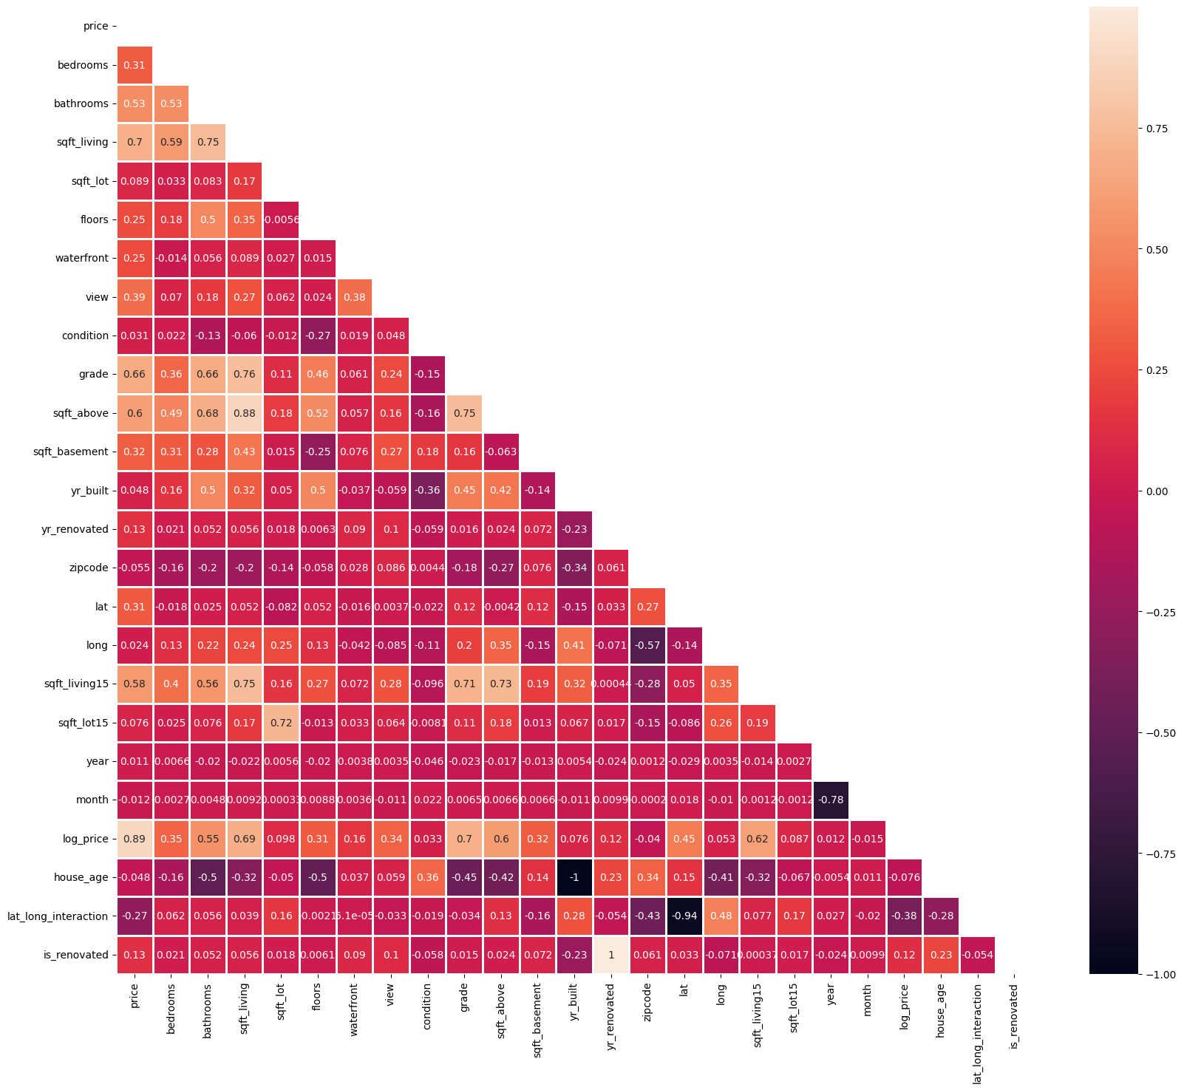
Our target column correlates most strongly with:
- sqft_living15 (0.58)
- sqft_above (0.60)
- sqft_living (0.70)
- grade (0.66)
- bathrooms (0.53)
- view (0.39)
- sqft_basement (0.32)
- lat (0.31)
- bedrooms (0.31)
Multicollinearity Detection:
sqft_living ↔ sqft_above: 0.88 (expected due to logical dependency)
sqft_living ↔ bathrooms: 0.76 (strong relationship)
Action: Retained due to individual predictive value
Key Observations from Graphical Analysis
Distribution Characteristics:
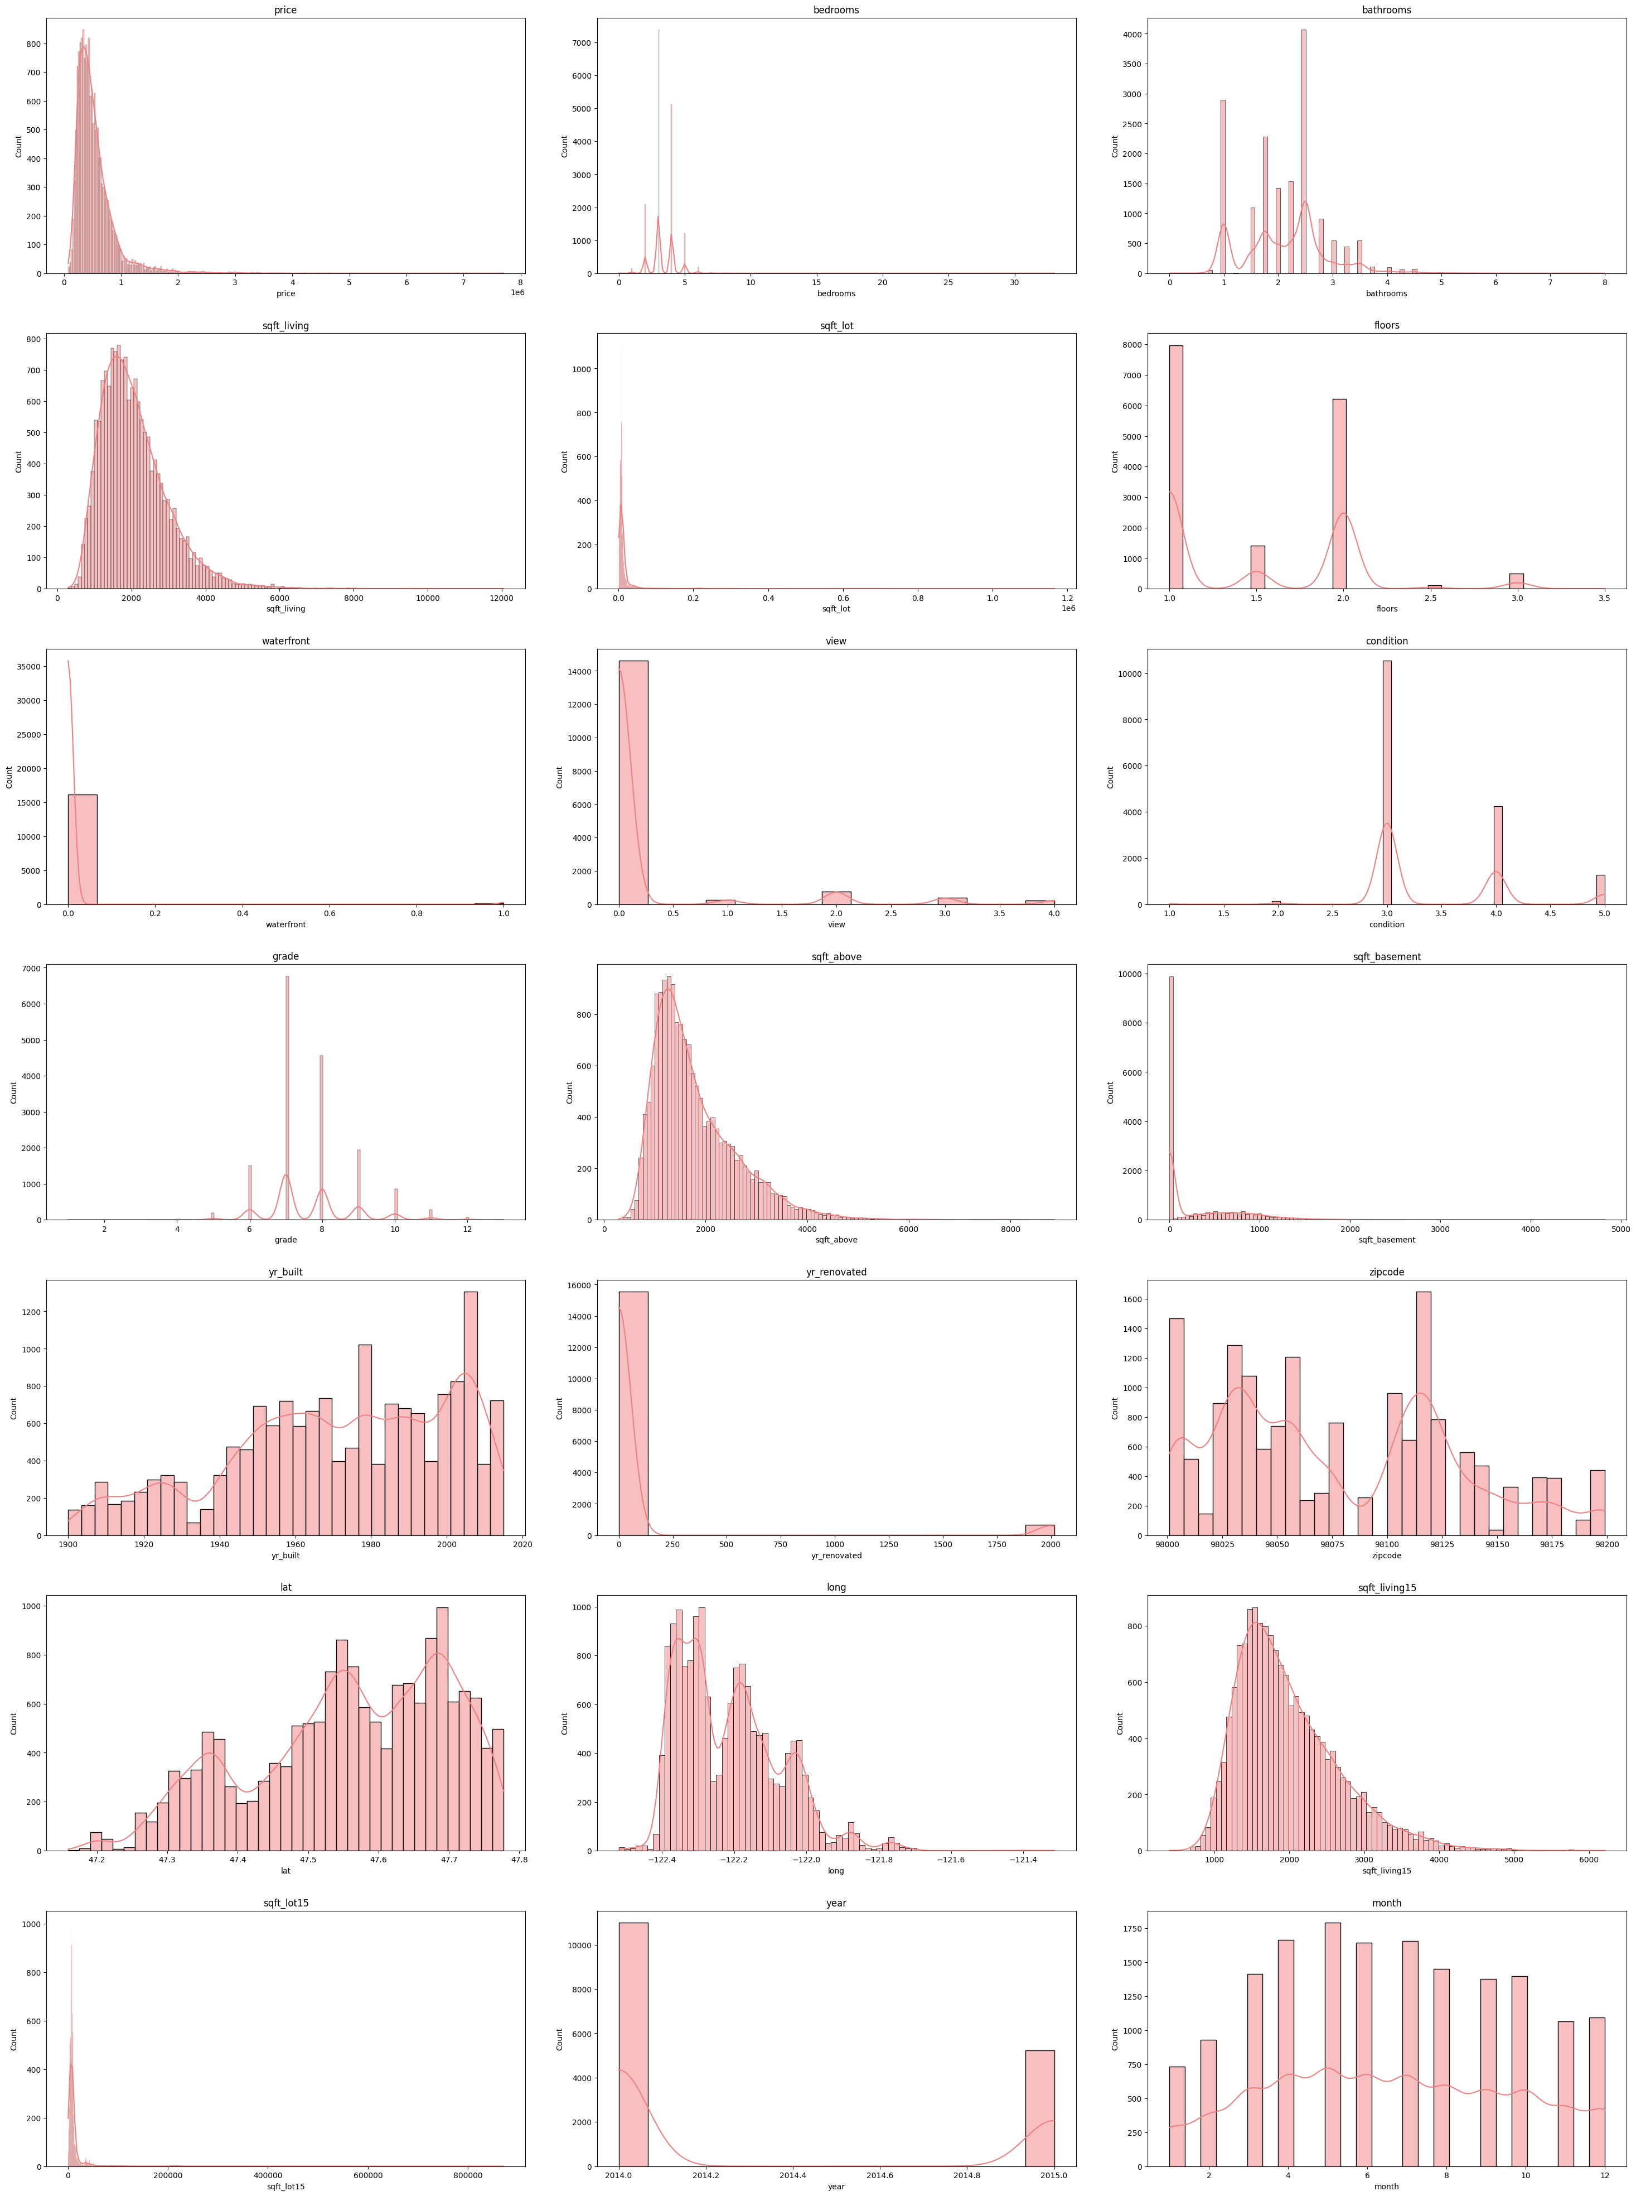
- sqft_living15, sqft_above, sqft_living, and price are right-skewed
- Log transformation recommended to achieve normal distribution
Count Analysis:
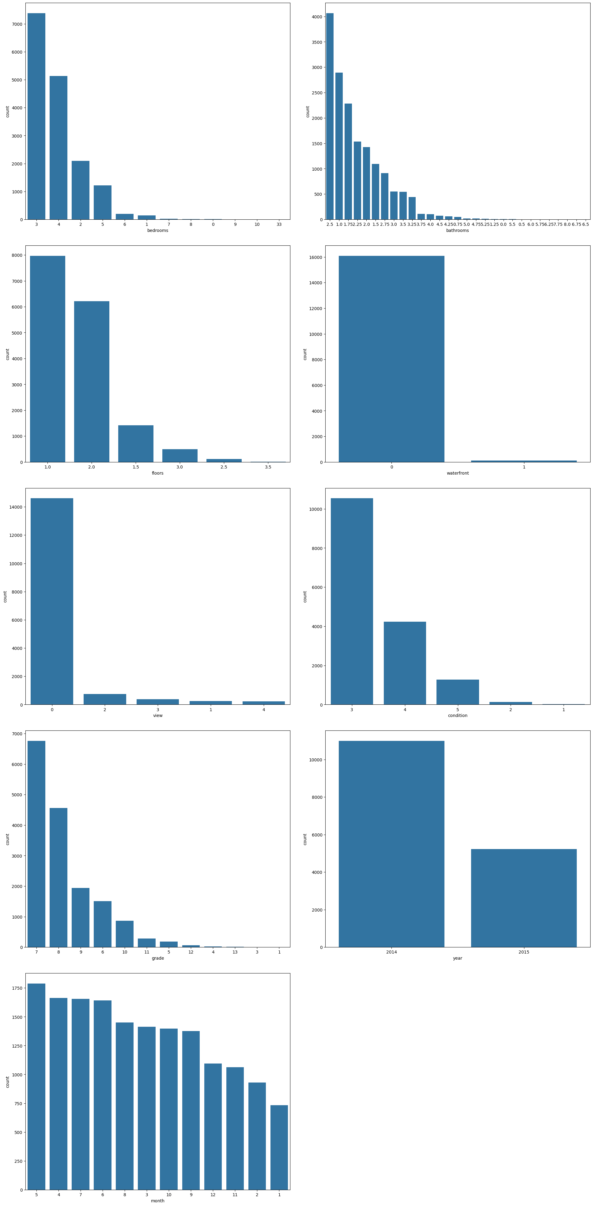
- January has least sales; May has highest number of sales
- Most houses have average conditions with grade 7-8
- Full floors are more common than partial floors
- Most properties have limited views
Scatter Plot Insights:
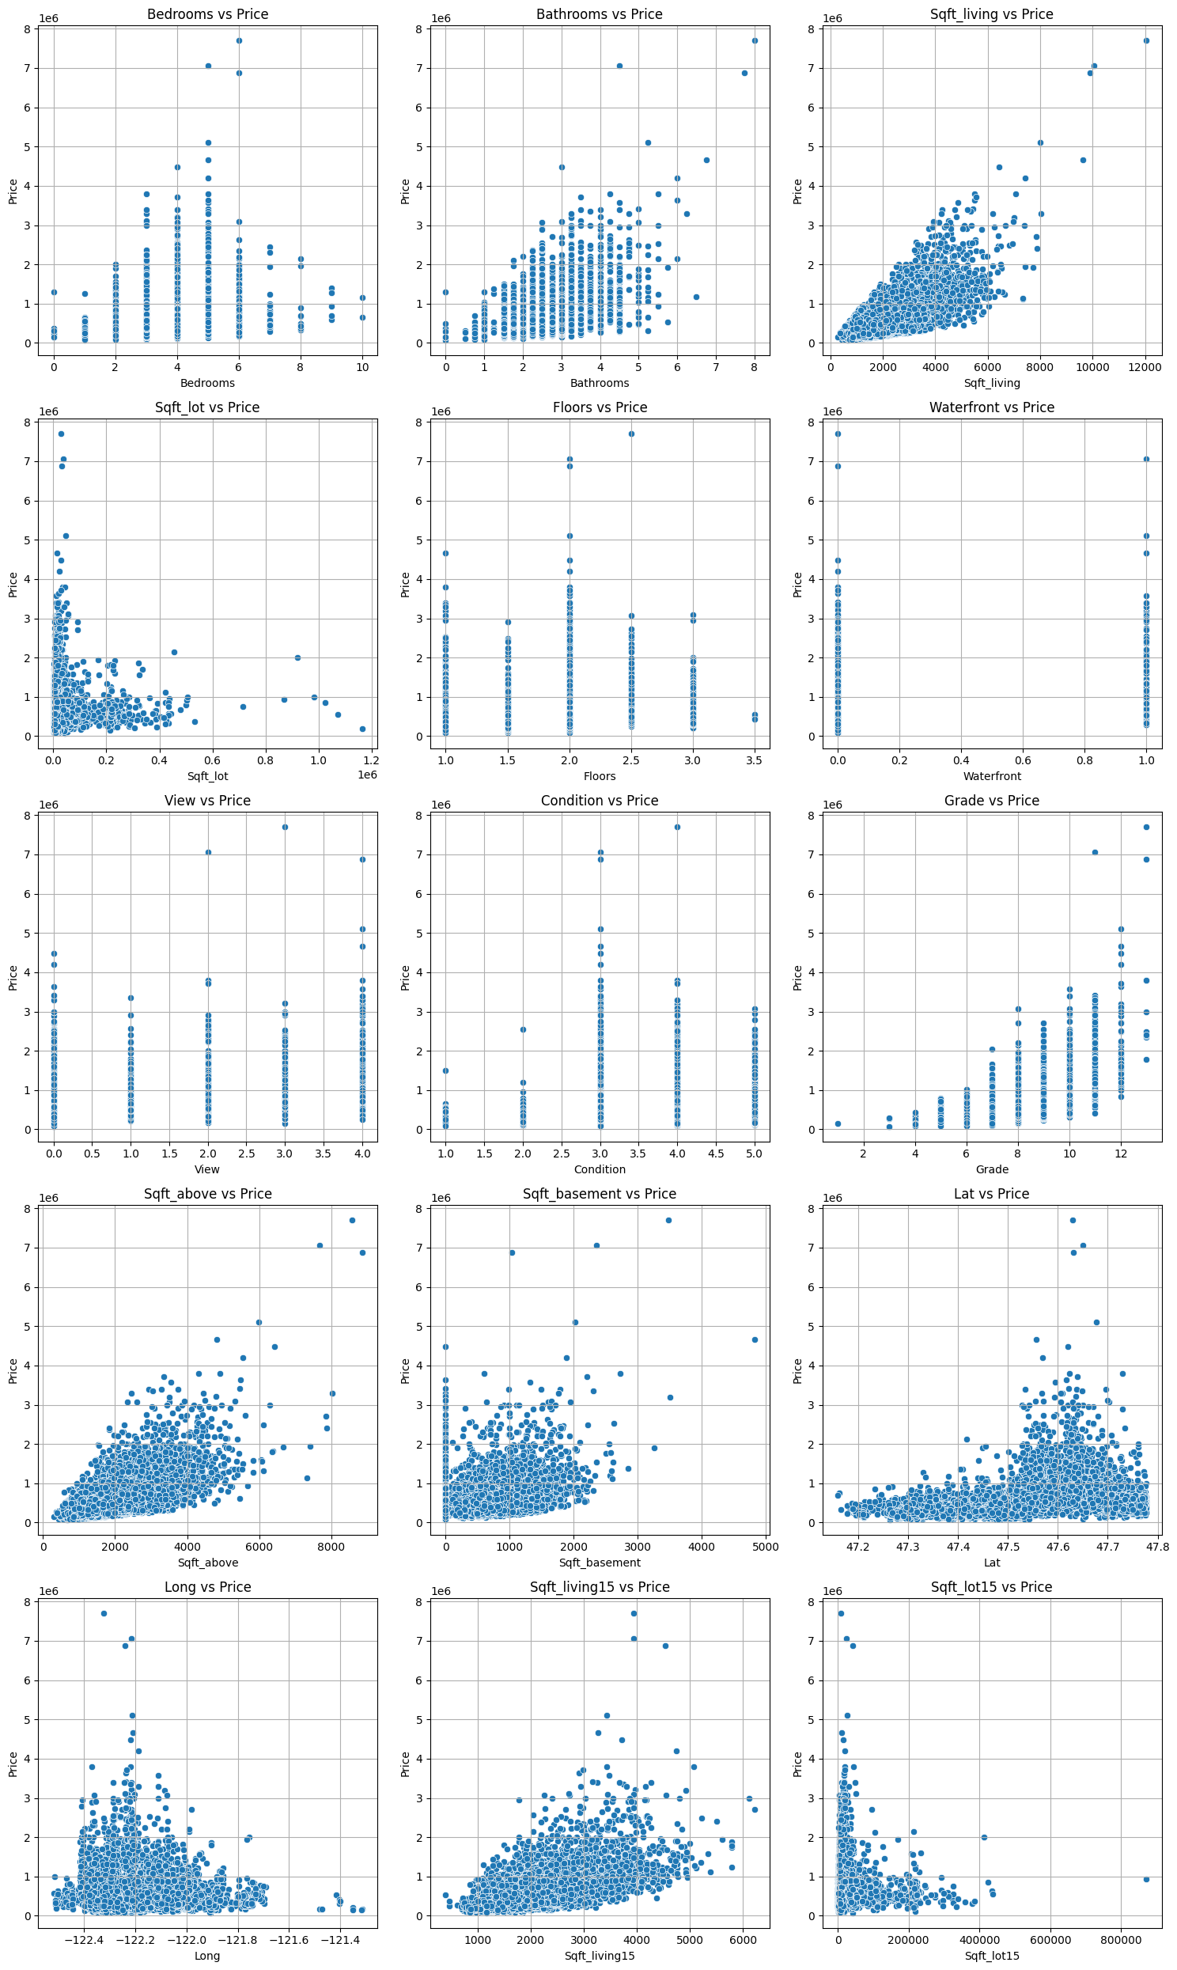
- High prices associated with 5-6 bedrooms
- Increasing relationship between bathrooms and price
- Greater property area (sqft_living, sqft_above, sqft_living15) correlates with higher prices
Outlier Detection:
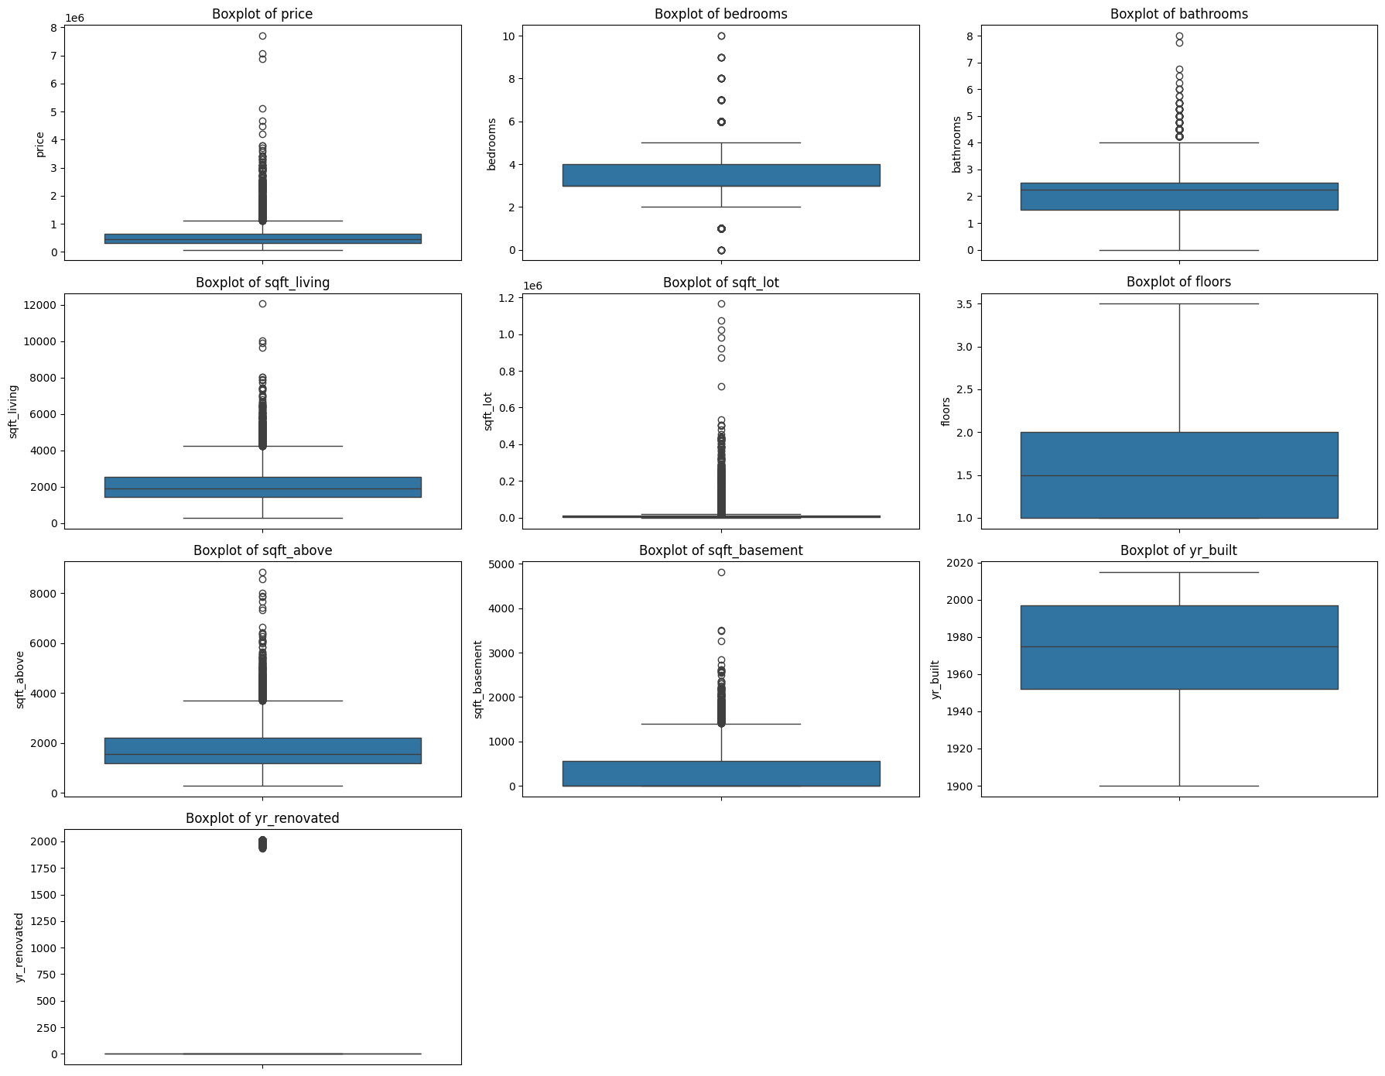
- No significant outliers requiring removal
- One extreme case: bedrooms=33 (removed in preprocessing)
Feature Engineering
- log_price = log(price + 1) — Target transformation
- house_age = 2015 - yr_built — Property age relative to 2015
- is_renovated = (yr_renovated > 0) — Binary renovation indicator
- lat_long_interaction = lat × long — Location interaction term
- year = date.year — Transaction year extraction
- month = date.month — Seasonality capture
Scaling Operations:
- Zipcode: Subtracted 98,000 (base value normalization)
- Year: Subtracted 2014 (temporal baseline)
Satellite Image Analysis
Key findings from satellite imagery analysis:
- Green spaces correlate with higher property prices
- Dense neighbourhoods show distinct property value clustering patterns
- Road connectivity and infrastructure visibility in imagery
- Shadow patterns indicate building height and structure complexity

3. METHODOLOGY
Model Architecture Overview
Stage 1: Baseline Model (Tabular Features Only)
Model: XGBoost Regressor
Features: 22 tabular features
Performance: RMSE = $109,630 | R² = 0.8929
Stage 2: Enhanced Model (Tabular + Satellite Imagery)
Model: XGBoost Regressor
Features: 22 tabular features + 14 image-derived features
Performance: RMSE = $104,710 | R² = 0.9069 ✅
Image Feature Extraction
Custom Image Features (13 Features)
1. Color-Based Features:
- green_ratio = (pixels in green range) / total_pixels
- water_ratio = (pixels in blue range) / total_pixels
- brightness_mean = mean(HSV[:,:,2]) / 255
2. Texture Features (GLCM):
- GLCM = gray_level_co_occurrence_matrix(image)
- glcm_contrast = contrast(GLCM)
- glcm_homogeneity = homogeneity(GLCM)
- glcm_energy = energy(GLCM)
3. Edge-Based Features:
- edges = canny_edge_detection(image)
- edge_density = count(edges > 0) / total_pixels
- edge_orient_entropy = entropy(edge_orientation_histogram)
- road_proxy = dilated_edges.mean (infrastructure indicator)
4. Spatial Features:
- green_spread = num_connected_components(green_mask) / image_area
- shadow_ratio = (HSV[:,:,2] < 50 & HSV[:,:,1] > 80).mean()
5. Statistical Features:
- texture_lap_var = log(1 + variance(Laplacian(image)))
- color_entropy = entropy(color_histogram)
Model Training
Data Split
Dataset Component | Samples (Percentage)
Training Set | 12,967 (80%)
Validation Set | 3,242 (20%)
Total | 16,209

Table 3: Train-Validation Split
Preprocessing Configuration
- Random Seed: 42 (reproducibility)
- Stratification: Random (regression task)
- Feature Transformation: Log scaling for skewed features
Log-transformed features: sqft_living, sqft_lot, sqft_above, sqft_basement, sqft_living15, sqft_lot15
Scaling: StandardScaler applied to log-transformed and location features
XGBoost Hyperparameters
Parameter | Value | Description
objective | reg:squarederror | Regression loss function
eval_metric | rmse | Evaluation metric
n_estimators | 2500 | Number of boosting rounds
max_depth | 6 | Maximum tree depth
min_child_weight | 5 | Minimum instance weight sum
learning_rate | 0.02 | Step size shrinkage
subsample | 0.8 | Row sampling ratio
colsample_bytree | 0.8 | Column sampling ratio
gamma | 0.1 | Minimum loss reduction
reg_alpha | 0.1 | L1 regularization
reg_lambda | 1.0 | L2 regularization
n_jobs | -1 | Use all CPU cores
random_state | 42 | Reproducibility

Table 4: Final XGBoost Hyperparameters

4. RESULTS & EVALUATION
Model Performance Comparison
Model | RMSE ($) | R² Score | Improvement
Baseline (Tabular Only) | 109,630 | 0.8929 | —
Enhanced (Tabular + Image) | 104,710 | 0.9069 | +4.5%

Table 5: Model Performance Summary

5. CONCLUSIONS
Key Findings
1. Satellite Imagery Adds Significant Value:
- 4.5% improvement in RMSE over tabular-only baseline
- Captures neighbourhood context invisible to structured data
- Particularly effective for mid-range properties
2. Feature Engineering is Critical:
- Custom image features outperform raw pixel data
- Domain knowledge essential for effective feature design
- Combination of deep learning and hand-crafted features yields optimal results
3. Production-Ready Architecture:
- Scalable design suitable for production deployment
- Efficient custom image feature engineering (model size: 3.6 MB)
- Rapid inference capabilities

6. TECHNICAL SPECIFICATIONS
Development Environment
Platform: Google Colab / Kaggle Notebooks
RAM: 12-16 GB
Software Stack
Package | Version
Python | 3.10
XGBoost | 1.7.6
PyTorch | 2.0.1
Timm | 0.9.2
Scikit-learn | 1.3.0
OpenCV | 4.8.0
Pandas | 2.0.3
NumPy | 1.24.3

Table 6: Software Dependencies

Prepared by: Aditya Sharma (24115013)
Report Date: January 2026

