|  |
| --- |
|  |
| CIS 505 Team Project |
|  |

|  |
| --- |
| Cohort A Aditya Puttaparthi Tirumala Ganapriya Kalavagunta Sonal Deshmukh  10-10-2015 |

The data for this analysis was collected from the Yelp database from sql server. The data was uploaded into Tableau by connecting to the MySql in tableau. So, when you open the dashboard you will be asked for a password. In our case username is MSBAA and password is mongodb.

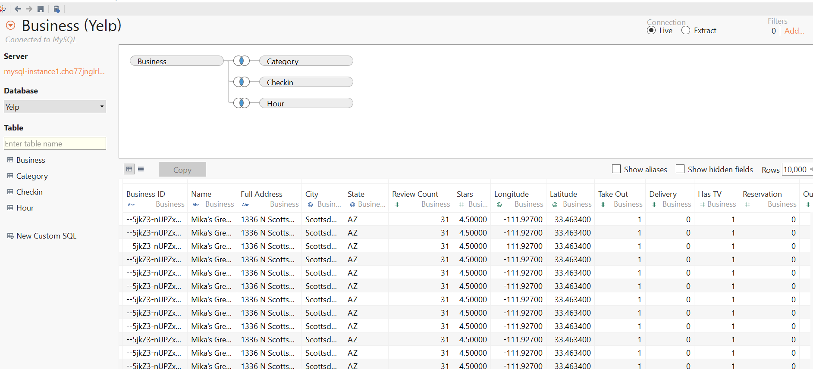

The data is uploaded by doing an inner join on Business Id on all the other three tables category, checkin and hour.

Yelp is an American multinational corporation headquartered in San Francisco, California. It develops, hosts and markets Yelp.com and the Yelp mobile app, which publish crowd-sourced reviews about the top most restaurants in most of the cities in USA.

In this analysis, we have created a dashboard which answers some of the interesting questions for which people want answers regarding the restaurants, the top most categories in each city and availability of certain facilities in each restaurant in each city.

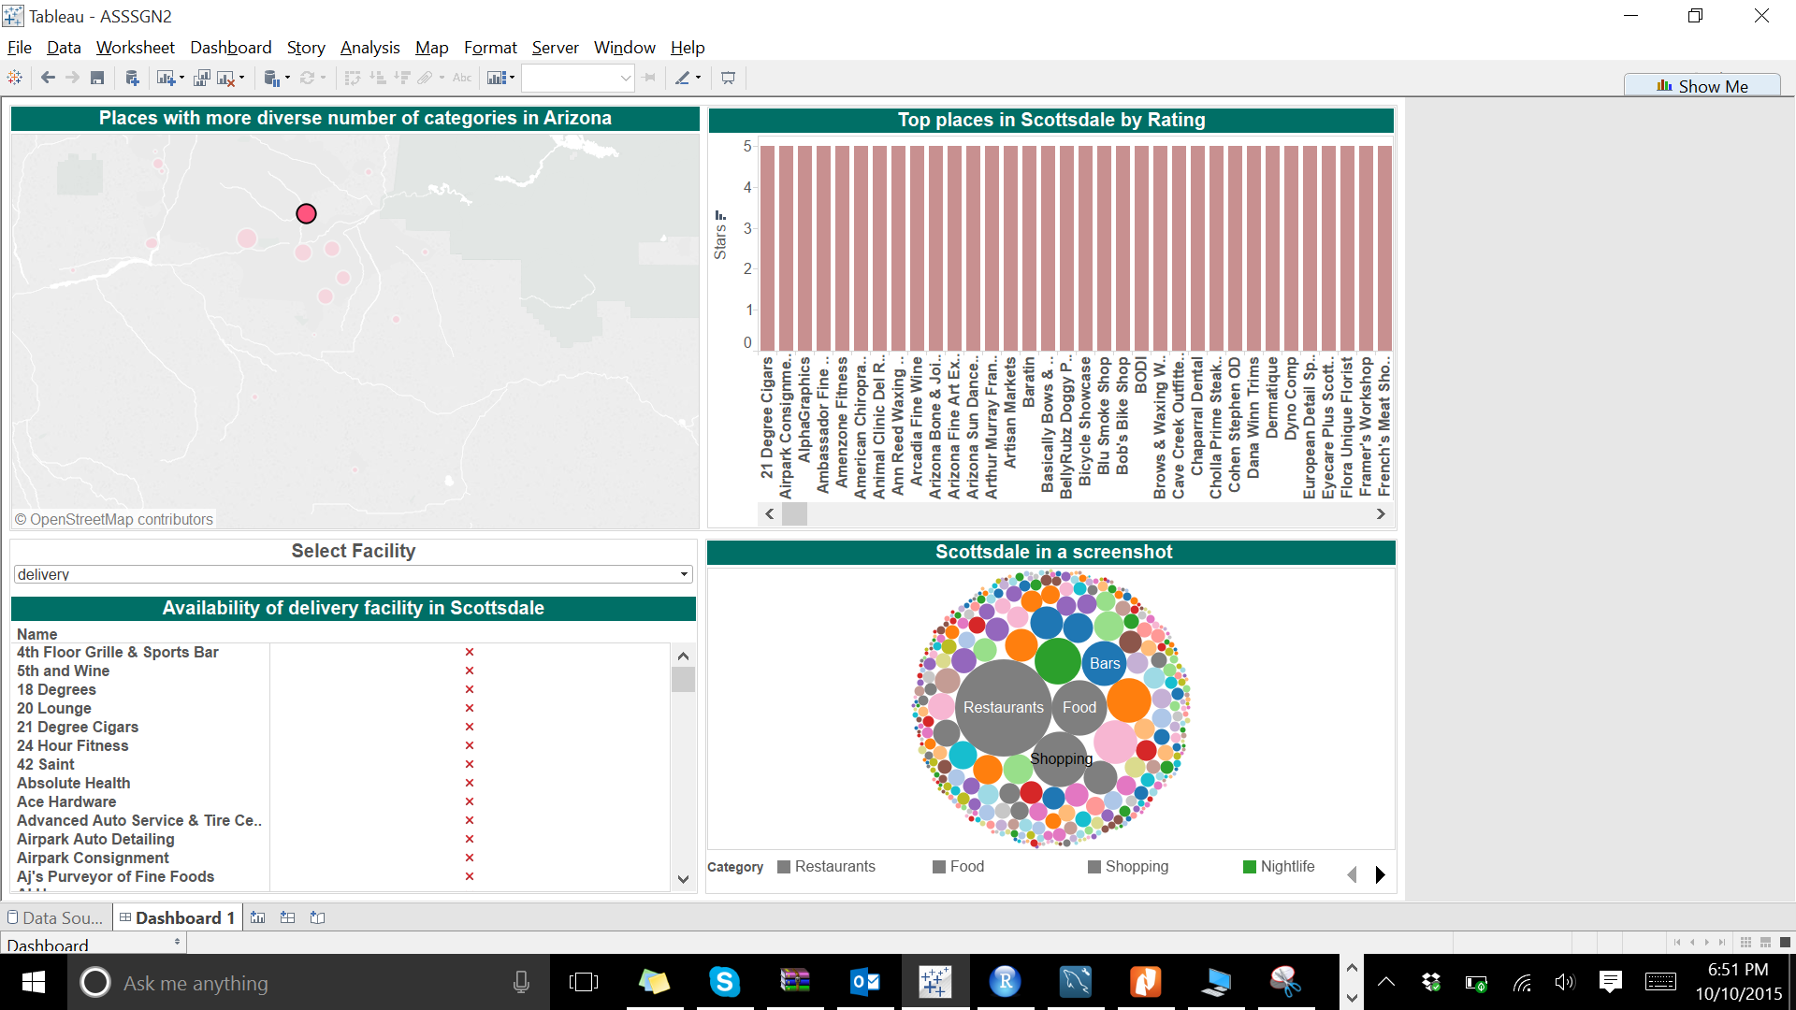

The powerview with different points (locations) on the map in the previous picture allows us to filter the city.

**People wanted to pick the places with more diversity(more number of categories) so that they can plan their holidays perfectly and can cover maximum number of places in the city of Arizona.**

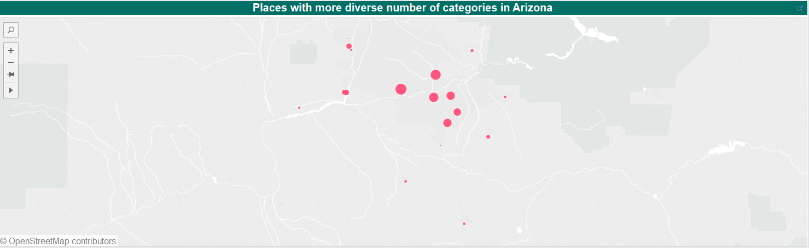

The data plotted on the map shows the cities with diverse number of categories in Arizona State. The size of the point indicates the magnitude of diversities.

The different points in the map correspond to different cities in Arizona. This acts as a filter so that if we select one city, the data in the other screenshots will get changed to the selected city.

Now, you have decided which city to go and want to know number of industries present in each category in the city selected

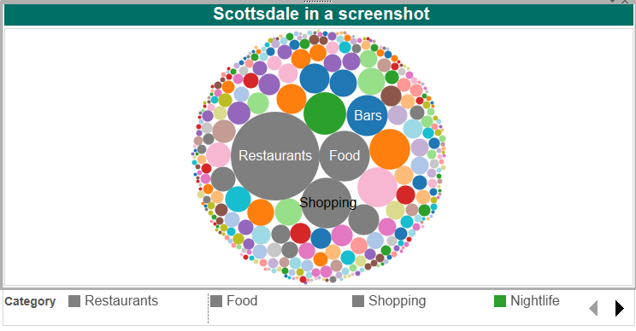

**If you have decided to go to phoenix you can decide which place in specific you want to go depending on your interest and availability of those facilities in different places in selected city**

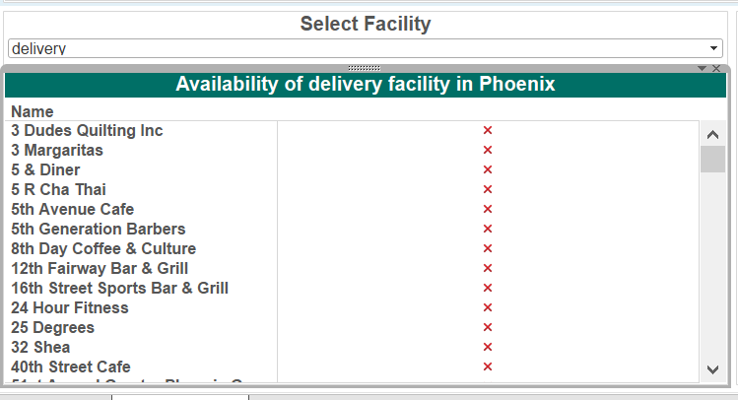

A parameter is created in tableau which allows us to select the different types of facilities that are available. i.e., back end data has all these facilities as different columns. When you create a parameter, you can select any column that you want by selecting in the dropdown

Once we select delivery, the availability of delivery facility across all the restaurants in the city selected is shown by a tick mark or cancel mark that distinguishes the availability and unavailability of that service.

The city can be changed from phoenix to other or we can get the details of all the cities in the state or so on.

**Also, top places in Scottsdale by Rating can be understood if anybody is new to the place and want to know which place to visit , they can see the below graph which shows the top places by rating**

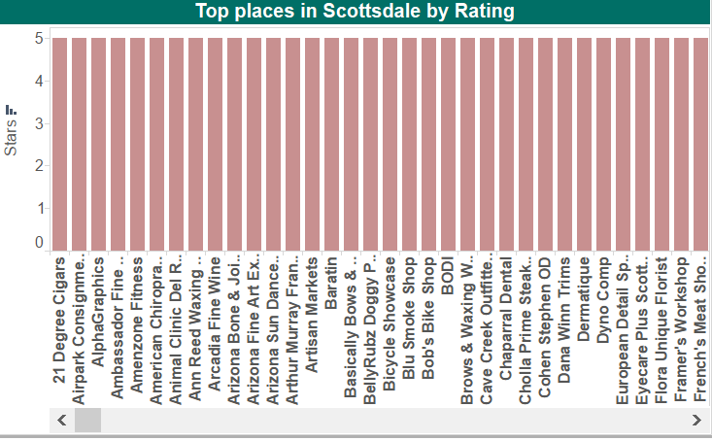

If you want to know in all cities in Arizona just deselect the city in map. Otherwise it shows places in the selected city