**Q) Explanation of how your code works.**

**Ans:**

* In this code, the function “def dijkstra ” takes the source and destination from the user and calculates the shortest path between those vertices.
* If the source is not found in the graph, the root cannot be found out and throws an error.
* If the destination is not in the graph, the shortest path between the vertices cannot be found out.

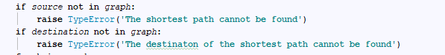

* If source is the destination, program returns 0.
* Everytime when a source and destination is given, the program keeps track of visited and unvisited nodes or vertices. The visited nodes will be initially nil and appends everytime when it finds the shortest distance between source and destination.
* From the last know visited node, again it checks for shortest distance or possible shortest path from that last visited node and this is called neighbour in the program.

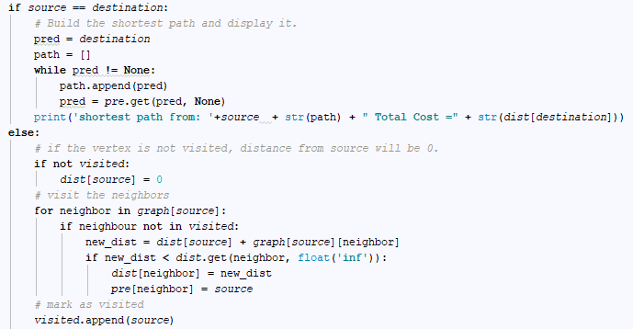

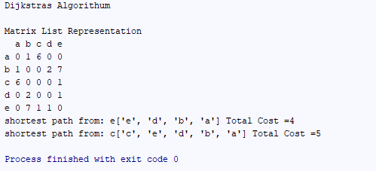

**Q) Time complexity for Dijkstra’s algorithm.**

**Ans:** The time complexity is O(V^2).

**Q) Real life example of usage of Dijkstra’s algorithm with link.**

**Ans:** It is used in Navigation maps. Also used by Google .

Also used in Geographic Information System

* https://www.ncbi.nlm.nih.gov/pmc/articles/PMC3755817/
* http://geoawesomeness.com/the-famous-algorithm-that-made-navigation-in-google-maps-a-reality/
* <https://motherboard.vice.com/en_us/article/4x3pp9/the-simple-elegant-algorithm-that-makes-google-maps-possible>

**REFERENCES:**

1. Introduction to Algorithms- By H. Cormen
2. [www.geeksforgeeks.com](http://www.geeksforgeeks.com)
3. [www.stackoverflow.com](http://www.stackoverflow.com)

**Instructions to Execute the code:**

The program has been executed in PyCharm.

To run the program in any Python editor, simply import it and run.

To run it in terminal, type python ./djalg.py