**WRITEUP:**

1. Coding has been done in Java.

2. The Project newDS has 2 files: ServerConnection and ClientConnection under the package DSPROJ1.

3. Run the code of each file without any argument.

4. It will pop-up a Swing based Window for each Run.

5. Run ClientConnection program 3 times to get 3 clients.

6. Enter the User name in each client Window and click on Connect.

7. It will start sending messages to Server and Server will wait and respond back with the message. The process will repeat until the client is closed manually.

8. The Available User area will show the available users online.

**SCREENSHOTS:**

**The Server is up and starts running**

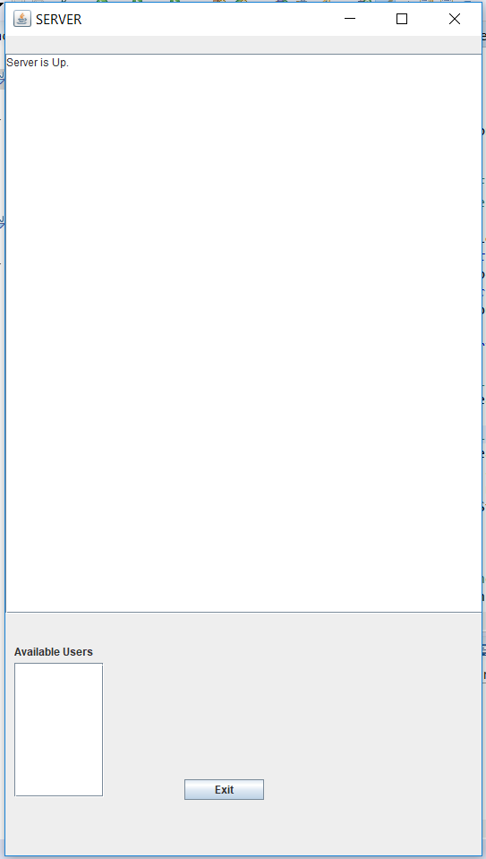

**The Clients getting connected:**

**CLIENT_1**

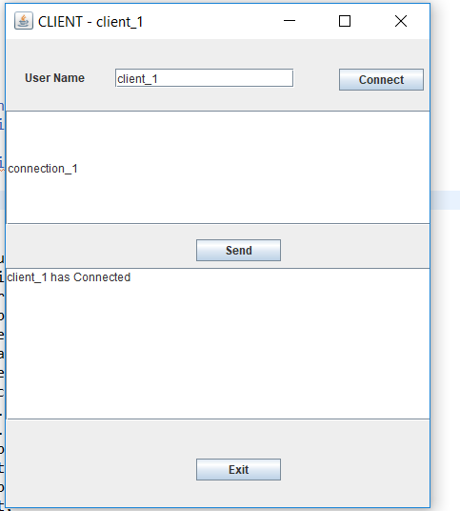

**CLIENT_2**

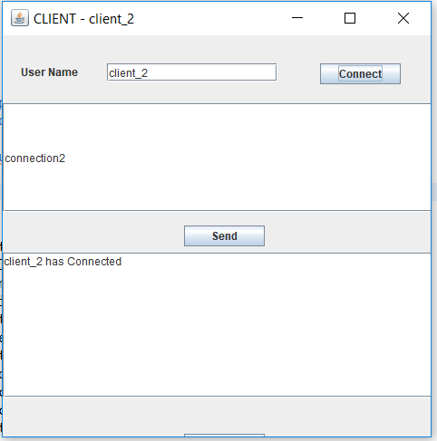

**CLIENT_3**

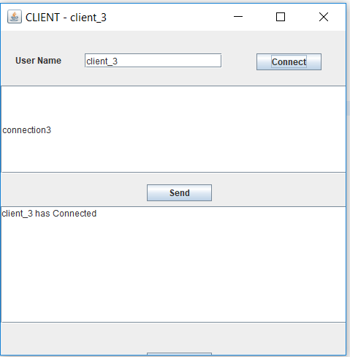

**SERVER AFTER 3 CLIENT CONNECTION**

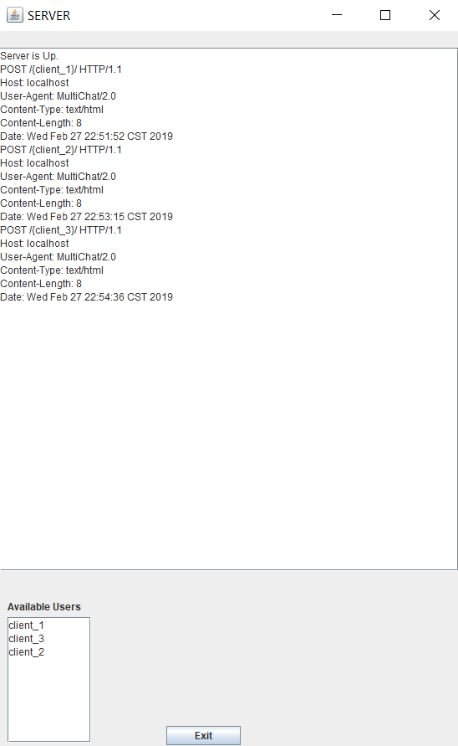

* 1. **MESSAGE:**

**Client sending message to only 1 client :**

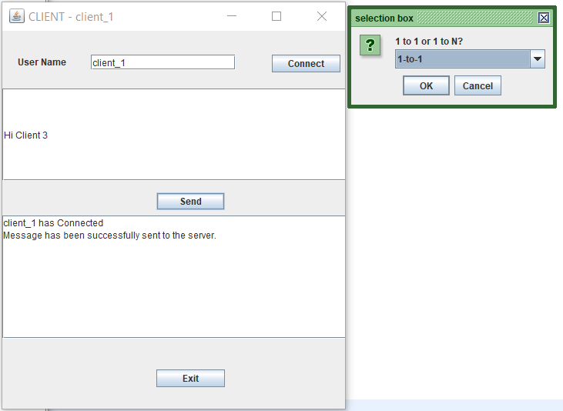

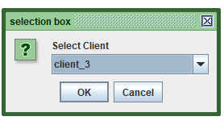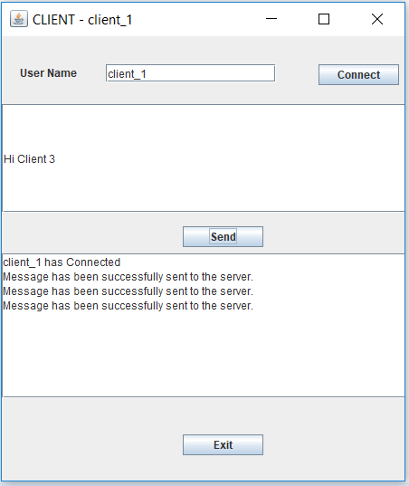

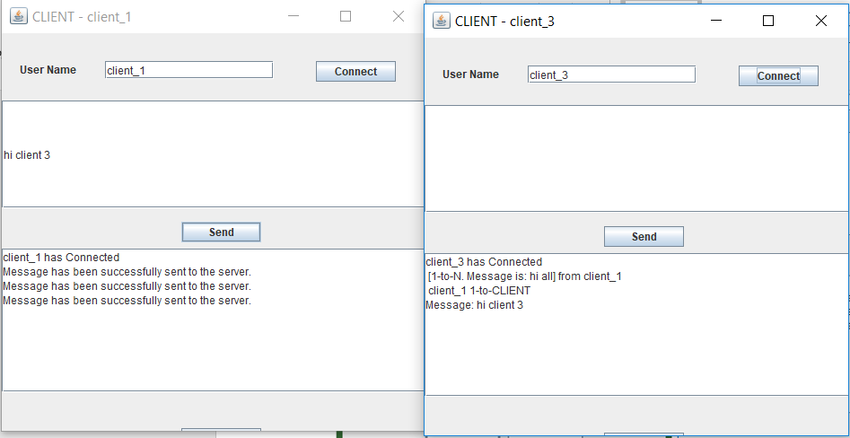

**SERVER AFTER CLIENT_1 SENDING 1-1 MESSAGE to CLIENT_3**

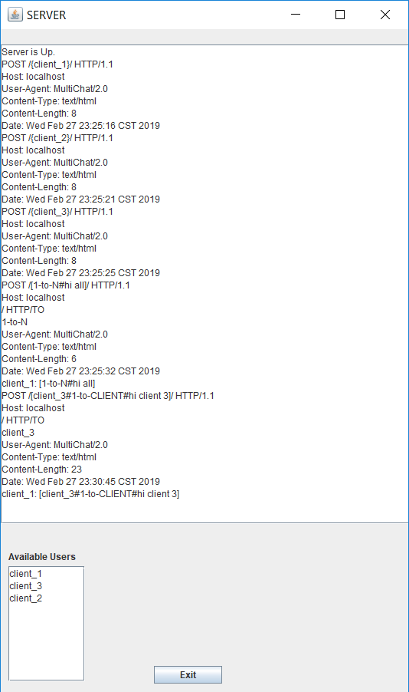

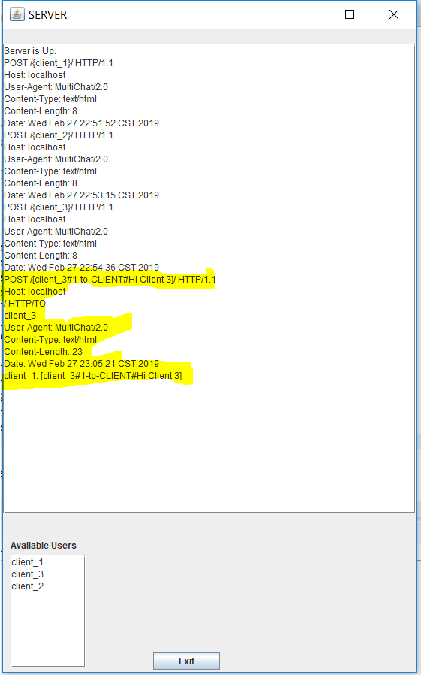

**1-N Message:**

**CLIENT_1 sending message to all CLIENTS.**

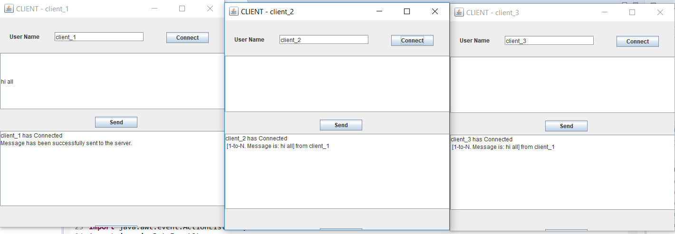

**SERVER after 1-N message**

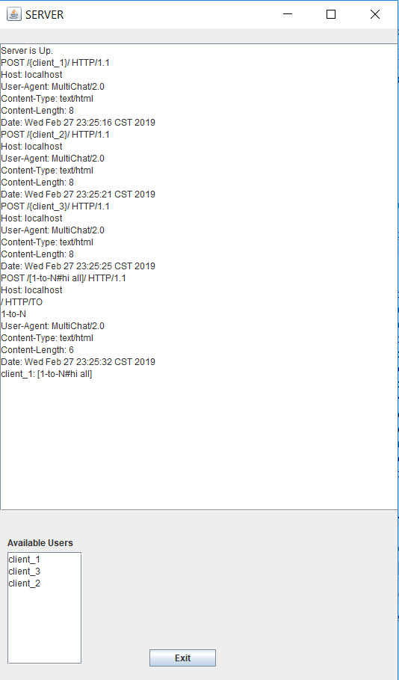

**REFERENCES:**

* https://stackoverflow.com/questions/13207519/adding-a-new-windowlistener-to-a-jframe
* https://winterbe.com/posts/2015/04/07/java8-concurrency-tutorial-thread-executor-examples/
* https://github.com/asingh51/Multithreading-Counter-Synchronization
* https://www.geeksforgeeks.org/multi-threaded-chat-application-set-1/