Indian Institute of Information Technology, Sri City, Chittoor

Name of the Exam: Digital Design SET5 Duration: 60+30 mins (for uploading) Max. Marks: 18
Question 1 to 4: 4 marks each, Question 5: 2 marks
------------------------------------------------------------------------------------------------------------------------------------------
- For the given circuit diagram (NOR gates), applying Boolean algebra find the minimized expression for ouput F=

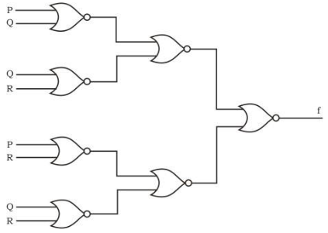

- Design a Full adder using two half adders (include truth table, K-maps, logic expression and diagram)

- Write the truth table of 8x3 enoder by encoding single bit 0. Include logic expression and circuit diagram. Represent inputs D0 to D7, and outputs X, Y and Z.

- 1) Simplify into SOP using K-maps and draw the logic diagram for simplified expression
i) F(a,b,c,d)=∑(0,1,2,5,8,9,10) ii) F(a,b,c,d)=∑(0,2,4,5,6,7,8,10,13,15)

- Write the binary numbers for decimal equivalent of 0-15 in a sequence. Adjacent to binary number write the corresponding gray code.

