SCM LAB ASSINGMENT

How to open and close pull request.

OPENING A PULL REQUEST

Frist step opening up the repository on GitHub to create pull Request.

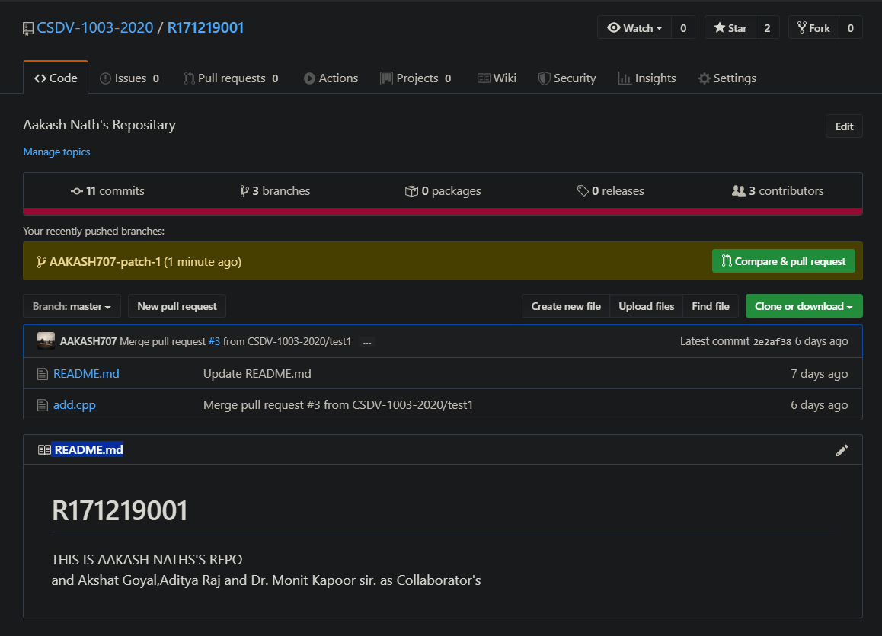

* Next step is click on the button Compare &pull request (which is popping on screen in green color). which will lead you to new screen as shown below ----

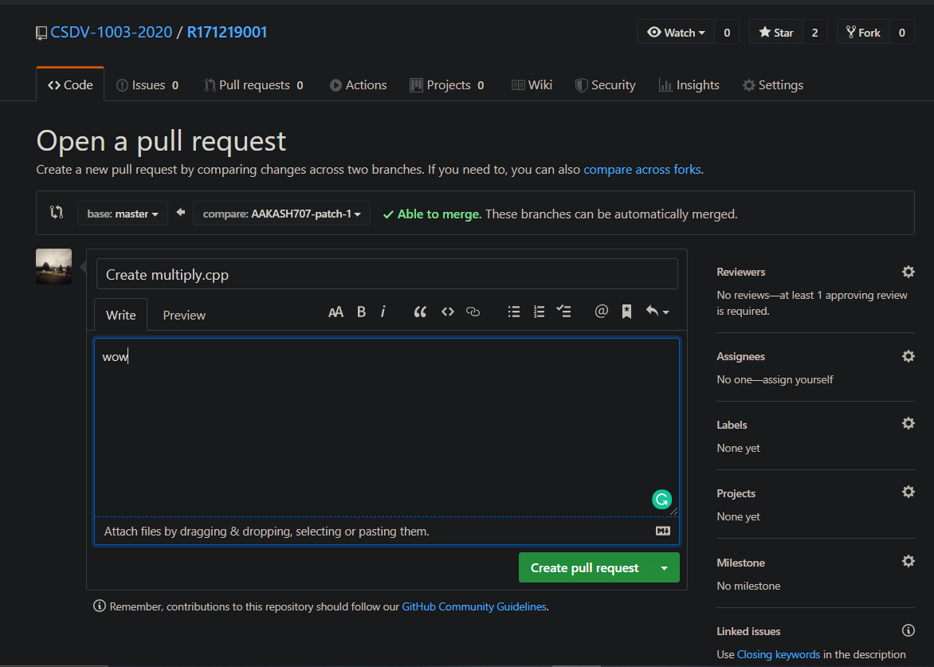

* Clicking on the Create pull request will successfully led to the creation of pull request.
* Now next is to close the pull request which is discussed in the next section

CLOSING A PULL REQUEST

Closing of pull request as two cases that are closing when there is no merge conflicts and the next case is closing a pull request when there are merge conflicts

1.CLOSING WITHOUT MERGE CONFLICTS

* Open GitHub repository and go to the pull request section and select the pull request you want to close it .

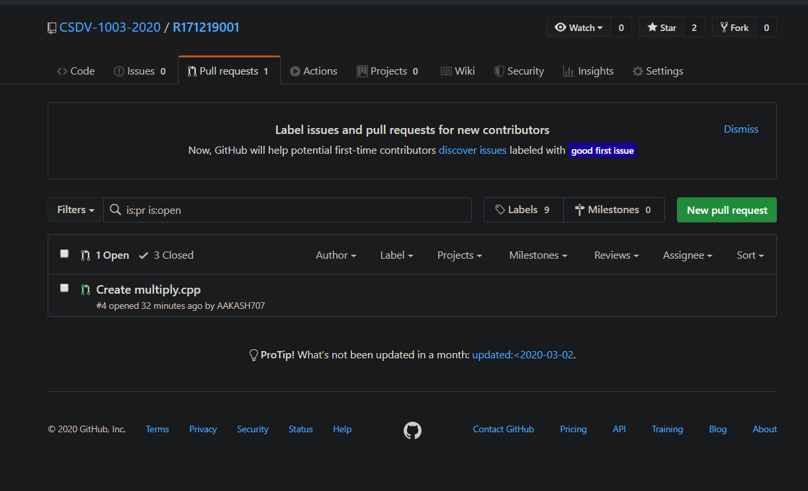

* Now two option are there either (close pull request) or (Merge pull request) any one can be selected merge pull request will merge to the selected branch .and close it

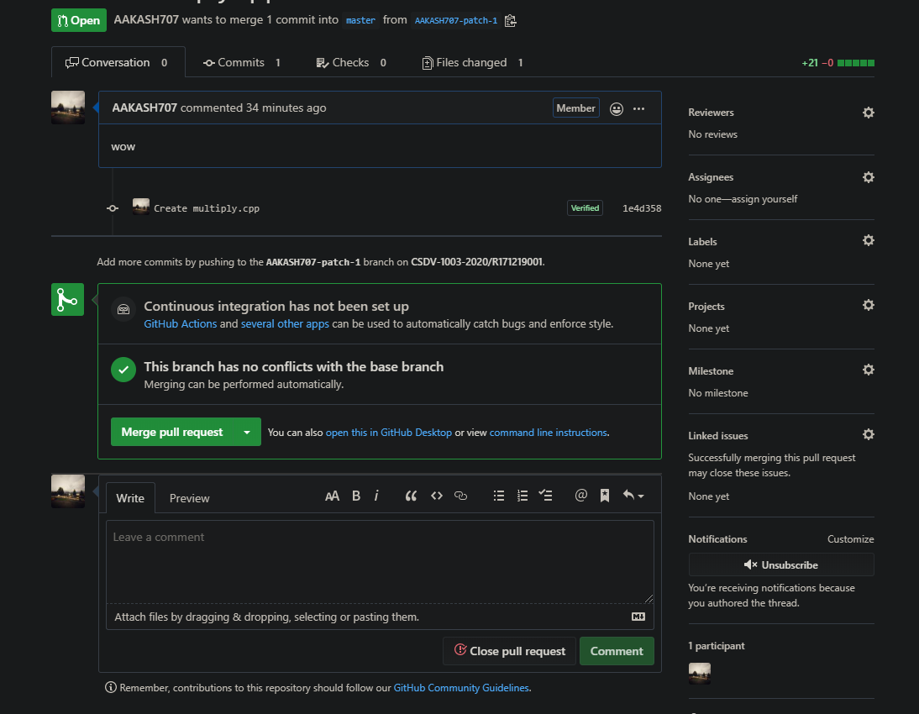

**2.MERGE CONFLICT: RESOLVING & CLOSING.**

**\* first step is same as the previous one that is in first case**

**\* As conflict occur the following screen will appear**

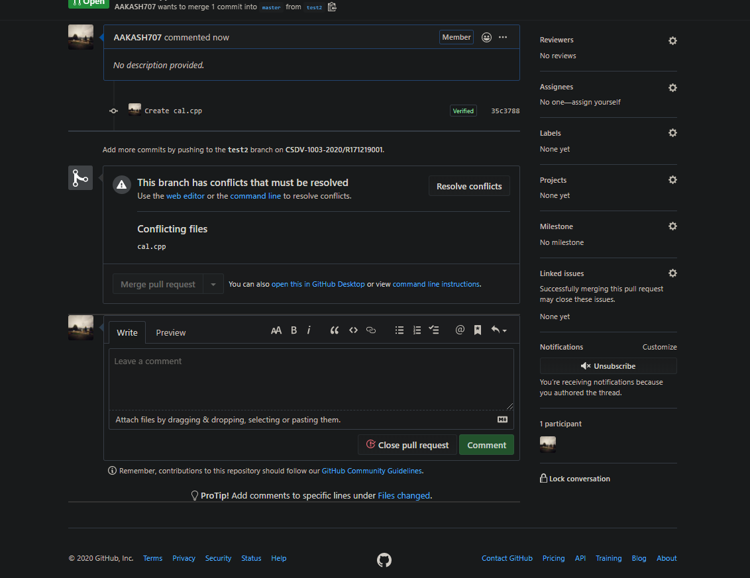

* Click on the resolve conflicts button, and the following screen will appear

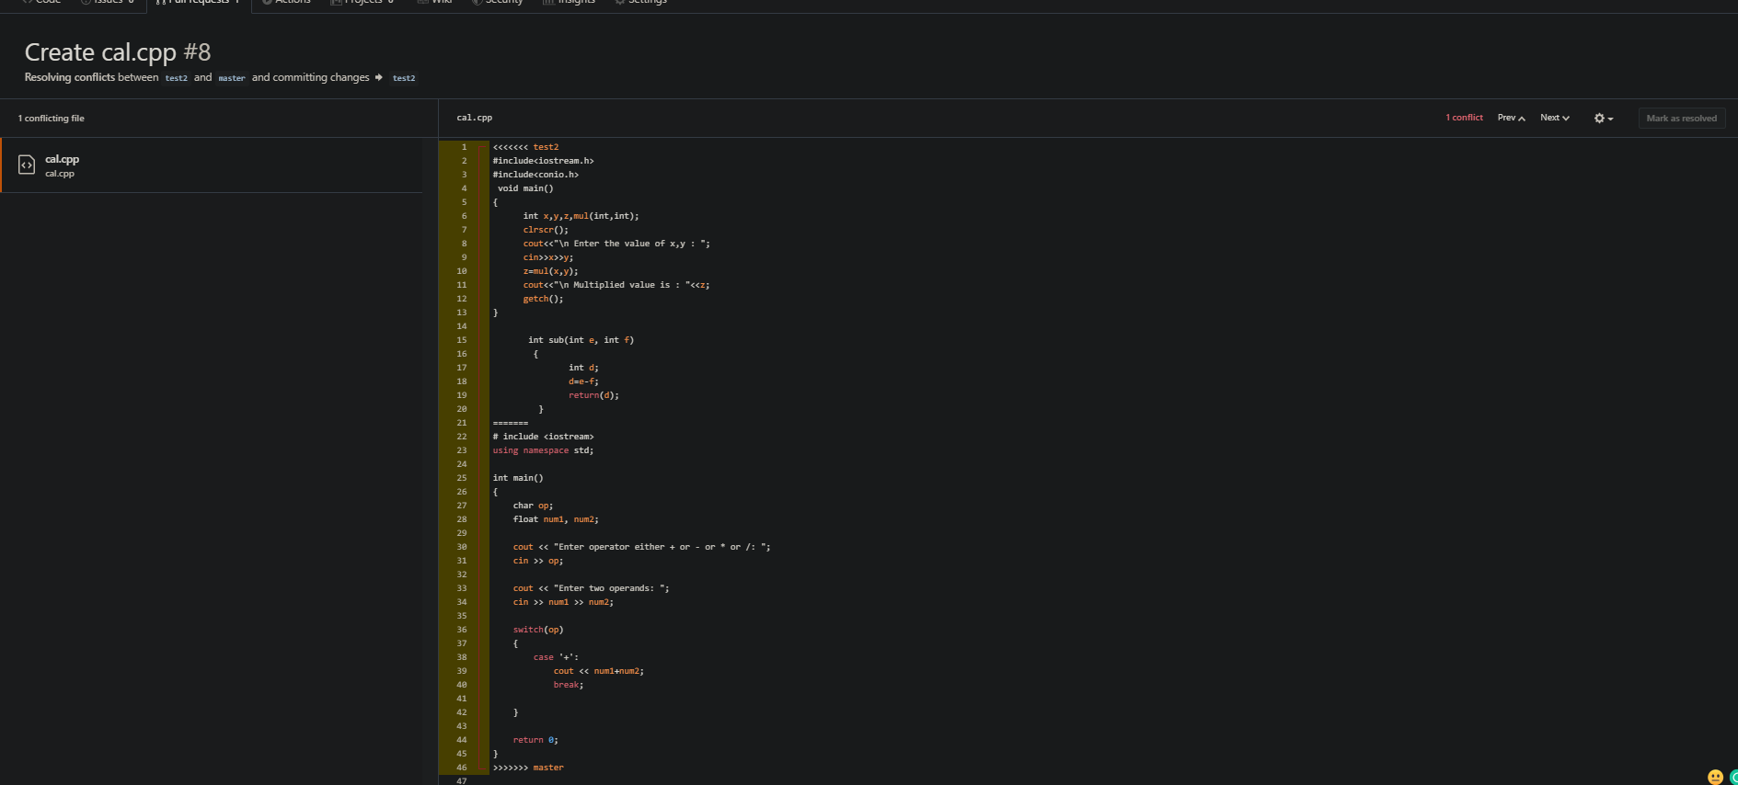

* Resolve the conflicts and select the button present on the top right corner which is (Mark as resolve)
* Now you will notice that a new button named commit merge has appeared, clicking on it follow us to next step

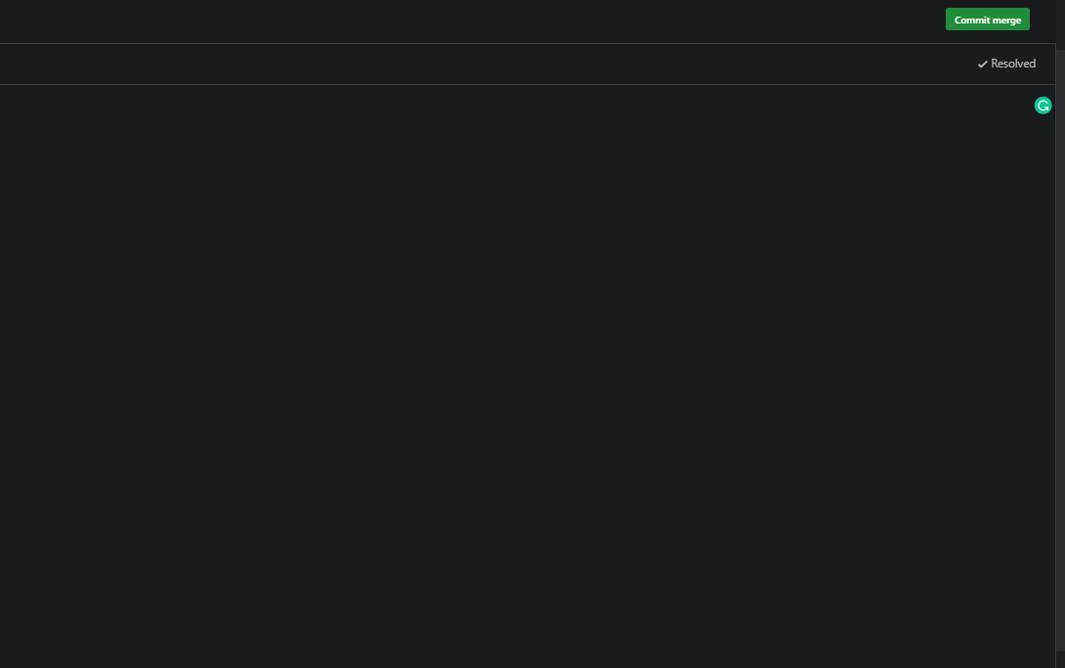

* That is merge, now click on the button (merge pull request) to merge, which ask confirm merge clicking on it close the pull request.

