**Bundle Trip CRM**

**1. CRM: - Customer Relationship Management Software:**

Customer relationship management (CRM) is an approach to manage a company's interaction with current and potential customers. It uses data analysis about customers' history with a company to improve business relationships with customers, specifically focusing on customer retention and ultimately driving sales growth.

One important aspect of the CRM approach is the systems of CRM that compile data from a range of different communication channels, including a company's website, telephone, email, live chat, marketing materials and more recently, social media.[2] Through the CRM approach and the systems used to facilitate it, businesses learn more about their target audiences and how to best cater to their needs.

**2. CRM Workflow for Bundle Trip**

BundleTrip is in the process of optimising their customer management methodology by implementing a CRM. This CRM helps in maintaining data about the existing and potential customers. Various sales practices will be employed in this implementation thereby providing an optimised sales model for the business to sustain and grow.

The below is the identified flow of the business process workflow:

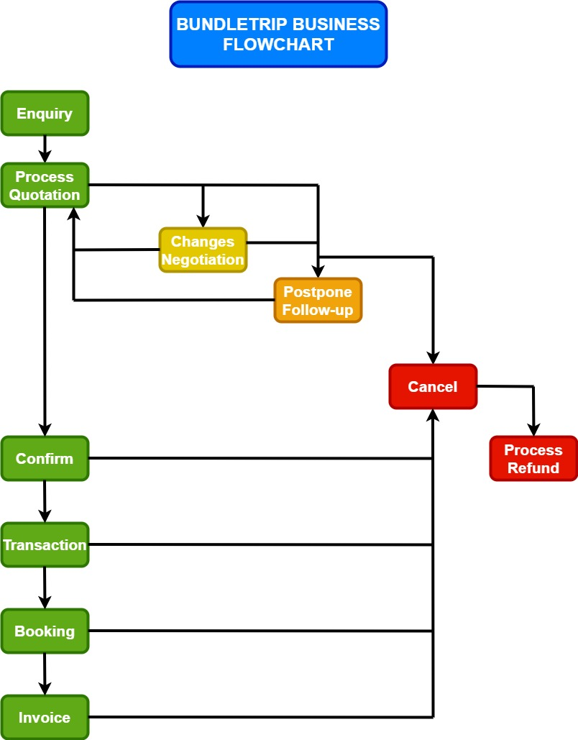

The process has the following stages:

* Enquiry.
* Quotation.
* Amendments.
* Postpone.
* Follow Up.
* Confirm.
* Payment.
* Booking.
* Invoice Generation.
* Cancellation.

Each of the above-mentioned steps have a significance on how the business is carried.

This business workflow is how the business functions and in each phase the customer details are captured.

**The details of each phase in the process is as follows:**

**Enquiry:**

* + Here the customer will enquire of the various tourist packages available.
    - The BundleTrip will explain the customer about the various services they offer and will get know the customer whether the customer is new or old customer or has come through a reference.
  + On the process of enquiry, the customer details are captured by the representative.
    - BT will collect the details of the customer like
      * Travel date
      * No of pax
      * Preferred location(destination)
      * Preferred airline
      * Preferred type of accommodation required.
  + The customer here may be a private tourist or a company touring many people at once.
    - In case of company touring BT has to check the different payment options like giving credit time or renew api balance as soon as company deposits the amount.
  + Bundle trip expects the customer to share his/her details so that further processing can be done.
    - Customers details ids are taken and then the details are stored in the folder for the further requirement.
* Quotation:
  + Here based on the enquiry done by the customer in the above phase, a quote of the total expense will be generated by BundleTrip for the client.
    - Before giving the total bill commission to BT is added and then the detailed itinerary of the trip is given.
  + The client is free to accept the quorate or can go through the negotiation process.
    - Here client can accept the quotation or negotiate about the money and also client can even ask for the change in hotels, itinerary, or may ask to include/exclude any no of places.
* Negotiation:
  + Here the client will negotiate on various factors so that an acceptable price can be quoted.
  + This process is handled by the business team of BundleTrip.
* Postpone:
  + The client may postpone the decision until further notice for various reasons.
  + If the client is ready to share the reason, the CRM can store the reason.
  + The CRM will have a notification system to the business team, who will follow up, upon the postponement of the trip by the client.
* Follow Up:
  + The activity notification system will get hold of all the businesses in the postponed state and notify the business team for actions to be taken upon.
  + The time frame for the follow-up will be shared by the business team.
  + Upon a certain date of follow up, if the trip is still in postponed state, the activity will be escalated to the higher officials to take action on the business.
  + For all the above-mentioned points, the CRM will have to implement the necessary functionalities.
* Confirmation:
  + Once the client confirms the trip the rest of the contact details will be taken by BundleTrip for further processing.
    - The contact details of the customer are stored and these details are sent to the supplier.
    - The payment for the supplier will be done on the basis of which the customer pays the amount.
    - If it is an international package, visa is applied for the customer.
  + All the contact details will be stored in CRM and the necessary processing will be done.
    - The contact detail will include,
      * Name of the passenger.
      * PAN card of each passenger if it is a domestic package.
      * Passport of each passenger if it is an international package.
  + During the course of the confirmation process, the CRM will require various contact details of the customer and his team for the successful processing of the trip.
    - If the customer is a repeated customer then the details must not be asked again.
* Payment:
  + Here the payment will be done by the client for the trip that he/she is about to enjoy.
  + The various payment details should be shared by the customer for the successful processing of the trip.
  + The payment mode and methods will be shared by the business team.
* Booking:
  + Once the payment is done the booking of trip which include transportation, accommodation etc, shall be taken care.
  + More contact information is taken for the booking purpose.
* Invoice Generation:
  + The invoice will be shared to the customer on the successful booking of the trip.
  + The various details of the booking will be shared by BundleTrip on to the customer.
* Cancellation:
  + The cancelation of the trip is done by the customer due to various reasons.
  + Some of the common cancellation reasons would be shared by BundleTrip.
  + Once the trip is cancelled by the client, the trip will go into a pending state, which is kind of treated like a pending trip.
  + When in pending cancellation, the client will be giving some time to reconsider the decision on the cancellation.
  + After some decision, the trip will be cancelled.
  + The cancellation decision will be explained in detail in the functional document.

**The Booking Process**

The booking for the trip is done when the customer completes the transaction.

Here in the booking process the various hotels, travel means etc. will be booked.

The funtional details is as follows:

* The payment done by the customer can be either partial or complete.
* This mode does not affect the booking process as the process is handled by BundleTrip officials.
* The booking process needs extra contact details from the customer for the various bookings to be done for a successful trip.
* The various bookings include the following:
  + Visa Processing
  + Hotel Room booking.
  + Travels(Air, Water, Road).
  + Identity proofs for various other things.
* The Contact details to be taken will include the following:
  1. First, last and middle names.
  2. Birthdate, Govt Identification Numbers (UIDAI, PAN, etc.)
  3. Address of current residence and other addresses if the client is willing to share.
  4. Preference of document delivery.
  5. Number of co-travellers and their details in the aforementioned points.
  6. If its a company travel, the company details. Attach this company details to each of the contact.
* After the details are captured, the booking is done by BundleTrip.
* The customer is free to cancel the booking and the cancellation process will be initiated.
* After the booking is done, the booking confirmation is sent to the client. If individual confirmations are opted, the individual confirmations are sent to the individual people.
* The negotiations is not possible in this phase.
* Changes in the trip details are possible. But changes with respect to the price is not possible.
* After booking confirmation, the invoice generation process is initiated.
* The invoice will be generated and sent to the primary contact of the client.

**PAYMENT AND INVOICE/ RECEIPT GENERATION**

* Once the customer is satisfied with all details provided and booking confirmation is made, then it further proceeds to the payment.
* Payment is of three types: -
* **One-time payment** [Credit/ Debit/ GPay/ PhonePe/ Net Banking/ Link based Payment]
* **Two-time payment (TTP)** [Credit/ Debit/ GPay/ PhonePe/ Net Banking/ Link based Payment]
* **EMI** [Credit/ Debit]
* Invoice is generated only when full payment is done.
* Receipt is generated for every installment being paid [TTP/EMI].
* Invoice and Receipt are to be generated within 24Hrs of payment and forwarded to the customer.
* Airline ticket is generated as soon as the flight booking is done.
* Airline ticket will include: -
* Customer details
* Airline info
* Amount Breakup [Base Charges/ Taxes]
* Receipt will include: -
* Customer details
* Receipt Number
* Date of payment
* Amount paid
* Remaining amount
* Invoice will include: -
* Customer details
* Invoice Number
* Date of payment
* Amount Breakup [Airfare (inclusive of taxes)/ Land package/ Taxes]
* Reminders are sent to the customer as the payment date approaches.
* Follow up is to be made in case of delay or failure of the payment.

**Cancellation process**

* Client is free to cancel the enquiry/trip anytime till confirmation without any penalties.
* After confirmation and transfer of amount, cancellation penalty is applicable.
* Cancellation penalty includes a non-refundable penalty for Bundletrip, airline penalty as per their policy and hotel penalty as per their policy as applicable.
* The stages before confirmation includes receipt of enquiry and submit of quotation, amendments and postponement. At any point of these stages, client can cancel the enquiry without any penalty.
* Cancellation at any point of following stages will attract applicable penalty/charges.
  + Confirmation
  + Payment
  + Invoice generation
  + Any time before the intended start date

All the applicable stages for cancellation and their respective processes are as follows.

**Scenario 1 : Direct cancellation**

* Bundletrip receives enquiry from client
* Bundletrip collects necessary information to process the enquiry and shares the quotation with the client
* Client is unhappy with the quote / client cancels the enquiry due to some reasons (client is willing share the reason / client is not willing to share the reason)
* Client cancels the enquiry
* No refund or cancellation charges are applicable

**Scenario 2 : Cancellation after amendments**

* Bundletrip receives enquiry from client
* Bundletrip collects necessary information to process the enquiry and shares the quotation with the client
* Client is unhappy with the quote and asks for some amendments
* Bundletrip processes those amendments and share a new quotation with the client with all the amendments incorporated
* Client is still unhappy / cancels the enquiry (with/without sharing the reason)
* Client cancels the enquiry
* No refund or cancellation charges are applicable

**Scenario 3 : Cancellation after negotiation**

* Bundletrip receives enquiry from client
* Bundletrip collects necessary information to process the enquiry and shares the quotation with the client
* Client is unhappy with the price and negotiates for a better price
* Client is still unhappy with the quote / client cancels the enquiry due to some reasons (client is willing share the reason / client is not willing to share the reason)
* Client cancels the enquiry
* No refund or cancellation charges are applicable

**Scenario 4 : Cancellation after confirmation**

* Bundletrip receives enquiry from client
* Bundletrip collects necessary information to process the enquiry and shares the quotation with the client (This step may have included amendments or negotiations)
* Client is happy with the price and plan. Client confirms the enquiry
* Due to some unforeseen reasons / reasons client is not willing to share, client informs Bundletrip that the trip/enquiry is cancelled
* Client cancels the enquiry
* Cancellation charges are not applicable if there is no transaction of amount
* Bundletrip processes the refund as per the cancellation policy

**Scenario 5 : Cancellation after transfer of amount**

* Bundletrip receives enquiry from client
* Bundletrip collects necessary information to process the enquiry and shares the quotation with the client (This step may have included amendments or negotiations)
* Client is happy with the price and plan. Client confirms the enquiry
* Client transfer the agreed amount to Bundletrip
* Due to some unforeseen reasons / reasons client is not willing to share, client informs Bundletrip that the trip/enquiry is cancelled
* Client cancels the enquiry
* Cancellation charges are applicable if booking is confirmed by Bundletrip (Amount transferred to supplier and confirmation is given to supplier by Bundletrip)
* Cancellation penalty includes a non-refundable penalty for Bundletrip, airline penalty as per their policy and hotel penalty as per their policy as applicable
* If booking is not confirmed, no cancellation charges are applicable
* Bundletrip processes the refund as per the cancellation policy

**Scenario 6 : Cancellation after booking process**

* Bundletrip receives enquiry from client
* Bundletrip collects necessary information to process the enquiry and shares the quotation with the client (This step may have included amendments or negotiations)
* Client is happy with the price and plan. Client confirms the enquiry
* Client transfer the agreed amount to Bundletrip
* Bundletrip processes the booking and confirms the booking
* Due to some unforeseen reasons / reasons client is not willing to share, client informs Bundletrip that the trip/enquiry is cancelled
* Client cancels the enquiry/trip
* Cancellation charges are applicable in this case
* Cancellation penalty includes a non-refundable penalty for Bundletrip, airline penalty as per their policy and hotel penalty as per their policy as applicable
* Bundletrip processes the refund as per the cancellation policy

**Scenario 7 : Cancellation after invoicing**

* Bundletrip receives enquiry from client
* Bundletrip collects necessary information to process the enquiry and shares the quotation with the client (This step may have included amendments or negotiations)
* Client is happy with the price and plan. Client confirms the enquiry
* Client transfer the agreed amount to Bundletrip
* Bundletrip processes the booking and confirms the booking
* Due to some unforeseen reasons / reasons client is not willing to share, client informs Bundletrip that the trip/enquiry is cancelled
* Client cancels the enquiry/trip
* Cancellation charges are applicable in this case
* Cancellation penalty includes a non-refundable penalty for Bundletrip, airline penalty as per their policy and hotel penalty as per their policy as applicable
* Bundletrip processes the refund as per the cancellation policy

**Special Scenarios :**

* Special scenarios are situations where some unforeseen reasons / similar reasons may affect the enquiry/trip at advanced stages of the business flow.
* Some of the scenarios are listed below.
* **Change of the entire plan before start date :** 
  + Client enquiries with Bundletrip, confirms the tour, transfers the amount and booking is confirmed.
  + Due to unforeseen reasons (natural calamities, death in family, health issues, epidemic virus/diseases etc) the client requests Bundletrip to change the entire plan.
  + Change of plan may include change of date, change of hotel, change of destination, change of no of pax, change of flight etc.
  + Cancellation / reschedule penalty is applicable and includes a non-refundable penalty for Bundletrip, airline penalty as per their policy and hotel penalty as per their policy as applicable.
  + Changes may attract applicable surcharges and taxes, difference in the amount for the required change.
  + Bundletrip processes the cancellation / reschedule and refund the amount as per the cancellation policy.
* **Change of the entire plan after start date :** 
  + Client enquiries with Bundletrip, confirms the tour, transfers the amount and booking is confirmed
  + Client starts the tour
  + Due to unforeseen reasons (natural calamities, death in family, health issues, epidemic virus/diseases etc) the client requests Bundletrip to change the entire plan
  + Change of plan may include change of date, change of hotel, change of destination, change of no of pax, change of flight etc
  + Cancellation / reschedule penalty is applicable and includes a non-refundable penalty for Bundletrip, airline penalty as per their policy and hotel penalty as per their policy as applicable
  + Changes may attract applicable surcharges and taxes, difference in the amount for the required change
  + Bundletrip processes the cancellation / reschedule and refund the amount as per the cancellation policy
* **Client not satisfied with the service of Bundletrip and demands refund after the trip :** 
  + Client enquiries with Bundletrip, confirms the tour, transfers the amount and booking is confirmed
  + Client starts the tour
  + Client faces many problems / obstacles during the tour
  + Above may include problems with driver, problems with flight / airline, problems with hotel, problems with car etc
  + Client informs such situations to Bundletrip
  + Bundletrip takes measures to make sure all these problems are sorted
  + If the problems are sorted, client is happy and continuous with the tour and come back with happy memories
  + If the problems are not sorted or new issues arises, client is unhappy with the tour/service from Bundletrip and askes for refund
  + Bundletrip investigates the problems and comes up with a solution which is acceptable to all
  + Solution may include refund, discount voucher or no action