An Internship Report
Of
Software Development & AI Integration at itsfolio.tech
Submitted
To
School of Computer Science and Engineering
IILM University, Greater Noida, U.P.
In partial fulfilment of the requirement of degree of
B-Tech (CSE)

By
Roll Number of Student:- 2410030369
Name of Student: ADITYA RAJ
Batch: 2026-27

CANDIDATE'S DECLARATION
I, ADITYA RAJ, do hereby declare that the internship report titled "Software Development & AI Integration at itsfolio.tech" has been completed by me to fulfil the requirement for the award of the degree of Bachelor of Technology in Computer Science and Engineering. All the references have been quoted and I have not taken as such any material from any other source. I affirm that this report is my own and has not been submitted to any other institute for any degree/diploma requirement, and further I shall be solely responsible for any kind of copyright violation in this regard.

Signature:-
Student Name: ADITYA RAJ
Roll No.: 2410030369

ACKNOWLEDGEMENT
I am using this opportunity to express my gratitude to everyone who supported me throughout the Internship Program. I am thankful for their aspiring guidance, invaluably constructive criticism and friendly advice during this work. I am sincerely grateful to them for sharing their truthful and illuminating views on a number of issues related to this work.
I would like to thank Mr. Ashish Umrao, Founder of itsfolio.tech, and the itsfolio.tech team for providing me the opportunity to work as a Software Development Intern on a live, growing product and for their constant guidance and mentorship throughout the internship. I am also thankful to my institute, IILM University, Greater Noida, and the faculty of the School of Computer Science and Engineering for their continuous support and encouragement.
I express my gratitude to my parents for their blessings.

Signature:
Student Name: ADITYA RAJ
Roll No.: 2410030369

TABLE OF CONTENTS
1. Candidate's Declaration i
2. Acknowledgement ii
3. Internship Offer Letter -
4. Project Description 1
4.1 Introduction 1
4.2 Organization Profile 2
4.3 Problem Statement 3
4.4 Project Objectives 3
4.5 Scope of the Project 4
4.6 Technologies and Tools Used 4
4.7 System Architecture 5
4.8 Methodology 6
4.9 Expected Outcomes 7
4.10 Certificates of Completion and Communication Proof 8
5. Bibliography/References 9

3. INTERNSHIP OFFER LETTER
The Internship Offer Letter for the position of Software Development Intern was received via official email from itsfolio.tech. The Certificate of Internship and Letter of Recommendation are issued by itsfolio.tech on successful completion of the internship.
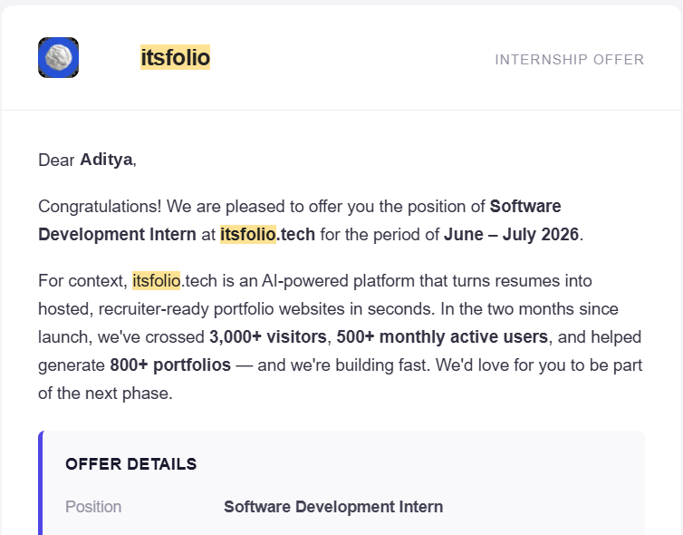

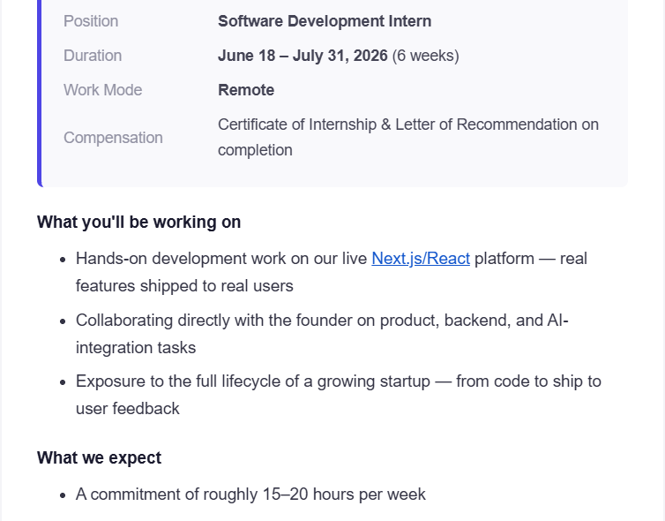
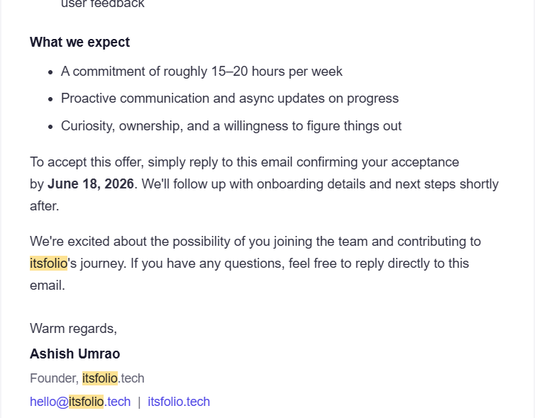

4. PROJECT DESCRIPTION
4.1 Introduction
This report presents a detailed account of the 6-week Software Development Internship undertaken at itsfolio.tech, carried out from June 18, 2026 to July 31, 2026 in remote work mode, as part of the requirement of the Bachelor of Technology (Computer Science and Engineering) programme at IILM University, Greater Noida. The primary aim of this internship was to gain real-world, hands-on software development experience by working on a live product used by real users, and to bridge the gap between academic learning and professional, production-grade web development.
During the internship, the intern worked directly with the founder on hands-on development tasks across the product — including frontend features on the live Next.js/React platform, backend and API development, and AI-integration tasks — and gained exposure to the full lifecycle of a growing startup, from writing code to shipping features and responding to user feedback. The internship required a commitment of roughly 15–20 hours per week along with proactive communication and asynchronous progress updates.
4.2 Organization Profile
itsfolio.tech is an AI-powered platform that turns resumes into hosted, recruiter-ready portfolio websites in seconds. A user uploads their resume, and the platform automatically generates a polished, professionally designed personal portfolio website that is instantly hosted and shareable with recruiters. Within the first two months since its launch, the platform crossed 3,000+ visitors and 500+ monthly active users, and helped generate 800+ portfolios, making it a fast-growing early-stage product. The company was founded by Mr. Ashish Umrao and operates with a lean, product-focused team, with its tagline being “From resume to portfolio — instantly.”
4.3 Problem Statement
Students and early-career professionals often struggle to present their skills effectively to recruiters. While almost everyone has a resume, very few have a personal portfolio website — building one traditionally requires design skills, web development knowledge, hosting setup, and considerable time. itsfolio.tech solves this by automating the entire journey from resume to a hosted portfolio using AI. From the internship perspective, the problem addressed was to contribute to this live platform as a software developer: building and improving real features, strengthening the backend and AI-integration pipeline, and helping the product scale reliably as its user base grows — all within a fast-moving startup environment.
4.4 Project Objectives
- To gain hands-on development experience on a live Next.js/React platform by shipping real features to real users.
- To develop and refine responsive, user-facing frontend components and portfolio templates.
- To work on backend logic and API routes supporting the resume-to-portfolio generation pipeline.
- To collaborate directly with the founder on product, backend, and AI-integration tasks.
- To integrate and improve AI-powered resume parsing and portfolio content generation using LLM APIs.
- To understand deployment, testing, and optimization workflows used in a production web application.
- To experience the full lifecycle of a growing startup — from code to ship to user feedback.
- To practice professional work habits including proactive communication, async updates, ownership, and self-driven problem solving.
4.5 Scope of the Project
The scope of this internship covered end-to-end software development work on the itsfolio.tech platform — spanning frontend development in React/Next.js, backend and API development, AI-integration tasks for resume parsing and portfolio generation, testing and deployment of features, and iteration based on analytics and user feedback. The work was carried out remotely on the live production codebase under the direct guidance of the founder. The internship focused on assigned features and improvements within the platform and did not extend to independent ownership of company infrastructure, billing systems, or business operations.
4.6 Technologies and Tools Used
- Frontend Development: Next.js, React, JavaScript/TypeScript, HTML, CSS (utility-first styling)
- Backend Development: Node.js runtime, Next.js API routes, RESTful services
- AI Integration: Large Language Model (LLM) APIs for resume parsing and content generation, prompt engineering, structured output handling
- Database & Storage: Cloud database and file storage for user resumes and generated portfolio data
- Version Control & Collaboration: Git, GitHub, code reviews, async communication tools
- Deployment & Hosting: Cloud deployment platform for the live web application and hosted portfolio sites
- Analytics & Feedback: Web analytics and user feedback for feature iteration
4.7 System Architecture
The general architecture of the itsfolio.tech platform, as worked on during the internship, can be summarized in the following layers:
- Presentation Layer: A responsive Next.js/React web application through which users upload resumes, customize their portfolio, and manage their hosted site.
- API Layer: Next.js API routes and server-side logic that handle resume uploads, user management, and portfolio generation requests.
- AI Processing Layer: LLM-powered services that parse the uploaded resume, extract structured information (skills, experience, education, projects), and generate polished portfolio content.
- Data Layer: Databases and storage services that persist user accounts, resume data, and generated portfolio configurations.
- Hosting & Delivery Layer: Cloud infrastructure that builds and serves each generated portfolio as a fast, publicly accessible, recruiter-ready website.
- Feedback Layer: Analytics on visitors and portfolio generation that inform product iteration and feature prioritization.
4.8 Methodology
The internship followed an agile, ship-fast methodology typical of an early-stage startup — combining assigned development tasks, direct collaboration with the founder, regular async progress updates, and iterative delivery of features to the live platform. The week-wise breakdown of the work is summarized below.
Week | Module | Description
1 | Onboarding & Codebase Familiarization | Introduction to the itsfolio.tech product and roadmap, development environment setup, walkthrough of the live Next.js/React codebase, Git/GitHub workflow, and understanding the resume-to-portfolio generation flow.
2 | Frontend Feature Development | Building and refining React components and portfolio template layouts, responsive design with modern CSS utilities, UI polish, and shipping user-facing improvements to the live platform.
3 | Backend & API Development | Working on Next.js API routes and server-side logic, resume upload and processing pipeline, data modelling and storage, and integration between frontend and backend services.
4 | AI Integration Tasks | Collaborating with the founder on AI-powered resume parsing and portfolio content generation, prompt design, handling structured outputs from LLM APIs, and improving generation quality and reliability.
5 | Testing, Deployment & Optimization | Bug fixing, testing of new features, deployment workflow on cloud hosting, and performance, SEO, and load-time optimization of generated portfolio sites.
6 | User Feedback & Final Delivery | Analysing user behaviour and feedback from live users, iterating on features accordingly, documentation of completed work, and final handover with async progress updates.

Throughout the internship, progress was communicated proactively through asynchronous updates, and completed work was reviewed before being shipped to the live platform. Emphasis was placed on curiosity, ownership, and a willingness to figure things out independently.
4.9 Expected Outcomes
- Ability to independently build and ship production-quality features on a modern Next.js/React codebase.
- Practical understanding of full-stack web development, including frontend, backend APIs, and data handling.
- Hands-on experience integrating AI/LLM capabilities into a real product used by hundreds of active users.
- Exposure to the complete lifecycle of a growing startup — from code to ship to user feedback.
- Strengthened professional skills: proactive communication, async collaboration, ownership, and time management alongside academics.
- Certificate of Internship and Letter of Recommendation from itsfolio.tech on successful completion.
4.10 Certificates of Completion and Communication Proof
The Internship Offer Letter received via official email from itsfolio.tech, confirming selection for the position of Software Development Intern for the period June 18 – July 31, 2026 (6 weeks, remote), is attached in Chapter 3 of this report. As per the offer, the Certificate of Internship and Letter of Recommendation are issued by itsfolio.tech upon successful completion of the internship, and all internship communication was carried out through the official email hello@itsfolio.tech.

5. BIBLIOGRAPHY/REFERENCES
1. itsfolio.tech, "Internship Offer – Software Development Intern," official offer email from Mr. Ashish Umrao, Founder, itsfolio.tech, 2026.
2. itsfolio.tech — AI-powered resume-to-portfolio platform, https://itsfolio.tech
3. Next.js Documentation, https://nextjs.org/docs
4. React Documentation, https://react.dev/
5. Node.js Documentation, https://nodejs.org/docs/
6. MDN Web Docs, https://developer.mozilla.org/
7. Git Documentation, https://git-scm.com/doc

