Climate Change

(A Fundamental Analysis of the Greenhouse Effect)

By

John Nicol

jonicol@netspace.net.au

Introduction

Over recent years there has been considerable debate concerning the possibility of industrially induced increases in the concentration of carbon dioxide in the atmosphere giving rise to increased warming across the world.

This Global Warming, often referred to in later times as “Climate Change”, has been accepted as a challenge by laymen, respected scientists, media moguls and politicians in a significant attempt to pursue the source of the problem and to prevent further damage being done to an increasingly fragile environment. However, a large number of equally respected scientists and members of the public, appear to be less convinced of the need to take action and have put forward in some cases well and passionately argued reasons that the warming and other climatic changes observed since the industrial age are simply manifestations of many different natural cycles in global and regional climate.

Let there be no mistake, climate change is real, very real and of course has been for many millions of years. The questions we now face is whether the large increases in recent years, in the concentration of atmospheric Carbon Dioxide, which is commensurate with the rate of increase in our burning of fossil fuels, is the main cause of the observed variations in climate and what will be the effect in the future. Fortunately, in relation to this problem, there is an apparently unprecedented level of cooperation between the nations of the world, all of whom are keen to find the answers to these questions and to contribute significant resources, if necessary, towards reducing the impact of the predicted cataclysmic outcomes if we continue along the current path of developing energy sources based on these fuels. A timely attempt has also been made by the United Nations to establish an effective working committee employing a large team of dedicated scientists to collate the evidence, from earlier literature, related to climatic effects of the presence of CO₂ in the atmosphere and to establish accurate analytical models of the atmosphere based on this science, from which long range predictions might be made of the outcomes from increased levels of this otherwise benign and in fact life-giving gas. While there appears to be a wide consensus in accepting the basic science used to create all of the very large number of these computer based models being used to quantify the problem, it is also reported that the outcomes from the models vary quite significantly and that the results given by them relating to various climatic parameters often show large differences between models, as indicated in Chapter 8 of the UN Intergovernmental Panel on Climate Change (IPCC) Report 2007. The one exception to this uncertainty in the results appears to be that of changes in global temperatures for which the models consistently provide a well recognized increase in temperature of 1 to 4 ºC over the next 50 to 100 years. Further modeling appears to indicate that such increases in the average global temperature will not allow for a sustainable future for mankind on this planet as we know it, and that very dramatic and perhaps costly changes will need to be made to our energy production programmes in order to quell the flow of ever increasing calamitous events such as unprecedented melting of ice at the poles and the rising of sea levels in the tropics. A worrying corollary to the apparent lack of consistency in the values obtained for many of the atmospheric parameters, is that this perhaps points to greater uncertainty in the temperature results than has yet been recognized and that the consistency with which they predict a positive change in temperature, while clearly showing that there will be a continuing increase, may in fact indicate a much larger increase than predicted. A matter of concern to many scientists seeking to understand this important issue, is the fact that the average global temperature appears not to have increased in the last ten years or may even have slightly decreased while CO₂ levels have continued to rise. Is this the lull before the storm?

Flowing quite naturally from these overwhelmingly pessimistic results obtained from very carefully designed computer based climate models, the world population is becoming increasingly anxious about facing an uncertain future and as a result, governments, quite rightly, are keen to provide the appropriate protection, by setting up committees of expert economists, scientists and engineers to advise, with a growing sense of urgency, on the necessary courses of action to quell the increasing anxieties of their constituents and to reduce as much as possible the burning of fossil fuels which are the main source of increased carbon emissions.

The Green House Effect

As is very well known, the basis of the concerns over climate change is what has become known as “the green house effect”, even though it is almost as well known that the effect contains many elements which are not common to the gardener’s green house. In the latter object, the main process which results in the warming of the interior is the removal of convection currents which are among the most significant means of cooling of the earth. A secondary feature of the glass covering, is that its windows are approximately 90% transparent to the most intense parts of the solar spectrum, thus allowing the heat from the sun to enter almost unimpeded and to warm the surface of the leaves and the ground inside. However, the warmed surfaces themselves are naturally cooled by radiation of the heat at a rate determined by the characteristics of the surface and given by the well established fourth power law derived by Stefan which states that the power radiated per unit area of the heated surface is given by
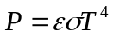 (1)
where ε is a constant known as the emissivity and depends on the characteristics such as colour and degree of roughness of the surface, 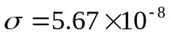WT⁻⁴ is Stefan’s constant and T is the temperature of the surface. In most environments, the surface will simultaneously receive energy from an ‘enclosing’ surface of temperature T_{o} and Stefan’s law is more completely written as
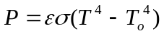 (2)
As for the earth, the enclosing surface is simply the cold outer space with a temperature of approximately zero.

Returning to the green house, the warmed plants will now radiate energy but the frequency (wavelength) characteristics of this re-radiation is determined by the temperature of that surface, just as the frequencies received from the sun depend on the solar temperature of approximately 6,000 ºK. This frequency spectrum is defined theoretically by Planck’s Law, which is written in terms of the intensity 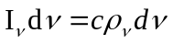over an elemental range of frequencies δν, where ρ_{ν} is the energy density, for the radiation from a black body at frequency ν at the surface in the form
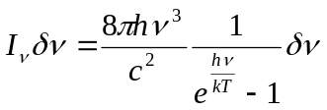 (3)
where h is Planck’s constant of 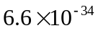Joule-seconds, c is the velocity of light, 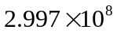ms⁻¹, k is Boltzmann’s constant of 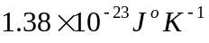 and the function on the right gives the intensity per unit frequency interval. Equation (3) may be written in terms of wavelength as
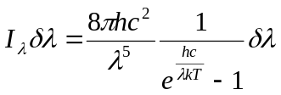 (4)
From this expression, it is easy to show that the maximum intensity in the blackbody spectrum occurs at a wavelength λ_{m} which is related to the temperature T of the surface by Wien’s displacement law
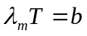 (5)
in which 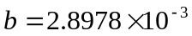m ºK. Applying Equation (5) to the temperature of the earth’s surface and to that in the greenhouse, each about 293 ºK, it is found that the maximum wavelength in the spectrum of radiation from these sources is approximately 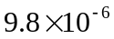m or roughly 10 μ. This is to be compared with the maximum of the sun’s radiation received by the earth of approximately 0.5 μ from a temperature of about 6,000 ºK. The range of wavelengths of significant intensity represented by the black body spectrum at 293 ºK lie between 1.0 and 100.0 μ which lies within the defined infra red (IR) band of the electromagnetic spectrum. Within this band of wavelengths and at equilibrium temperature, the power radiated is the same as that received, within the quite different spectral range having been produced by a much hotter body, the sun, but having been significantly reduced in intensity because of the large distance of the earth from the sun which is approximately 1.5 million km. However, the long wavelength characteristics of the radiation from the earth’s surface lead to a quite different absorption process from that experienced by the incoming radiation from the sun for most of which the atmosphere is transparent. Similarly, the glass of the green house, through which all visible radiation passes quite freely, being reduced significantly only through reflections from the surfaces leading to a loss of about 8%, is quite opaque to the infra red radiation and both absorbs and reflects this energy, thus retaining much of the heat within the enclosed space of the glass house.

In the case of the open atmosphere, where there is no constraint to movement of the air as in the glass greenhouse, conduction and convection play very important roles in the process of removing heat away from the surface of the ground or any other heated body. However, the interception of energy by certain constituents of the atmosphere, which have radiation and absorption bands lying within the range of the infrared wavelengths (1.0 and 100.0 μ), acts as a warming influence by impeding the rapid removal of heat from the vicinity of the surface. This process thus leads those gases to play a role similar to that of the infra-red opaque glass in the windows of the greenhouse. However, the clear determination of the manner in which this role is played out, requires a very careful analysis of the spectroscopic characteristics of the gases involved as well as consideration of the various processes by which the acquired internal energy may be transferred from the absorbing species to the other gases, both back to the earth and out to the cold external space surrounding its uppermost mantel.

Green House Gases

While there are several different gases in the atmosphere which have appropriate absorption bands allowing them to play a significant role in maintaining the comparatively constant temperatures experienced in various latitudes and regions of the earth, the two most prominent species which are credited with providing the major source of warmth to the atmosphere are water vapour 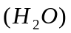 and carbon dioxide 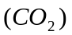. In order to gain an appreciation of the various important spectral characteristics of a greenhouse gas, it is perhaps instructive to deal initially with one such gas only which will provide a general insight into the various physical processes involved, which may then be applied to the other gases.

Spectroscopic analysis of the Greenhouse Effect

An analysis of the acceptance of radiation by a greenhouse gas (GHG) involves an examination of its absorption spectrum together with the external effects upon this spectrum arising from collisions with the molecules of their own species and with foreign gases. It is important at the outset to realize that the free molecules in gases, no matter how dense the ensemble may be, cannot absorb or emit radiation except that which corresponds to the frequencies of their own spectrum. However, significant energy is usually transferred from an excited gas through collisions, whether these are within the walls of an enclosing vessel or with other molecules, or atoms, in the ensemble. In the case of atmospheric gases, a channel may seem to exist for the escape of the absorbed energy through its transfer by collisions to particulate matter or aerosols which are of dimensions significantly larger than a wavelength of the radiation and so can radiate as other black bodies. However, most of this radiation will be at the same frequency as that from the earth and be quickly reabsorbed in the atmosphere and that which is not absorbed may not be significant, since the density of such particulate matter, which effects all wavelengths almost equally, is obviously very small, except in smog, as can be readily observed when we look to the sky by day or night. In addition, the collisional process gives rise to the transfer of energy to all of the other gaseous constituents of the atmosphere which again, through multiple collisions and the consequent exchange of momentum, distribute the energy throughout the population in the form of a Maxwellian (Gaussian) distribution.

To appreciate the magnitude of the quantities with which we are required to deal, it is instructive to consider a single gas species (GHG) and to consider the energy transfer processes involved for a given level of solar irradiation within a column of air bounded at the bottom by the radiating surface of the earth and at the top by the extreme level of the Troposphere. For this purpose we select carbon dioxide gas and consider a column of varying temperature and gas density, both on average reducing, up to a height of 10,000 m within the tropics where we will assume a ground level irradiation which leads to a surface temperature of 289 ºK. In this case, the spectrum of the surface radiation is shown in Figure 1.
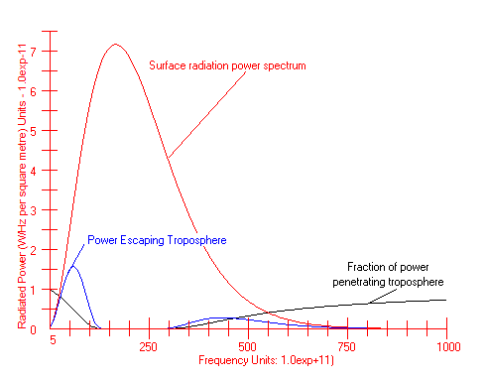
Figure 1. Power per unit frequency in a 1 m² column (a) radiated by the earth surface ------- (b) escaping from the top of the troposphere ----. The inverted curve (c) ----- shows the fraction of power at a given frequency escaping from the top of the troposphere. The density of CO₂ is taken as 380 ppm and the spectral line width is 1.0 x 10⁸ Hz. The width used for the other calculations is 5.0 x 10⁹Hz.

This diagram represents the behaviour of the CO₂ in the atmosphere in absorbing radiation emitted from the earth’s surface at a temperature of 289 ºK. The red curve shows the frequency distribution from Equation (3) of the energy in terms of the power per unit frequency interval across the significant part of the spectrum assuming an emissivity factor of unity at all frequencies. The absolute values are obtained by comparing the integrated power from this function with the total power radiated as given by Stefan’s Law, Equation (1). The black inverted curve shows the fraction of radiation emitted at each frequency which escapes from the top of the troposphere at a height of 10 km and thus represents the proportion of the energy which could be additionally captured by an increase of CO₂ and so contribute to the further warming of air in the various layers of the troposphere. It thus represents the effective absorption spectrum of CO₂ within the range of frequencies shown after accounting for collisional line broadening which provides a reduced but significant level of absorption even in the very far wings of the line which is represented in Figure 3 on page 6. This phenomenon follows from very well established principles of line broadening and is ‘observable’ in the very far wings, only because of the enormously long path (up to 10,000 m) followed by radiation through the atmosphere and will probably never be observable in any laboratory experiment where the path length is strictly limited. However, one possible means of making measurements would be to use a high pressure sample of air inside a very long but stable Fabry-Perot interferometer together with a highly sensitive infrared detector and scanning IR laser at the appropriate frequencies. The blue curve (b) in Figure 1., shows the product of curves (a) and (c) and gives a measure of the actual power which breaks free from the troposphere and would thus be available to provide further heating of the atmosphere if it were captured by increasing levels of CO₂ and represents approximately 0.75% of all radiation from the earth. It must be noted that this is the proportion which escapes directly from the earth by radiation as an electromagnetic wave, not having been absorbed and reradiated or ‘processed’ in any way by the atmospheric gasses. The most significant power in this category is seen to be dominant at the extremes of the spectral range.

In calculating these absorption profiles, the variation of the atmospheric density shown in Figure 2 is taken into account as described later. This profile, represents the effective number of absorbing CO2 molecules per unit frequency interval at the centre of a single component of the broad CO2 band at 15.0 μ (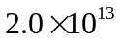~Herz), at various heights within the troposphere.
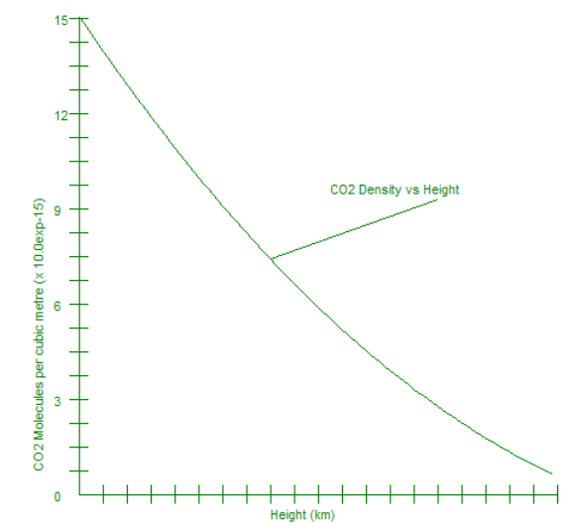
Figure 2. The number density N_{o} of CO₂ molecules contributing to absorption over unit frequency interval of the radiation at the centre of the absorption line as a function of height and calculated from the expression 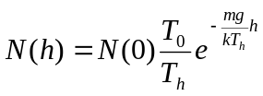. Account is taken of the variation of temperature (the lapse rate) and it is assumed that the variation with height is similar to that in a column of pure CO₂. The range of the horizontal axis is 10 km.
Structure of the radiation Field and a Molecular Absorption Band

The initial radiation field to be considered is simply that of a hot body. The intensity and frequency distribution of this field, represented by the red curve in Figure 1, vary with the temperature as described by equations (1) and (3) above and to some extent with the characteristics of the surface. As the field passes through a system of molecules, its energy, at those frequencies which correspond to an allowed transition of the molecule, will be absorbed in packets or ‘quanta’, equal to hν, corresponding to a change in the energy of the field and of the molecule of 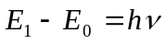 where E_{o} is the ground state energy of the molecule and E₁ is that of a higher energy state to which it is coupled by an allowed transition. For a single allowed transition, there is a very narrow but finite range of frequencies over which absorption can take place defining a spectrum which is referred to as a ‘spectral line’.

The typical shape of a spectral line is shown in figure 3. This particular profile is referred
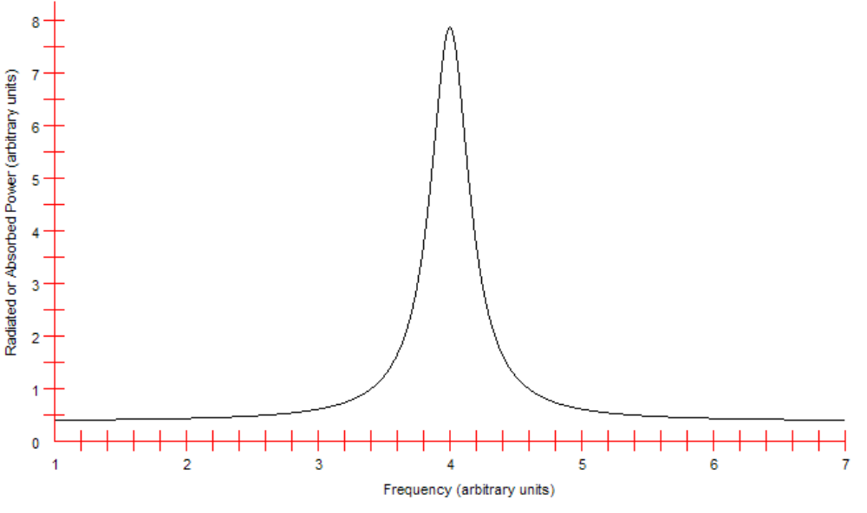
Figure 3. The classical shape of a spectral line characterized by a narrow central profile and comparatively high wings which in principle extend to infinity according to the function representing intensity per unit frequency, 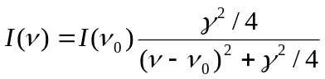. Here ν is the frequency, ν_{o} is the frequency at the line centre and γ is a parameter known as the line width and corresponds to the frequency width of the profile at the points where the power is equal to half that at the peak.
to as a ‘Lorenzian’ which is represented by the function
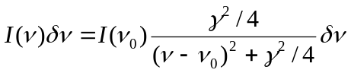 (6)
and in the simplest case arises because of the finite lifetime τ of the upper state of the excited molecule which also defines the frequency range γ = 1/τ between the points on either side of the centre corresponding to half the peak power. This is defined as the width or half-width of the line or sometimes more completely as the Full Width at Half Maximum (FWHM). Interactions with other molecules in the system also contribute to this line shape and increase the width γ, often quite considerably, which correspondingly increases the extent of the wings and hence the range of frequencies over which significant radiation may be absorbed from the field. Another contribution to the line shape arises because of the movement of molecules in a gas in which their velocities at LTE follow a Gaussian distribution. The resulting Doppler induced frequency shift for each molecule is given by
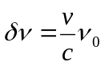 (7)
where ν_{o} is the central frequency of the spectral line, v is the component of the molecule’s velocity along the line of sight and c is the velocity of light. The characteristics of the Doppler profile are those of a Gaussian with a broad inner region and rapidly decaying wings sometimes represented, in a crude approximation, by a rectangle. The statement of the profile is given by
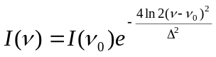 (8)
in which ν_{o} is the central frequency and Δ is the half-width which is given by equation 7 when v is replaced by the mean velocity of the radiating molecules.

The combination of these two types of broadening effects with resulting Lorenzian and Gaussian profiles combined, leads to an intermediate line shape referred to as a Voigt profile. At its centre this profile is equally affected by the two line widths, but at frequencies far from the centre the high wings of the Lorenzian dominate and the Voigt profile in these regions is very well approximated by the Lorenzian alone.

In Figure 4 we show the general form of the different basic line shapes of similar half widths corresponding to a Lorenzian (-------), arising from natural and collisional broadening and a Gaussian (-------), corresponding to Doppler broadening, together with the profile which results when both are present and which, it is easy to show, is obtained through a convolution of these two initial profiles. The resultant Voigt line shape is shown in red and as can be seen is broader than the individual components, but in the far wings tends to the form and magnitude of the Lorenzian component only.
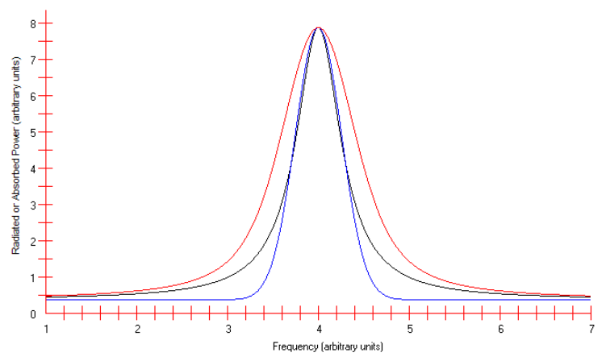
Figure 4. The diagram shows the general form of the basic line shapes, a Lorenzian (-------), and a Gaussian (-------), together with the Voigt (--------) profile arising from the combination of these two through a convolution. For clarity the baseline of the profiles, which corresponds approximately to the level of the far wings of the Doppler broadened line, has been raised.

Absorption Bands in CO₂

The radiation field of interest here is a continuum covering all of the frequencies of the absorption lines of CO₂ which lie within the boundaries of this thermal field. Absorption takes place through the superposition of many individual, narrow, spectral lines as shown in Figure 5 and referred to as an absorption, or emission, ‘band’. An in principle measurement of the spectrum of the radiation filed which has passed through this gas, would reveal a ‘hole’ in the region across this absorption band and of a shape corresponding to the inversion of the diagram in this figure. For a very long path or very high molecular density, the power absorbed at frequencies corresponding to the wings of the lines will also become significant and of a magnitude represented by the sum of the wings of all of the spectral lines.
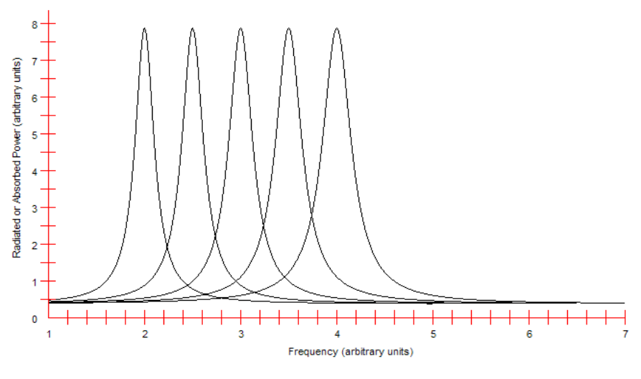
Figure 5. This diagram illustrates the formation of broad molecular bands from a very large number of narrow spectral lines positioned close together and having individual shapes corresponding to the natural line width, Doppler broadening and collision broadening.
Absolute values of Absorption

The rate of absorption from a continuum by a spectral line is a characteristic of the molecular transition involved and is linearly proportional to the energy density ρ_{ν} of the radiation field and the number density N_{ν} of the molecules present. We may thus define the rate of change in the field density in the form
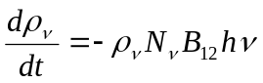 (9)
where the negative sign indicates depletion of the field density ρ_{ν} Jm⁻³Hz⁻¹ (energy per cubic metre per unit frequency interval across the spectrum) , B₁₂ is a constant for the transition from level E₁ to E₂ known as the Einstein B coefficient, h is Planck’s constant and ν is the frequency of the radiation absorbed. Thus the product ρ_{ν}N_{ν}B₁₂ gives the rate at which photons are absorbed and hν is the energy of each photon.

The quantity B₁₂ is given by
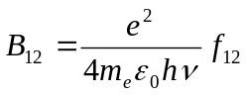 (10)
where e and m_{e} are the electric charge and mass of the electron respectively, ε_{o} is the dielectric permittivity of free space and f₁₂ is known as the ‘oscillator’ strength which is the characteristic factor defining the relative effective absorbing power of the transition compared to a classical oscillator of the same frequency. The classical oscillator in this context is an ‘atom’, sometimes referred to as a ‘Lorenz’ atom, with one active electron, which can only make a transition corresponding to a single unique frequency. In the case of atoms or molecules with an electron in any of their many available states, there are a large number of possible transitions of different frequencies which can take place with the absorption of a photon from the continuum. However, the average power absorbed by each of the different transitions, is only a given fraction of that which would be absorbed by a classical oscillator since in one instance the atom is absorbing at one frequency and in another instance at an entirely different frequency. Thus the power absorbed by all of the molecules in the ensemble at all possible frequencies, is equal to the power absorbed by the same number of classical oscillators. Thus for a number density of N₀ molecules in a lower state 1 in a radiation field covering all frequencies, which is referred to as a ‘continuum’, an average fraction of f₁₂ will make a transition to the state 2. Similarly an average fraction of f₁₃ will make a transition to the state 3 etc. However, the total absorption from a weak electromagnetic field by all possible transitions will be equal to that by N₀ classical oscillators and so we may write 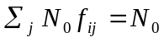 or 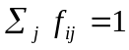. For a very intense field, such as that from a laser, for which stimulated emission (j → i) must be taken into account, the downward transitions are taken into account by including negative oscillator strengths in the sum over f_{ij}. In the case of an atom or molecule with two equivalent electrons in state i the corresponding result is given by 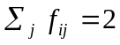. For the spectral lines which comprise the absorption bands of carbon dioxide as illustrated in Figure 4, the oscillator strengths are all much less than unity. However, from the form of the measured absorption band, which is approximately represented by a square top, it is seen that all of the oscillator strengths are approximately equal and can be written as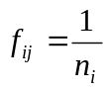 where n_{i} is the number of discreet spectral lines corresponding to all available transitions. Within the range of the main observed absorption band as defined by laboratory experiments, there is at least partial overlap of the individual lines. The degree of overlap will obviously depend on the local broadening conditions such as the Doppler width, which depends on the temperature of the gas, and natural width depending on A_{ij} and the collision broadening, which will depend both on the temperature through the velocity of the molecules and the gas density determining the rate of the collisions. Nevertheless, from equation (9), the rate of absorption is dependent to a large extent on the B coefficient and hence on the fractional oscillator strength. However, in the far wings of the line, the overlap is complete, and while there is a small difference between the absorption by the individual wings of the band components (the spectral lines), at large frequency differences from the centre of the band, the wings of all components are approximately equal. Thus at these points far from the central frequency of the band, the level of absorption will be similar to that by a single strong spectral line in the centre of the band with an oscillator strength of 1and the effective Einstein B coefficient will be given by
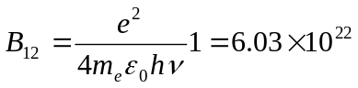

On the other hand, the magnitude of the absorption at these frequencies in the far wings, will be greatly reduced by the form of the wings described by the Lorentzian function which describes the line shape,
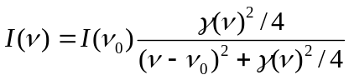 (11)
where here, I(ν) defines the intensity absorbed in the wing of the line at frequency ν compared to that at frequency ν_{o} which is the equivalent to a variation in the B coefficient or to a spreading of the number of molecules capable of making the transition across the range of frequencies. The number of molecules available for absorption at the line centre will be similarly reduced.

From Equation (9), , we obtain the relationship
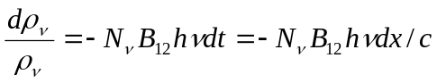 (12)
for the relative change in the field density with an elemental distance dx travelled through the absorbing system of molecules. The solution to this equation,
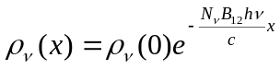 (13)
gives the radiation field density after traversing a distance x. Ignoring forward radiation from spontaneous downward transitions, which are very slow compared with the loss of energy by collisional radiationless transitions by the excited molecules, we find that the radiation density decays to a fraction 1/e of its initial value in a distance given by
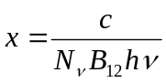 (14)

which yields a value of order 10⁻¹⁷ m. This figure is symbolic only but shows how very rapidly the radiation would be absorbed in the idealized circumstances represented by Equation (113).

The equation to the Lorenzian profile is written above in terms of the intensity of a radiation field and is defined as the power flowing through the system per unit area per unit frequency interval, representing an ‘emission’ line. However, the definition of the B coefficient is given in terms of the radiation energy density ρ_{ν} per unit frequency interval which is related to the intensity I_{ν}, also per unit frequency, through
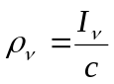 (15)
Thus we may write the spectral distribution of the radiation field energy density in the same form as Equation (6)
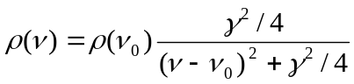 (16)
In this form, using intensity either I_{ν} or radiation density , the equation represents most directly, the spectrum which would be radiated by a system of atoms, even though this is also the form of its absorption spectrum. As mentioned above, another valid interpretation of line broadening, which is perhaps easier to picture in the case of absorption, is that the mechanisms leading to natural, Doppler or collisional shaped profiles, can be thought of as determining the number of molecules in the system which are in an energy state capable of absorbing a particular frequency. That is to say, any perturbation of the energy levels of a molecule produces a new value for the ‘resonant’ frequency at which it may absorb energy.

Radiation and the Einstein A Coefficient

The most basic of the energy level perturbations leads to ‘natural’ broadening, and arises from the intrinsic decay rate of the system, determined by the Einstein coefficient A_{ij}, complementary to B_{ij}, and which is related to B_{ij} through
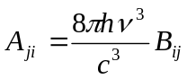 (17)
In terms of A_{ji}, the spontaneous or natural rate of decay of a system of N_{j} molecules in the upper level j to a lower level i, is given by
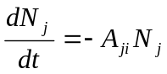 (18)
Thus for each pair of states, or energy levels, there are unique values of the Einstein coefficients which determine the rates of absorption and emission of photons. The solution to Equation (18) is simply
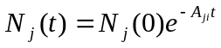 (19)
The decay process defined by Equation (19) is obviously continuous and the A coefficient may thus be interpreted as representing the probability that an excited molecule in the upper state j will make a transition to the lower level i in a given time t after being excited by the absorption of a photon or through an energetic collision. It is not difficult to show that this process, through which all of the atoms do not release their excitation energy simultaneously, is associated with a variation also in the absolute value of the energy of the emitted photon. The distribution of energies is found to be Lorenzian with a frequency half-width equal to A_{ji,} which for the resonant transition of carbon dioxide is approximately 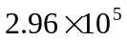Hz. In the case of the CO₂ molecular lines in the absorption bands where the oscillator strengths are much less than 1, the coefficients lead to estimated line widths of the order of 10⁴ - 10⁵ Hz.

Doppler Broadening

The phenomenon of Doppler broadening of a spectral line arises because of the random distribution of velocities of the radiating system of molecules along the line of sight to an observer. This velocity distribution is described accurately by a Gaussian profile which then impresses a similar shape on the radiation spectrum. The line broadening about the initial central frequency, arising because molecular velocities occur in pairs both towards and away from the observer, is referred to as inhomogeneous broadening, since each molecule radiates at an apparent frequency which is determined by its velocity relative to an observer and as such is quite independent of the characteristics of the other molecules. Natural broadening on the other hand, is considered from a classical view point at least, as an inherent trait of all molecules and so is referred to as ‘homogeneous’ broadening.

In any system of atoms or molecules at temperatures above absolute zero, the mean kinetic energy of the molecules, of mass m and velocity v, is related to the temperature through
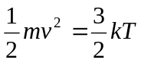 (20)
where k is Boltzmann’s constant given by 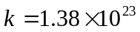. The velocity of these molecules, which also determines the Doppler frequency shift given by Equation (6), leads, on its own, as discussed above, to a Gaussian frequency profile with a half-width also given by Equation (6) in which v is the mean velocity obtained through Equation (20).

At temperatures corresponding to those of the atmosphere of around 290 ºK, the velocity of a carbon dioxide molecule of molecular weight 44 au or 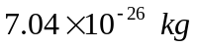, is found to be approximately 400 ms⁻¹ leading to a Doppler width of approximately 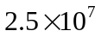Hz. This is of little consequence as we shall see, since the height of the wings of the Gaussian shaped profile rapidly approach zero and the role played by this broadening is simply to smooth out the main parts of the absorption band by increasing the degree of overlap of the adjacent spectral lines from which the band is constructed.

Molecular Collisions

As mentioned above, molecules in a gas are continuously moving and making collisions with other molecules in the ensemble. The results of these collisions is to cause the de-excitation of internally energetic molecules, the energy being transformed in general, into kinetic energy of both of the colliding particles and/or into excitation energy of the second molecule. Thus excitation energy may be shared between the two molecules in many different ways, with the constraint that the total energy and momenta of the two molecules must remain constant. A secondary effect of this process, even in the absence of energy transfer, is the change in width of the associated absorption or emission spectral line, the shape being found to be in the form of a Lorenzian as is the case for natural broadening.

In a formal sense, the energy of a collision consists of a dipole-dipole interaction where the initial, small net charge on one molecule induces a dipole on the other and vice versa. It is readily shown that the electric field E of a dipole varies with distance r from its source as 1/r³. Thus if a neutral molecule is introduced to this field, its positive and negative charges will be displaced along the direction of the field leading to an induced dipole moment p of magnitude which is also proportional to 1/r³. The net result is that the two induced dipole moments p, are of a magnitude commensurate with the dipole fields of 1/r³. It is easy to show that the energy of the interaction W between an electric dipole of moment 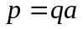, where q is the charge and a is the distance of separation, and an electric field E, is given by 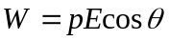 where θ is the angle between the direction of the field and that of a . Thus, since the magnitudes of p and E both vary as 1/r³, the strength of the interaction energy between the two molecules varies with their distance of separation r as 1/r⁶ and the energy is given by 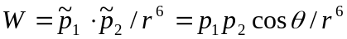 where p₁ and p₂ are the dipole moments of the molecules and θ is the angle between the directions of the moments.

Irrespective of the variation of the strength of the interaction with distance, it is clear that the energy of a very close collision will be dependent only on the energy of the colliding molecules. If these energies are two low, the repulsive force between the molecules will cause their trajectories to change so that the distance of closest approach is strictly limited. The probability of a clearly defined collision, depends on a parameter known as the collision cross section, σ, in which each of the two colliding species have a given circular area defining their interaction distance. The larger these areas, the higher is the probability of a collision.

To obtain a measure of the rate of collisions, we define the mean free path l of a molecule which describes the average distance travelled between such collisions. This may be readily shown to be given by
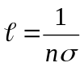 (21)
where n is the number density of the target molecules and σ is the cross section for the collision which has the dimensions of area and corresponds to a disc of radius equal to the sum of the radii of the colliding molecules. From the density ρ_{CO2} of liquid CO₂ which is 1,150 kgm⁻³, and the mass m of the CO₂ molecule 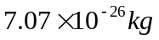, one finds an effective diameter of approximately 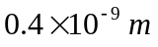 or 0.4 nm which is consistent with the values given by other published data. Similarly, target molecules of oxygen and nitrogen have published diameters of 0.354 and 0.375 nm respectively which are of the same order as that for CO₂. Thus the number of collisions per second, the collision frequency ν_{c}, is determined from the mean free path and the mean relative velocity between molecules which is of order 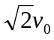,where ν₀ is the mean velocity of the heated CO₂ molecules, ignoring the relatively higher velocities of the lighter target molecules which would increase further the rate of collisions. Thus we have 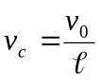 or
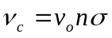 (22)
where, from Equation (20) v_{o} is found, for a temperature of 289 ºK, to be of the order of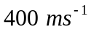. The value of the number density n in this expression refers to all of the molecules in air, and at ground level n is approximately 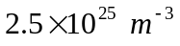. Given that the interaction between molecules depends on relatively longer range electric fields arising from an asymmetrical charge distribution across the molecules, an effective cross section would be expected to be much larger than the physical area of the molecule defined by the average diameter of the combination of atoms comprising the molecule. However, a very conservative estimate of the collision frequency may be obtained from the known volume and hence diameter, of the molecules which is obtained from measurements of viscosity or from the volume of a known mass of the molecules in the solid or liquid state as referred to above. For the most significant atmospheric gases of oxygen and nitrogen as target molecules of CO₂, the minimal collisional radius is approximately 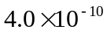m from which the effective hard collision cross-section is equal to 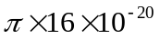 or m². From this we find an approximate value for the mean free path of 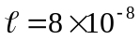m and for the collision frequency 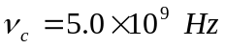. This value is lower than that suggested by Barrett of about 10⁵ times the value of the A coefficient of Hz but is used here to ensure that the estimates of Greenhouse absorption err well on the side of being conservative. In the calculations, a smaller collision cross section is used giving a maximum value for ν_{c} of 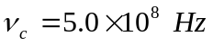.

Collisional Line Broadening

The most significant broadening mechanism in a mixture of gases at high density such as in the atmosphere, is produced through collisional perturbations of the molecular energy levels which in the limiting case may produce a frequency shift from the spectral line centre corresponding to the total kinetic energy E_{K} of the colliding molecules such that 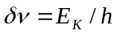 where h is Planck’s constant.

The theory of collisional line broadening is complex and very accurate calculations require a knowledge of the magnitude, form and effective range of the interaction potentials between the colliding atoms, approximated in the section above as varying as 1/r⁶. This is generally based on a full Hartree-Foch analysis of all of the atomic orbital electrons and for molecules this is very difficult because of the non central fields and asymmetries involved in mixed atom cases such as CO₂. In the special case of collisions between similar species, where the transition of interest in the excited atom ends in the ground state, the interaction is found to be comparatively strong with a strength that varies with the distance of the intermolecular separation r as 1/r³. While this longer range interaction would be expected to contribute to the broadening of the spectral lines of CO₂ through mutual collisions with other CO₂ molecules in the atmosphere, the much higher density of other gas molecules, referred to as ‘foreign’ gases, would indicate that the most significant contribution to the collisional broadening will be through foreign gas collisions or non-resonant broadening corresponding to the shorter range interaction, proportional to 1/r⁶ as described above.

However, the classical theory of line broadening provides a comparatively accurate value for the spectral width of a collision broadened line corresponding to the frequency ν_{c} of strong collisions defined by close approaches involving molecules with relative directions of motion very close to the direction of the line joining their centres. This may be used to calculate the characteristics of absorption by carbon dioxide over the entire effective breadth of the lines comprising the absorption bands. We note that the collisional line width, arising from and equal to, the calculated value of the collision frequency of , as shown in the previous section, is significantly greater than those of the natural or Doppler broadening, of order 10⁵ Hz and 10⁷ Hz respectively, which may thus be safely ignored. Probably because of the relatively small chosen collision cross section σ used here, the value is approximately one order of magnitude lower than the width shown in measurements by Heinz Hug with an approximate width for the 15.0 μ band lines of about 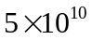 Hz. These measurements by Hug have been criticized for having a low resolution which might provide an apparently higher value for the broadening. However, a broad instrumental width would be in the form of a rectangular function convoluted with the line shape and a careful examination of the plotted output from his spectrometer indicates that there is no suggestion in Hug’s published results that the line shapes have been significantly distorted in this way. As mentioned above, this value given by Hug, is also consistent with the collision frequency suggested by Jack Barrett. Nevertheless, the value of for the line width used in the present work, has been taken as a conservative estimate which is justified by the physical conditions and the minimum collision cross section. As will be seen, using the value of Barrett and Hug, would not change in any way the conclusions which have been reached in this study. If used they would even more emphatically emphasize further these conclusions. It should be noted, that in the calculations at heights above ground level, the collisional frequency and hence the spectral line width, is adjusted for reduced velocity at the lower temperatures and for the variations in molecular number density at the lower pressures as indicated by Equations (20) and (22). In addition, the number of effective energy changing collisions is continuously adjusted to take account of the cut-off level of energy, below which a collision is incapable of causing sufficient change in the energy of a single level to cause the required change in absorption frequency. This may be seen as unnecessary, since the energy levels of the absorbing molecule may be change in opposite directions, imposing no limit on the energy of the collision, but is included as a precaution since the characteristics of the collision processes are not known to that level of detail.

From these considerations, we may calculate the absorption of radiation at all frequencies across the black body spectrum of a hot, 289 ºK surface, taking account of the full breadth of the spectral lines making up the bands of a Green House Gas (GHG) and in particular we use the 15.0 μ, 4.3.0 μ and 2.7 bands of CO₂ to illustrate the effects of line broadening through collisions. Similar calculations could be undertaken for any of the GHGs with spectra corresponding in frequency to any part the blackbody radiation field from the earth. One would expect similar results to follow from such an analysis.

Thermal distribution of energy in the atmosphere

The general description of absorption of radiation given above, allows us now to make some quantitative calculations of the changes in the absorption of radiation by the atmosphere arising from changes in the levels of CO₂. The results should thus provide information on the effective increase in atmospheric temperatures at various levels within the troposphere, which can then be used in the more detailed weather and global climate models to obtain better values for the likely initial forcing arising from defined temperature increases at these levels and the consequent positive feedback giving rise to the major and serious conditions of Global Warming and consequential Climate Change.
The calculations have been done to first order, neglecting second order effects such as the variation in molecular number density as the temperature of the air increases through absorption of radiation, but they do include the standard temperature lapse rate with height. It would be expected that such second order effects would be small since any temperature sensitive changes will be subject, in most cases, to linear variations so that, for instance, a change of 1 ºK (also 1 ºC) in temperature will cause a 0.3 % change in a temperature sensitive parameter. The main exception to this is the power radiated by a hot body which is proportional to the fourth power of the temperature, meaning that a 1 ºK change will give rise to an approximately 1.2% variation in the power output.
Before we consider the full theory of the absorption and redistribution process, it is instructive to obtain a ‘feel’ for the system being dealt with in terms of the energy movements that take place and the capacity for the atmosphere to cope, temperature wise, with changes in the input of energy.
At a temperature of 289 ºK, the power output per square metre by a black body is, according to equation (1) or (2), approximately equal to 396 Watts. Assuming that this is the mean daily temperature and that radiation continues at this temperature for 20 minutes, the total energy output will be 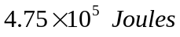. We now consider the energy stored simultaneously in the CO₂ molecules of a one square metre column reaching from the ground to the top of the troposphere, with 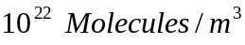 at ground level leading to a total of approximately 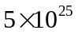 Molecules in the whole column after allowing for the reduction in density with height. Since the energy per molecule will be equal to the total stored energy will be 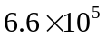J. It is quite obvious that the whole process of energy flowing into the atmosphere from the sun for a period of 20 minutes followed by transfer between other heat storages, and the simultaneous outflow of energy, requires the storage of only a fraction of this total energy at any one time. Not all of the CO₂ molecules in the atmosphere are being used to collect energy, but simply to increase the probability that it will be collected within, say half a metre from the ground, rather than one metre. Thus, irrespective of the GHG concentration, throughout any column reaching from the surface of the earth to the top of the troposphere, the actual number of internally excited molecules must depend only on the total power being radiated by the earth’s surface which in turn will only depend on the solar insolaton. Similarly, for all of the molecules in the air, 10²⁹ in our column, with an increase of temperature of 10 ºC, they will each acquire an amount of 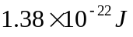for a total of 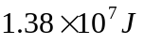which is equivalent to the energy radiated by 1 m² from the surface of the earth in about 10 hours.
As for the role played by convection, we might consider a parcel of one cubic metre of the atmosphere at ground level, which increases in temperature by 5 ºK and then rises at 3.6 km/hour or 1 ms⁻¹ carrying the trapped energy upwards to a high level where radiation and other processes discussed below will allow this energy to escape, although any molecular radiation will still be quickly trapped by CO₂ in the atmosphere as described above. The total additional energy, from this increase in temperature of the parcel, will be given by the product of the number of molecules,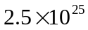, and the average energy corresponding to a 5 ºK degree rise in temperature or . At an upward velocity of 1 ms⁻¹, this means that approximately 1725 J could flow through any surface in the one metre column per second, equivalent to 1725 Watts per square metre which is equivalent to about four times the power radiated by the earth’s surface. While these assumptions of the air movement may not match the real world of atmospheric transport, they do give some insight into the rate at which energy could be dissipated by such a process.
Another feature which must be emphasized follows directly from the maximum possible value of the A Coefficient which corresponds to the situation that the oscillator strength is equal to unity. This value for the 15.0 μ band is approximately Hz. However, the fact that there are an unknown but large number of component lines in the band and only a limited number of electrons to service them, the oscillator strength and hence the A coefficient of each individual line will be much smaller than this stated value. However, conservatively using this given value for A, and taking the rate of strong collisions to be that calculated above of 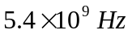it is clear that within the lifetime of the upper state for all of the spectral lines, there will be of order 10⁴ collisions in which, for each collision, following work by Massey and Burhop in the 1960s, there will be a very high probability that a radiationless transition will take place in which the excited molecule returns to a lower state, usually or at least eventually to the ground state, and that the energy of excitation will be converted to kinetic energy of the colliding molecules. Because these molecules will of course continue to make rapid collisions with other members of the system, the energy will be very rapidly distributed throughout the whole population and form part of an ensemble in pseudo local thermal equilibrium (LTE) with an almost Gaussian energy distribution. This redistribution of the energy into LTE considerably reduces the average momentum of individual atoms, removing to a very large extent, the possibility of reciprocal collisions returning the energy to internal excitation of molecules. A calculation of the Maxwellian velocity distribution at these temperatures of a thermalised system, shows that only a very small fraction of the molecules will have sufficient kinetic energy, equivalent to that of a 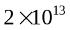 Hz (15 μ) photon, to re-excite CO₂.
Any radiation, with a frequency lying inside the range of the main absorption bands, which does escape from a molecule, will be very rapidly reabsorbed and could again be radiated, but as before, will be much more likely to take part in a radiationless transition and the subsequent collisional redistribution process. For this reason, radiation of a frequency within the band of absorption frequencies of any atmospheric molecule, not just those nominated as GHGs, plays at least a small part in this energy trapping process, the movement of energy at the lower levels of the atmosphere being overwhelmingly carried out by convection and thus taken invariably upwards. Outside this range of frequencies however, any radiation may pass through an atmosphere which for these frequencies is transparent except for the scattering effects of aerosols.
At levels close to the earth, where the air temperature is close to that of the radiating ground, dust and other aerosols will be warmed to a similar temperature and being macroscopic, will radiate as a black body, with similar characteristics to those of the earth’s surface. However, as the parcels of warmed air rise, the system cools under the influence of declining pressure which allows expansion of the molecular system and simultaneous conversion of the molecular kinetic energy into potential energy associated with the long range though weak, attractive forces between the different molecules. At these greater heights, the aerosols present will, as before adopt the temperature of the surrounding air and will again radiate in all directions. However, all of this energy will be over a frequency range which lies within the same bounds as those of the radiation from the lower, warmer particles in the atmosphere, although being cooler the spectrum will have greatly reduced output at the higher frequencies, but will be largely reabsorbed by CO₂ as before, particularly for those photons travelling in the downwards direction where the density of absorbers is always marginally higher than in the upward direction.
Thus as the energy progresses upwards from the surface, any radiation from molecules or aerosols will be continuously absorbed and collisionally redistributed as molecular kinetic energy, leading to a rapid depletion of the intensity of the initial radiation as the height increases, and since the density of molecules N(h), a function of the height h and given by
(23)
is also decreasing with height, the amount of energy absorbed in higher layers of the troposphere is much less than that absorbed in layers nearer to the earth’s surface. In this equation, N(0) and T₀ are the number density and temperature respectively at the earth’s surface, m is the mass of a molecule of carbon dioxide, g is the gravitational acceleration of 9.8 ms⁻², k is Boltzman’s constant of 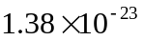JºK⁻¹ and T_{h} is the temperature at height h. Here, the ratio, 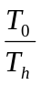 takes account of the increase in the number density associated with the cooler temperatures at more elevated regions. Although the absorption coefficient is much smaller for frequencies further from the line centre, the process described above will still apply, although penetration of this radiation will continue through much larger distance, projecting further into the lower density, upper levels, of the troposphere where a very sensitive measurement of the absorption spectrum would show a form similar to that obtained from a laboratory experiment. As the originally warm parcels of air rise towards the top of the troposphere, the reduced molecular density, together with the lower temperatures and associated lower velocities of the molecules, lead to a reduced intermolecular collision rate, defined by equation (22) and hence to a narrower collisional line width than is the case closer to ground level. The combination of these changed characteristics provides much greater transparency for all of the radiation, although for those frequencies closer to the main peak of the 15 μ band, absorption will remain comparatively high. Thus in these very high levels of the troposphere radiation at frequencies in the wings of the spectral lines, will escape upwards much more easily than at ground level but downwards directed radiation will again be captured by the denser regions below.
Taking the expression for the Lorenzian profile, assumed to be the dominant line shape function as represented by Equations (11) and (16), and using the interpretation that this function represents the number of molecules with energy states, modified, through their interaction with the rest of the system, to absorb a photon of frequency ν, we may determine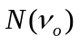, the normalized number of molecules per unit frequency interval at the line centre. Integrating over the expression to obtain the total number of molecules, N_{o}, which is fixed, we find 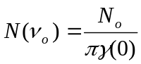 (24)

where γ(0) is the effective spectral line width at the line centre.

We may then write the number of CO₂ molecules in an appropriate energy state to absorb a photon of frequency ν in the form
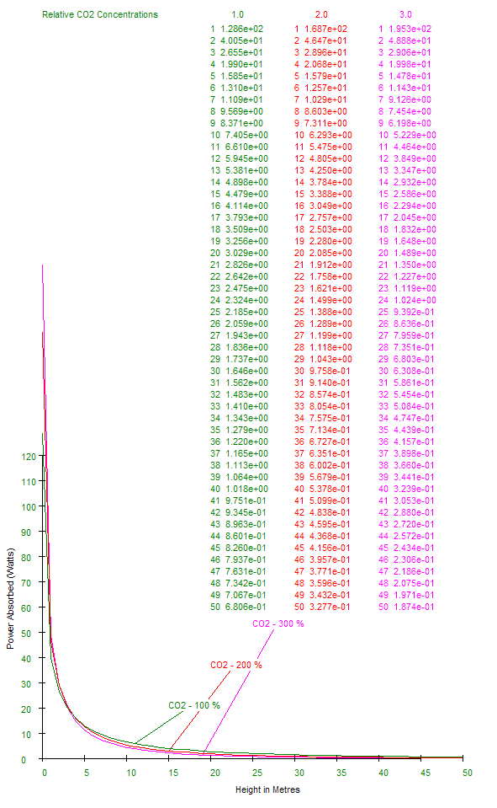
Figure 6. This diagram shows the power absorbed by carbon dioxide within a sequence of 10 m thick layers up to a height of 50 metres in the troposphere. The five curves represent the level of absorption for concentrations of CO₂ equal to 100%, 200% and 300% of the reported current value of 380 ppm. As can be seen, the magnitude of absorption for the different concentrations are largest close to the ground and the curves cross over at heights between 3 and 4 metres, reflecting the fact that for higher concentrations of CO₂, more radiation is absorbed at the lower levels leaving less power for absorption in the upper regions.

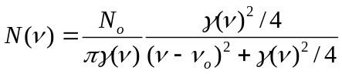 (25)

Substituting this equation for 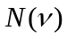 into Equation (13), together with the expression for the natural variation with height described by equation (23), we may determine the magnitude of the radiation absorbed by a given layer, at any frequency and at any height in the atmosphere. It is well recognized of course that these equations have their limitations of accuracy and that for very accurate spectroscopic measurements, de Beere’s law should not be applied indiscriminately for very thick or dense absorbing media. However, the discussion on collisional transfer of energy shows that little re-ordered radiation will remain in the system and excited molecules will very rapidly return to the ground state to become available for absorption purposes, indicating that the equations given above should retain their validity under the prevailing conditions.
The basic results of the analysis are represented in the earlier diagram shown in Figure 1. The main finding, represented there, is that by taking account of collisional line broadening, it is clears that absorption by CO₂ at present concentrations of this gas in the atmosphere, across the IR spectrum radiated from the earth at normal temperatures, is almost complete. The diagram shows a modified representation of the energy escaping from the top of the troposphere as a function of frequency for an assumed collisional line width of only 10⁸ Hz. This allows the features of the absorption process to be observed with approximately 2.5 % of the radiation escaping above 10 km. The calculations show that doubling the level of CO₂ leads to an escape of only 0.75 %, a difference of 1.8 %. Thus, in this example where the chosen value of the broadening used is significantly less than the actual case in the atmosphere, an additional 6 Watts, from the original 396 Watts, would be retained in the 10 km column within the troposphere, when the density of carbon dioxide is doubled. This result of course relates only to CO₂. A similar analysis for water vapour, a much more aggressive greenhouse gas, would be expected to show significantly more additional absorption at both levels of concentration of carbon dioxide, resulting in a much smaller value for the escaping energy at both 380 ppm of CO₂ and the projected 760 ppm thus reducing the difference between these two cases. Absorption bands in all other GHGs could be treated identically and the combination with CO₂ would show a further reduction in the escaping energy.
The most interesting result from the analysis is displayed in Figure 7. This shows the power absorbed by carbon dioxide within a sequence of 1 m thick layers up to a height of 50 metres in the troposphere. The five curves represent the level of absorption for concentrations of CO₂ equal to 100%, 200% and 300% of the reported current value of 380 ppm. As can be seen, the magnitude of absorption for the different concentrations are largest close to the ground and the curves cross over at heights between 3 and 4 metres, reflecting the fact that for higher concentrations of CO₂, more radiation is absorbed at the lower levels leaving less power for absorption in the upper regions. As would be expected, the forms of the curves for the different concentrations are similar giving a quantitative description of the absorption rates at different heights. It is seen that for all concentration levels, most of the radiated energy is absorbed at the lowest levels below about 10 m. As the concentration of CO₂ increases, the upper levels receive less energy which might be expected to lead to a cooling effect resulting from higher densities of this gas. Close to the ground, however, the initial energy density will increase with increased carbon dioxide leading to a warming of these lower layers with an upper temperature limit equal to the temperature of the ground.

Return of Radiation Energy to Ground Level
The discussion above has concentrated on the simplest scenario, considering so called resonance radiation, which corresponds to the strongest lines in the absorption band which are coupled to the ground state. These are almost the only absorbers, since by far the most significant numbers of the molecular population will be in their ground state and the oscillator strengths for transitions from this state to the nearest higher levels will in general be largest. These particular excited levels will also provide, correspondingly, the strongest emission at the same frequency as has been absorbed. This is not to be confused with the absorption of frequencies in the wings, even the far wings of the line, where the collisionally shifted ground state will also be involved.
However, a much less obvious, but in the case of the Greenhouse effect, more important process involving radiation, arises because of the decay of excited molecules from higher levels of internal energy to lower levels above the ground state, which may involve the emission of a photon of a frequency which lies outside the range of even the far wings of the broadened resonance transitions. These transitions, demonstrated schematically in Figure 7, will invariably correspond to a smaller oscillator strength and hence have a lower probability of occurrence than the much stronger transition to the ground state. However, for a photon produced from these transitions between two higher level states of the molecule, at a non-resonant frequency (NRF), the atmosphere will be highly transparent and this energy will be partly returned to the earth as radiation and partly escape to space providing the only significant radiative cooling from the lower levels of the atmosphere. Given the discussion on collisional effects of course, this radiation process will also be competing with internal energy losses to kinetic energy of the molecules. However, because of the transparency of the atmosphere, this process will have the same effect on the warming by downwards radiation and cooling by upwards radiation, independent of the actual height at which the photons are released. It is probably impossible to say, without a very detailed analysis to determine each of the oscillator strengths of the transitions involved, whether this process of radiation from upper level transitions or the process of convection followed by radiation at higher, more transparent, levels of the atmosphere, is the dominant path for cooling of the globe. However, it is quite clear, that the radiation from the solar heated surface of the earth, trapped by the GHGs and taken upwards by convection, will not be directly responsible for the return of similar frequencies of radiation to the earth and hence for Global Warming.
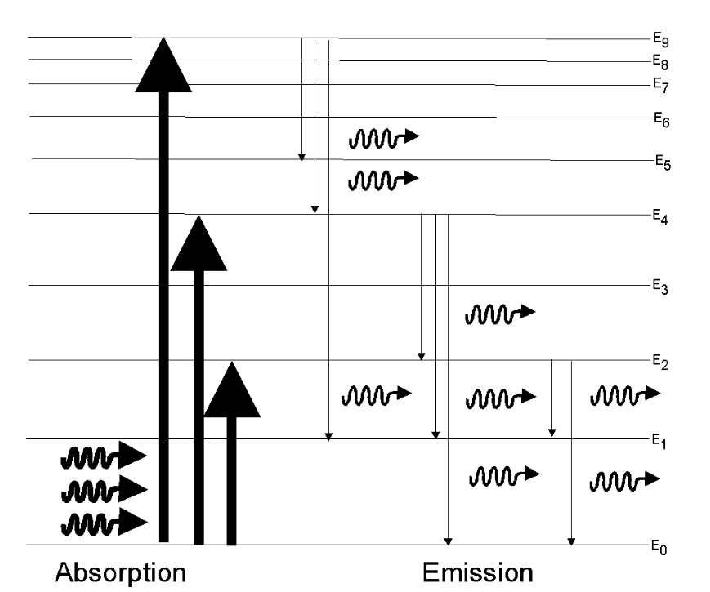

Figure 7 Illustrative diagram of vibrational/rotational energy levels in CO₂ molecules showing the symbolic absorption of IR photons on the left and possible allowed transitions from excited states to various lower levels on the right, with the emission of photons of various energies and frequencies. Some of these frequencies will lie outside the absorption bands of any atmospheric molecules and will serve to transport energy back to earth (warming) and to outer space. (cooling). Photons corresponding to transitions back to ground state, E₀ will be reabsorbed almost immediately.
As for that half of the very low frequency NRF radiation which will be directed downwards, this will be but a small fraction of all the energy radiated but will be that which contributes to the stabilization of the temperature of the earth and will constitute a fixed fraction φ of the initial surface radiation. Thus we may write for the equilibrium condition at the surface of the earth, where power radiated is equal to the power absorbed from a solar intensity I_{o},
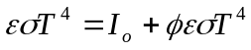 (26)
from which we find
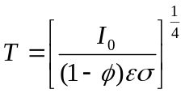 (27)
showing, that as a result of this Greenhouse gas, the temperature of the earth’s surface will be raised by a factor of
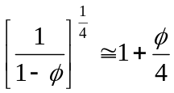 (28)
Thus the temperature would be expected to be 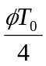higher than T₀, where T₀ is the equilibrium temperature for an incoming intensity of I₀ in the absence of any Greenhouse gas.

Conclusion
The above analysis appears to indicate that the warming of the earth by Greenhouse gases takes place through the effects of downward radiation to which the atmosphere is transparent, arising from molecular emissions at frequencies outside the resonance bands of any atmospheric gases, which could include those not nominated as being a GHG. It further shows that the actual level of GHGs in the atmosphere, which are those gases capable of absorbing any radiation of a frequency lying within the range of the blackbody spectrum from a temperature corresponding to that of the earth’s surface in any region and therefore covering a range of about -50 ºC to 50 ºC, (or 223 ºK to 323 ºK), is almost of no consequence in determining the increase in surface temperature from the Greenhouse effect. It is thus apparent that Greenhouse gases act only as a conduit through which flows the radiation energy captured initially by certain gases in the atmosphere. It moves from the internal energy of the absorbing gases into a relatively stable thermalised volume of local air. This energy flows almost independently of the number of Greenhouse molecules present just as water from a fixed source, flows through a pipe independent of increases in the diameter of the pipe. Collisions between these radiatively excited molecules and the many other neutral molecules, cause the energy to be converted to kinetic energy of an ensemble which is thus heated. This sample of air then transfers most of this effectively trapped energy upwards through convection to a more transparent region in the upper troposphere where the energy may progressively escape upwards through radiation, but from which most of the corresponding downwards radiation will be recaptured at a significant height above the earth’s surface by the denser warmer air at these lower levels. However, some radiation from the excited molecules is radiated at frequencies to which the atmosphere is almost totally transparent. It is this radiation and this radiation only, which will be in a fixed proportion of the energy radiated by the earth, and will be emitted in all directions – 50%+ above the horizon, 50% - below horizontal thus contributing to the warming of the earth.
In summary, small quantities of radiation from excited Greenhouse gases, at frequencies corresponding to a transparent window of the atmosphere, provide direct feed back of heat towards the earth, causing some heating, and towards outer space producing cooling. The proportion of this free radiation, relative to the amount of excitation energy trapped in the Greenhouse gas, is a characteristic of the gas and will be independent of both the total heat energy present and the concentration of a given Greenhouse gas.

-The results of calculations shown in Figures (1) and (7), illustrate this conclusion and in particular Figure 6, shows that there is little significant difference between the spatial distributions of heat captured by the Greenhouse gases along a vertical column within the troposphere, for a range of concentrations equal to that defined at present, nominally 380 ppm of CO₂ and possible future concentrations of 760 ppm and 1140 ppm. While it is not possible to calculate the actual proportion of energy returning to the earth via these very low frequency photons passing through a transparent atmosphere, the proportion relative to that held by excited CO₂ molecules will always be exactly the same, irrespective of the total amount or density of carbon dioxide present.
The transparency ensures that such radiation will contribute equally irrespective of the height in the atmosphere from which it has been emitted. Further, the diagram, Figure 6 shows that the effect of increasing the density of carbon dioxide in the atmosphere, is simply to change the height distribution, and then only slightly, of its thermal heating. In each case, the proportion of energy contained as excitation of a Greenhouse gas, compared to that released through collisions to heat the surrounding gases, will remain essentially the same unless the density of the radiation were sufficient to saturate the corresponding resonant transitions. This is demonstrably not the case, since the rapid transfer of molecular excitation energy to thermal kinetic energy takes place in much less than a microsecond. The CO₂ molecules in only 10 m³ on the other hand, if half were simultaneously excited, would be holding 660 Joules of energy, an amount which could only be radiated by the earth in about 2 seconds.
Thus, at no stage are all of the Greenhouse gas molecules in a state of excitation and any increase in that gas density will only reduce the height above the earth at which the radiation is absorbed. It will not alter the total number in this upper state and hence have no effect on the proportion of radiation in the frequency range of a transparent atmosphere. Because of this transparency, the height at which the process takes place will have no bearing on the proportion, or amount, of radiation returned to the earth.
No attempt has been made here to construct a model of atmospheric behaviour which relates in any way to the detailed structures of modern GCMs. The emphasis has been to try to understand the possible processes which can take place according to the well established laws of physics, beginning with the absorption of radiation by a selective gas and the subsequent, physically necessary, redistribution of that energy which may lead to increases in the temperature of the earth because of such absorption.
The findings clearly show that any gas with an absorption line or band lying within the spectral range of the radiation field from the warmed earth, will be capable of contributing towards raising the temperature of the earth. However, it is equally clear that after reaching a fixed threshold of so-called Greenhouse gas density, which is much lower than that currently found in the atmosphere, there will be no further increase in temperature from this source, no matter how large the increase in the atmospheric density of such gases.
While some of the ‘pictures’ painted in this discussion may seem at odds with expectations, none of the apparently extreme circumstances described will appear as unusual to anyone with even modest experience in optical spectroscopy.
We refer for instance to the very rapid absorption of radiation as it enters the atmosphere from ground level which has been referred to before by experienced scientists suggesting that the radiation is absorbed in the first few metres. This is often disputed by others without reason. However, anyone with experience in studying absorption of visible radiation by metal vapours, where the density of atoms is miniscule compared to the density of atmospheric CO₂, is familiar with the need to “reduce the temperature of the oven” to allow the laser beam being used in the measurements to get through even the first few millimeters of the atoms of the metal vapour.
The transfer of significant energy by collisions between molecules is also perhaps conceptually difficult until one realizes that the most common of all lasers, the He-Ne laser, which radiates effectively at a single frequency, easily provides an intensity over an area of about 1 mm² corresponding to 100 kW/m² compared to the sun’s irradiance at the earth’s surface, of 1.3 kW/m². The energy emitted by this laser depends totally on collisional energy transfer from the Helium atoms, which absorb energy, to the Neon atoms, which radiate the same energy.
Similarly, the most powerful of lasers, the CO₂-N₂ industrial laser used for precision cutting of hard metals with power outputs exceeding a kilowatt (with intensity several MWm⁻²), depend entirely on the transfer of energy from one type of molecule, which absorbs energy from an electric current, to another entirely different molecule which engorges that energy through mutual collisions and then radiates. Yet some writers have criticized the work of Jack Barrett when he also points out the role of collisions in the energy distribution process in the atmosphere.
While any analysis such as given above must speak for itself, criticism, argument, corrections to the assumptions made and the analysis performed, and most importantly, constructive disagreement with the conclusions, will be enthusiastically welcomed by the author.

Note:

Collisional conversion of Internal Energy to Kinetic Energy

If energy of one type, e.g. kinetic energy, is converted, through collisions between molecules, to another type e.g. internal energy of one or both of the molecules, the collision is referred to as being diabatic or non-adiabatic. The probability of a collision of the ‘second kind’, as this process is sometimes called, taking place is found to depend on the time scale of the interaction compared to the period of oscillation associated with the internal electronic transition. From this we may derive a criterion (Massey and Burhop, 1952) for the collision to be diabatic which states that 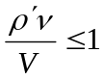 where 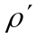 is the range of the interaction, is the transition frequency and V is the relative velocity of the molecules. The complementary criterion for an adiabatic collision is given as 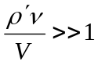. Taking the average velocity for CO2 to be 360 m s⁻¹ and the relevant frequency at 15.0 μ of Hertz with the range of the interaction being about 0.5 Angstrom, gives 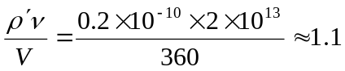 For this interaction range, the collision frequency is of the order of 1.5e07 which is about 100 times the rate of spontaneous emissions indicating that predominantly the loss of energy by excited CO2 molecules will be by collisions of the second kind, feeding the kinetic energy of the surrounding molecules and heating the air sample in that vicinity.

