**Custom Entry Point**

**Step 1:** **Go to Custom >> Extension >> application >> Ext >> EntryPointRegistry (if doesn't exist, then create a folder) >> create showContacts.php file and write code in this file, with file path and auth**

**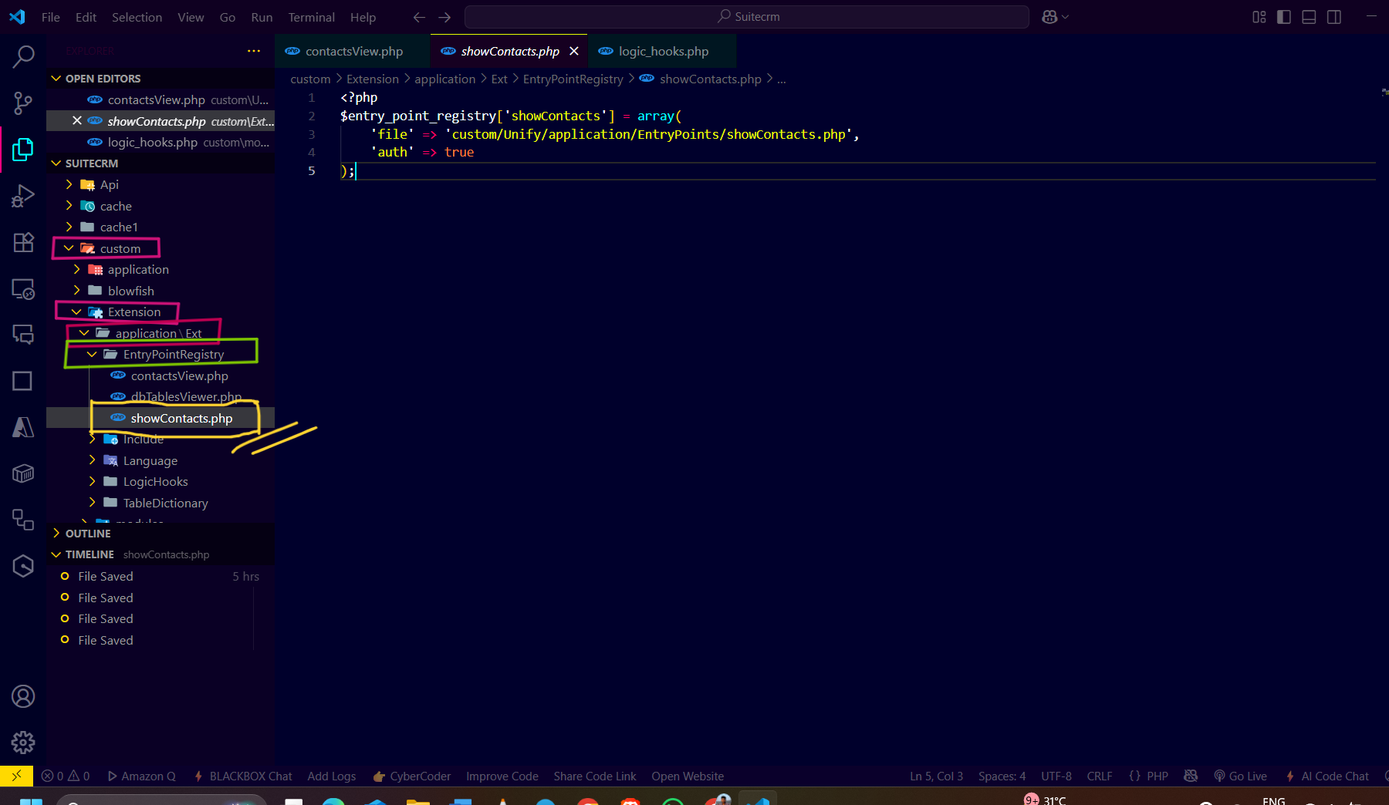  
Step 2: Create the showContacts.php file in custom >> Unify >> applications >> EntryPoints. And write code in it.**

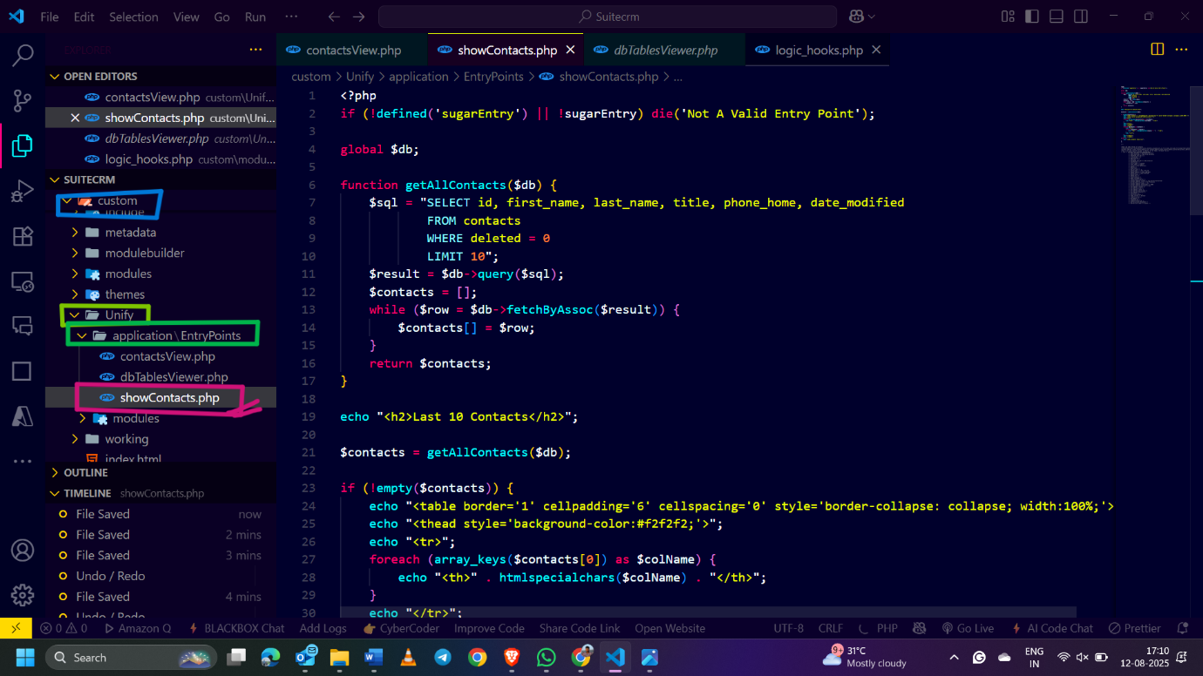

**Step 3: After the code is done, go to the admin panel >> repair >> Quick Repair and Rebuild.**

**Step 4 : After creating both files in the following path, open the browser and run this “ http://localhost:7007/Suitecrm/index.php?entryPoint=showContacts “. You will get output like this, here we used print_r() to display data.**

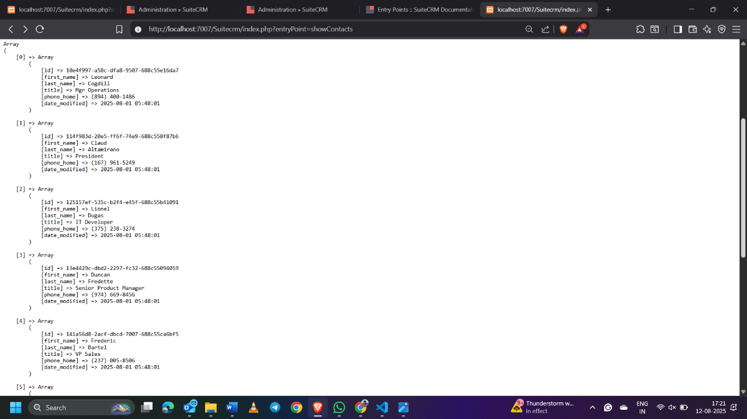

**To display the data in table format, instead of using “print_r()”, use echo and html table tag**

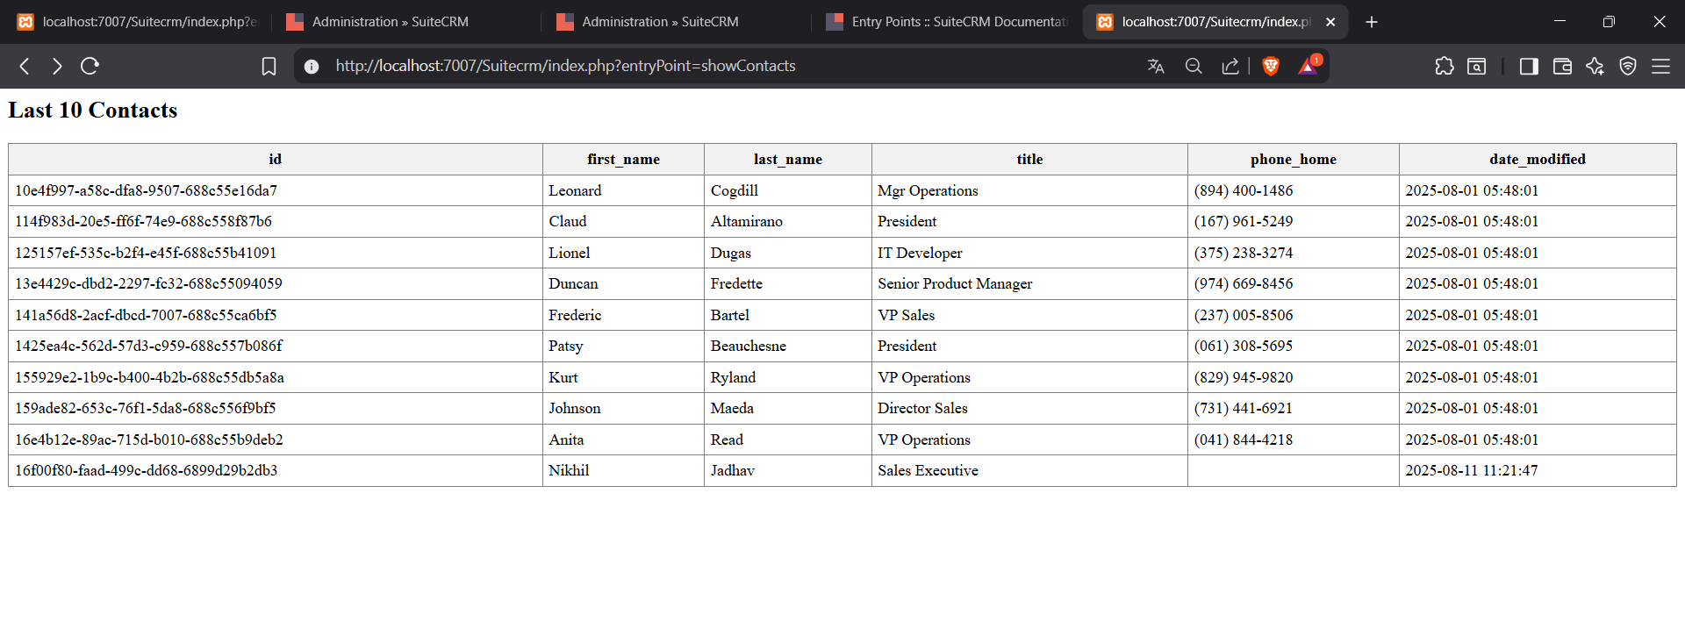

**Also Checkout the code file in drive.(day20-EntryPoint)**