**Lead Module Customization and Operations**

**Create a Lead Record with PHP Beans**

**Objective:** Create a new Lead record in SugarCRM/SuiteCRM using PHP Beans.

**Steps:**

1. Open your custom PHP script inside custom folder  
   (e.g., custom\Unify\modules\Leads\Hooks.php).
2. Use the Lead Bean to instantiate a new record.
3. Assign values to first_name, last_name, and email1.
4. Save the record.

**Path:-Logic_ Hooks.**  
 custom\Extension\modules\Leads\Ext\LogicHooks\logic_hooks.php  
  
  
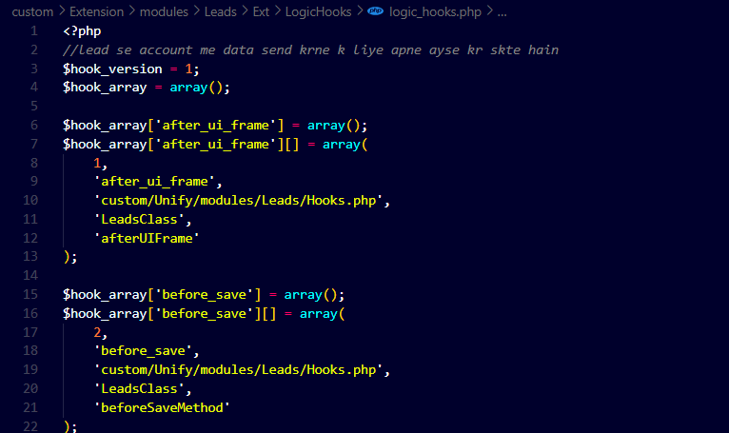  
  
 **Path:-Logic_ Hooks.**  
 custom\Extension\modules\Leads\Ext\LogicHooks\logic_hooks.php  
  
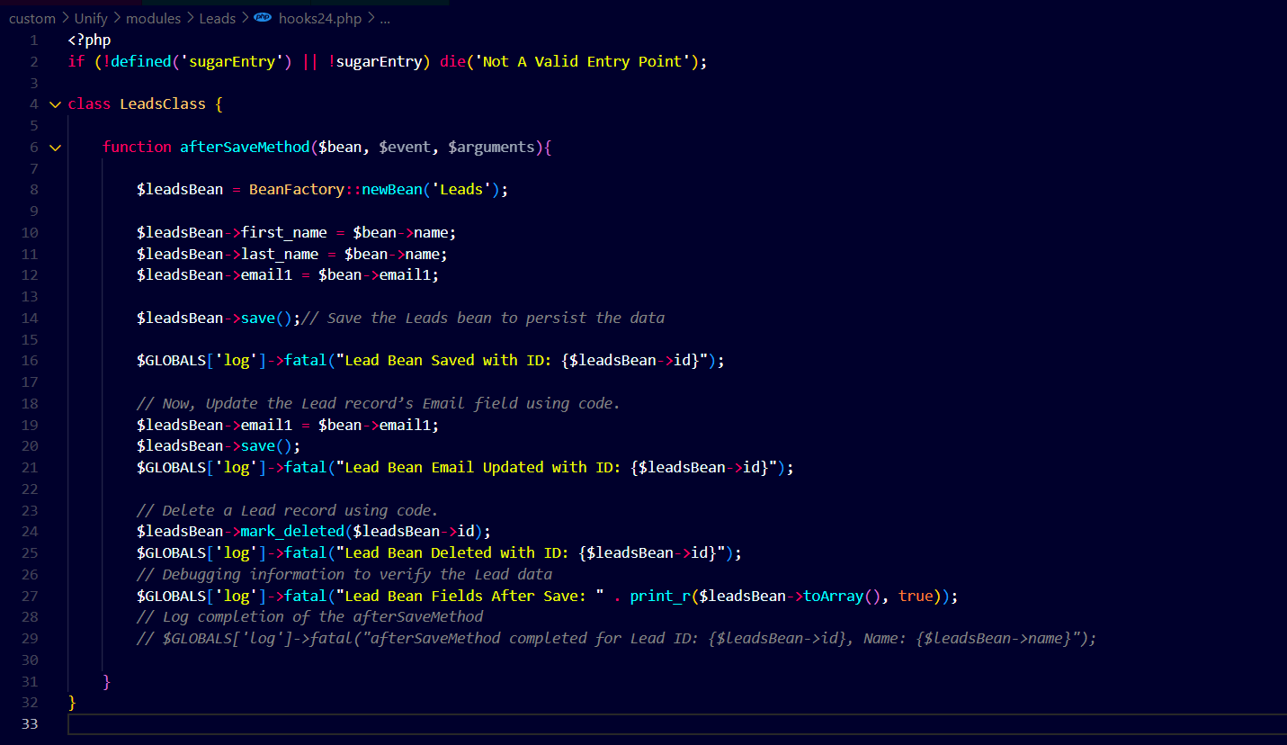  
  
**Output:  
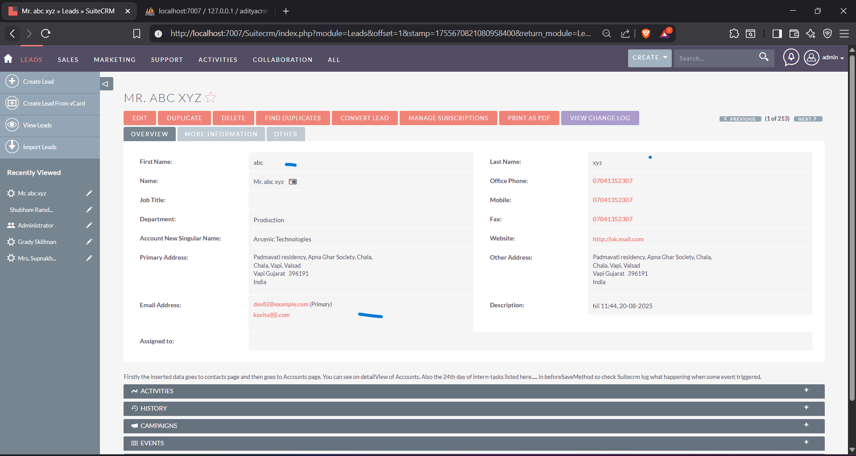  
  
Now, check out the steps :  
2. To Update the Lead Record’s Email Field**

**Objective:** Update an existing Lead record’s email1 field.

**Steps:**

1. Load the Lead record by ID.
2. Change the email1 property.
3. Save the record.

**3. Delete a Lead Record Using Code**

**Objective:** Remove a Lead record from the database.

**Steps:**

1. Retrieve the Lead record.
2. Call the mark_deleted() method.

**4. Add a New Dropdown Field in Leads Module via Studio**

**Objective:** Create a custom dropdown field named **Lead Source Type**.

**Steps (in Studio):**

1. Go to **Admin → Studio → Leads → Fields**.
2. Click **Add Field**.
   * **Data Type:** Dropdown
   * **Field Name:** lead_source_type_c
   * **Dropdown List:** Create new list lead_source_type_list with values:
     + Online
     + Offline
     + Referral
3. Save the field.

**5. Add Field to Layout, Create Records, and Test**

**Steps:**

1. Go to **Studio → Leads → Layouts → Edit View**.
2. Drag and drop **Lead Source Type** into the layout.
3. Save & Deploy.  
   Not nessessary but,After Repair/rebuid it shows as:  
   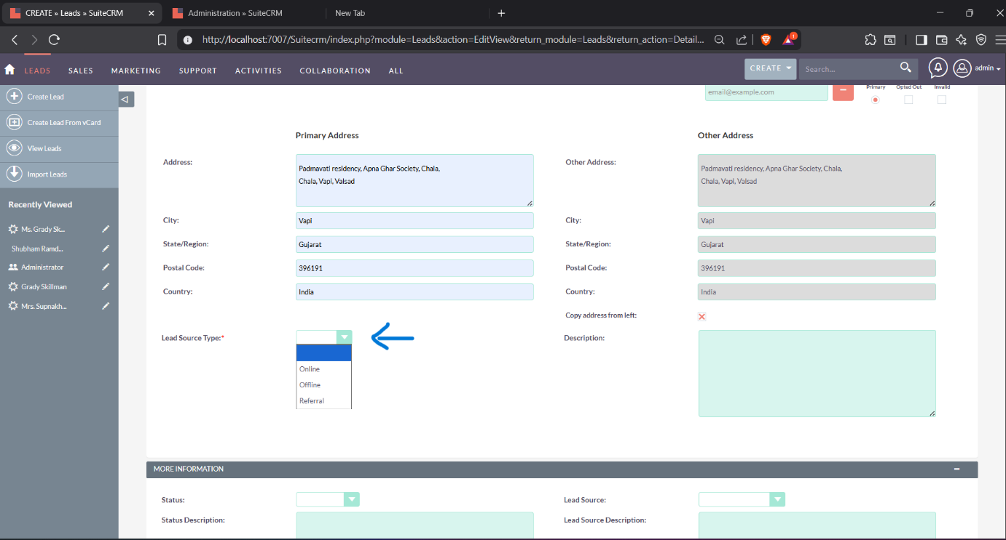
4. Navigate to **Leads Module**.  
     
     
   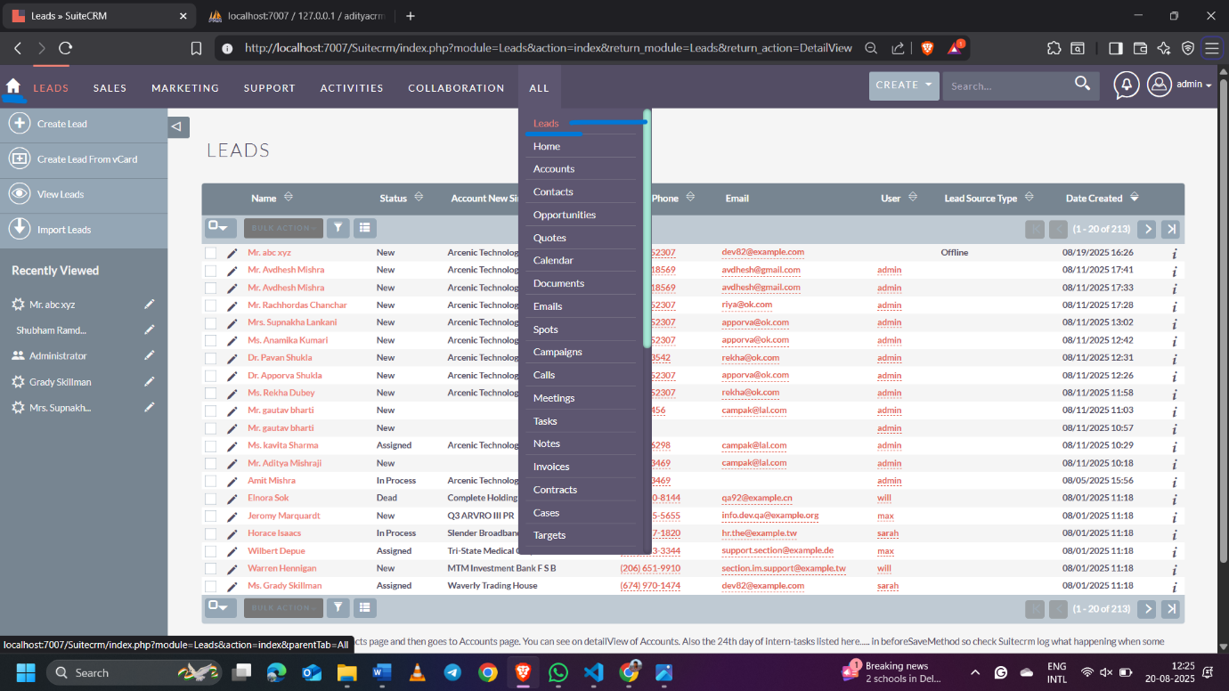
5. Create 2 new Lead records:
   * Record 1: First Name = abc, Last Name = xyz, Email = dev82@example.com, Lead Source Type = Offline.



* + Record 2: First Name = Bob, Last Name = Johnson, Email = bob@example.com, Lead Source Type = Referral.

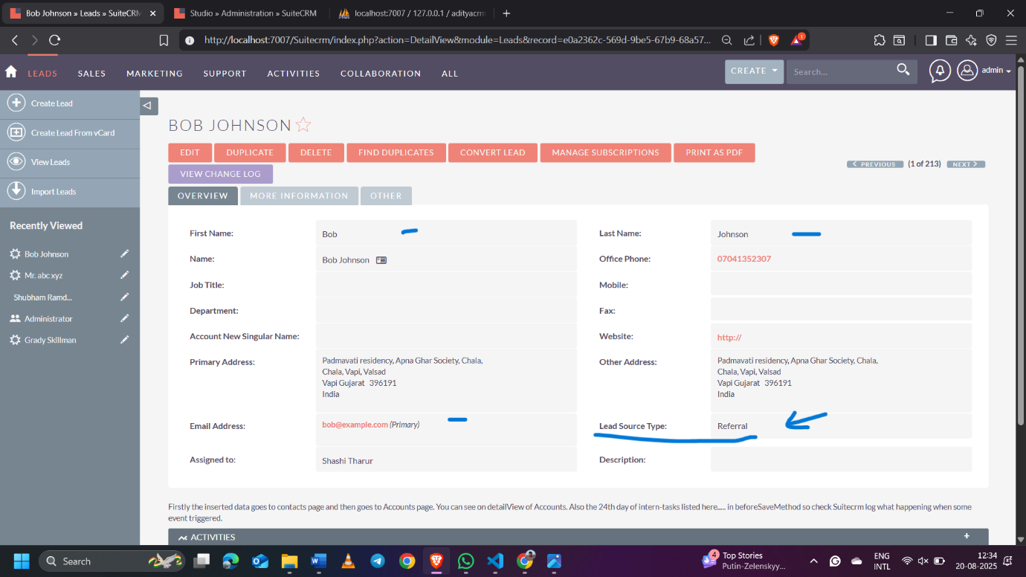

1. Here, you confirm, save both records, and verify that the dropdown values appear correctly in the Detail View and List View.

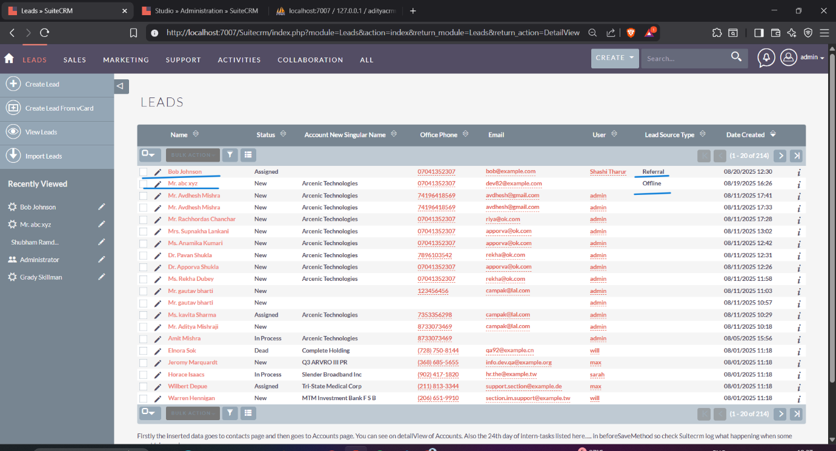  
  
 **Add Custom Field: Contact Reference (Contacts Module)**

**Module:** Contacts  
**Purpose:** Store a custom reference string for each Contact record.

**Steps in Studio**

1. Navigate to **Admin → Studio → Contacts → Fields**.
2. Click **Add Field**.
3. Configure the field using the values above:
   * Data Type: **TextField**
   * Field Name: **contact_reference_c**
   * Display Label: **Contact Reference**
   * Max Size: **255**
   * Importable: **Yes**
   * Duplicate Merge: **Disabled**
4. Save the new field.

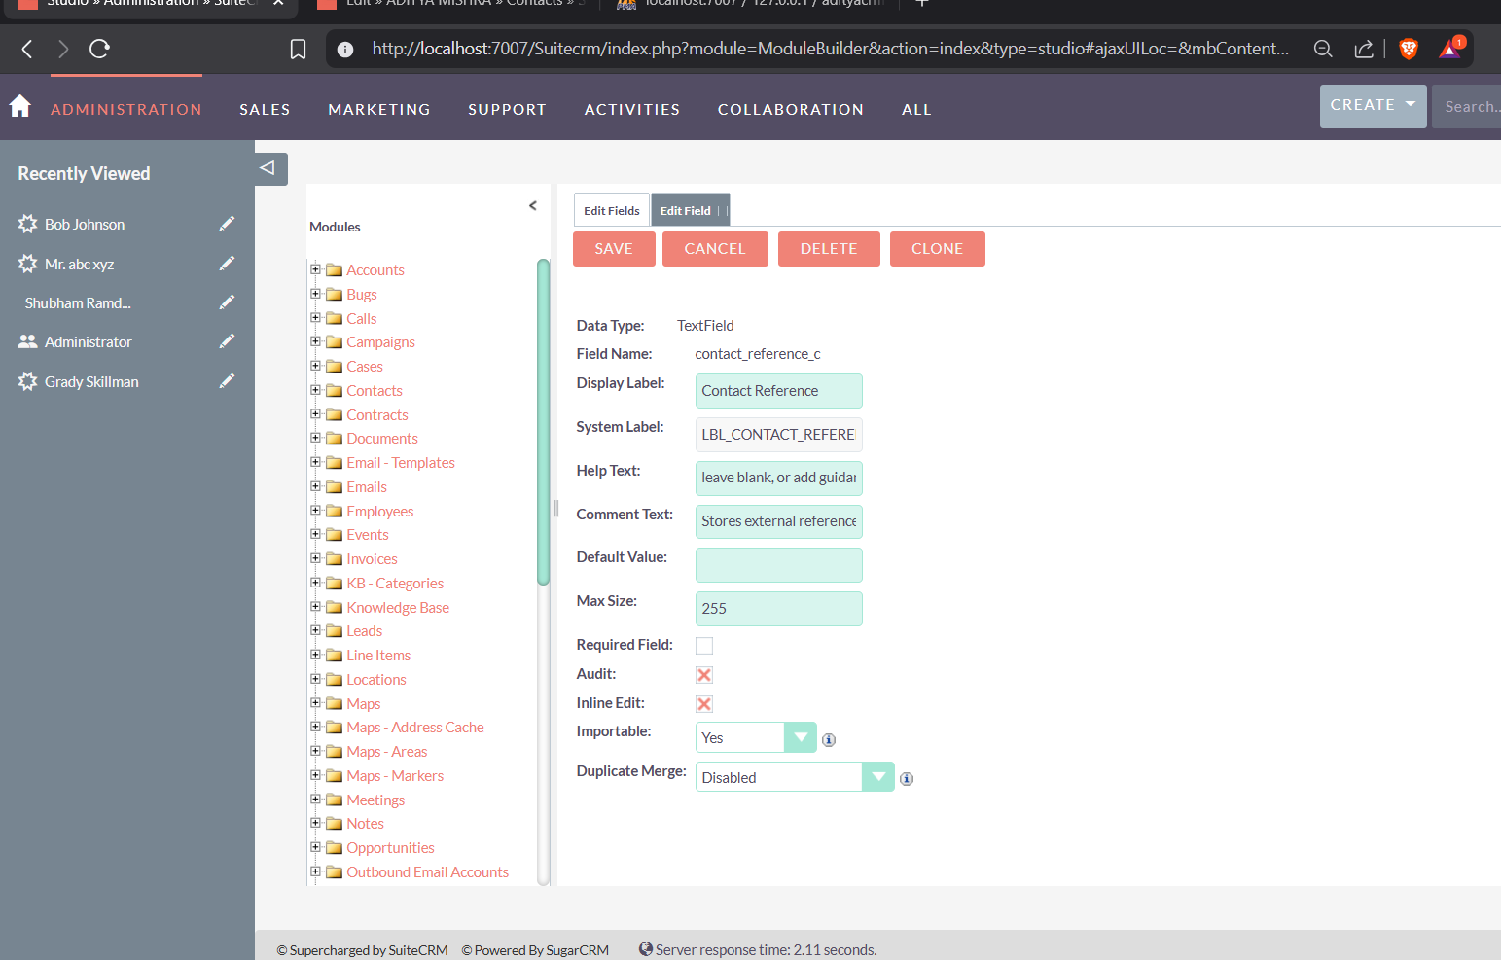

**Add to Layout**

1. Go to **Studio → Contacts → Layouts → Edit View**.
2. Drag the **Contact Reference** field into the layout.
3. Repeat for **Detail View** and **List View** if needed.
4. Click **Save & Deploy**.

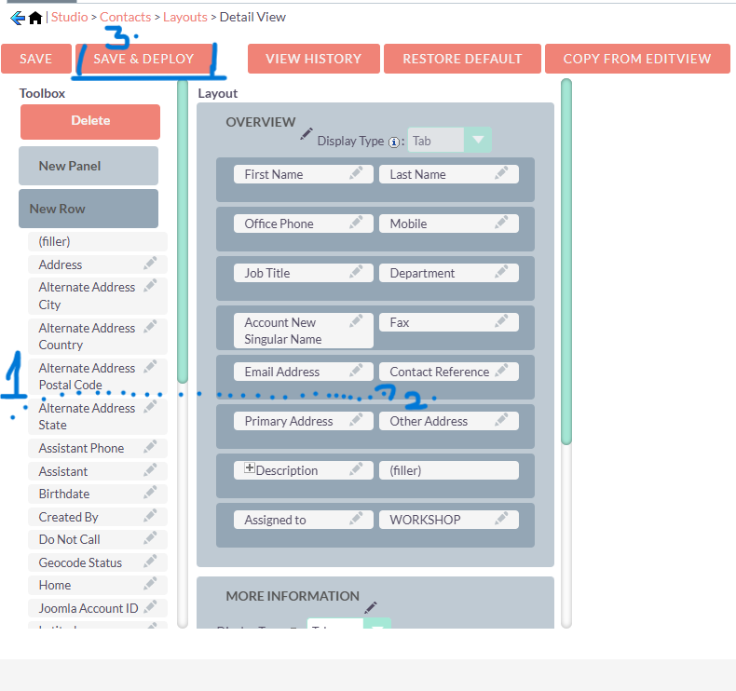  
  
here is the output of created records display in detail  
  
