Course Name: | Web Development Laboratory (316U01L306) | Semester: | III
Date of  Performance: | 18/08/26 | DIV/ Batch  No: | C2
Student Name: | Yashwardhan Ramesh Rathod | Roll No: | 16010125209

Experiment No: 2
Title: Design web Portal using CSS3.
Aim of the Experiment: To apply CSS3 style sheets to an existing HTML5-based Web Portal for the given Use Case study in order to enhance layout, responsiveness, visual aesthetics, and user interaction using modern CSS3 features.

Objectives for the Experiment:
- Implement different CSS3 styling techniques
- Design responsive layouts using Flexbox and media queries
- Enhance user interaction using animations
- Maintain separation of content and presentation

COs to be achieved:
CO1: Use CSS to prepare the layout of web pages.

Books/ Journals/ Websites references:
1. Students should write ……..

Theory:
Students should write about CSS3 (citation needed for content taken (IEEE or APA7 style))

Problem statement: Demonstrate the implementation of CSS3 features to enhance the layout, responsiveness, and aesthetics of the selected HTML-based web portal for the selected Use Case in experiment 1.
Note: All tasks are compulsory to use.

Task 1: Style the Homepage Header (Inline CSS) Requirements:
- Use inline CSS to:
  - Set background color for header
  - Change text color of store name
  - Center align slogan
  - Add padding and border
- Apply inline style to:
  - <h1>, <p>, <header>

Concepts tested:
Inline CSS, color, background, padding, text-align, border.

Task 2: Internal CSS for Navigation Menu

Navigation menu should look professional and consistent across the page.

Requirements:

- Use internal CSS (<style> in <head>)
- Style navigation menu:
  - Remove bullet points
  - Display menu items horizontally
  - Add hover effect
  - Change link colors
- Use:
  - :hover, text-decoration, display: inline-block

Concepts tested:
Internal CSS, selectors, pseudo-class, styling links.

Task 3: External CSS for Whole Website Theme
For a consistent look across all pages.

Requirements:

- Create file: style.css
- Link it using <link>
- Apply:
  - Body font-family

- Background color
- Common heading color
- Common footer style

Concepts tested:
External CSS, reusable styles, site-wide theming. Deliverables : style.css linked with book.html Task 4: Style Book Categories Sidebar
The categories section should look like a card.

Requirements:

- Use external or internal CSS
- Apply:
  - Border
  - Box shadow
  - Padding
  - Rounded corners
- Style list items with:
  - Spacing
  - Hover color change

Concepts tested:
Box model, border-radius, box-shadow, list styling.

Task 5: Book Card Layout Using CSS Box Model

To make Each item appear as a product card.

Requirements:

- Style a <div> as a book card:
  - Width, margin, padding, border
  - Center align content
- Use:
  - display: inline-block
  - Add background color and shadow

Concepts tested:
Box model, margin, padding, display property. Deliverable : link this .css file with book.html Task 6: Image Gallery Styling with CSS
To make Featured appropriate items/ attributes, whichever applicable in the Use Case look like a grid.

Requirements:

- Use CSS to:
  - Set same size for all images
  - Add border and hover zoom effect
  - Add spacing between images
- Use:
  - transition, transform: scale()

Concepts tested:
Image styling, hover effects, transitions. Deliverable nav.css , link to nav bar of expt1 Task 7: Table Styling for Price List

Requirements:

- Use CSS to:
  - Collapse borders
  - Add header background color
  - Zebra-striping rows
  - Center align text
- Use:
  - border-collapse, nth-child(even)

Concepts tested:
Table styling, pseudo-classes.

Deliverable table.css , link to the corresponding file.

Task 8: Style Registration Form

Requirements:

- Style:
  - Input boxes width, padding
  - Submit button color and hover effect
  - Fieldset and legend
- Use:
  - :focus, :hover
  - border-radius

Concepts tested:
Form UI styling, pseudo-classes, layout. Deliverable : form.css
Task 9: Page Layout Using CSS (Header, Sidebar, Content, Footer)

To Create a proper website layout.

Requirements:

- Use CSS to:
  - Set sidebar to left
  - Content to right
  - Footer at bottom
- Use:
  - float or flex
  - Set widths and spacing

Concepts tested:
Layout design, positioning, float/flex. Deliverable : layout.css

Task 10: CSS Effects & Highlighting.

To attract attention for Special events/data/section, etc..

Requirements:

- Create an “Offer” box:
  - Blinking or glowing effect
  - Different background color
  - Bigger font

- Use:
  - @keyframes animation OR hover effect
  - text-shadow, box-shadow

Concepts tested:
CSS animations, effects, visual emphasis.

Code:
Sign In Page –

<!DOCTYPE html>
<html>
<head>
<title>City Care Hospital - Sign In</title>
<link rel="stylesheet" type="text/css" href="style.css">
<style> nav ul {
list-style: none; margin: 0;
padding: 0;
background-color: #1f4f66; display: flex;
flex-wrap: wrap;
}
nav ul li {
display: inline-block;
}

nav ul li a {
display: inline-block; padding: 12px 16px; color: #ffffff;
text-decoration: none;
}

nav ul li a:hover { background-color: #2f6f8f;
}

.page-layout { display: flex; width: 90%; margin: 20px auto; gap: 20px;
flex-wrap: wrap;

align-items: flex-start;
}

.content {
flex: 1 1 100%;
}
form .form-box {
border: 1px solid #cfd8dc; border-radius: 6px; padding: 20px;
margin: 15px 0; max-width: 500px; margin-left: auto; margin-right: auto;
}

form .form-box h3 { padding: 0;
margin: 0 0 15px 0; color: #1f4f66;
}
form input, form textarea, form select { width: 90%;
max-width: 300px; padding: 8px; margin: 6px 0;
border: 1px solid #cfd8dc; border-radius: 4px;
box-sizing: border-box;
}

form input:focus, form textarea:focus, form select:focus { border-color: #2f6f8f; outline: none;
}

form input[type="submit"], form input[type="reset"], form button {
width: auto;
background-color: #2f6f8f; color: #ffffff;
border: none; padding: 8px 20px; border-radius: 4px;

cursor: pointer;
}

form input[type="submit"]:hover, form button:hover {
background-color: #1f4f66;
}

form input[type="reset"] { background-color: #888888;
}
.form-table { width: 100%;
border-collapse: collapse;
}

.form-table td { border: none; padding: 8px; text-align: left;
}

.form-table td:first-child { width: 35%;
}

footer {
text-align: center; margin-top: 20px;
}
</style>
</head>
<body>

<header style="background-color:#1f4f66; color:#ffffff; padding:20px; text-align:center; border-bottom:3px solid #2f6f8f;">
<h1 style="margin:0; color:#ffffff; text-align:center;">Sign In</h1>
</header>

<nav>
<ul>
<li><a href="index.html">Home</a></li>
<li><a href="about.html">About Us</a></li>
<li><a href="departments.html">Departments</a></li>
<li><a href="doctors.html">Doctors</a></li>
<li><a href="appointment.html">Book Appointment</a></li>
<li><a href="facilities.html">Facilities</a></li>
<li><a href="contact.html">Contact Us</a></li>
<li><a href="sign_in.html">Sign In</a></li>

<li><a href="sign_up.html">Sign Up</a></li>
</ul>
</nav>

<div class="page-layout">

<main class="content">

<form action="index.html" method="get">

<div class="form-box">
<h3>Sign In Details</h3>

<table class="form-table">

<tr>
<td>
<label for="username">Username</label>
</td>

<td>
<input type="text" id="username" name="username" placeholder="Enter Username" required>
</td>
</tr>

<tr>
<td>
<label for="password">Password</label>
</td>

<td>
<input type="password" id="password" name="password" placeholder="Enter Password" required>
</td>
</tr>

<tr>
<td colspan="2" style="text-align:center;">
<input type="submit" value="Sign In">
</td>
</tr>

</table>
</div>

</form>

<p style="text-align:center;">

Don't have an account?
<a href="sign_up.html">Sign Up</a>
</p>

</main>

</div>

<footer>
<p><small>Copyright City Care Hospital 2026</small></p>
</footer>
</body>
</html>

Sign Up Page –

<!DOCTYPE html>
<html>
<head>
<title>City Care Hospital - Sign Up</title>
<link rel="stylesheet" type="text/css" href="style.css">
<style> nav ul {
list-style: none; margin: 0;
padding: 0;
background-color: #1f4f66; display: flex;
flex-wrap: wrap;
}
nav ul li {
display: inline-block;
}

nav ul li a {
display: inline-block; padding: 12px 16px; color: #ffffff;
text-decoration: none;
}

nav ul li a:hover { background-color: #2f6f8f;
}

.page-layout { display: flex;

width: 90%; margin: 20px auto; gap: 20px;
flex-wrap: wrap; align-items: flex-start;
}
.content {
flex: 1 1 100%;
}

.card-row {
text-align: center; margin: 15px 0;
}

.info-box {
display: inline-block; width: 150px; margin: 8px; padding: 15px;
border: 1px solid #cfd8dc; background-color: #eaf3f6;
box-shadow: 2px 2px 6px rgba(0,0,0,0.1); text-align: center;
vertical-align: top;
}

.gallery-img { width: 120px; height: 90px;
border: 2px solid #cfd8dc; margin: 5px;
transition: transform 0.3s ease;
}

.gallery-img:hover { transform: scale(1.1);
}

table {
border-collapse: collapse; width: 100%;
margin: 15px 0;
}
th, td {
border: 1px solid #cfd8dc; padding: 8px;
text-align: center;
}

th {
background-color: #1f4f66; color: #ffffff;
}

tr:nth-child(even) { background-color: #eaf3f6;
}

form .form-box {
border: 1px solid #cfd8dc; border-radius: 6px; padding: 20px;
margin: 15px auto; max-width: 600px;
}

form .form-box h3 { margin: 0 0 15px 0; color: #1f4f66;
}

form input, form textarea, form select { width: 90%;
max-width: 300px; padding: 8px; margin: 6px 0;
border: 1px solid #cfd8dc; border-radius: 4px;
box-sizing: border-box;
}

form input:focus, form textarea:focus, form select:focus { border-color: #2f6f8f; outline: none;
}

form input[type="submit"], form input[type="reset"], form button {
width: auto;
background-color: #2f6f8f; color: #ffffff;
border: none; padding: 8px 20px; border-radius: 4px;

cursor: pointer;
}

form input[type="submit"]:hover, form button:hover {
background-color: #1f4f66;
}

form input[type="reset"] { background-color: #888888;
}
.form-table { width: 100%;
border-collapse: collapse;
}

.form-table td { border: none; padding: 8px; text-align: left;
}

.form-table td:first-child { width: 35%;
}

.highlight-box { background-color: #fff8e1; color: #7a5b00;
font-size: 18px; padding: 12px; margin: 15px 0; text-align: center; border-radius: 6px;
text-shadow: 1px 1px 1px #ffffff; animation: glow 2s infinite alternate;
}
@keyframes glow { from {
box-shadow: 0 0 4px rgba(224,180,0,0.4);
}
to {
box-shadow: 0 0 12px rgba(224,180,0,0.8);
}
}
</style>
</head>

<body>

<header style="background-color:#1f4f66; color:#ffffff; padding:20px; text-align:center; border-bottom:3px solid #2f6f8f;">
<h1 style="margin:0; color:#ffffff; text-align:center;">Sign Up</h1>
</header>

<nav>
<ul>
<li><a href="index.html">Home</a></li>
<li><a href="about.html">About Us</a></li>
<li><a href="departments.html">Departments</a></li>
<li><a href="doctors.html">Doctors</a></li>
<li><a href="appointment.html">Book Appointment</a></li>
<li><a href="facilities.html">Facilities</a></li>
<li><a href="contact.html">Contact Us</a></li>
<li><a href="sign_in.html">Sign In</a></li>
<li><a href="sign_up.html">Sign Up</a></li>
</ul>
</nav>

<div class="page-layout">

<main class="content">
<form action="index.html" method="get">

<div class="form-box">

<h3>Create Account</h3>

<table class="form-table">

<tr>
<td>
<label for="fullname">Full Name</label>
</td>
<td>
<input type="text" id="fullname" name="fullname" placeholder="Enter Full Name" required>
</td>
</tr>

<tr>
<td>
<label for="email">Email</label>
</td>
<td>
<input type="email" id="email" name="email" placeholder="Enter Email" required>
</td>
</tr>

<tr>
<td>
<label for="username">Username</label>
</td>
<td>
<input type="text" id="username" name="username" placeholder="Enter Username" required>
</td>
</tr>

<tr>
<td>
<label for="password">Password</label>
</td>
<td>
<input type="password" id="password" name="password" placeholder="Enter Password" required>
</td>
</tr>

<tr>
<td>
<label for="confirm_password">Confirm Password</label>
</td>
<td>
<input type="password" id="confirm_password" name="confirm_password" placeholder="Confirm Password" required>
</td>
</tr>

<tr>
<td colspan="2" style="text-align:center;">
<input type="submit" value="Sign Up">
</td>
</tr>

</table>

</div>

</form>

<p style="text-align:center;"> Already have an account?
<a href="sign_in.html">Sign In</a>
</p>

</main>

</div>
<footer>
<p><small>Copyright City Care Hospital 2026</small></p>
</footer>

</body>
</html> Facilities page –
<!DOCTYPE html>
<html>
<head>
<title>City Care Hospital - Facilities</title>
<link rel="stylesheet" type="text/css" href="style.css">

<style> nav ul {
list-style: none; margin: 0;
padding: 0;
background-color: #1f4f66; display: flex;
flex-wrap: wrap;
}

nav ul li {
display: inline-block;
}

nav ul li a {
display: inline-block; padding: 12px 16px; color: #ffffff;
text-decoration: none;
}

nav ul li a:hover { background-color: #2f6f8f;
}

.page-layout { display: flex; width: 90%; margin: 20px auto; gap: 20px;
flex-wrap: wrap; align-items: flex-start;
}

.content {
flex: 1 1 100%;
}

.gallery-img { width: 120px; height: 90px;
border: 2px solid #cfd8dc; margin: 5px;
transition: transform 0.3s ease;
}
.gallery-img:hover { transform: scale(1.1);
}

table {
border-collapse: collapse; width: 100%;
margin: 15px 0;
}

th, td {
border: 1px solid #cfd8dc; padding: 8px;
text-align: center;
}

th {
background-color: #1f4f66; color: #ffffff;
}

tr:nth-child(even) { background-color: #eaf3f6;
}

form .form-box {
border: 1px solid #cfd8dc; border-radius: 6px; padding: 15px;
margin: 15px 0;
}

form .form-box h4 { margin: 0 0 10px 0; color: #1f4f66;
}

form input, form textarea,

form select { width: 90%;
max-width: 300px; padding: 8px; margin: 6px 0;
border: 1px solid #cfd8dc; border-radius: 4px;
box-sizing: border-box;
}

form input:focus, form textarea:focus, form select:focus { border-color: #2f6f8f; outline: none;
}

form input[type="submit"], form input[type="reset"], form button {
width: auto;
background-color: #2f6f8f; color: #ffffff;
border: none; padding: 8px 20px; border-radius: 4px; cursor: pointer;
}
form input[type="submit"]:hover, form button:hover {
background-color: #1f4f66;
}
form input[type="reset"] { background-color: #888888;
}

.highlight-box { background-color: #fff8e1; color: #7a5b00;
font-size: 18px; padding: 12px; margin: 15px 0; text-align: center; border-radius: 6px;
text-shadow: 1px 1px 1px #ffffff; animation: glow 2s infinite alternate;
}

@keyframes glow {

from {
box-shadow: 0 0 4px rgba(224,180,0,0.4);
}

to {
box-shadow: 0 0 12px rgba(224,180,0,0.8);
}
}
</style>
</head>

<body>

<header style="background-color:#1f4f66; color:#ffffff; padding:20px; text-align:center; border-bottom:3px solid #2f6f8f;">
<h1 style="margin:0; color:#ffffff; text-align:center;">Facilities</h1>
</header>

<nav>
<ul>
<li><a href="index.html">Home</a></li>
<li><a href="about.html">About Us</a></li>
<li><a href="departments.html">Departments</a></li>
<li><a href="doctors.html">Doctors</a></li>
<li><a href="appointment.html">Book Appointment</a></li>
<li><a href="facilities.html">Facilities</a></li>
<li><a href="contact.html">Contact Us</a></li>
<li><a href="sign_in.html">Sign In</a></li>
<li><a href="sign_up.html">Sign Up</a></li>
</ul>
</nav>

<div class="page-layout">
<main class="content">

<h2>Our Facilities</h2>

<video src="Videos/1.mp4" width="100%"
style="max-width:500px; display:block; margin:0 auto 15px auto; border-radius:6px;" controls autoplay muted loop>
</video>

<h3>Facility Gallery</h3>
<img class="gallery-img" src="Images/ICU.jpg" alt="ICU">
<img class="gallery-img" src="Images/OP.jpg" alt="Operation Theatre">
<img class="gallery-img" src="Images/Ambulence.jpg" alt="Ambulance">
<img class="gallery-img" src="Images/pharmacy.avif" alt="Pharmacy">

<table>
<tr>
<th>Facility</th>
<th>Details</th>
</tr>
<tr>
<td>ICU</td>
<td>24 bed fully equipped Intensive Care Unit</td>
</tr>
<tr>
<td>Operation Theatre</td>
<td>Modular OTs with advanced surgical equipment</td>
</tr>

<tr>
<td>Ambulance</td>
<td>24x7 ambulance service with trained paramedics</td>
</tr>

<tr>
<td>Pharmacy</td>
<td>In-house pharmacy open round the clock</td>
</tr>

</table>
<h3>Diagnostic Lab</h3>

<p>
Our NABL accredited pathology lab provides accurate and quick results for all routine and specialised tests.
</p>

<form method="POST" action="#">

<div class="form-box">

<h4>Request Facility Information</h4>

<label>Your Name:<br>
<input type="text" name="req_name">
</label>
<br>

<label>Facility of Interest:<br>
<select name="facility_choice">
<option>ICU</option>
<option>Operation Theatre</option>

<option>Pharmacy</option>
</select>
</label>
<br>

<input type="submit" value="Send Request">
</div>

</form>

<div class="highlight-box">
24x7 Emergency &amp; Ambulance Facility Available - Call 102
</div>

</main>

</div>
<footer>
<p><small>Copyright City Care Hospital 2026</small></p>
</footer>

</body>
</html>

Output / Screenshot:
Sign In Page –

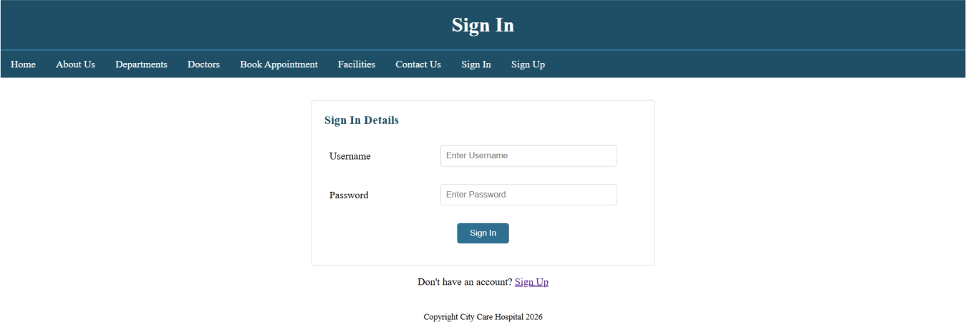

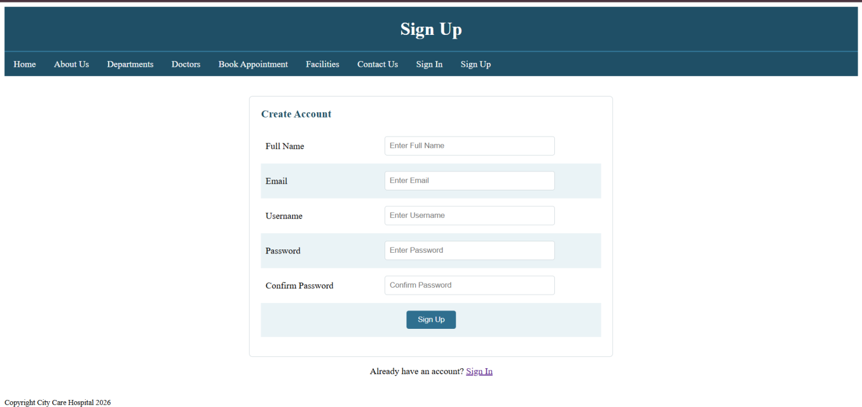
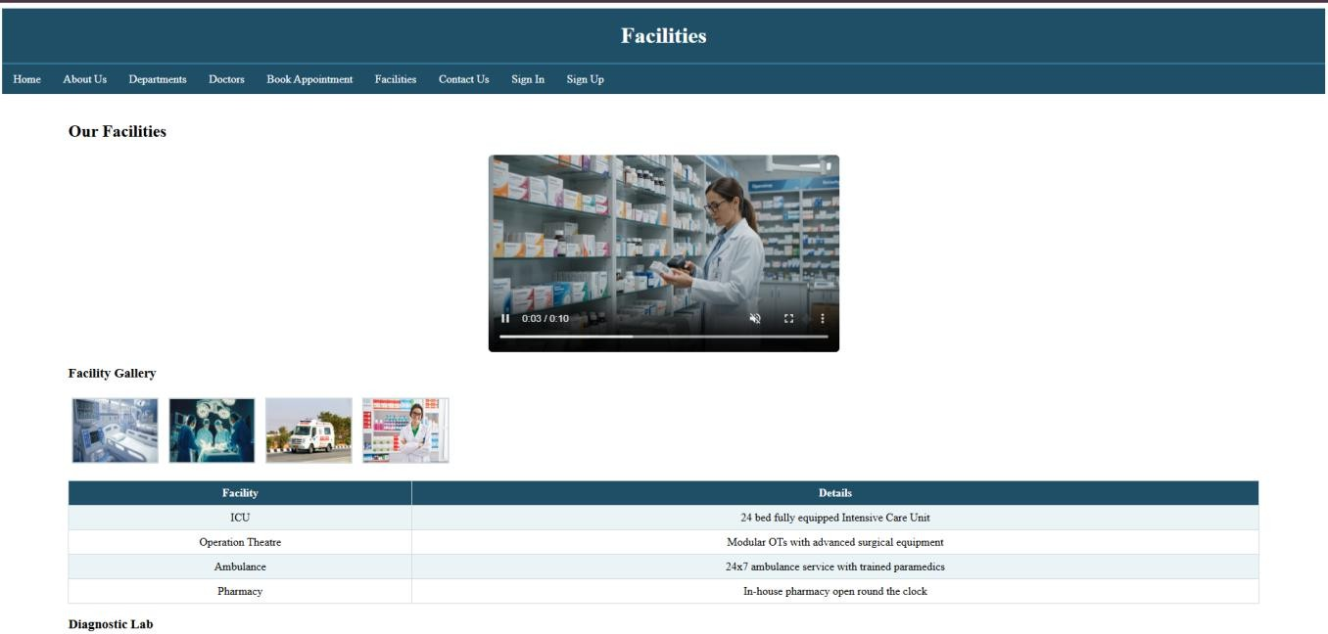
Sign Up Page –

Facilities –

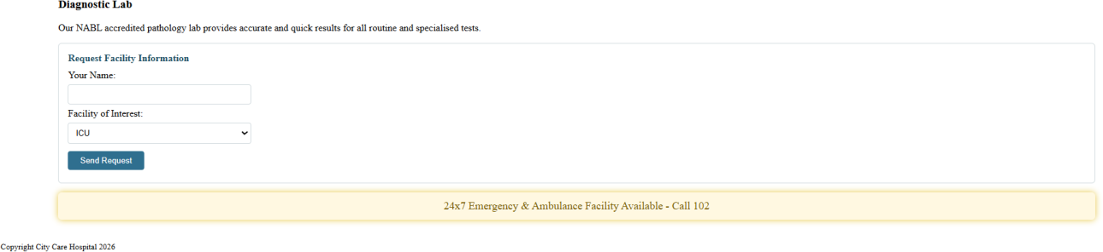

Post Lab Subjective/Objective type Questions:
1. Use Bootstrap for CSS.
Using bootstrap can make the website look more professional and organized with ready-made styles and components. It can also help create a responsive and attractive design with less CSS code

Conclusion and Discussion:
The Sign In and Sign Up pages provide a simple and user-friendly way for patients to manage their accounts.
The Facilities page presents the hospital’s services, equipment, gallery, and diagnostic facilities clearly.
Overall, these pages demonstrate effective use of HTML and CSS to create a clean, organized, and functional website.

