SVKM’s NMIMS
Mukesh Patel School of Technology Management & Engineering
Department of Aritificial Intelligence, Mumbai Campus
Program: B.Tech/MBA Tech AI Semester: VI/VIII

Course: Advance Topics in Machine Learning
List of Experiments

Faculty: Dr Vaishali Kulkarni/Dr Radhika Chapaneri/Dr. Ami Munshi WEF Dec2025

Exp No. | Title | Prerequisite* | CO#
1. | a. Introduction to AutoML Frameworks for machine learning and deep learning  b. To implement zero shot learning | AutoML  Zeroshot | 1
2. | Siamese Network  - To curate training and testing dataset as required by the Siamese network  - To write a function for contrastive loss  - To train Siamese Network model using concept of difference vector  - To train Siamese Network model using concept of Euclidean distance  - To test the model for some unseen test sample using a support set required for one-shot learning  - To compare the above two approaches | Concept of contrastive loss, Euclidean distance, Siamese network | 1
3 | Autoencoder training and application  - To comprehend the concept of Autoencoders  - To design, implement and train Autoencoder for data compression and reconstruction using Tensorflow or PyTorch  - To explore dimensionality reduction aspect of Autoencoder  - To evaluate the performance of Autoecoder using evaluation metric such as reconstruction loss  - To experiment and explore the effect of various hyperparameters such as number of layers, bottleneck size, and learning rate.  - To demonstrate the function of Autoencoder in any one real world problem | Concept of Autoencoder, Comparison of Autoencoder with PCA, Significance of using Autoencoder | 2
5
6
7
8
9
10
11

SVKM’s NMIMS
Mukesh Patel School of Technology Management & Engineering
Program: BTech/MBA Tech AI Semester: VIII
Faculty: Dr Ami Munshi

Course: Advanced topics in Machine Learning
Experiment No.3
PART A
A.1 Aim: Autoencoder training and application
- To comprehend the concept of Autoencoders
- To design, implement and train Autoencoder for data compression and reconstruction using Tensorflow or PyTorch
- To explore dimensionality reduction aspect of Autoencoder
- To evaluate the performance of Autoencoder using evaluation metric such as reconstruction loss
- To experiment and explore the effect of various hyperparameters such as number of layers, bottleneck size, and learning rate.
- To demonstrate the function of Autoencoder in any one real world problem
A.2 Prerequisites: Concept of Autoencoder, Comparison of Autoencoder with PCA, Significance of using Autoencoder
A.3 Learning outcomes:
After completing the experiment, you will be able to-
- Design, implement and train Autoencoder
- Evaluate the performance of Autoencoder
- Appreciate the significance of Autoencoder in dimensionality reduction
- Build real world applications using Autoencoder
A.4 Theory

A.4.1 Introduction to Autoencoders
An autoencoder is a type of artificial neural network used for unsupervised learning. Its main purpose is to learn a compressed representation (encoding) of input data and then reconstruct it as closely as possible. Autoencoders are particularly useful for applications like:
- Dimensionality reduction
- Anomaly detection
- Denoising data
- Feature extraction

A.4.2 Structure of an Autoencoder
An autoencoder consists of two main parts:
- Encoder: Compresses the input data into a lower-dimensional representation called the latent space or bottleneck.
- Decoder: Reconstructs the input data from the compressed representation.
The network is trained to minimize the reconstruction error, which measures the difference between the original input and its reconstruction.

A.4.3 Architecture of an Autoencoder
The architecture of an autoencoder typically has:
- Input Layer: Takes in the input data (e.g., images, vectors).
- Hidden Layers (Encoder): Applies transformations to compress the input data into a smaller representation (latent space).
- Latent Space (Bottleneck): The most compressed representation of the data, which ideally captures the most important features.
- Hidden Layers (Decoder): Maps the latent space back to the original input space.
- Output Layer: Produces the reconstructed data.
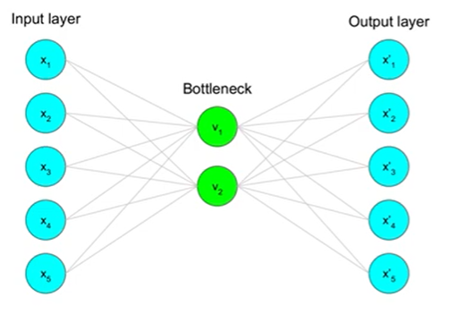
Fig 1: Architecture of an Autoencoder

A.4.4 Loss Function
The objective of an autoencoder is to minimize the reconstruction error between the input $x$and the reconstructed output $\hat{x}$
Common loss functions include:
- Mean Squared Error (MSE):
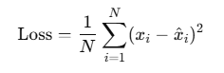
- Binary Cross-Entropy Loss: Used for inputs normalized between 0 and 1.

A.5 Task to be completed
- Design, implement and train an Autoencoder on MNIST dataset using TensorFlow or PyTorch
- Evaluate the performance of the trained Autoencoder on the test dataset by calculating reconstruction error
- Experiment and explore the significance of various hyperparameters such as number of layers, size of bottle neck and learning rate
- Use Autoencoder to develop any one real world application such as Anomaly detection, Denoising, Colorization etc

References
https://www.analyticsvidhya.com/blog/2021/06/complete-guide-on-how-to-use-autoencoders-in-python/
https://machinelearningmastery.com/autoencoder-for-classification/
https://youtu.be/D9HjlqIrB-c?si=00bH-PVEdipbusTr

PART B
(PART B : TO BE COMPLETED BY STUDENTS)
(Students must submit the soft copy as per following segments within two hours of the practical.)

Roll No. | Name:
Class : | Batch :
Date of Experiment: | Date of Submission
Grade :

B.1 Task1
B.2 Task 2
B.2 Task 3
B.2 Task 4

B.5 Conclusion:
(Students must write the conclusion in their own words.)

