SVKM’s NMIMS
Mukesh Patel School of Technology Management & Engineering
Department of Aritificial Intelligence, Mumbai Campus
Program: B.Tech/MBA Tech AI Semester: VI/VIII

Course: Advance Topics in Machine Learning
List of Experiments

Faculty: Dr Vaishali Kulkarni//Dr. Ami Munshi WEF Jan 2026

Exp No. | Title | Prerequisite* | CO#
1 | Explore Advanced topics in Machine Learning Concepts using Generative AI Research Tools
2. | Introduction to AutoML Frameworks for machine learning and deep learning |  | 1
3. | Siamese Network  - To curate training and testing dataset as required by the Siamese network  - To write a function for contrastive loss  - To train Siamese Network model using concept of difference vector  - To train Siamese Network model using concept of Euclidean distance  - To test the model for some unseen test sample using a support set required for one-shot learning  - To compare the above two approaches | Concept of contrastive loss, Euclidean distance, Siamese network | 1
4 | Autoencoder training and application  - To comprehend the concept of Autoencoders  - To design, implement and train Autoencoder for data compression and reconstruction using Tensorflow or PyTorch  - To explore dimensionality reduction aspect of Autoencoder  - To evaluate the performance of Autoecoder using evaluation metric such as reconstruction loss  - To experiment and explore the effect of various hyperparameters such as number of layers, bottleneck size, and learning rate.  - To demonstrate the function of Autoencoder in any one real world problem | Concept of Autoencoder, Comparison of Autoencoder with PCA, Significance of using Autoencoder | 2
5 | Generative Adversarial Network (GAN).  - To comprehend the concepts of GANs by summarizing the paper by Goodfellow.  - To implement generator and discriminator network for GANs on fashion MNIST dataset.  - To evaluate the performance of GAN using evaluation metric such as reconstruction loss | Concept of Autoencoders, KL Divergence
6
7
8
9
10
11

SVKM’s NMIMS
Mukesh Patel School of Technology Management & Engineering
B.Tech/MBA Tech AI Semester: VI
Faculty: Dr. Ami Munshi
Course: Advanced topics in Machine Learning
Experiment No.4
PART A
A.1 Aim: To implement Generative Adversarial Network (GAN).
- To comprehend the concepts of GANs by summarizing the paper by Goodfellow.
- To implement generator and discriminator network for GANs on fashion MNIST dataset.
- To evaluate the performance of GAN using evaluation metric such as reconstruction loss
A.2 Prerequisites: Concept of GANs
A.3 Learning outcomes:
After completing the experiment, you will be able to-
- Know the working of GAN.
- Design, implement and train GAN
- Evaluate the performance of GAN

A.4 Theory

A.4.1 Introduction to GAN

A.4.2 Structure of an Autoencoder

Generative modeling involves automatically discovering and learning the regularities or patterns in input data in such a way that the model can be used to generate or output new examples that plausibly could have been drawn from the original dataset.

A.4.3 Architecture of an GAN
The architecture of a GAN typically has:
- Generator network: A generator in GANs is a neural network that creates fake data to be trained on the discriminator

- Discriminator network: A discriminator is a neural network model that identifies real data from the fake data generated by the generator
- The generator learns to generate plausible data. The generated instances become negative training examples for the discriminator. It takes a fixed length random vector carrying noise as input and generates a sample. The main aim of the generator is to make the discriminator classify its output as real.
- The discriminator's training data comes from two sources:
  - the real data instances such as real pictures of birds humans currency notes etc are used by the discriminator as positive samples during the training
  - the fake data instances created by the generator are used as negative examples during the training process
- The generator and the discriminator both play an adversarial game where the generator tries to fool the discriminator by generating data similar to those in the training set and the
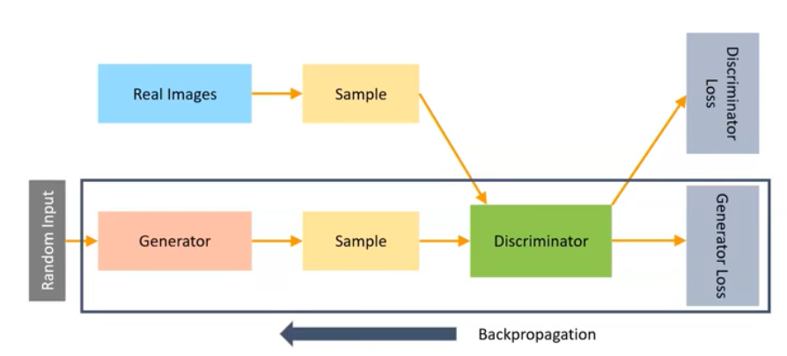
Fig 1: Architecture of a GAN

A.4.4 Training
- The mathematical equation of training again can be represented as
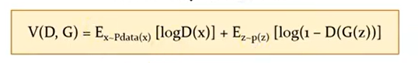
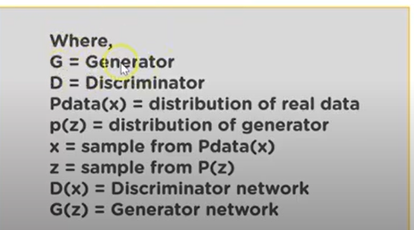
- The discriminator focuses to maximize the objective function such that D (x) is close to 1 and G(x) z is close to 0.
- It simply means that the discriminator should identify all the images from the training set as real that is one and all the generated images as fake that is zero.
- The generator wants to minimize the objective function such that
- D(G(z)) is one.
- This means that the generator tries to generate images that are classified as real

A.5 Task to be completed
Task 1: Read the paper by Goodfellow given in the link below:
https://arxiv.org/abs/1406.2661
Answer the following questions:
- Summarize the paper
- State and explain the minimax formulation used in training the network.
- Highlight the advantages and challenges in this simple Generative model.
Task 2: load the fashion mnist dataset available in keras.
- Normalize the dataset to the range (-1,1).
- Reshape the data so that one sample at a time can be given as input to the network.
- Plot some sample data from the dataset using matplotlib.
- Choose a batch size of 32.
- Using tensor flow and from_tensor_slices, slice the dataset into batches of 32.
Task 3: Build a generator network
- Build a sequential generator network
- You can start with any number of neurons in the hidden layer.
- Choose appropriate layers, activation function, momentum etc.
- The input shape will be dependent on noise given as input to the generator.
- Reshape the output of generator to (28,28,1).
Task 4: Build a discriminator network.
- Build a sequential discriminator network.
- The input shape would be (28,28,1)
- Choose appropriate layers, activation function etc.
- The final layer will have one neuron and sigmoid activation.
Task 5: Build a GAN network
- Build a sequential GAN network using the generator and discriminator

Task 6: Choose appropriate optimizer and compile the model.
- Run the model and plot the generated images.
- Change the number of epochs and note the difference in the quality of images generated.
References:
PART B
(PART B : TO BE COMPLETED BY STUDENTS)
(Students must submit the soft copy as per following segments within two hours of the practical.)

Roll No. | Name:
Class : | Batch :
Date of Experiment: | Date of Submission
Grade :

B.1 Task1
B.2 Task 2
B.2 Task 3
B.2 Task 4

B.5 Conclusion:
(Students must write the conclusion in their own words.)

