SVKM’s NMIMS
Mukesh Patel School of Technology Management & Engineering
Department of Aritificial Intelligence, Mumbai Campus
Program: B.Tech/MBA Tech AI Semester: VI

Course: Advance Topics in Machine Learning
List of Experiments

Faculty: Dr. Ami Munshi WEF Jan2026

Exp No. | Title | Prerequisite* | CO#
1 | Explore Advanced topics in Machine Learning Concepts using Generative AI Research Tools
2. | Introduction to AutoML Frameworks for machine learning and deep learning |  | 1
3. | Siamese Network  - To curate training and testing dataset as required by the Siamese network  - To write a function for contrastive loss  - To train Siamese Network model using concept of difference vector  - To train Siamese Network model using concept of Euclidean distance  - To test the model for some unseen test sample using a support set required for one-shot learning  - To compare the above two approaches | Concept of contrastive loss, Euclidean distance, Siamese network | 1
4 | Autoencoder training and application  - To comprehend the concept of Autoencoders  - To design, implement and train Autoencoder for data compression and reconstruction using Tensorflow or PyTorch  - To explore dimensionality reduction aspect of Autoencoder  - To evaluate the performance of Autoecoder using evaluation metric such as reconstruction loss  - To experiment and explore the effect of various hyperparameters such as number of layers, bottleneck size, and learning rate.  - To demonstrate the function of Autoencoder in any one real world problem | Concept of Autoencoder, Comparison of Autoencoder with PCA, Significance of using Autoencoder | 2
5
6
7 | Encoder-Decoder Architecture and Application  - To comprehend the concept of Encoder-Decoder Architecture  - To design, implement and train Encoder and Decoder for Machine Translation Application  - To analyze and interpret the performance of Machine Translation Encoder-Decoder system for the give data set  - To develop any other real world application such as Image Captioning, Next Word Prediction, Summarization etc. using encoder decoder architecture | Language Modeling, Encoder-Decoder Architecture
8
9
10
11

SVKM’s NMIMS
Mukesh Patel School of Technology Management & Engineering
Program: B.Tech/MBATech AI Sem 6
Faculty: Dr Ami Munshi

Course: Advanced topics in Machine Learning
Experiment No.6
PART A
A.1 Aim: Encoder-Decoder Architecture and Application
- To comprehend the concept of Encoder-Decoder Architecture
- To design, implement and train Encoder and Decoder for Machine Translation Application
- To analyze and interpret the performance of Machine Translation Encoder-Decoder system for the give data set
- To develop any other real world application such as Image Captioning, Next Word Prediction, Summarization etc. using encoder decoder architecture

A.2 Prerequisites: Concept of Language Modeling, RNN, LSTM, Encoder-Decoder Architecture
A.3 Learning outcomes:
After completing the experiment, you will be able to-
- Design, implement and train Encoder-Decoder Architecture for the Machine Translation Application
- Evaluate the performance of Machine Translation Application for various translation datasets
- Build real world applications such as machine translation, image captioning, next word prediction, summarization etc
A.4 Theory

A.4.1 Introduction to Encoder-Decoder Architecture
- Encoder-decoder architecture
  - It is a type of neural network model commonly used in tasks that involve transforming one sequence of data into another
  - It is particularly popular in areas such as machine translation, text summarization, image captioning, and speech recognition.

A.4.2 Structure of an Encoder-Decoder
  - Encoder
    - An encoder that accepts an input sequence, $x$, and generates a corresponding sequence of contextualized representations, $h$
    - LSTMs, convolutional networks, and Transformers can all be employed as encoders
  - Context Vector
    - A context vector, $c$, which is a function of $h$, and conveys the essence of the input to the decoder
  - Decoder
    - A decoder, which accepts c as input and generates an arbitrary length se quence of hidden states $h$ from which a corresponding sequence of output states y, can be obtained
    - Decoders can also be realized by any kind of sequence architecture like RNN, LSTM, GRU

A.4.3 Machine Translation Application
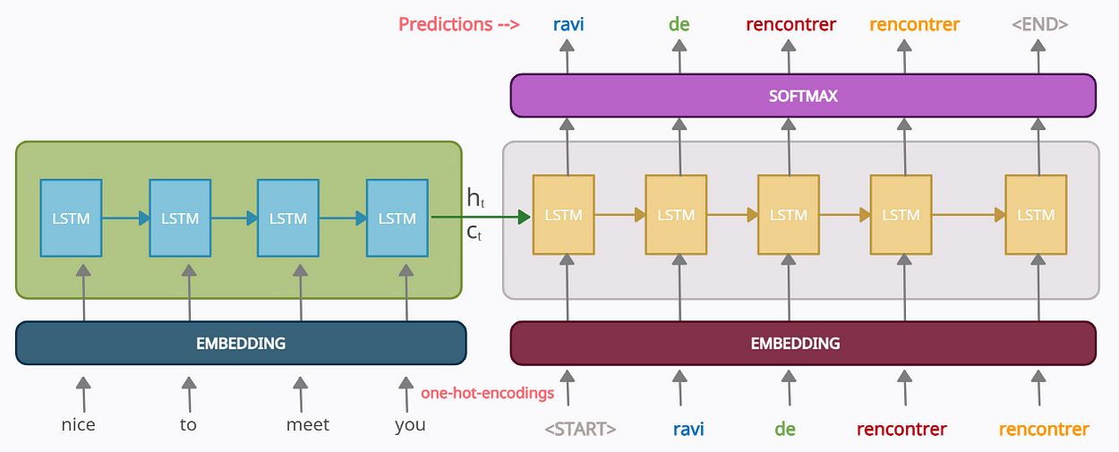
Fig 1: Machine Translation using Encoder-Decoder Architectrure

A.5 Task to be completed
- Design, implement and train an English to Hindi Machine Translation System for the given dataset using Encoder-Decoder Architecture
https://www.kaggle.com/code/uselessnoob/english-to-hindi-machine-translation
- Evaluate and analyse the performance of the trained encoder-decoder on the test dataset
- Implement and train Engish to Spanish Machine Translation for the Hugging Face opus_books dataset
- Build any other real world application such as image captioning, summarization etc using Encoder-Decoder Architecture
References

PART B
(PART B : TO BE COMPLETED BY STUDENTS)
(Students must submit the soft copy as per following segments within two hours of the practical.)

Roll No. | Name:
Class : | Batch :
Date of Experiment: | Date of Submission
Grade :

B.1 Task1
B.2 Task 2
B.2 Task 3
B.2 Task 4

B.5 Conclusion:
(Students must write the conclusion in their own words.)

