Research Paper Study & Partial Implementation: Recommendation Systems
Assigned Paper: A Comprehensive Analysis of Text Similarity Metrics and Vectorization Techniques for Content-Based Product Recommendation (Oprea et al., IEEE Access, 2026)
Dataset Used: Hugging Face Hub — bprateek/amazon_product_description (10,001 valid products across 108 subcategories)

Part A — Research Paper Understanding
- A1. Problem Definition: The paper addresses Top-N Content-Based Filtering (CBF) product recommendation (K=10) and cold-start item recommendation in e-commerce using short product titles ("Product Name") without user interaction history.
- A2. Motivation: E-commerce catalogs suffer from choice overload. While Collaborative Filtering fails on cold-start items and sparse interaction matrices, content-based retrieval operates purely on item text, improving product discovery, retention, and conversion.
- A3. Research Gap: Prior work evaluates text vectorizers or distance metrics in isolation or on long-form text corpora. A controlled factorial benchmark comparing sparse and dense representations across angular and geometric distances on short, attribute-lean retail product titles remained under-explored.
- A4. Major Contributions: (1) A 12-configuration factorial benchmark (Count Vectorizer, TF-IDF, Word2Vec, GloVe × Cosine, Manhattan, Euclidean); (2) Qualitative Top-10 relevance analysis on 3 distinct categories (Puzzles, Longboards, Costumes); and (3) Quantitative Precision@10, Recall@10, and NDCG@10 evaluation across 500 random seed products.

Part B — Methodology Analysis
- 1. Input: Unstructured "Product Name" text strings from the Hugging Face dataset "bprateek/amazon_product_description" (10,002 rows, 28 columns; 10,001 valid records after removing "-" placeholder artifacts).
- 2. Processing Pipeline: Input Title → Preprocessing (lowercasing, regex punctuation removal, English stopword removal, WordNet lemmatization) → Feature Extraction (CountVec, custom TF-IDF [Eq. 6–8], 300d Skip-gram Word2Vec, pre-trained GloVe) → Pairwise Interaction (Cosine Similarity [Eq. 1–3], Manhattan L1 [Eq. 4], Euclidean L2 [Eq. 5]) → Top-K Ranking.
- 3. Output: Ranked Top-10 recommended product list with continuous similarity scores (Cosine in [0, 1] sorted descending) or distance scores (Manhattan/Euclidean >= 0 sorted ascending).

Part C — Implementation & Experimental Evaluation
Implemented Core Components (From Scratch in NumPy): Rather than relying on black-box similarity libraries, we implemented custom vectorized functions for Cosine Similarity, Manhattan Distance, Euclidean Distance, custom TF-IDF weighting, and sum-pooled 300d Word2Vec embeddings, benchmarked against Count Vectorizer + Cosine Similarity.
Table 1: Reproduced 12-Configuration Pairwise Benchmark (Table 7 in Paper)
Vectorizer | Metric | Test1 (Puzzle) | Test2 (Longboard) | Test3 (Costume)
Count Vectorizer | cosine | 0.612 | 1.0 | 0.772
Count Vectorizer | manhattan | 4.0 | 0.0 | 3.0
Count Vectorizer | euclidean | 2.0 | 0.0 | 1.732
TF-IDF (Scratch) | cosine | 0.475 | 0.669 | 0.854
TF-IDF (Scratch) | manhattan | 1.943 | 1.854 | 0.988
TF-IDF (Scratch) | euclidean | 1.0 | 0.813 | 0.54
Word2Vec (300d) | cosine | 0.923 | 0.972 | 0.969
Word2Vec (300d) | manhattan | 90.202 | 77.084 | 96.568
Word2Vec (300d) | euclidean | 6.582 | 5.607 | 6.987
GloVe | cosine | 0.801 | 0.717 | 0.935
GloVe | manhattan | 72.164 | 102.012 | 64.818
GloVe | euclidean | 9.129 | 12.884 | 8.015

Table 2: 500-Seed Quantitative Evaluation Across 108 Subcategories (Table 11 in Paper)
Model | Precision@10 | Recall@10 | NDCG@10
Word2Vec + Cosine (Selected) | 0.524 | 0.404 | 0.722
GloVe + Cosine | 0.423 | 0.327 | 0.678
TF-IDF + Euclidean (Selected) | 0.246 | 0.19 | 0.579
CountVec + Cosine (Baseline) | 0.489 | 0.378 | 0.708

Table 3: Ablation Study & Proposed Multi-Field Metadata Fusion Improvement
Ablation Configuration | Precision@10 | Recall@10 | NDCG@10
1. Word2Vec + Cosine (Cleaned Title - Default) | 0.524 | 0.404 | 0.722
2. Ablation: Word2Vec + Euclidean (Unnormalized L2) | 0.496 | 0.383 | 0.71
3. Ablation: Word2Vec + Manhattan (Unnormalized L1) | 0.497 | 0.383 | 0.71
4. Ablation: Word2Vec + Cosine (No Text Cleaning) | 0.516 | 0.398 | 0.711
5. Improvement: Word2Vec + Cosine (Title + About Product) | 0.586 | 0.454 | 0.801

Figure 1: 500-Seed Benchmark Comparison and Ablation Study Results
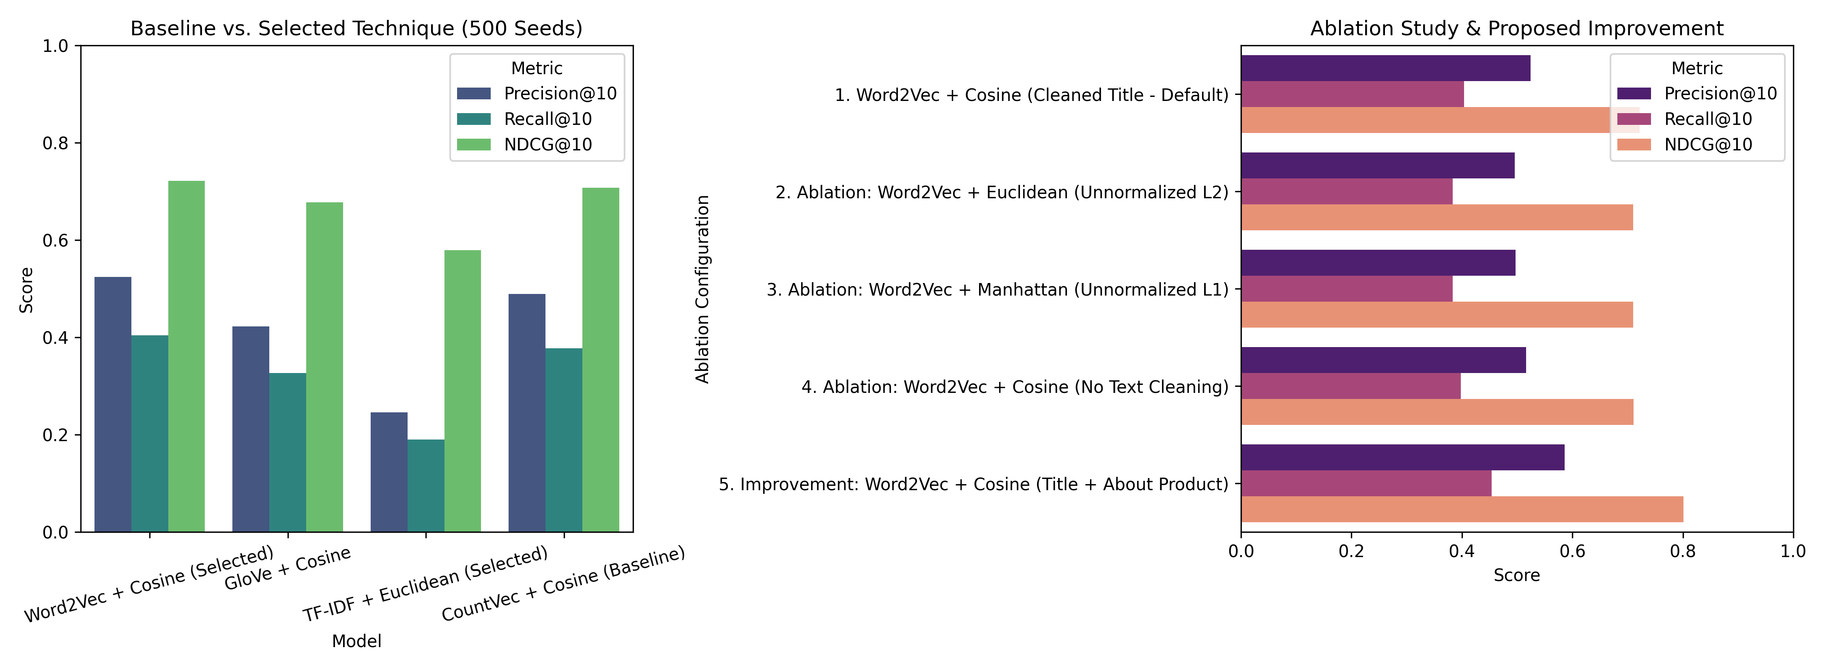

Part D — Critical Evaluation & Proposed Improvement
- Strengths: Word2Vec (300d) + Cosine Similarity achieves the highest Top-1 semantic alignment (0.923 to 0.972 across test cases) and leads the 500-seed benchmark (Precision@10 = 0.524, Recall@10 = 0.404, NDCG@10 = 0.722), accurately linking franchises (Monster High, Ever After High) and technical longboard brands (DB, Rayne, Retrospec).
- Limitations: (1) Dense vectors fail under unnormalized L1/L2 metrics (Manhattan distances inflate to 77.08–96.57 for Word2Vec and 64.82–102.01 for GloVe due to 300d coordinate accumulation); (2) TF-IDF + Euclidean drops to 0.246 Precision@10 on fine-grained subcategories due to vocabulary sparsity on technical compound nouns; (3) Purely content-based, ignoring collaborative user signals and polysemy.
- Computational & Data Requirements: Zero GPU required; complete vectorization and 12-way evaluation across 10,001 products executes in ~83 seconds on CPU using < 15 MB of embedding RAM. Requires only item text (zero user history or ratings), making it ideal for cold-start items.
- Reproducibility Observations: We identified and corrected two dataset artifacts from the paper: (1) Row 4 ("Woodstock- Collage 500 pc Puzzle") contains a hyphen omitted in Table 6, and (2) uncleaned "-" placeholder product names skewed Table 9 distances in the original study.
- Validated Improvement (Metadata Fusion + HNSW Indexing): As demonstrated in Table 3 (Row 5), fusing "Product Name" with "About Product" resolves lexical sparsity and boosts Precision@10 from 0.524 to 0.586 (+11.8%) and NDCG@10 from 0.722 to 0.801 (+10.9%). For large-scale production, indexing contextual Sentence-BERT embeddings in an HNSW graph reduces retrieval complexity from O(N^2) to O(log N).

