Python Project Report
by
Aditya ray(11913275)
SEC:RK19KB
ROLL NO: 31
---------------------------------------------------
Aniket Singh(11903027)
SEC:RK19KB
ROLL NO: 25
-------------------------------------------------
Paras(11913329)
SEC:RK19KB
ROLL NO: 37

Department of intelligent Systems
School of Computer Science and engineering
Lovely Professional University, Phagwara
01/11/2020

TABLE OF CONTENTS

- Student Declaration
- BONAFIDE CERTIFICATE
- Background and Objectives
- DESCRIPTION OF PROJECT
- Work Division
- Implementation of Scheduled Work of Project
- Technology and Framework Used
- SWOT Analysis

BONAFIDE CERTIFICATE

Certified that this Project report “Sudoku Solver” is bona-fide work of “Paras, Aditya Ray and Aniket Singh” who carried out the project work under my supervision.

Signature of the Supervisor

Name of the Supervisor

Academic Designation

ID of supervisor

Department of Supervisor

Background and Objectives

The main aim of the Project Is to implement the Learning of INT213 into real world so that we can start making GUI

The objective and motivation was to make work in groups to work with zeal, initiative, interest
to enhance what we have learned. We analyzed real life situational problems and thought creatively about the solutions for them. We applied the solution clearly and with great accuracy using python

Work Division

Aditya was made team leader by the consent of different team members. So as order to increase efficiency, it was very essential to assign different task to everyone according to their abilities. Even some small works was assigned individually so that each part is handled with great ease and efficiency.
- Aditya worked on Game initialization, Sudoku solver, grid modification with various other functions.
- Aniket was assigned with the grid design, game layout and compatibility and dealing with more such technical things.
- Paras was responsible with timer setting, database setup and color layout of the GUI

DESCRIPTION OF PROJECT 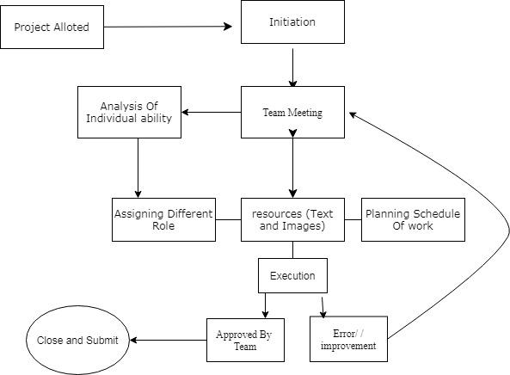

Project Management process flowchart

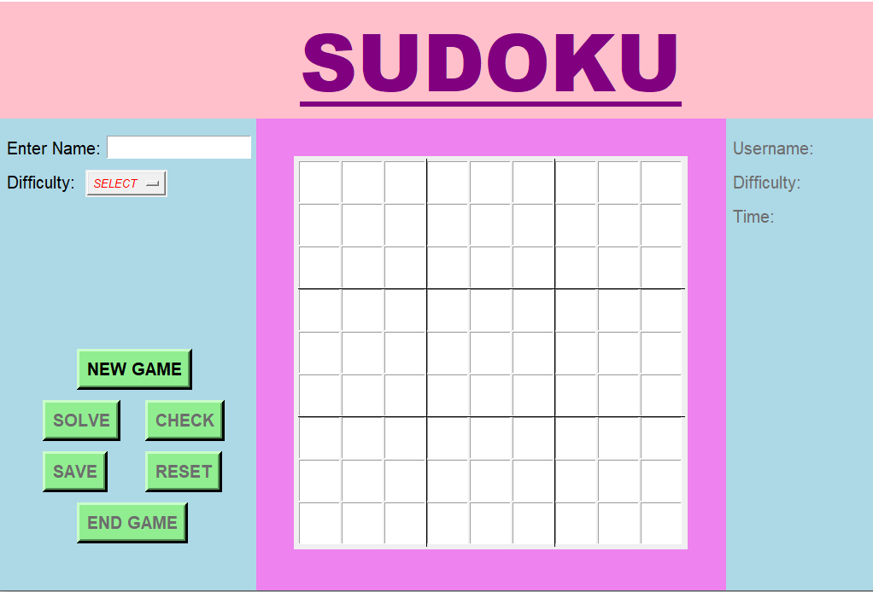
This is the starting interface of the game. Here you can enter your name, select the difficulty level and start the game. We have 3 level of difficulty for our users namely easy, normal and hard.

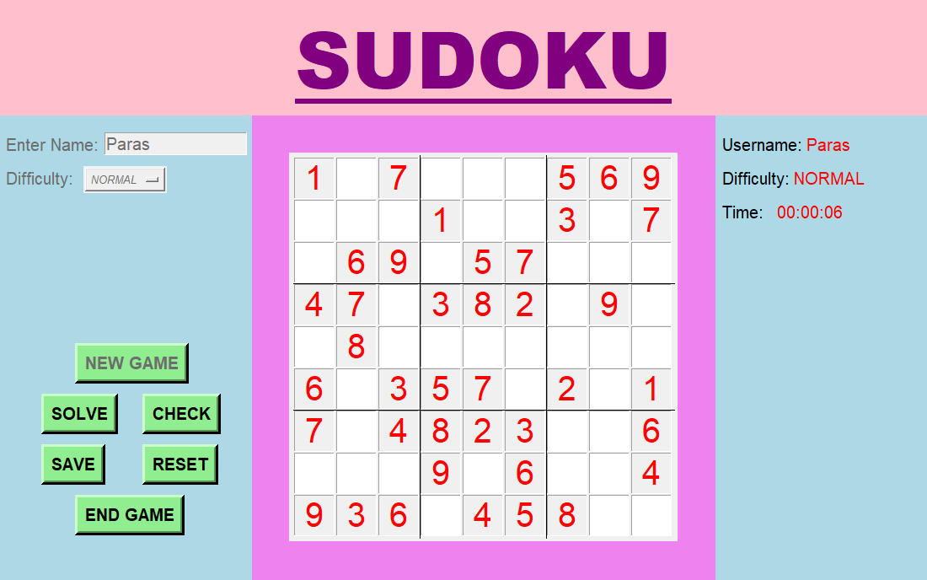
This is how our game looks like when you start playing a NEW GAME. We also have a SOLVE button for you to solve the game at one-click, if you got stuck at any point. You can reset your game to it’s initial stage using RESET button.

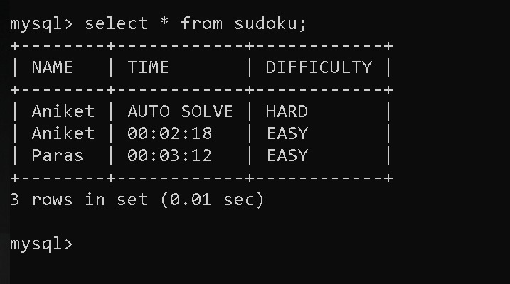
This is something how our DATABASE saves your record when you click on SAVE button

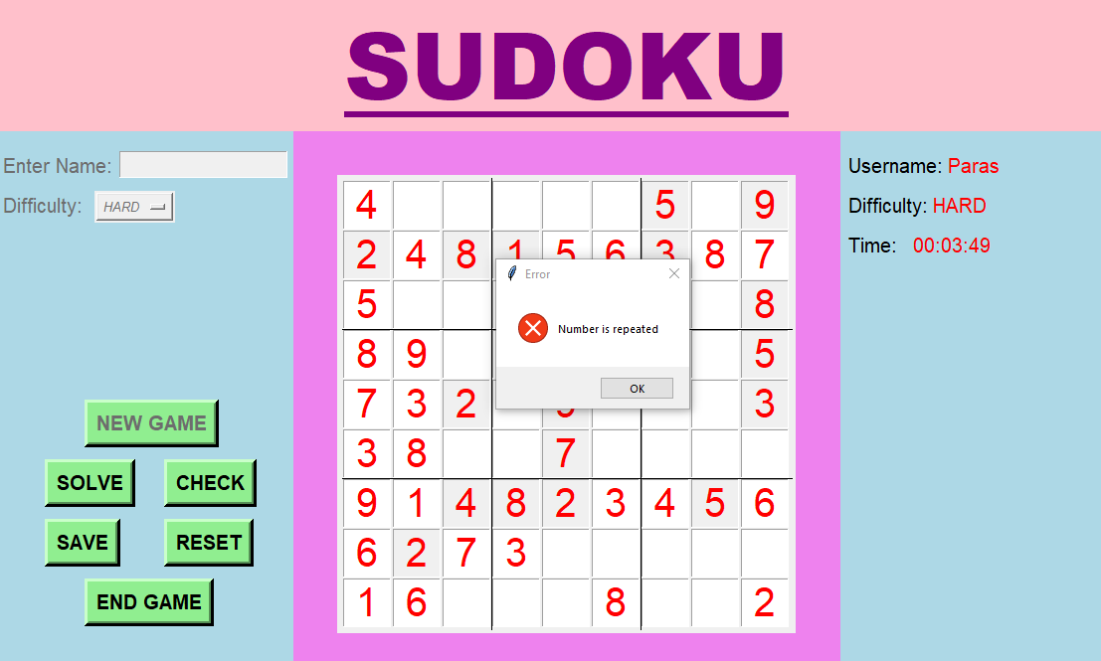

Here is the functionality of our CHECK button, which when clicked tells you whether all boxes are filled, incomplete, have repeated values or all values are alright.
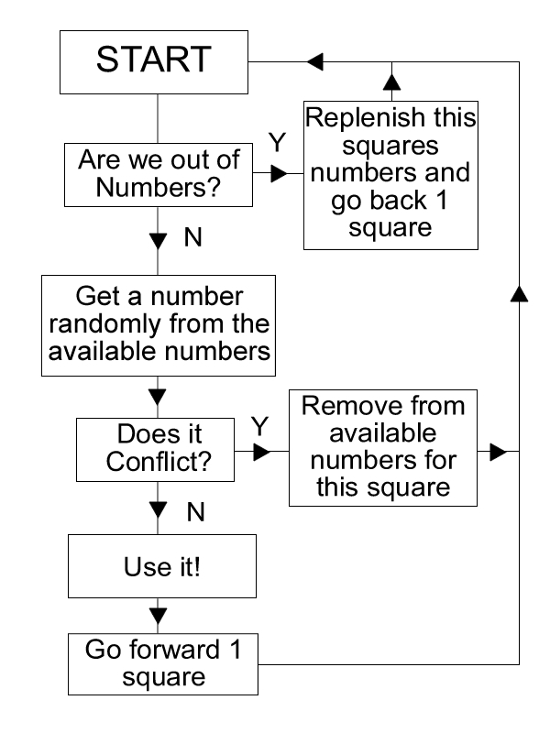
Technology and Framework Used
This Project is made using Python Programming Language which is an interpreted, high-level and general-purpose programming language and also one of the most widely used language.

Backtracking
Backtracking is an algorithmic-technique for solving problems recursively by trying to build a solution incrementally, one piece at a time, removing those solutions that fail to satisfy the constraints of the problem at any point of time.
- Method 1: Simple.
Approach: The naive approach is to generate all possible configurations of numbers from 1 to 9 to fill the empty cells. Try every configuration one by one until the correct configuration is found. After filling all the unassigned position check if the matrix is safe or not. If safe print else recurs for other cases.

Complexity Analysis:
Time complexity: O(9^(n*n)).
For every unassigned index, there are 9 possible options so the time complexity is O(9^(n*n)).
Space Complexity: O(n*n).
To store the output array a matrix is needed.

Method 2: Backtracking.
Approach: Sudoku can be solved by one by one assigning numbers to empty cells. Before assigning a number, check whether it is safe to assign. Check that the same number is not present in the current row, current column and current 3X3 subgrid. After checking for safety, assign the number, and recursively check whether this assignment leads to a solution or not. If the assignment doesn’t lead to a solution, then try the next number for the current empty cell.

Complexity Analysis:
Time complexity: O(9^(n*n)).
For every unassigned index, there are 9 possible options so the time complexity is O(9^(n*n)). The time complexity remains the same but there will be some early pruning so the time taken will be much less than the naive algorithm but the upper bound time complexity remains the same.
Space Complexity: O(n*n).
To store the output array a matrix is needed.

OUTCOMES:

- Gained knowledge about the vastness of Python Programming Language.
- Creating connection between various pages and interlinking them.
- Got grip Python scripts, Database creation, Using Tkinter to create Gui and much more.
- Learned about Teamwork
- We didn’t used GitHub just to host project but we also used it the way it is supposed to be used i.e. working on a project in a team. We did all things from version control like pull request, merge, branches

SWOT Analysis

S: Strengths
W: Weakness
O: Opportunities
T: Threats

These are the internal capabilities require to create the project.
S: Various Strengths are the support of the teachers to clear all doubts and the intense knowledge given by them which helped the completion of the project.

W: Internal weakness like fear of failure, the frustration regarding the completion of the project.

O: Opportunities include the knowledge gained in the field of various web-development languages availed in creating the project and the use of various online plateforms.

T: Threats usually include in the outer environment, usually outside the control of project.These are out of our reach also which have not come to the light.

