Aditya Kumar Ray

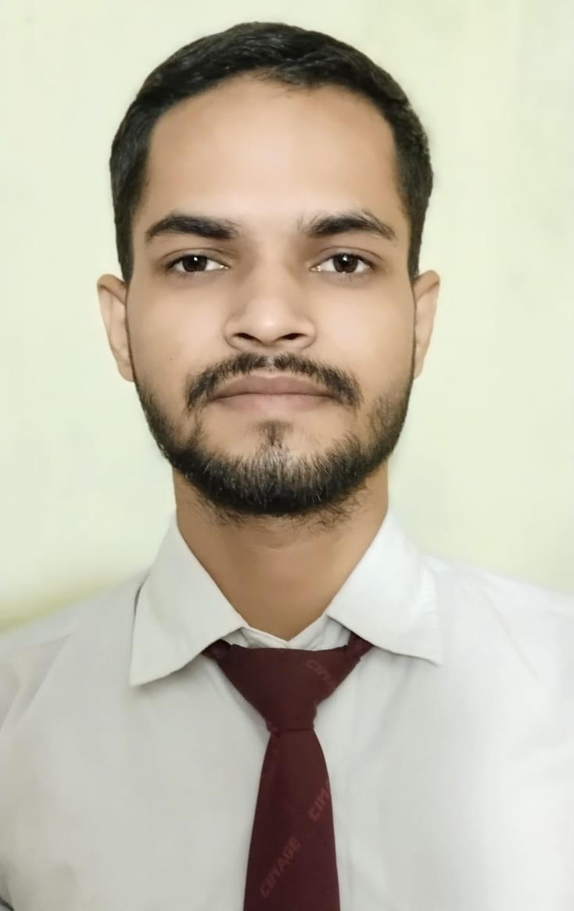

* [adityakumarray061@gmail.com](mailto:%20adityakumarray061@gmail.com)

• +91-9508549987

* LinkedIn: linkedin.com/in/aditya-kumar-ray-60b783233/

# Objective

A self-motivated and quick learner with a strong analytical mindset and a passion for technology. Adept at problem-solving and delivering innovative solutions through technical expertise.

# Skills and interests

**Programming Languages** C, C++, Java, OOP

**Database** SQL, MySQL

**Web Technologies** HTML5, CSS3, Bootstrap, REST APIs, React.js, Node.js, Express.js, MongoDB

**Version Control System** Git, GitHub

**Soft Skills** Problem-solving, Adaptability, Leadership, Team player

**Others** MS Office(Word, Excel, PowerPoint), Networking, Operating System

# EDUCATION

**CIMAGE College, Patna** July 2022 - July 2025

Bachelor of Science in Information Technology

# EXPERIENCE

**Web developer intern | CodSoft** July 2023 - August 2023

* Designed, developed, and deployed responsive web applications using React.js and HTML5, resulting in a 30% increase in user engagement through interactive features and mobile-first design.
* Developed dynamic UI components with React.js to enhance user interactivity and engagement.
* Conducted cross-browser testing to ensure compatibility and a 95% usability rate across platforms.
* Collaborated with a team of developers in an agile environment to deliver projects on time and meet client specifications.

# Certifications

* **Spoken Tutorial Project, IIT Bombay**. (C++ Programming Language Certificate)
* CCNA(Introduction to Networking)

# PERSONAL PROJECTS

**Doctor Appointment System**

* Developed a comprehensive Doctor Appointment System to streamline appointment scheduling, rescheduling, and cancellations.
* Implemented secure user authentication mechanisms to ensure data privacy and integrity.
* Designed responsive user interfaces using Bootstrap, optimizing the system for seamless compatibility across various devices.
* Integrated real-time notifications to improve user experience and enhance the efficiency of the appointment process.
* Achieved a 98% user satisfaction rate by focusing on intuitive design and functional efficiency.

**Farmer to Consumer(AgriVatika)**

* Developed a platform connecting farmers directly with consumers, eliminating intermediaries and ensuring fair pricing for fresh produce.
* Designed and implemented a responsive, user-centric interface to enhance accessibility across multiple devices.
* Created an intuitive product search and filter system, leading to a 35% reduction in bounce rate and a 25% increase in user engagement.
* Developed a user-friendly dashboard for farmers to manage inventory and orders, improving order fulfillment times by 20% and reducing operational errors by 15%.

**Personal Portfolio Website**

* Developed a personal portfolio website with HTML5, CSS3, and JavaScript, ensuring responsiveness and performance optimization (25% faster load times).
* Achieved 95% user satisfaction for the clean design, speed, and user-friendly layout across devices.

# Hobbies and interests

* Coding
* Volunteering
* Web Development
* Learning New Technologies